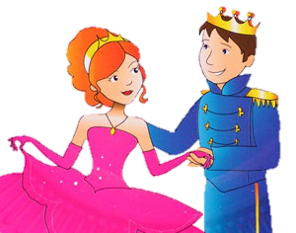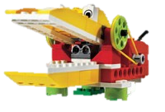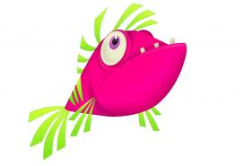

Further information Contact Simone on

61331308

or s_freiheit@hotmail.com

CREATIVE TUESDAYS

**Tuesday 10 July**

**Theme: THE OCEAN**

**Mindstorms/WeDo-challenge: Build a robot that can drive on the bottom of the sea or build a sailing ship.**

**Creative part: We will make beautiful fish with watercolours and acrylic painting.**

**Tuesday 17 July**

**Theme: FABULOUS MONSTERS**

**Mindstorms/WeDo- challenge: Can you find a minotaurus in the maze on Knossos?**

**Creative part: Draw and paint yor own fabulous monsters on wood or make a beautiful painting.**

**Tuesday 24 July**

**Theme: THE JUNGLE**

**Mindstorms/WeDo- challenge: Can you find the hidden treasure or build your own monkey?**

**Creative part: Draw and paint your own jungle with beautiful colours, animals and flowers.**

**Tuesday 31 July**

**Theme: PRINCES AND PRINCESSES**

**Mindstorms/WeDo- challenge: Build a dragon and make your own fairy tale.**

**Creative part: Draw and paint with acrylic painting or make accessories to your own fairy tale.**

Remember

Lunch

pack

Activity for children or the whole family in the summer vacation here in Hovborg , Lindevej 5, arranged by Holmeå Art Society.

**Every Tuesday in July from 10-13 o’clock** you and your family can come and play with **LEGO** **WeDo** or **Mindstorms** or you can **be creative** with different kinds of painting. If you are lucky, you can also be **face painted**.

Price: 120 kr/child. Children under 10 years in accompany with an adult.