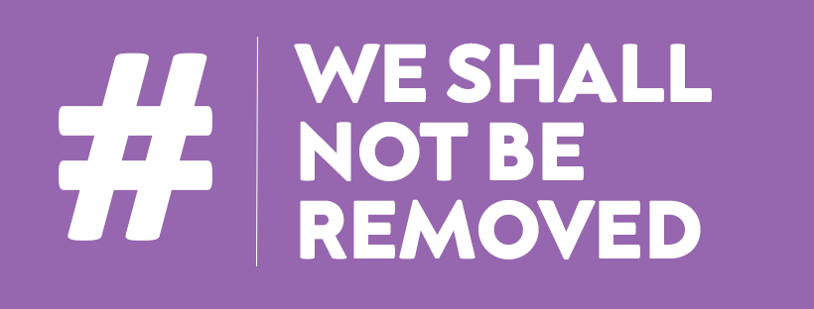

UK Disability Arts Alliance 2021 Survey Report:
The Impact of the Pandemic on Disabled People and organisations in Arts & Culture

Compiled by Alistair Gentry
Edited by Andrew Miller

May 2021

CONTENTS

Page
2 Summary Headlines
3 Introduction & Methodology
4 Part One: Individual Disabled Creative Practitioners
Key Findings
6 Who Responded?
16 Pandemic Impacts
22 The Impact of We Shall Not Be Removed
32 Part Two: Disability Arts & Cultural Organisations
Key Findings
33 Who Responded?
39 Pandemic Impacts
45 The Impact of the Seven Inclusive Principles
49 Notes on the Survey
50 Reflections on the Survey
51 The UK Disability Arts Alliance
52 Acknowledgements

SUMMARY HEADLINES

- This is the first survey to capture a snapshot of the disability arts sector since the pandemic began. It reveals that disabled people are operating in a highly fragile environment within arts and culture:
  - Half of our respondents told us they had less work than before the pandemic, or no work at all
  - Half did not access government or arts council financial support
  - About one third describe themselves as precariously employed or on a zero hours contract
  - A further third have experienced homelessness
  - Nearly two thirds are worried that they will have to leave the creative industries due to lack of work
  - The vast majority of our respondents are freelance, with only 7% reporting full time salaried work and half of them express worries about their long term job security
  - One in five disability arts organisations have already made people redundant, not renewed contracts, or not taken on new staff because of the pandemic.
  - Whilst 58% of organisations have needed to dip into their financial reserves, 13% had no reserves to spend

- Government and arts council emergency financial support schemes (including CRF, furlough and SEISS) have been vital in maintaining organisations, preventing further redundancies and supporting just over 50% of our respondents

- 82% of respondents expressed concern about continued provision of access for disabled audiences through reopening. The cultural sector needs to offer reassurance that access remains a top priority

- The #WeShallNotBeRemoved campaign is achieving better than average representation across most diversity metrics, with a high degree of support expressed for the Seven Inclusive Principles
INTRODUCTION & METHODOLOGY

In early 2021 the UK Disability Arts Alliance commissioned artist and researcher Alistair Gentry to survey individual disabled practitioners and organisations. The aim was to establish a snapshot of the Alliance’s supporters, and of disability arts in general, one year into the Coronavirus Pandemic and one year on from the founding of #WeShallNotBeRemoved (#WSNBR) and its campaign.

Whilst many surveys of the cultural sector have taken place during the pandemic, most marginalised or ignored disabled people altogether, so this was to be the first to focus specifically on the impact on deaf, disabled, learning disabled & neurodiverse artists, employees and organisations.

The survey is split into two sections: one for individual disabled creative practitioners and one for disability arts and cultural organisations. The questions in both sections focus on three areas, designed to:
- identify the demographics of who responded
- assess the impact of the pandemic on respondents work
- and finally to assess the impact of the #WSNBR campaign itself and the Seven Inclusive Principles

The survey was created and overseen by a working group of #WSNBR Conveners: Jo Verrent, Dr Jessi Parrott, Ellie Page (#WSNBR Administrator) and Andrew Miller.

The survey was made available online with bespoke access options between 1 - 30 April 2021. It was promoted on all #WSNBR platforms and on social media by our partner organisations. The survey received 131 responses which is split between 107 from individuals and 24 from organisations, and represents a sample size of just under 20% of known #WSNBR supporters.

This project was enabled by Unlimited thanks to additional financial support from the Paul Hamlyn Foundation.
PART ONE: INDIVIDUAL DISABLED CREATIVE PRACTITIONERS
a. KEY FINDINGS

- Nearly 50% of our respondents said they had less work than before the pandemic, or no work at all. A similar percentage received no additional government or arts council financial support. Nearly two thirds felt they would possibly or definitely have to leave the arts due to lack of work.

- About one third of respondents describe themselves as precariously employed or on a zero hours contract. The same proportion have experienced homelessness, marking these factors as new and concerning issues for disabled people in the cultural industries.

- Disabled creative practitioners exist in a fragile environment and the majority are freelance. Only 7% of respondents have a full time salaried job. About one in ten respondents are currently unemployed freelancers; one in five are freelancers with current contracts. About half of respondents (43%) said they had less work since the pandemic began. 6% said that they had not been able to find work at all during this period.

- Financial support schemes - including the Government’s Self Employment Income Support Scheme (SEISS) - have been important, necessary and productive to those who received them. 20% of respondents accessed SEISS grants, 15% were on furlough and a further 20% an emergency support grant from one of the UK’s national arts councils.

- As the culture sector re-opens, the top three concerns are: 1. continued access provision for disabled people in general, 2. health & safety issues, 3. Failure to meet individual personal access needs. The strength of this response suggests many disabled respondents have little trust in the wider cultural sector to prioritise access.
- On the two #WSNBR campaign aims, 60% of respondents felt that the aim to amplify disabled people’s voices during the pandemic had been mostly or extremely successful, whilst over a third felt it had been mostly or extremely successful in its aim to promote a sustainable future for disability arts.

- The top three forms of engagement with #WSNBR were: following on social media, reading online content, and engaging in campaigns/social media sharing. The top three factors preventing people from engaging are: “I don’t have enough time”, “I find it physically and/or mentally exhausting or overwhelming”, and “I’m too busy with paid work” (26%). Roughly equal numbers of people complained about too much information and too little information.

- Most respondents are quite relaxed about how they interact with the campaign, including their access needs. People who express a dislike for particular technologies or platforms are often vehement, but in a very small minority.

- #WSNBR is achieving better than average representation on diversity across disability, ethnicity, socioeconomic background, gender identity and age despite some perceptions to the contrary. However, people identifying as male or as trans/transgender are very significantly underrepresented.

- The physical location of respondents replicates the arts sector’s general orientation to cities and London in particular. Based on this survey, the campaign’s heartlands lie in England and Wales as there seems to have been only marginal penetration in Scotland and Northern Ireland.

- 86% of respondents think that #WSNBR should possibly or definitely continue, the majority saying it definitely should.

b. WHO RESPONDED?

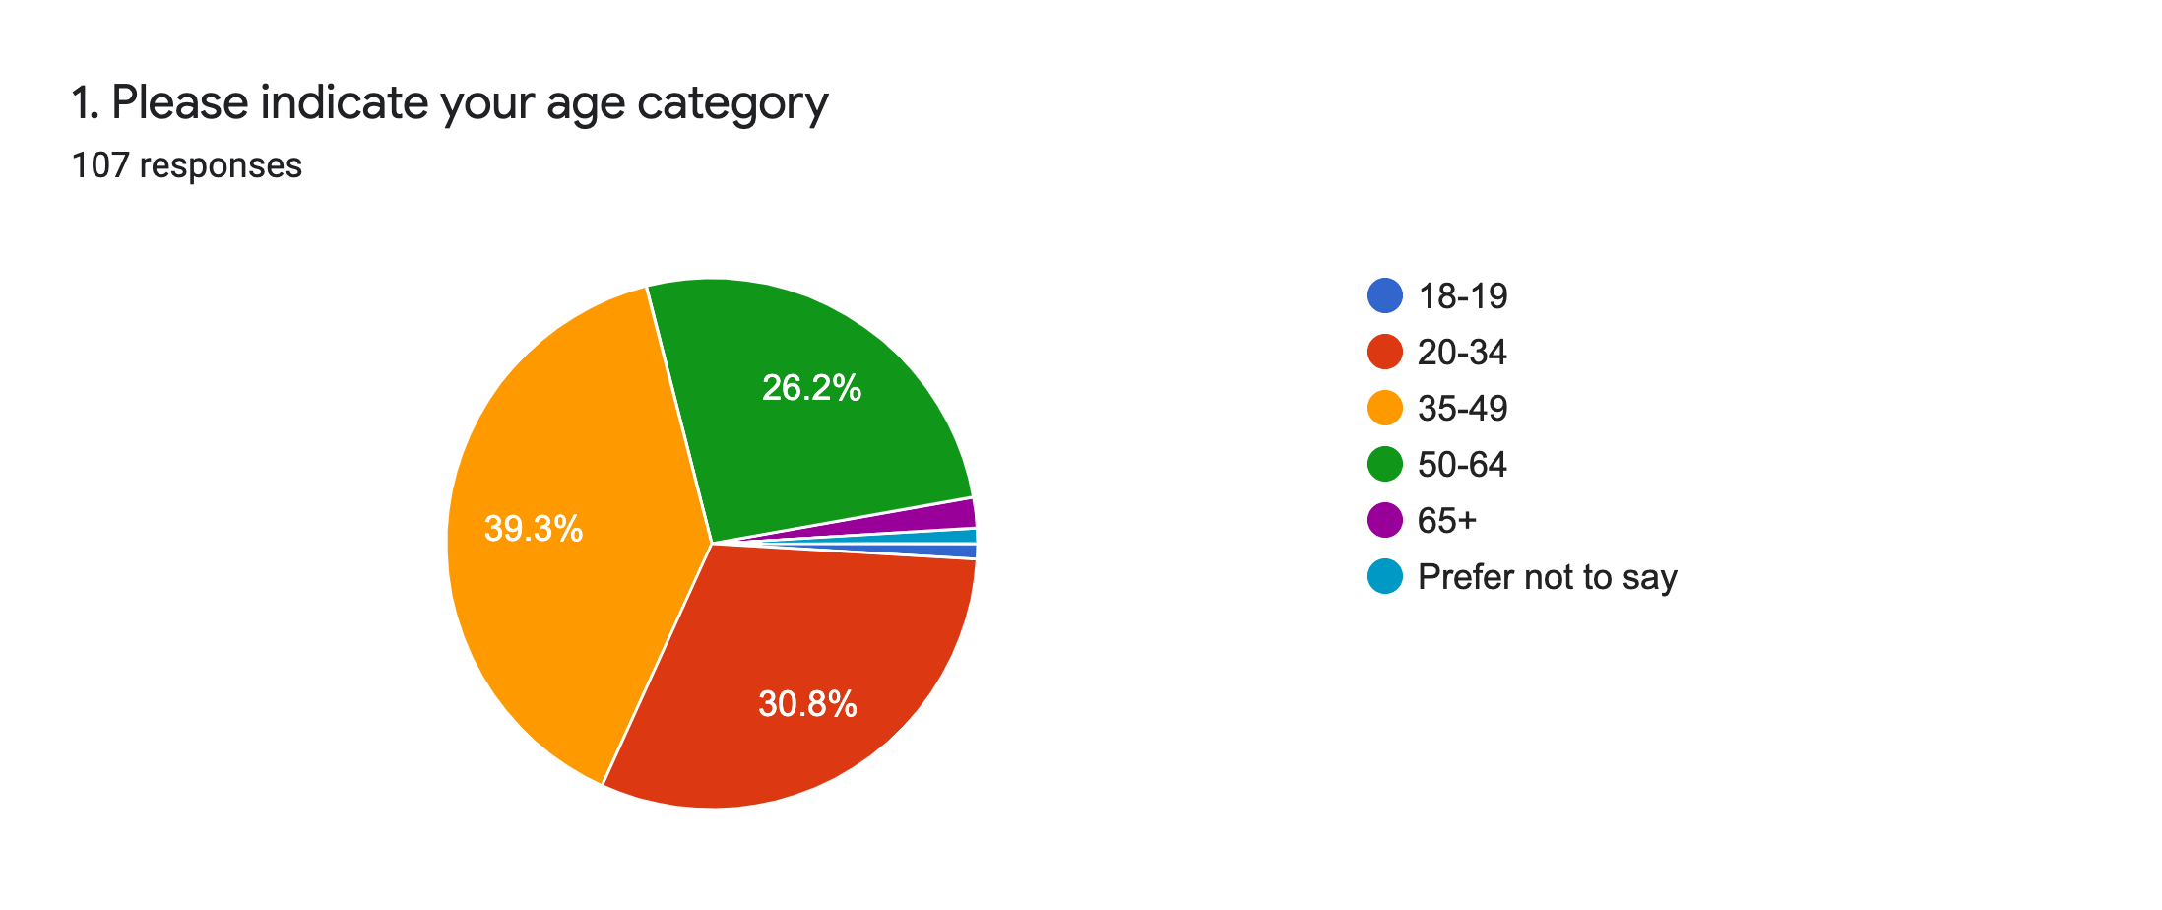

Age: A slight majority of respondents (39%) were in the 35-49 age group, closely followed by 20-34 year olds (31%) and 50-64 year olds (27%). This is an even spread of adult, working age participants and means that only about 4% of respondents are over 65 or under 20.
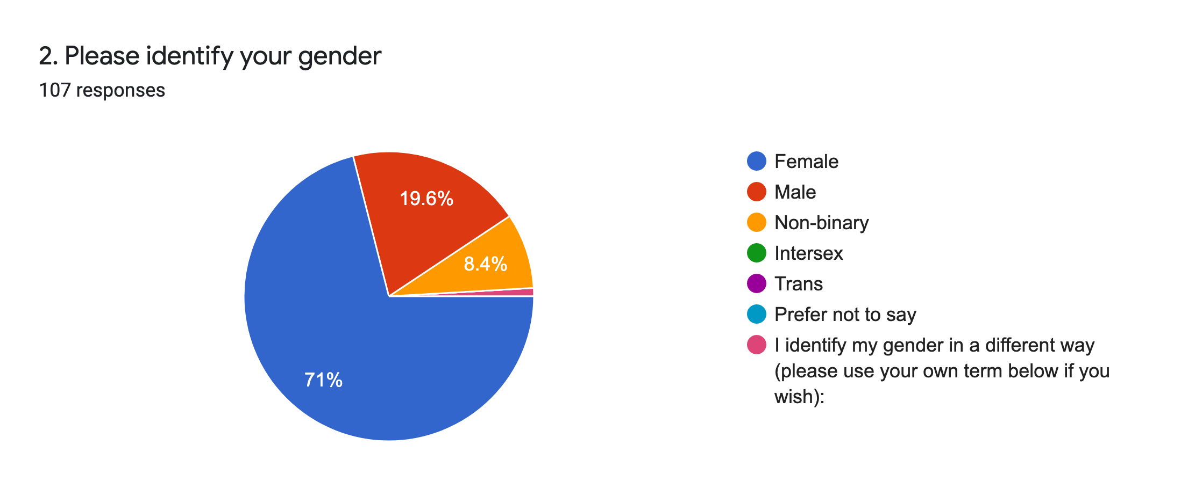
Gender: As demonstrated clearly by the diagram, the majority (71%) of respondents identify as female. While people identifying as male or as trans/transgender are very significantly underrepresented, 8% non-binary people is better than average representation and Q3 reveals there is a very striking 24% of respondents not identifying as the gender they were assigned at birth.
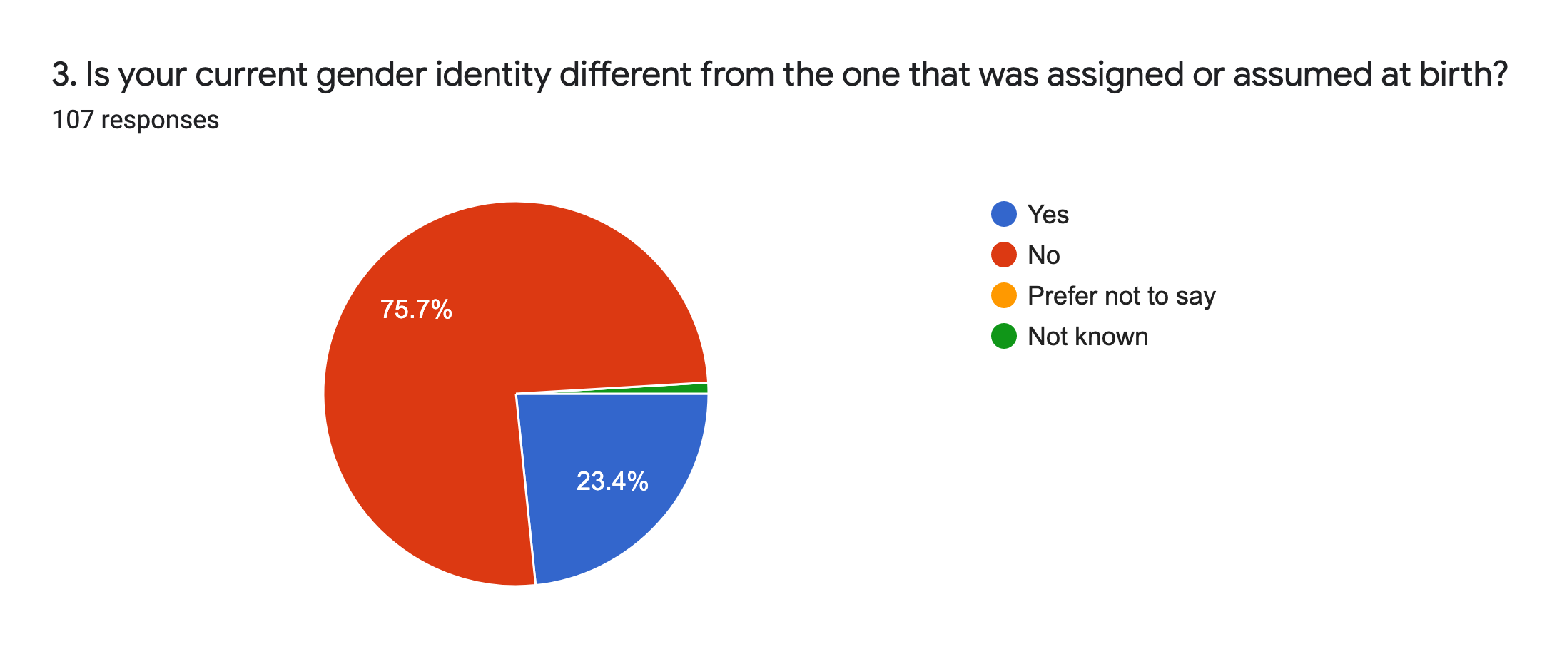
Changes in gender identity: Three quarters of the sample (76%) identify with their birth gender, but nearly a quarter do not although as identified in Q2, none described themselves as trans/transgender.
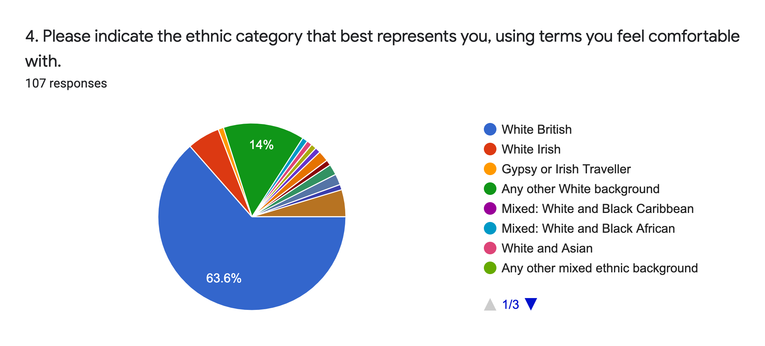
Ethnic categories: Under the system generally used by most ethnic monitoring forms in the UK, the majority of respondents (64%) identify as White British, with a further 14% identifying as from other White backgrounds, for a total of 78%. The figure of 64% White British is actually much lower than the 86% of people who identified as such in the 2011 UK census, i.e. the cohort of respondents is more ethnically diverse than the UK population.

Other ethnic identities were evenly represented in low numbers broadly consistent with the wider population, apart from people who identified as White Irish (here in red) and people who chose to identify themselves in another way (in brown). The total percentage of non-white respondents was 15.9% which is, again, slightly ahead of UK population demographics.
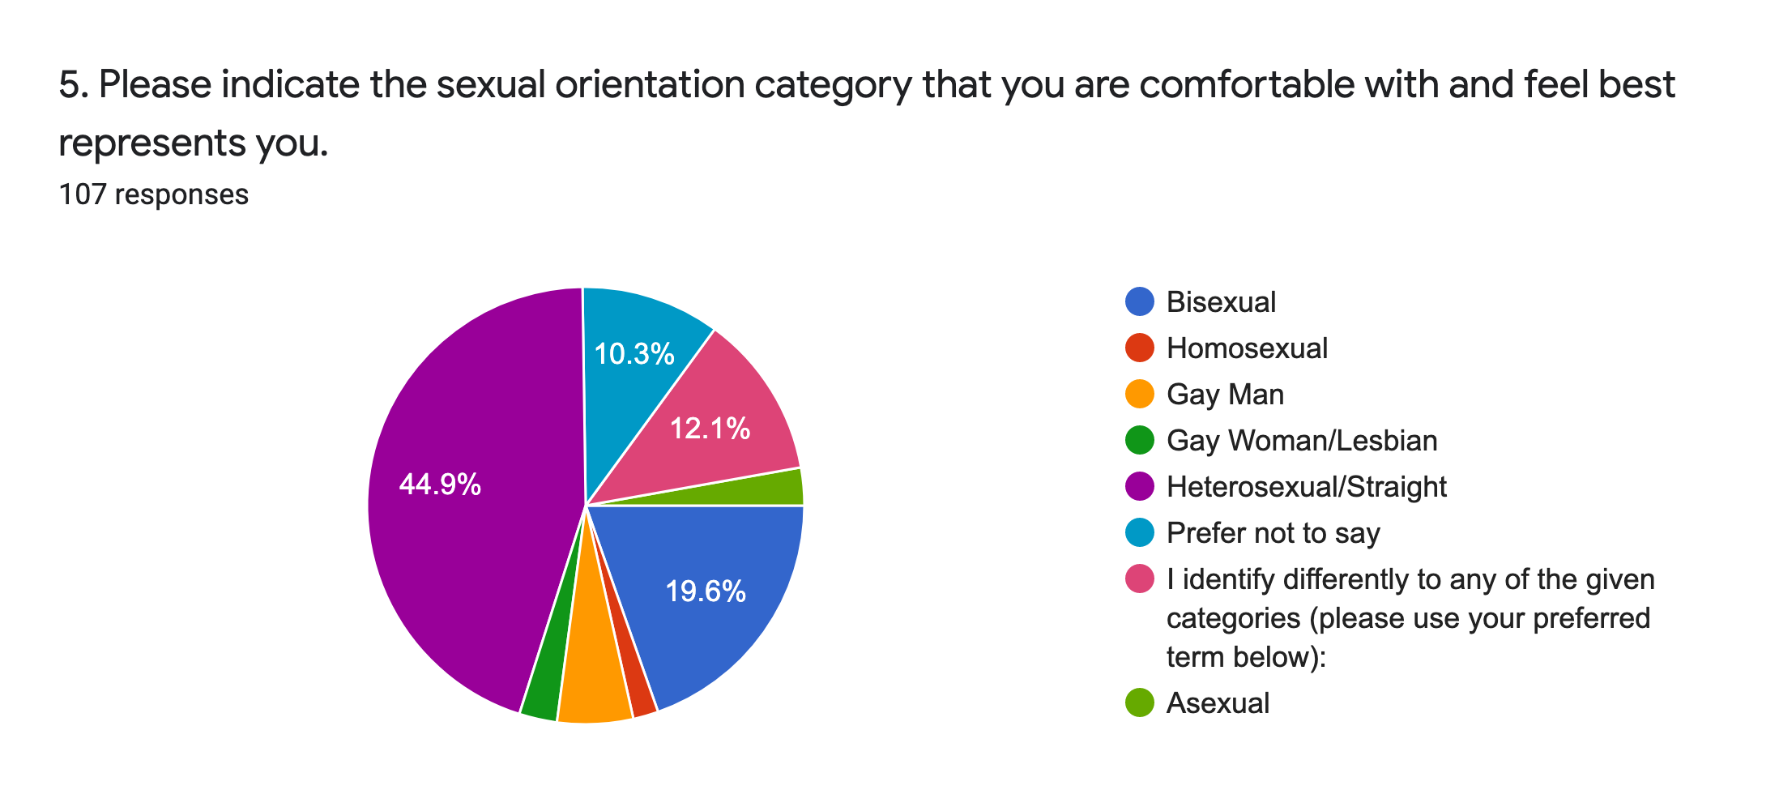
Sexual orientation: 45% of respondents identified as heterosexual/straight and highly unusually, an equal percentage declared being not heterosexual/straight. This is the only question where a significant (10%) number of people refused to answer. One in five (20%) identified as bisexual, and a large minority (12%) chose to use their own terms rather than those provided; these clustered almost universally around Pansexual, Queer, or both, with one exception who described themselves as Demisexual.

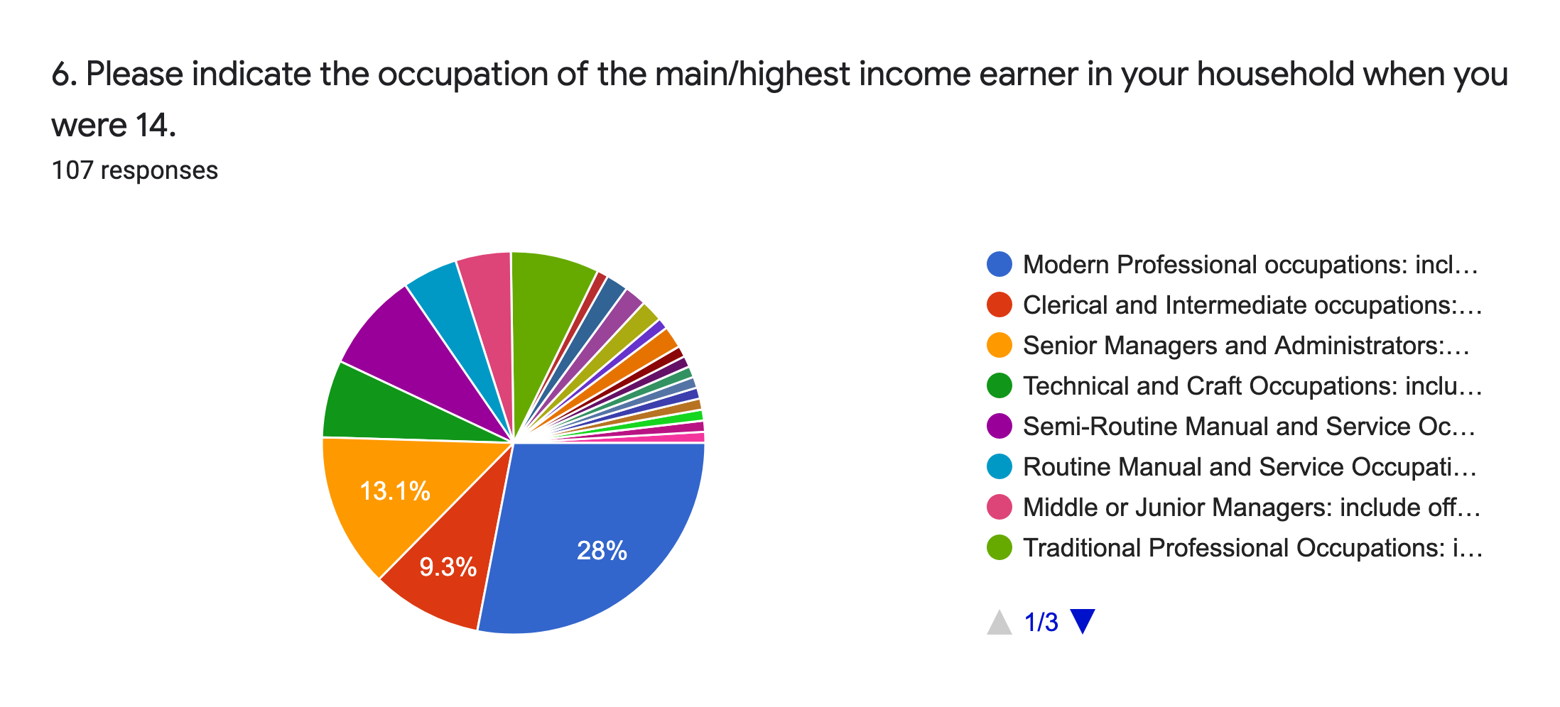

Economic background: Half of the total number of respondents came from households where the main income earner was employed in a modern profession (e.g. those requiring a qualification such as a teacher, nurse or social worker), senior management (e.g. “white collar” jobs at administrator level, such as banking), or clerical (e.g. less senior “white collar” office-based occupations) capacity. Other significant groups included semi routine manual and service occupations such as postal workers, machine operators or catering assistants (9%), technical and craft occupations like electricians, gardeners or mechanics (6%), and traditional professional occupations such as accountant, solicitor, or doctor (8%). These are occupations termed A, B, C1 and C2 according to the UK Office for National Statistics. The remaining (27%) of occupations were evenly distributed among the other options, apart from people who chose to specify free text options that were already available from the existing categories. In other words, using ONS social grade categories, about a quarter of respondents’ socioeconomic backgrounds fall into classes D or E, which is almost perfectly in line with the 26% of the UK population who also fall into this category. The percentage of respondents whose childhood household’s main income earner corresponded to AB, C1 or C2 groups is also consistent with national figures.
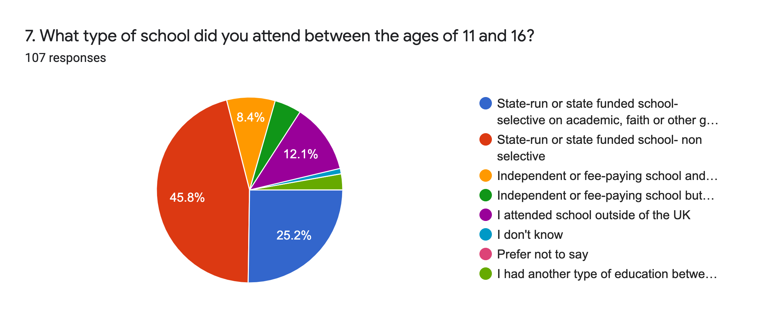
Educational background: Nearly half (46%) were educated at non-selective state run schools (e.g. free, comprehensive, secular) schools. A further 25% attended free state schools selected on educational, faith or other grounds, so in total 71% attended some form of free school. About one in ten (13%) attended a fee-paying (i.e. private) school, either with or without a scholarship, mostly the latter. A significant minority (12%) were educated outside of the UK.

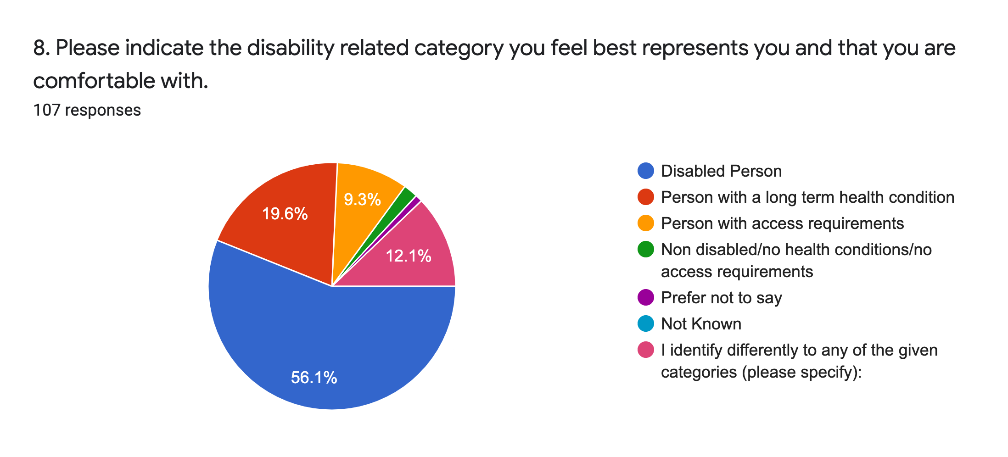
Disability identification: Over half (56%) of respondents identify as disabled. A further one-fifth (20%) identify as a person with a long term health condition.
Nearly one in ten said they did not have any particular access requirements, but only two respondents said they did not identify as disabled in any way. A further 9% described themselves as people with access requirements. The significant minority (12%) who said they identified differently from any of the provided categories clustered around the term neurodivergent, with a few using the term neurodiverse instead, and a very small number (<5) using other terms such as “crip” or “differently abled”.

(The following questions relate to intersectional inequalities)
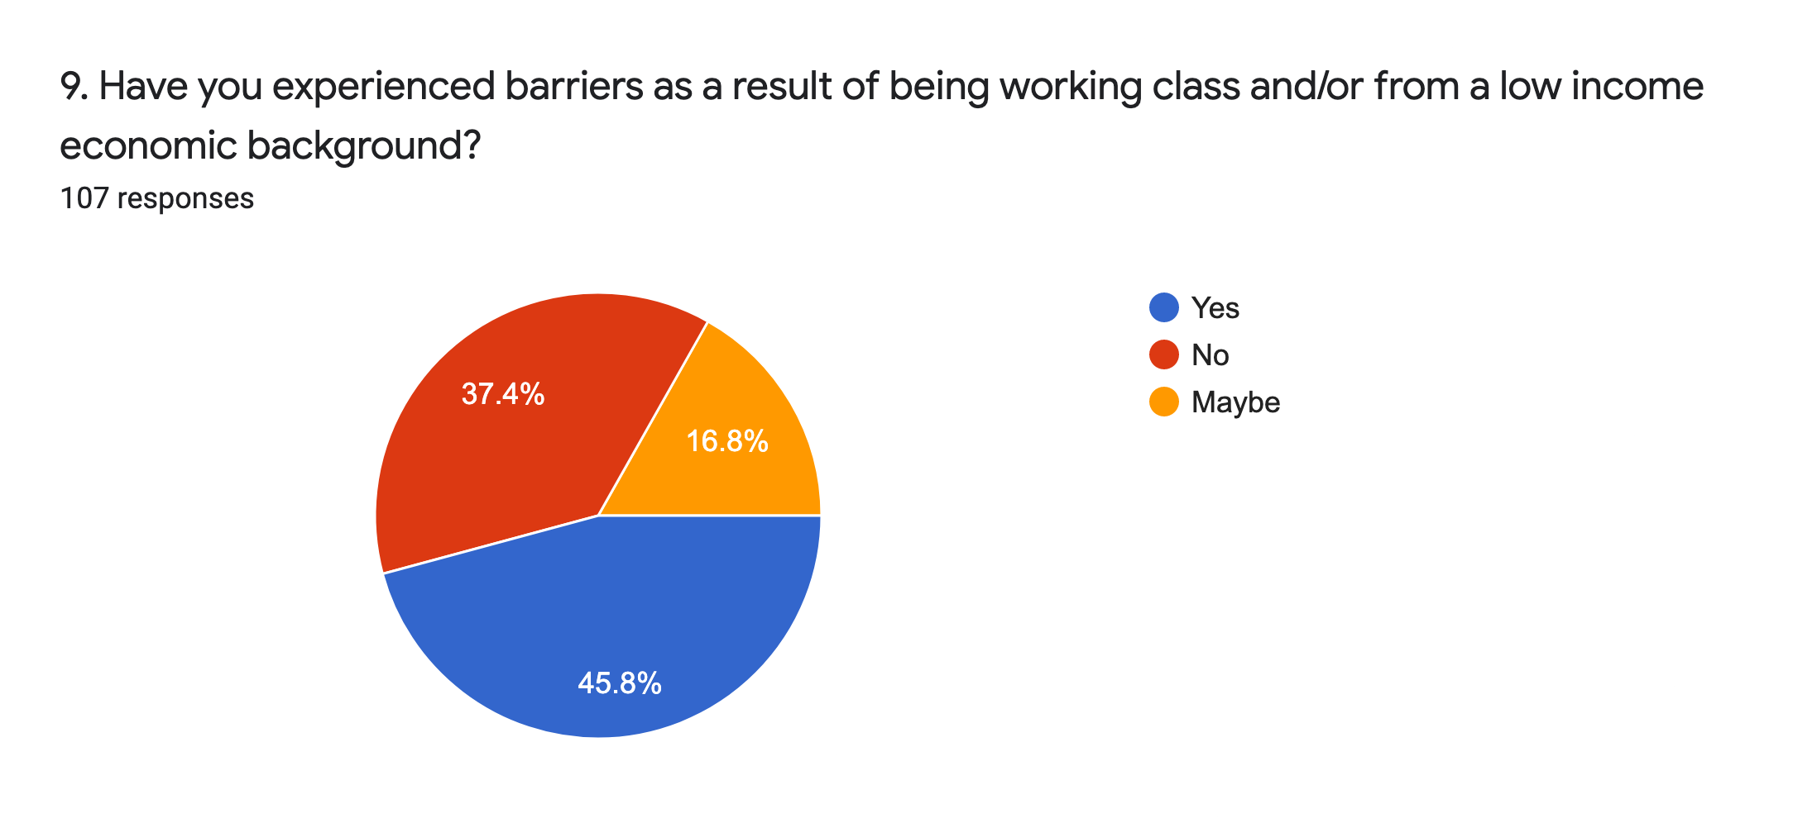
Barriers for people from low income backgrounds: Nearly half (46%) said they felt there were barriers for them as a result of having a working class and/or low income background. Note that this does not, however, match up even roughly with the proportion (27%) of respondents who could be identified as likely to be from socioeconomic backgrounds D or E, i.e. those that could logically be considered to be from low income backgrounds. Nor indeed does it match up with the nearly identical percentage of people in the UK as a whole who are from low income backgrounds.

This is a common problem when discussing class backgrounds in the UK in particular, because significant numbers of people either knowingly or unconsciously “downgrade” themselves to less middle class than their backgrounds actually are, and often regard a statistically high/above median income as low because they tend to compare themselves to people much richer than them instead of those who are even slightly poorer. Here the number who seem to have done so is about one in five of the respondents.

It’s also possible that this question needs more nuance or explanation so respondents don’t conflate the household they were brought up in with their current household and their own experiences of low income, precarity or poverty, which are different matters to one’s socioeconomic background and are explored in the following questions. What is perceived as prestige, secure and/or middle class jobs has also in some cases changed significantly over time, especially for a respondent in the older age groups.
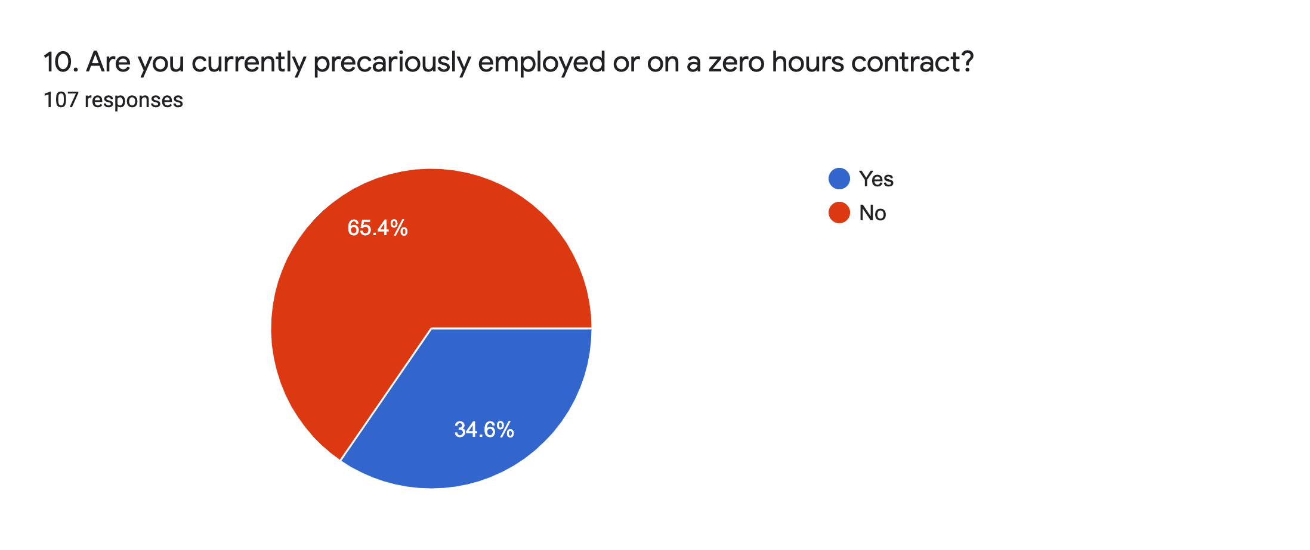
Precarious employment: Over one third of respondents (35%) are currently precariously employed or on zero hours (e.g. no work guaranteed or “gig economy”) contracts.

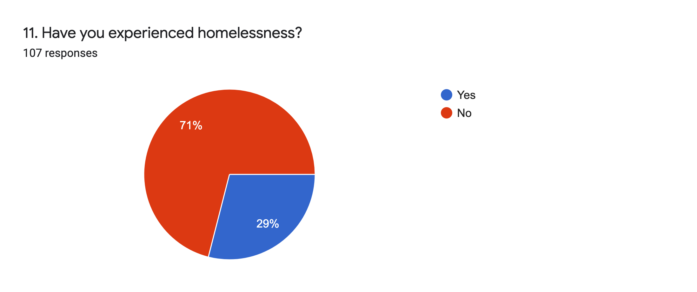
Homelessness: A large number (29%, nearly one third) of respondents have experienced homelessness, marking this as another major issue for disabled people, especially set against UK homeless population statistics. It should also be noted that contrary to the popular stereotype of what a homeless person looks like and why they are homeless, homelessness includes not just rough sleepers on the street, but also people forced to stay with relatives or friends for periods ranging from weeks to years, “couch surfers” and other people who are itinerant by necessity rather than choice or culture, people (women and teenagers especially) fleeing abusive households or relationships, and people in temporary accommodation.
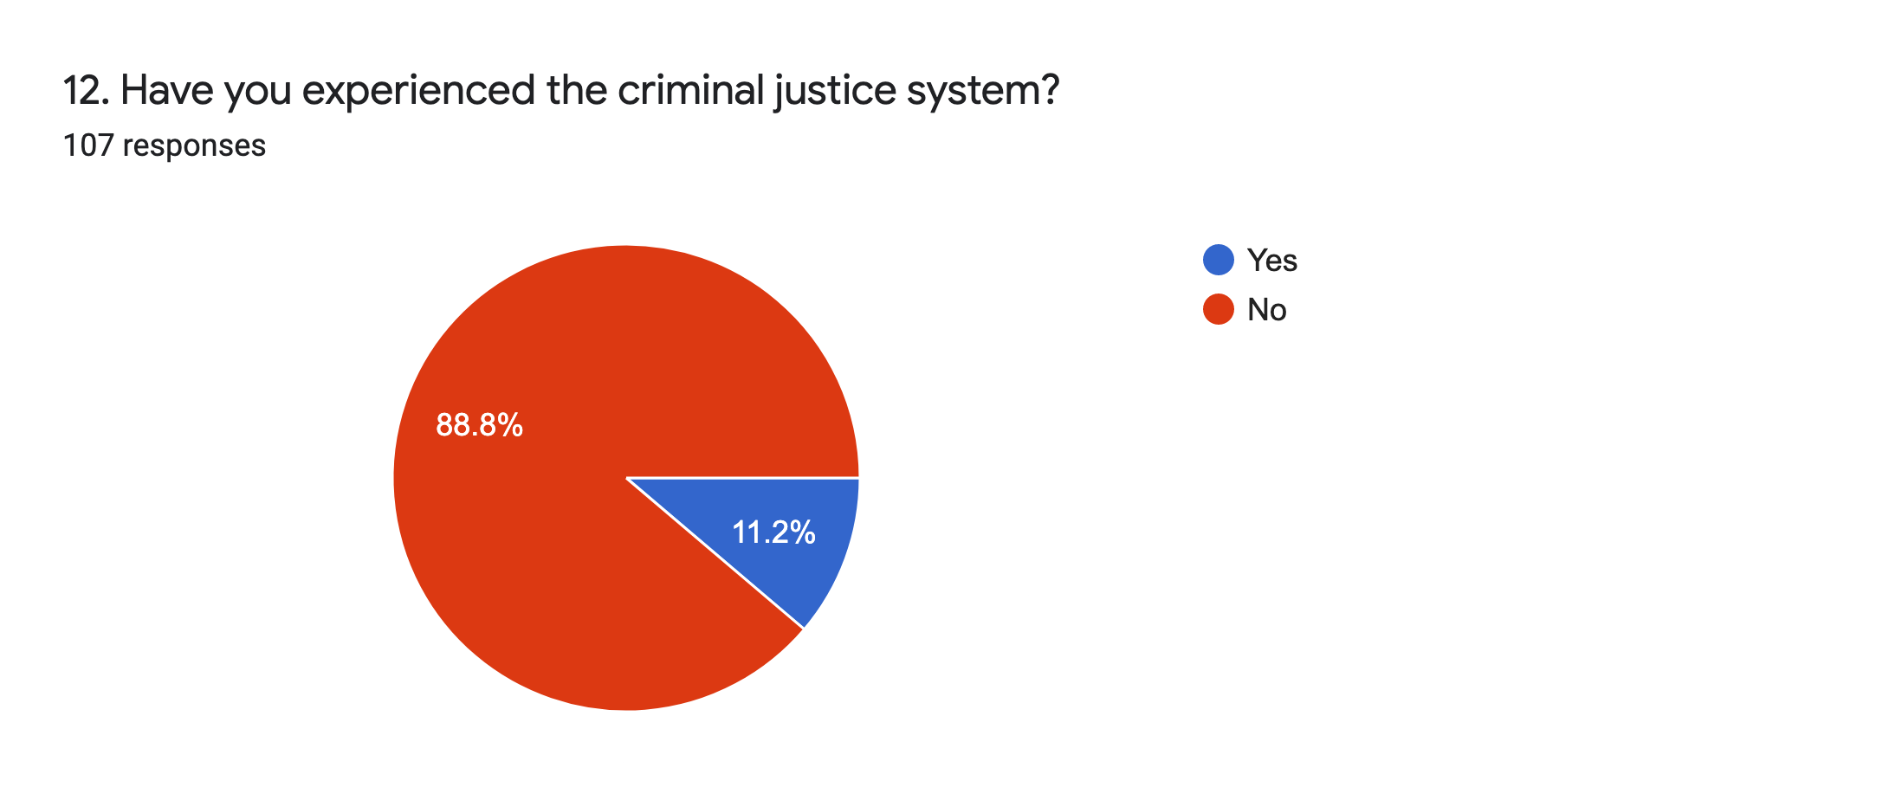
Criminal justice system: About one in ten respondents (11%) have experienced the criminal justice system.
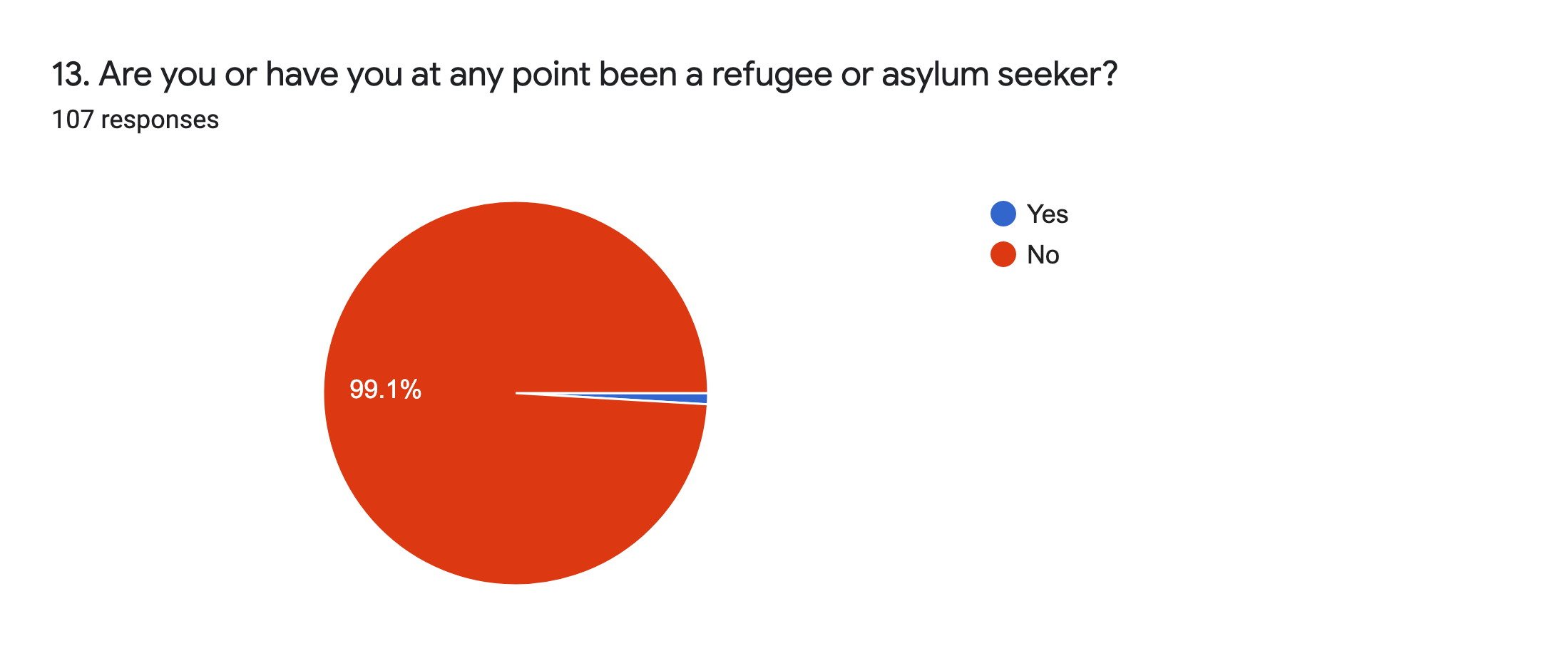
Refugee status: Only one respondent said they had been a refugee or asylum seeker.

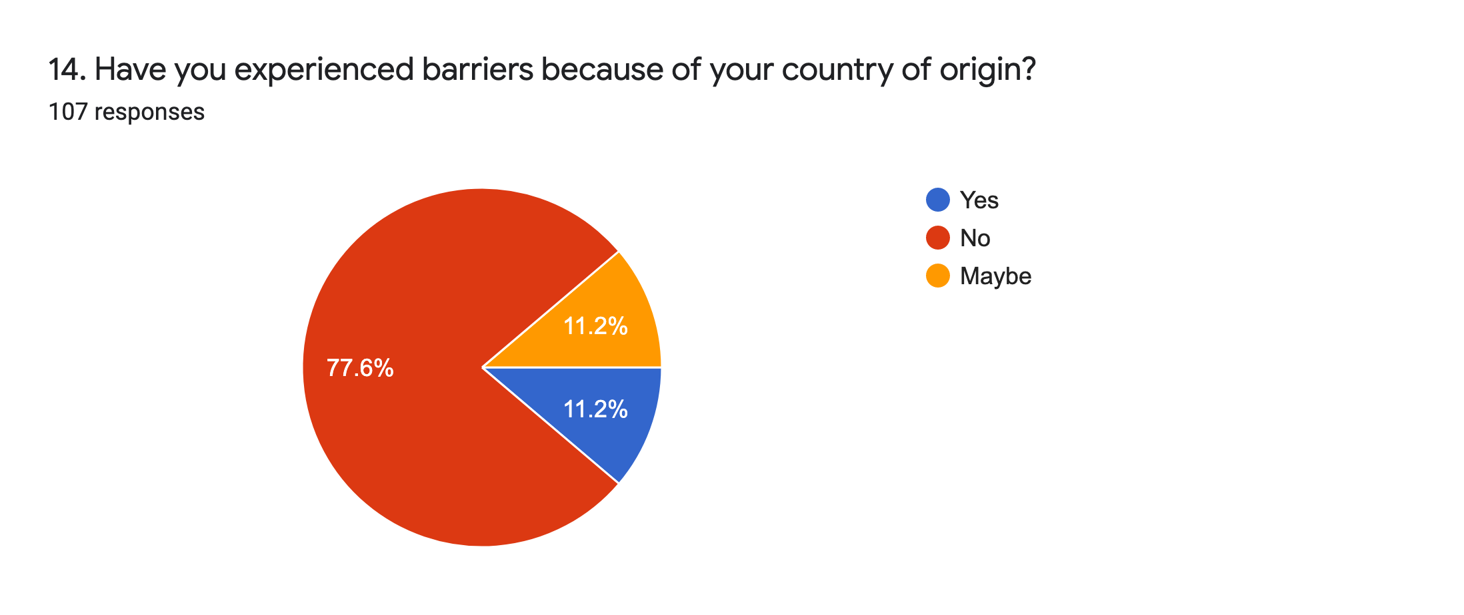
Nationality barriers: The majority of respondents (78%) have not experienced any barriers due to their country of origin. One in ten (11%) believed they definitely had experienced them.

Other barriers: In the free text section a few people mentioned ableism specifically. With hindsight it might have been worth exploring the impact of ableism, especially in the current context. Two respondents mentioned mental illness discrimination, and another two sexism/misogyny. Other responses with single instances included ageism and antisemitism.
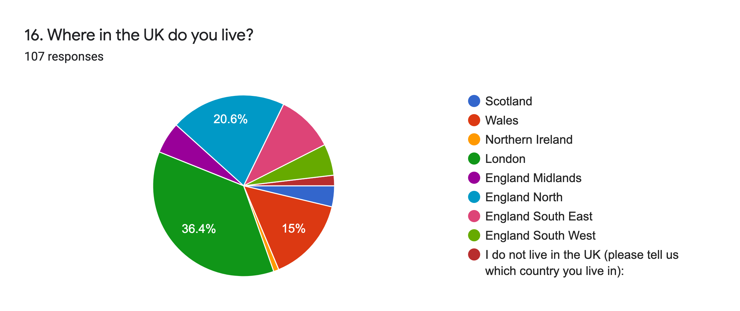
Location: These categories are based on the UK’s arts councils funding regions. The largest group of respondents (over one third or 36%) live in London, followed by one fifth (20%) in the North of England, 15% in Wales, and one in ten (10%) in South East England. Only 4% of respondents were from Scotland and there was only one respondent from Northern Ireland suggesting limited penetration of #WSNBR in these countries. Other regions of the UK were fairly evenly represented, but at low levels.

c. PANDEMIC IMPACTS
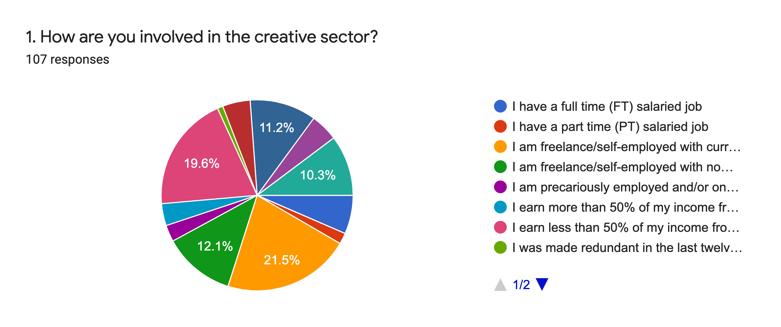

Working now: The most common category (22%) of involvement was being self-employed or freelance with current contracts. This is very close to the number (20%) who said “I earn less than 50% of my income from my creative practice and also have another FT or PT job”. Other significant groups are those who replied “I am freelance/self-employed with no current work” (12%), “I am involved in the arts or have an arts/creative practice and I am on disability related benefits” (11%) and the 10% who described themselves in a different way, all of whom gave various unique combinations of the options offered in the main questions, e.g. being on disability related benefits and also working.

Only 7% of respondents have a full time, salaried job (mirroring closely the ACE NPO 2018/19 Survey disability employment statistic of 6%). Only 3% of respondents directly stated that they earned more than 50% of their income from their creative practice, although some people in the freelance and working category may also potentially be included here; this would still only make the combined figure a maximum 25% of all respondents.
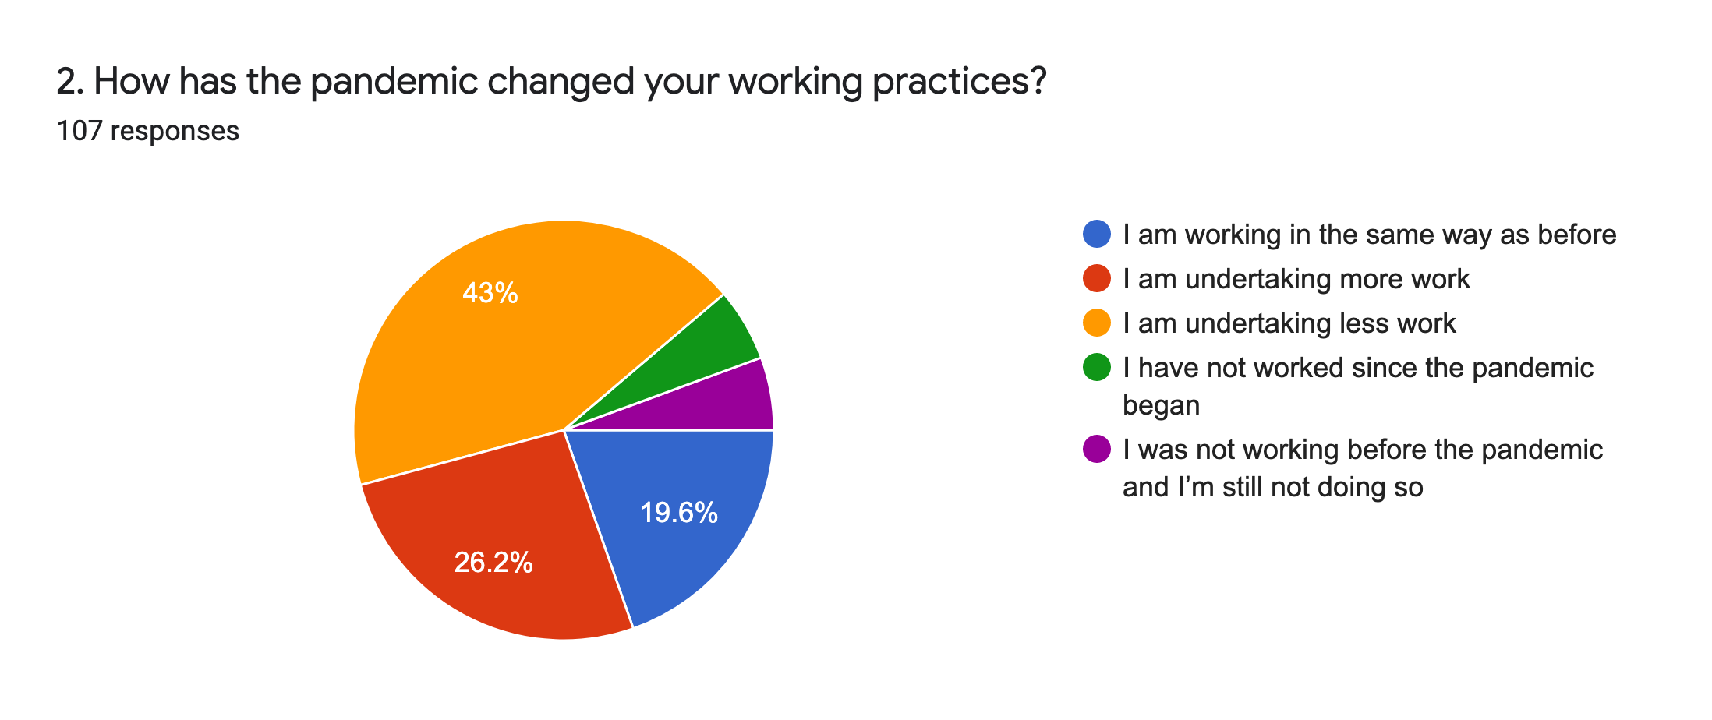
Employment and the pandemic: About half of respondents (43%) said they had less work since the pandemic began. 6% of them said that they had not been able to find work at all during this period. However, a quarter (27%) said they were working more, whilst 20% said the pandemic had not impacted their working lives.
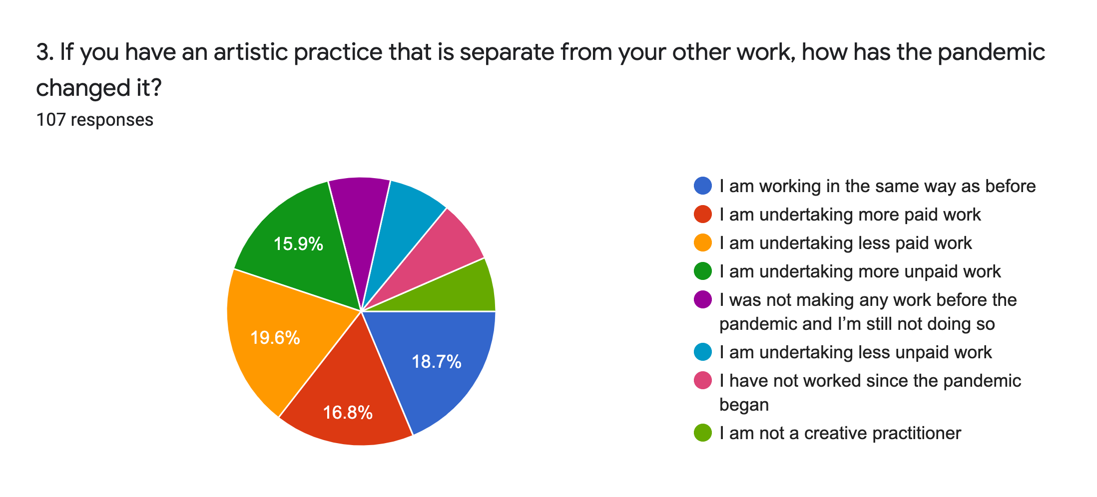
Artistic practice and the pandemic: Responses were evenly distributed but the largest group of respondents by a slight margin (20%) said they were undertaking less paid work as part of their artistic practice, due to the pandemic. A slightly smaller but similar proportion (19%) said they had been unaffected. 17% said they were doing more paid work, but 16% said they were doing more unpaid work.
It’s worth noting that with only 3% of respondents earning more than 50% of their income from their artistic practice, it’s unsurprising that the dip in available commissions/exhibitions/shows and the acknowledged lack of work has a lesser effect on the other 97% since they’re underpaid or unpaid even under normal circumstances.

It's also notable that only 7% said they were not a creative practitioner, leaving one third of all respondents describing themselves as practitioners despite rarely or never getting paid to do it; a quarter of this cohort (about 8% of all respondents) call themselves creative practitioners even though they weren’t even active as artists before the pandemic, and still aren’t.
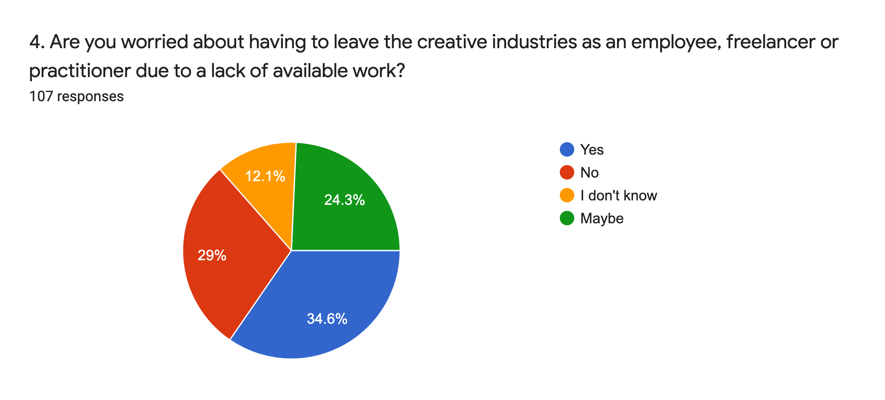
Future work: Nearly two thirds (59%) of respondents are possibly or definitely worried they may have to leave the creative sector due to a lack of available work.
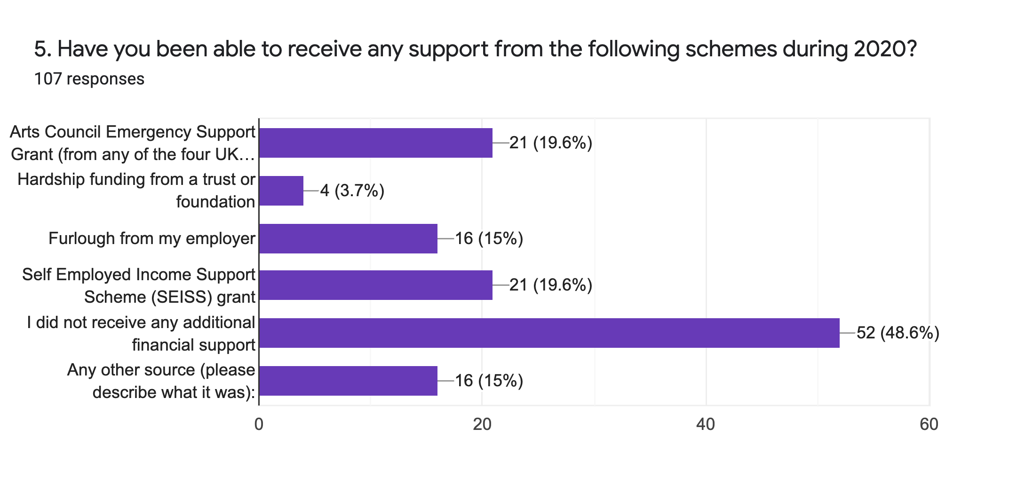
Impact of pandemic support schemes: One in five respondents (20%) received an emergency support grant from one of the UK’s national arts councils. The same proportion were able to access the UK government’s SEISS grants. 15% were furloughed by an employer. Half of the respondents received no additional financial support. The 15% of respondents who described other financial support cited a DYCP grant from Arts Council England, back payments from the DWP, being accepted to the PIP scheme, Cultural Recovery Fund (Wales), an Equity fund, and a specific Welsh fund.
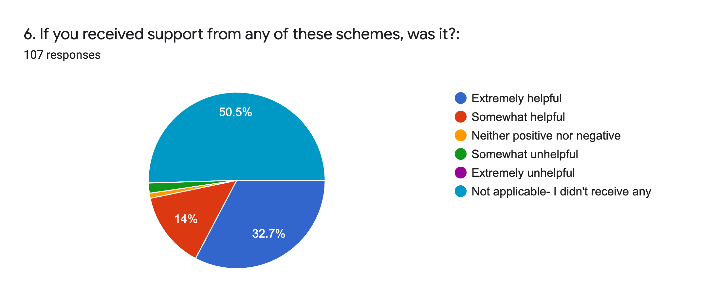

Support schemes: This question corroborates the data from Q5, i.e. that half of the respondents received nothing at all. Strangely, two people got financial assistance but claimed that getting it wasn’t helpful, and one said it had no particular impact. Otherwise those who received help from a support scheme found it somewhat or extremely helpful.
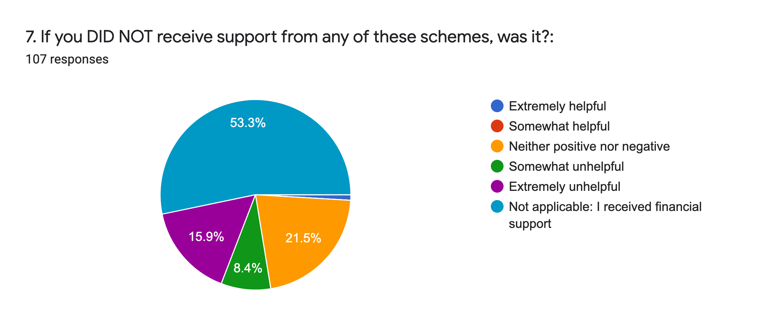
Unsupported individuals: Of those respondents who did not receive help (47% of them, according to this question, 49% in Q5, statistical variation here is not significant) nearly half of this cohort felt that their failure to do so ultimately did not impact them significantly. About a third of those receiving no help found it had a very negative impact. This is 16% of the total number of respondents and is probably an accurate estimate of deserving individuals who have been “missed” so far. This theory is borne out by results of our survey of organisations.

The contrasting responses to Qs 6 and 7 suggest that financial support schemes, including SEISS - which received some criticism, were broadly speaking well targeted, productive and necessary with regard to who received them, since among those who failed to get them, over half of these applicants (or people who chose not to apply) didn't consider the lack of financial support very damaging.

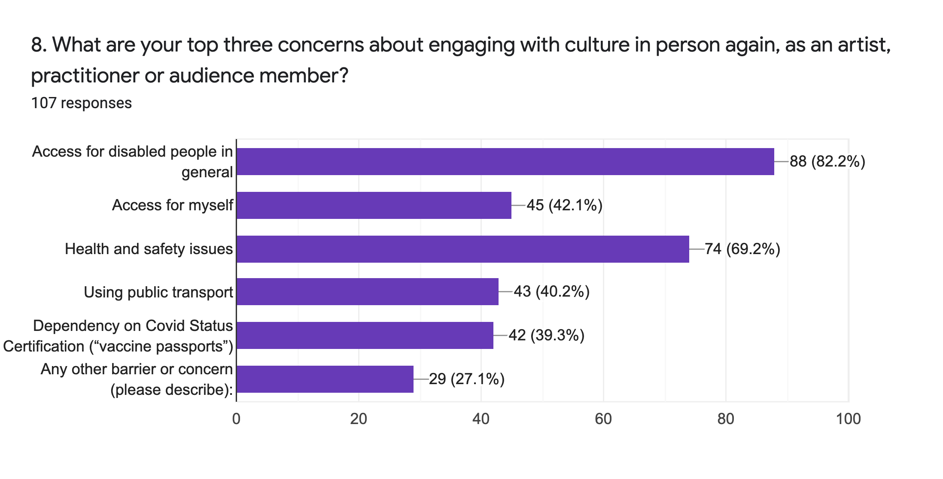
Post-pandemic cultural engagement: The top three concerns are: continued access for disabled people in general (82%), health and safety issues (69%) and one’s own personal access requirements (42%). These worries could be attributed to the ableist posturing of some commercial promoters aiming to focus their reopening on the “fit and able” and the initial ban on ‘Clinically Extremely Vulnerable’ people from the Government’s Events Research Test Programme.

But taken altogether, the strength of this response suggests many disabled respondents have little trust in the wider cultural sector to prioritise access during the initial reopening period.

Other barriers or concerns included: anxiety about post-Covid social or professional mixing in general; more normative/conservative funding and employment opportunities; freelancers/frontline staff being further disempowered and de-centred; racism; the time it takes to travel if/when work returns to being more offline again; lack of accommodation for chronic illnesses, including long Covid symptoms; lack of money and the cost of cultural activities; loss of contacts and being “out of the loop”; ageism; tokenistic representation of disabled people rather than genuine change.

d. THE IMPACT OF WE SHALL NOT BE REMOVED (#WSNBR)
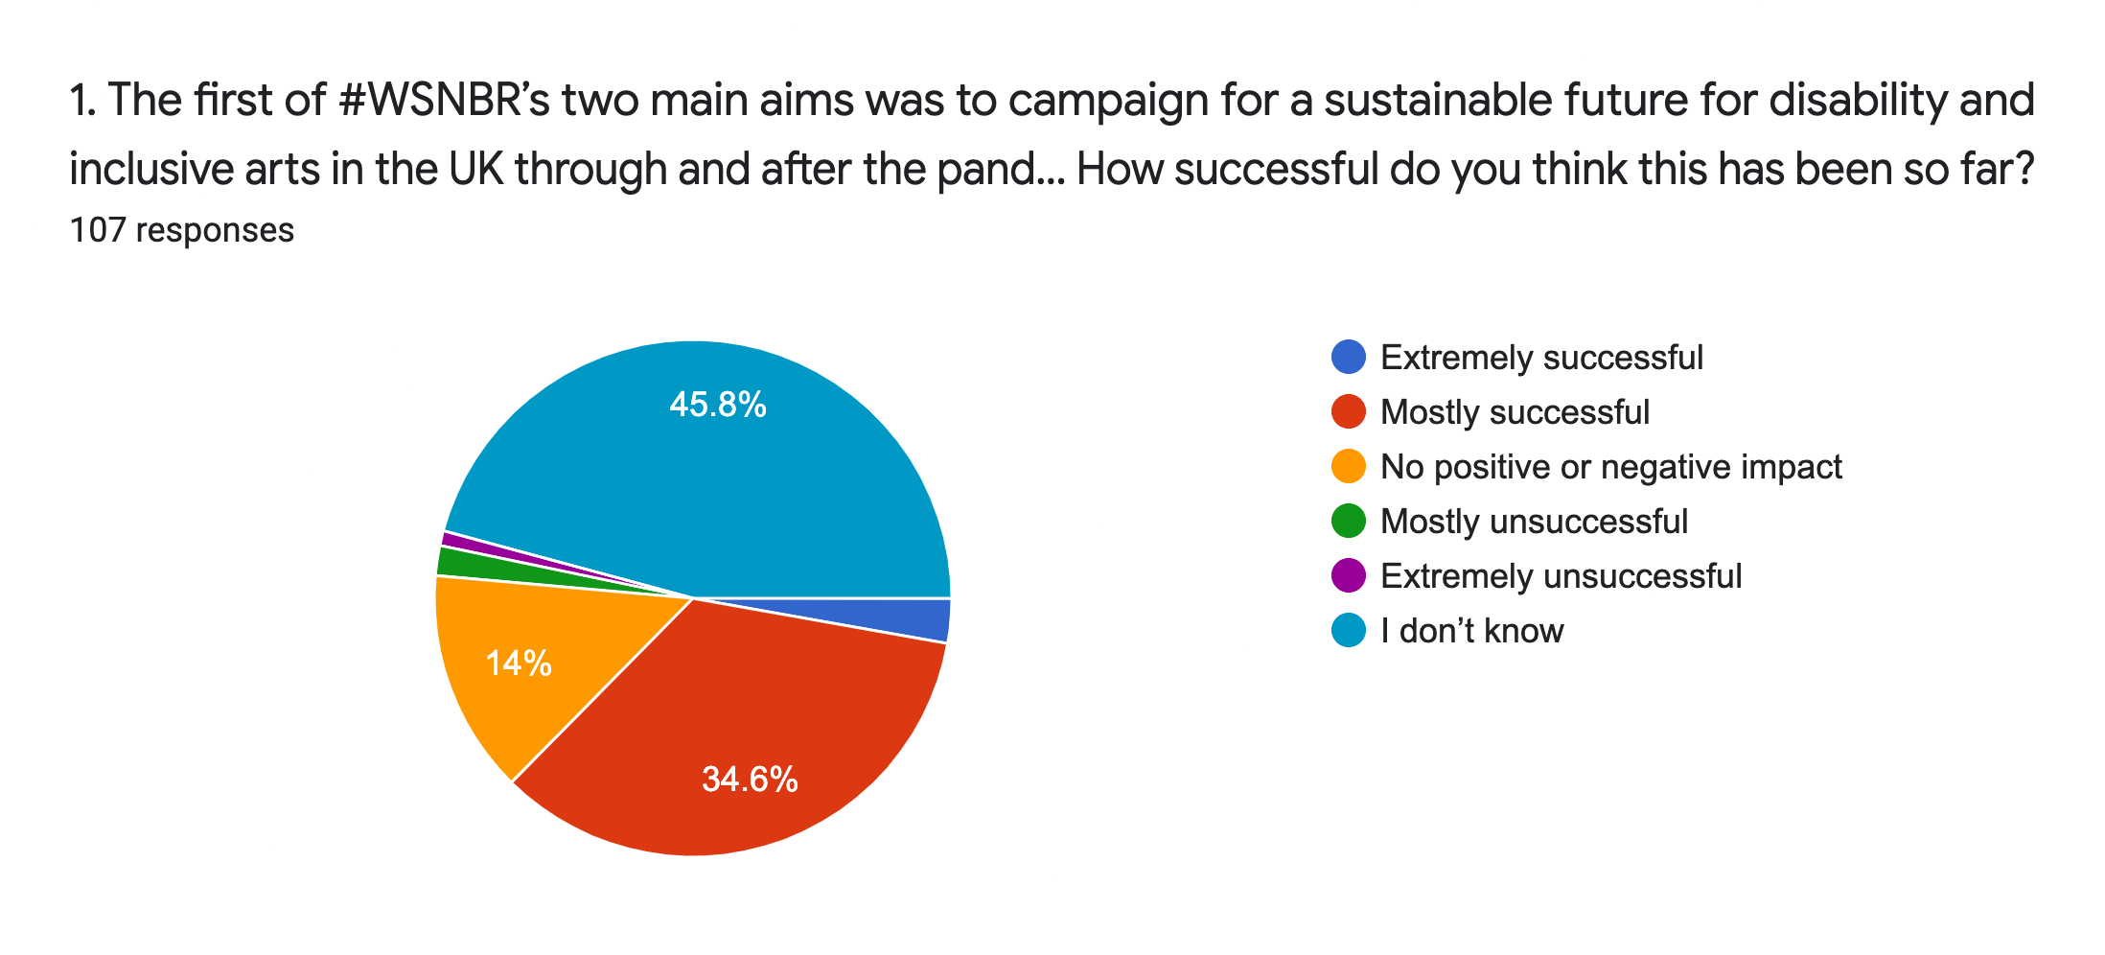
#WSNBR and sustainable futures: Nearly half (46%) of respondents felt they could not determine the success of this aim as at the point of survey in April 2021 the pandemic was still underway. Despite this, over a third (37%) felt it had been mostly or extremely successful. 14% felt it had no impact and a very small minority (3%) felt it had been mostly or extremely unsuccessful.

73 answers were also given in free text boxes to Q2: “What do you think has been a good outcome from this campaign for a sustainable future for disability and inclusive arts in the UK?” Responses included the following comments: “This work is not complete as the pandemic is not over yet”, “I love the hashtag & your approach”, and “Visibility, influence at policy level, bringing people together with a shared purpose at a time of crisis”.

For Q3: “What do you think could be better about it?” generated 71 responses including: “Organisational policy change, structural and systematic barriers removed, changing cultures”, “Inclusion of people with long term chronic illnesses which are not necessarily listed as a disability”, “ I don’t know - honestly it all feels a bit bleak and hopeless, we’re at the back of the queue” and “Just need to ensure it stays on everyone's agenda”.
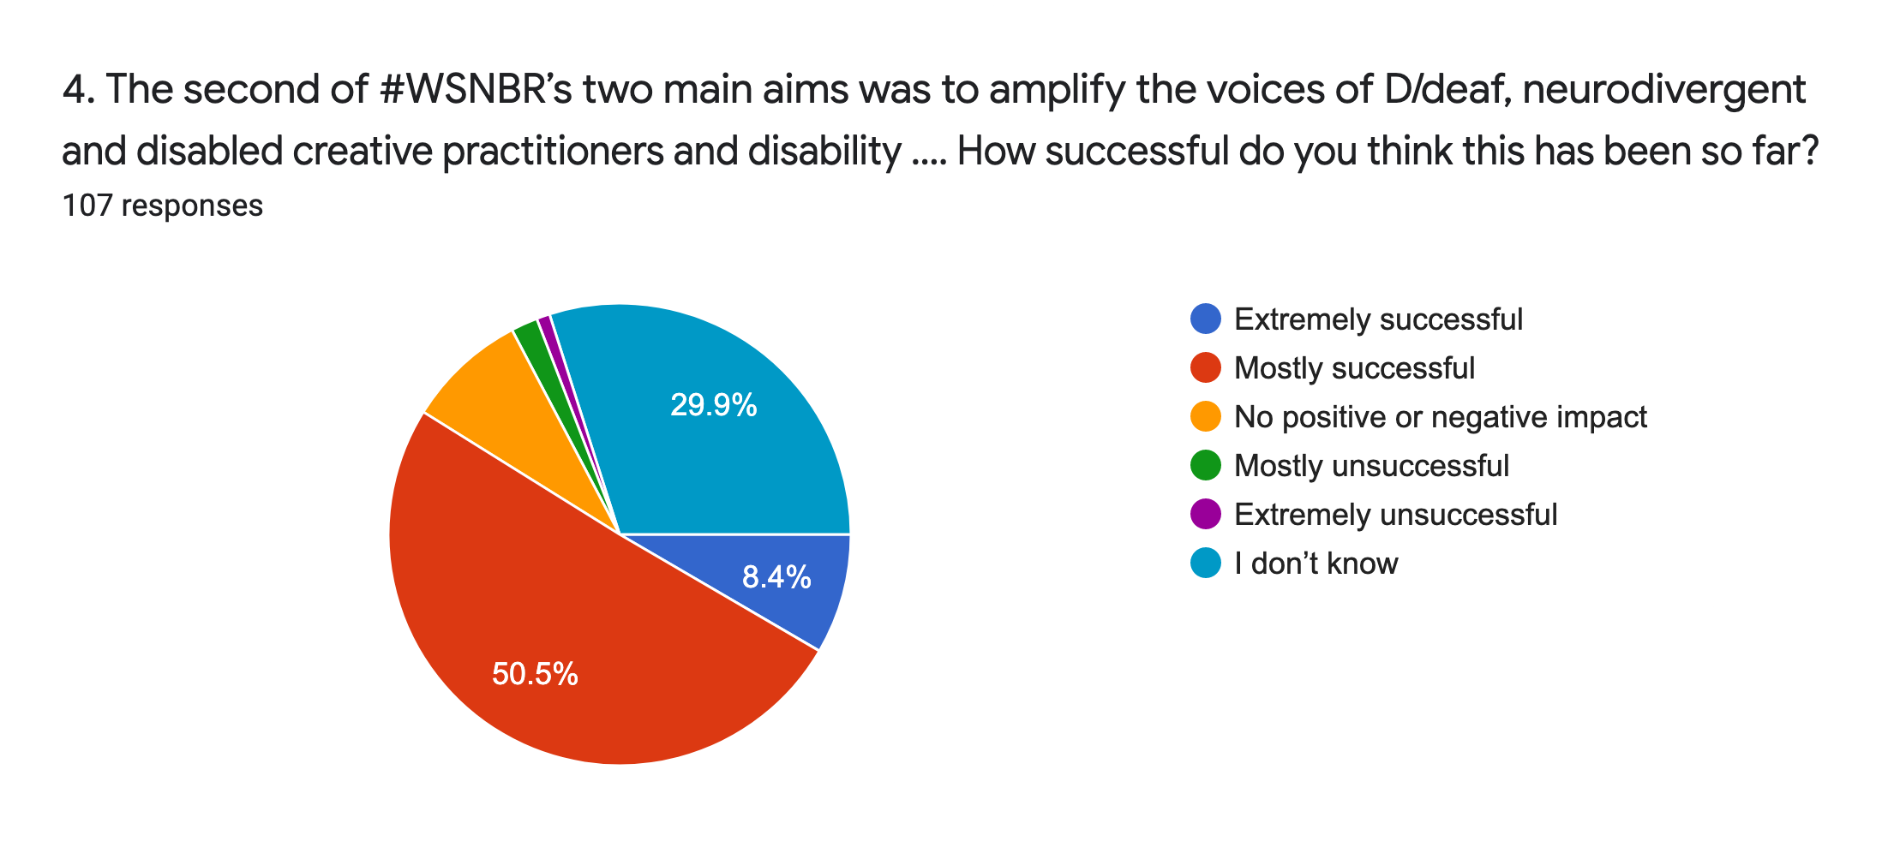
#WSNBR amplifying disabled voices: Respondents to this question were more positive: over half (60%) felt this aim had been mostly or extremely successful. A third (30%) didn’t know, compared to 46% who didn’t know in the question about sustainable futures. Again, a very small minority (3%) felt it had been mostly or extremely unsuccessful.

64 answers were given in the free text boxes to Q5: “What do you think has been a good outcome from trying to amplify the voices of D/deaf, neurodivergent and disabled creative practitioners and disability arts organisations?” Responses included: “Trending on Twitter & the possibility to connect art and activism”, “Giving all disabled artists the opportunity to speak with each other”,“I've discovered new organisations, I've made connections”, and “I feel heard by #WSNBR, which makes a big difference to my confidence in challenging organisations to be more inclusive in their practices”.

55 responses were received for Q6: “What do you think could be better about this aim?” and included: “Recognise the power of creating community and boost it further”, “Intersectionality and centering disabled people of colour”, “Sustained amplification” and “More publicity so people know about it”.

63 responses were received for Q7: “What do you think have been the key achievements of #WeShallNotBeRemoved overall?” and included: “Raising profile of disabled people in the creative industries and ensuring we were not forgotten”, “Bringing disabled people together at a time of crisis to create visible 'noise' about the issues that are affecting us in the arts”, “removing some of the politics in the community”, and “Just existing and taking action at a difficult time”.
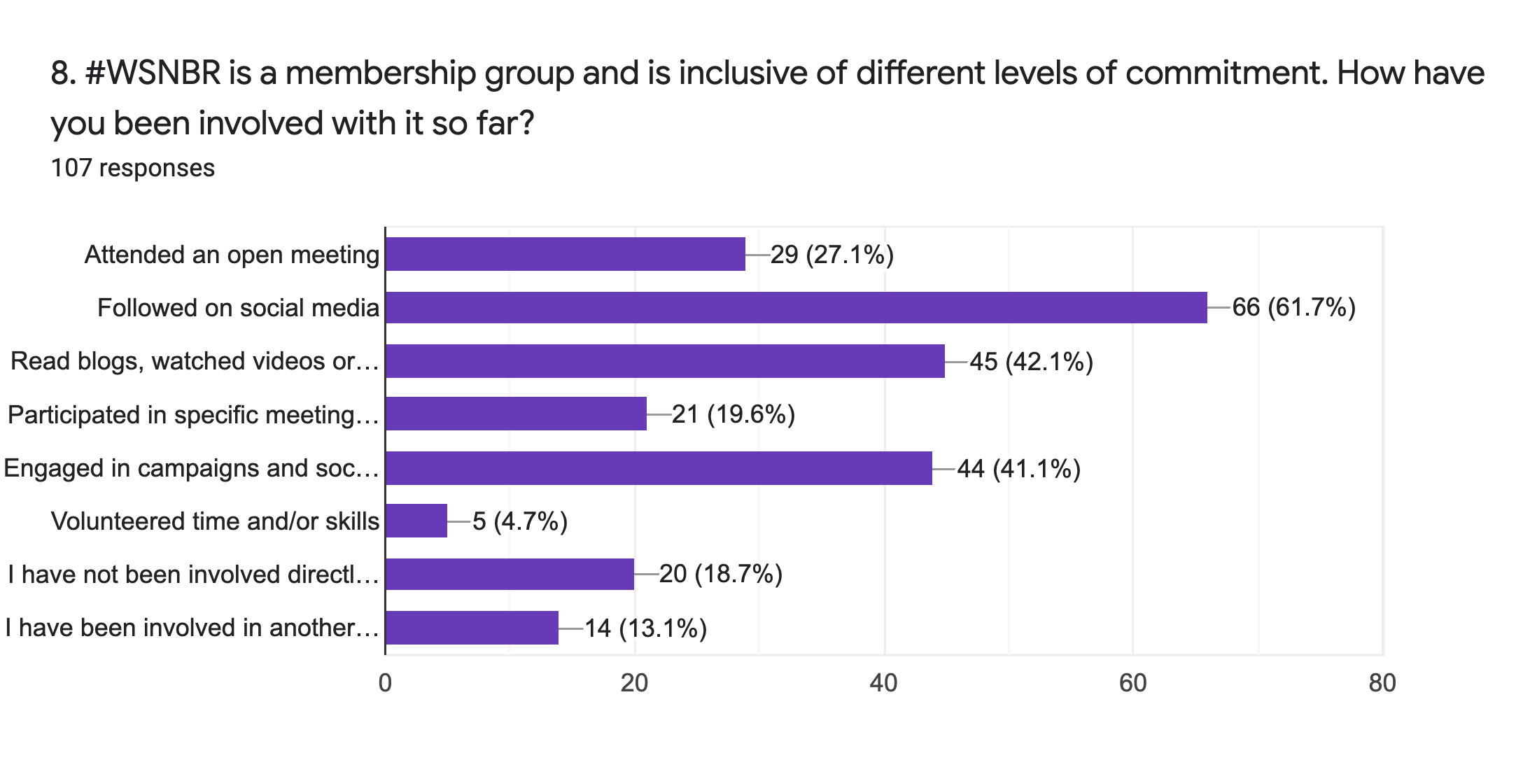
Past involvement: The top three forms of engagement were following on social media (62% of respondents), reading online content (42%) and engaging in campaigns/social media sharing (very similar to previous, 41%). 19% had no direct involvement, presumably indicating they knew of #WSNBR but didn’t feel they’d done anything specific. One in five (20%) had participated in a meeting. The 13% who said they had been involved in another way all replicated options that were offered in the multiple choice menu.
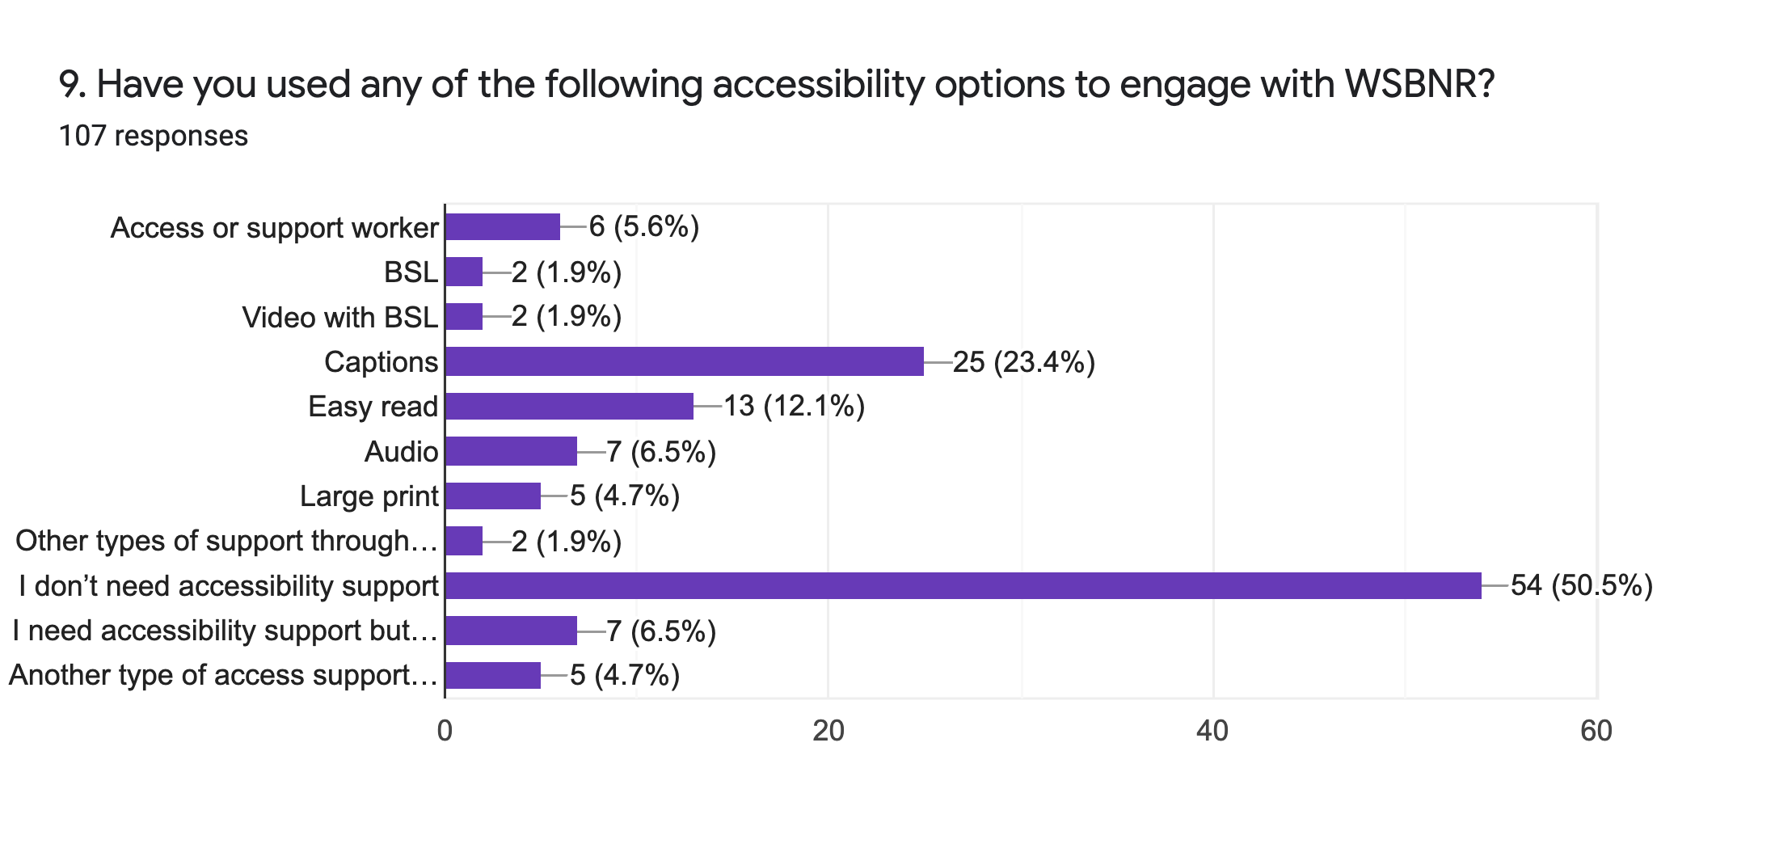
Accessibility and engagement: Half of the respondents reported no need for accessibility adjustments in order to take part. Nearly a quarter of respondents reported using captions. As can be seen in the chart, other accessibility options were occasionally used but in low numbers.

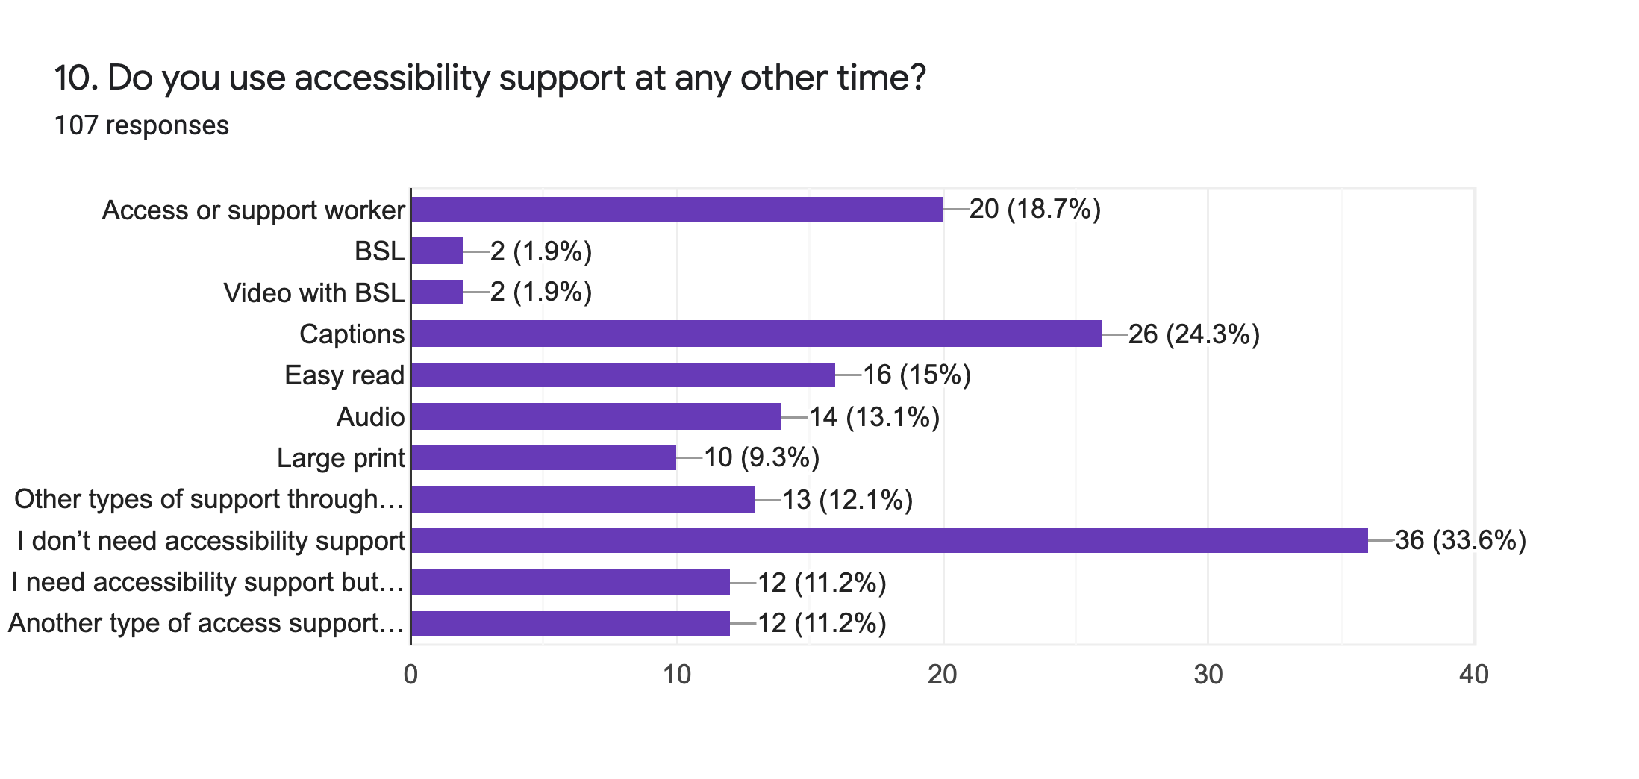
Accessibility in general: These responses are more in line with expectations for a cohort of disabled respondents, with various types of accessibility adjustments reported.
A notable exception is BSL, with very low reported usage of 2% despite its prominence as an advertised accessibility option in many online events. The number of people using captions, however, is far higher and matches responses to the previous section, with nearly a quarter of respondents using them both to access #WSNBR and elsewhere. Other responses, excluding those already included in the provided categories, were: text provided in advance, hearing loop systems, screen readers, note taking support worker, mental health support worker, physical/electronic magnifiers.

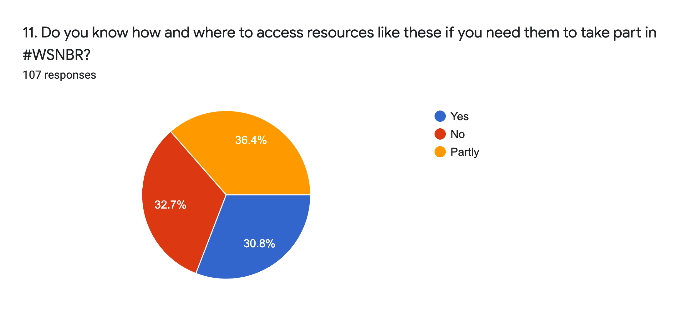
Access for #WSNBR: 67% of respondents fully or partly knew where to get access support to take part in #WSNBR if they needed it; a third of them did not.

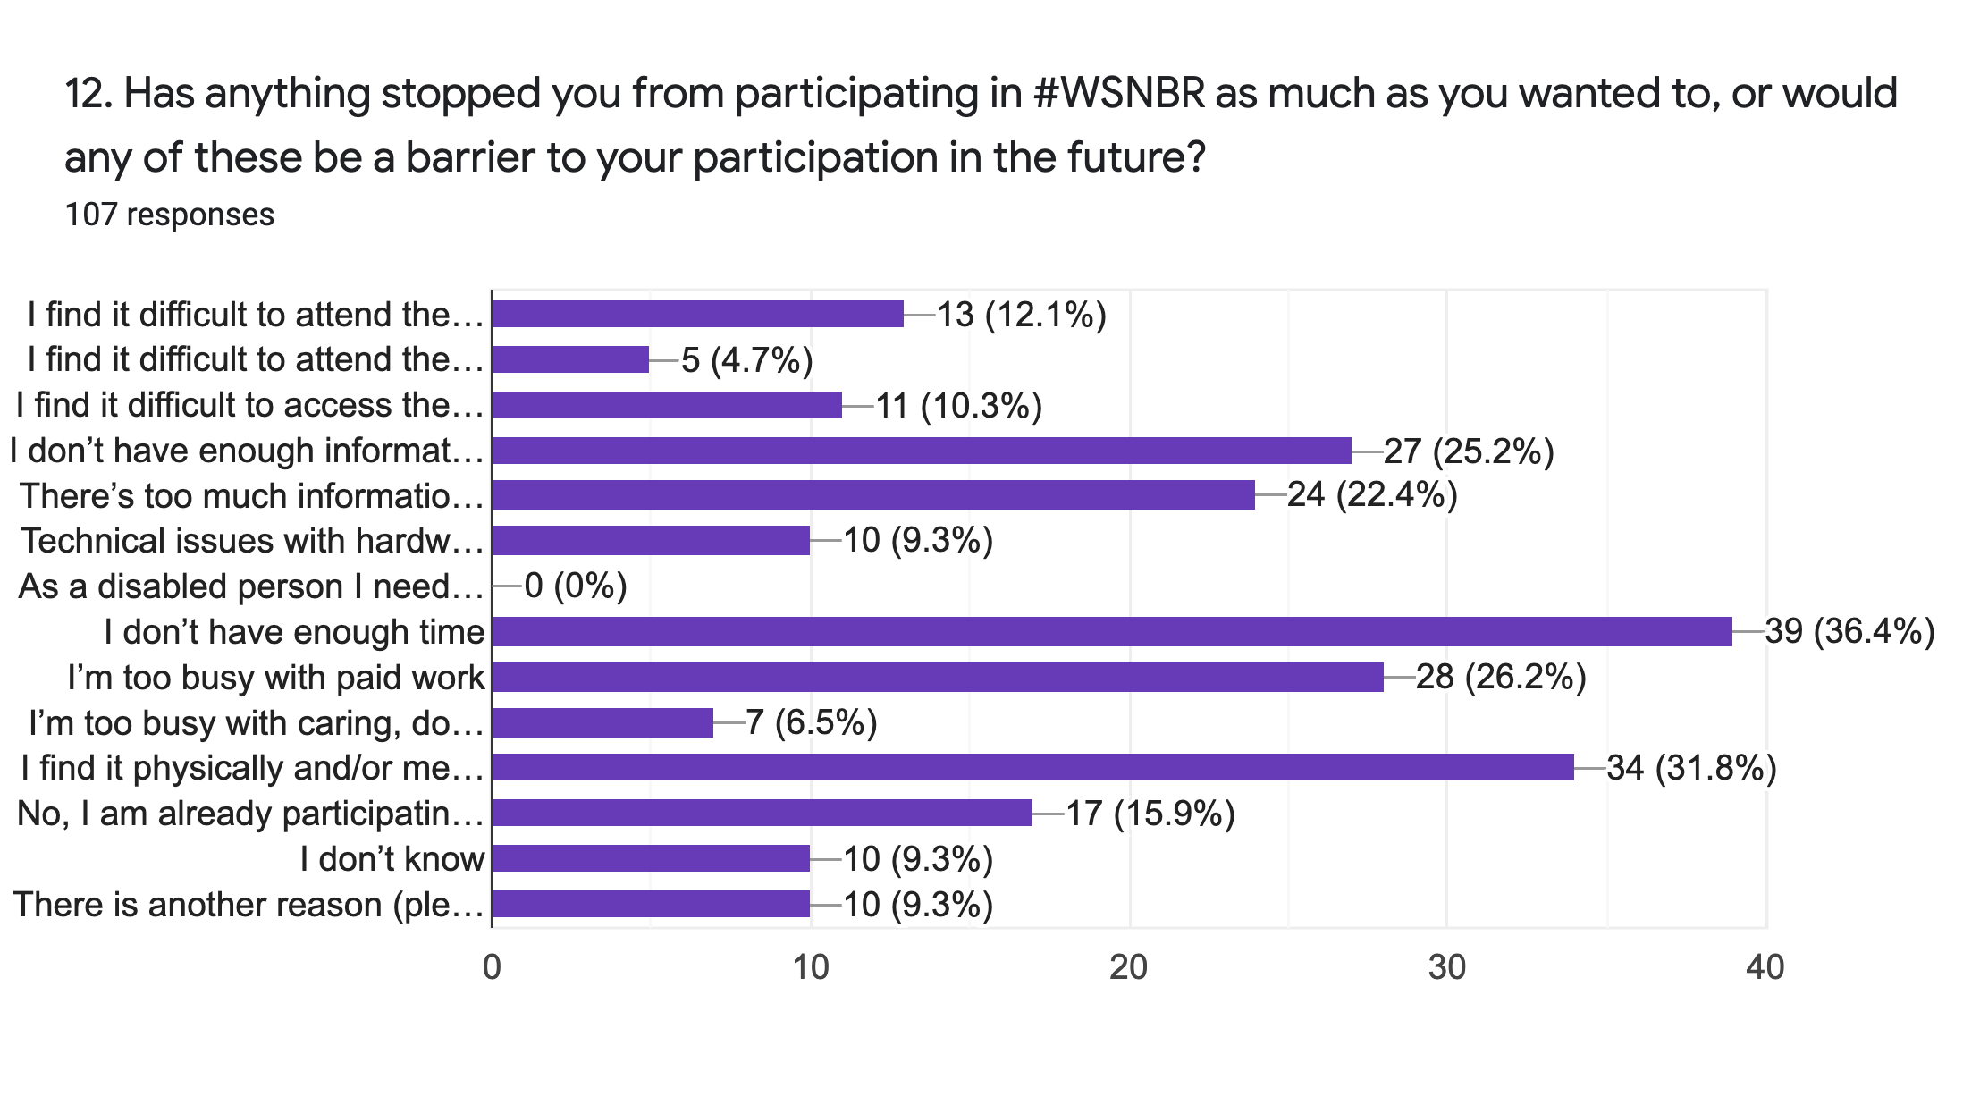
Barriers to participation: The top three factors stopping people from taking part are “I don’t have enough time” (36% of respondents), “I find it physically and/or mentally exhausting or overwhelming” (32%) and “I’m too busy with paid work” (26%). Other significant factors were lack of information (25%) and too much information (22%)... Since these two are obviously contradictory but roughly equal responses- even though they come from different people- this is still probably best taken as proof that whatever you do on this front will alienate somebody. About 16% of respondents felt they were already participating as much as they could, or wanted to.

Other reasons given were: the respondents’ own lack of focus or organisation; conversely, a perception that the campaign or group is disorganised, or that communication from the group to members was not clear; and individual caring responsibilities.

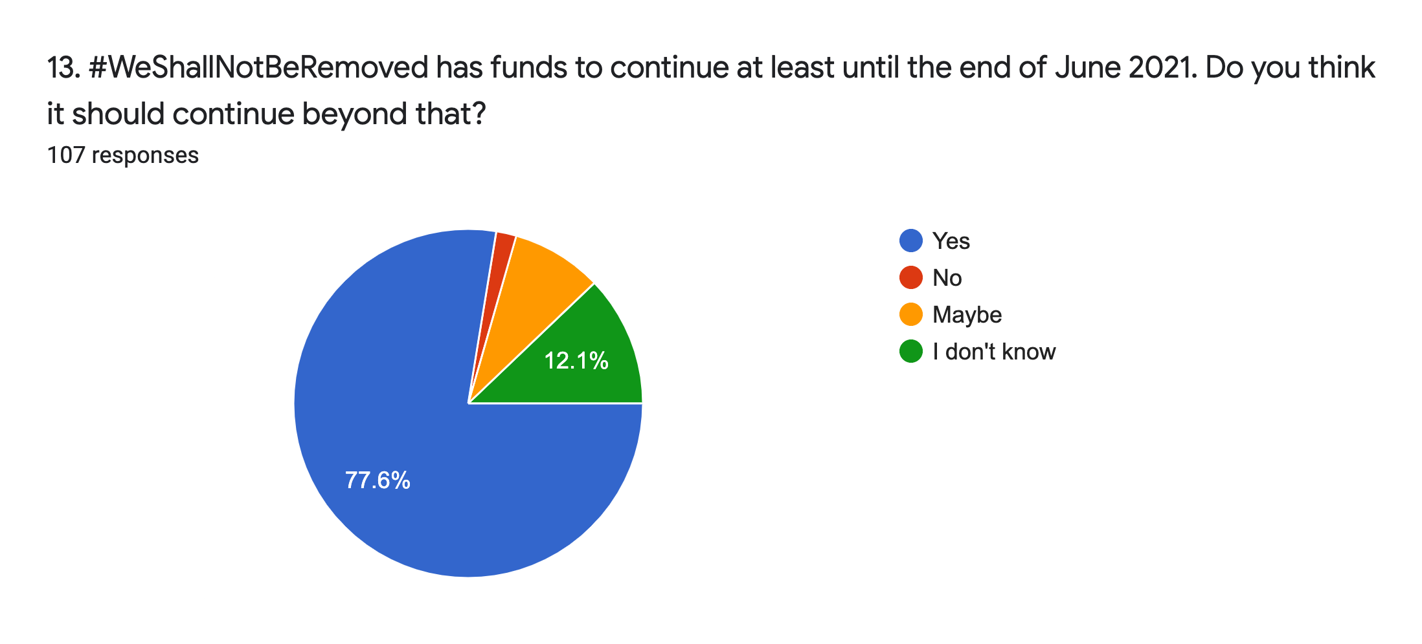
Future of #WSNBR: 86% of respondents thought that #WSNBR should definitely or possibly continue. 12% didn’t know. Two people said no.
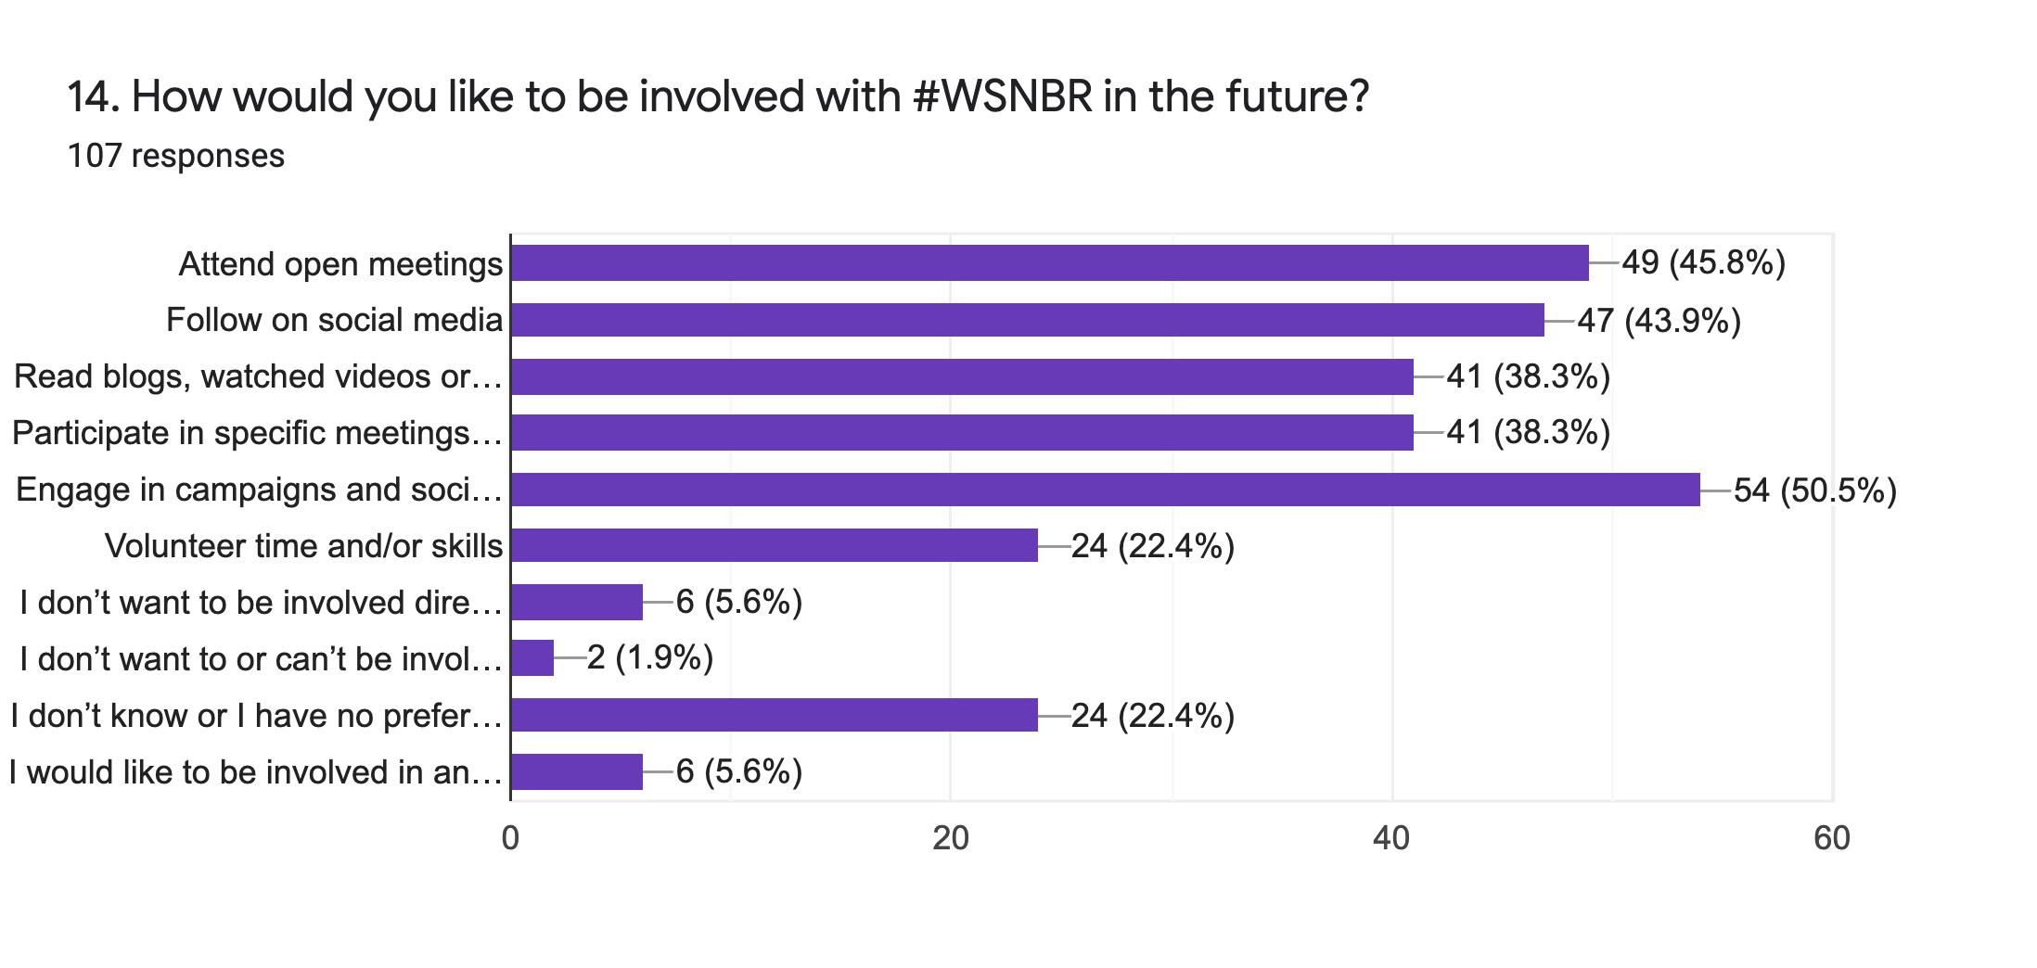
Future involvement: 50% of respondents would like to engage in campaigning and/or social media, 46% would like to attend open meetings, 44% would like to follow on social media, suggesting that key drivers of future involvement would be communication and inclusion with regard to open meetings, and focus on consolidating and expanding social media presence.
One fifth of respondents would like to volunteer time and/or skills. Only 5% of respondents have actually done so to date (see Q8).

Other major choices for future engagement are taking part in specific meetings or working groups (38%) and accessing written or media content from #WSNBR (also 38%). Other suggestions were: activist art works related to #WSNBR; paid freelance work for #WSNBR; joining as a convenor; offering training.
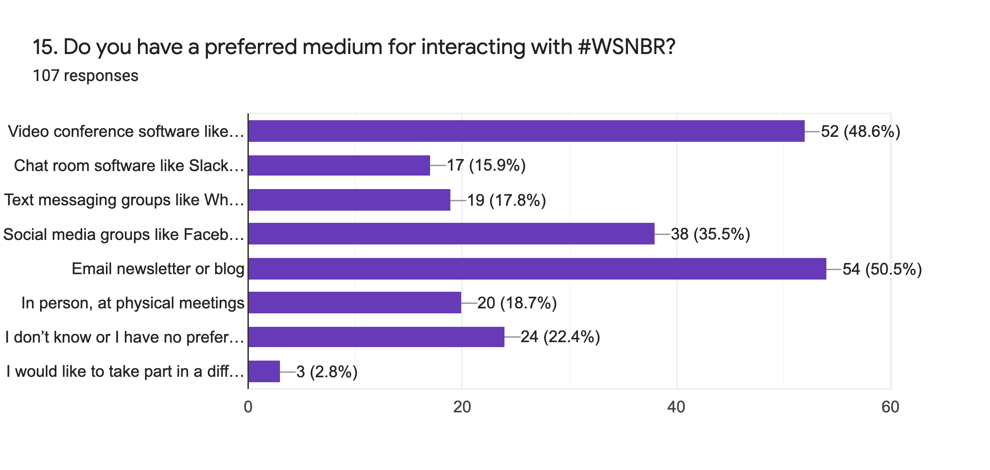
How people engage: By far the two most favoured methods of engaging with #WSNBR are via an email newsletter or regular blog (50% of respondents) and via video conferencing (e.g. Zoom, 49%). None of the other options offered were notably unpopular. Social media groups are the third most popular at 35%, despite strong objections from some other people.

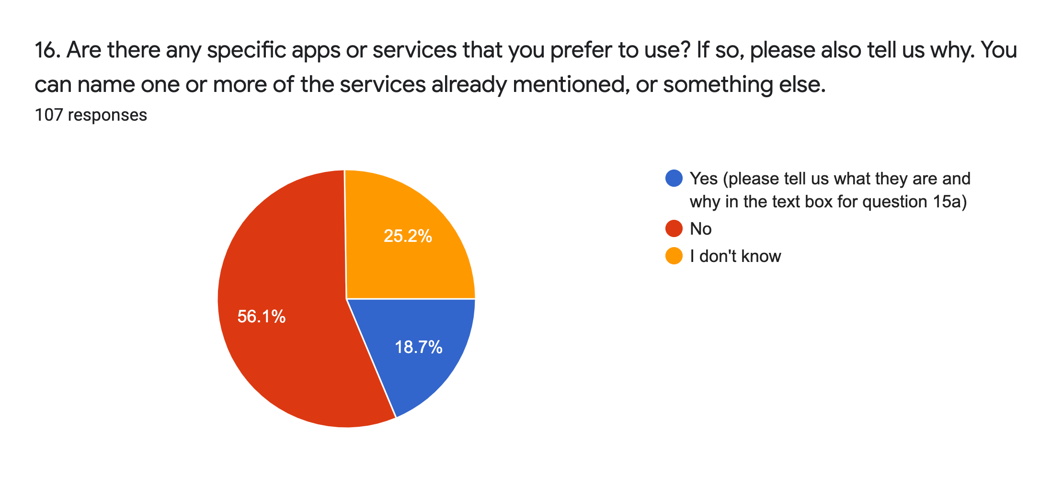
Preferred services: 81% of respondents have no preference or didn’t know. Specific preferred formats suggested (17 responses, some repeats): Slack, Discord, Telegram, Signal, Samepage, Google Chats/Drive, Social ARTery by axis, Phone or post, Instagram Close Friends story function, WhatsApp, email, Facebook, Zoom.
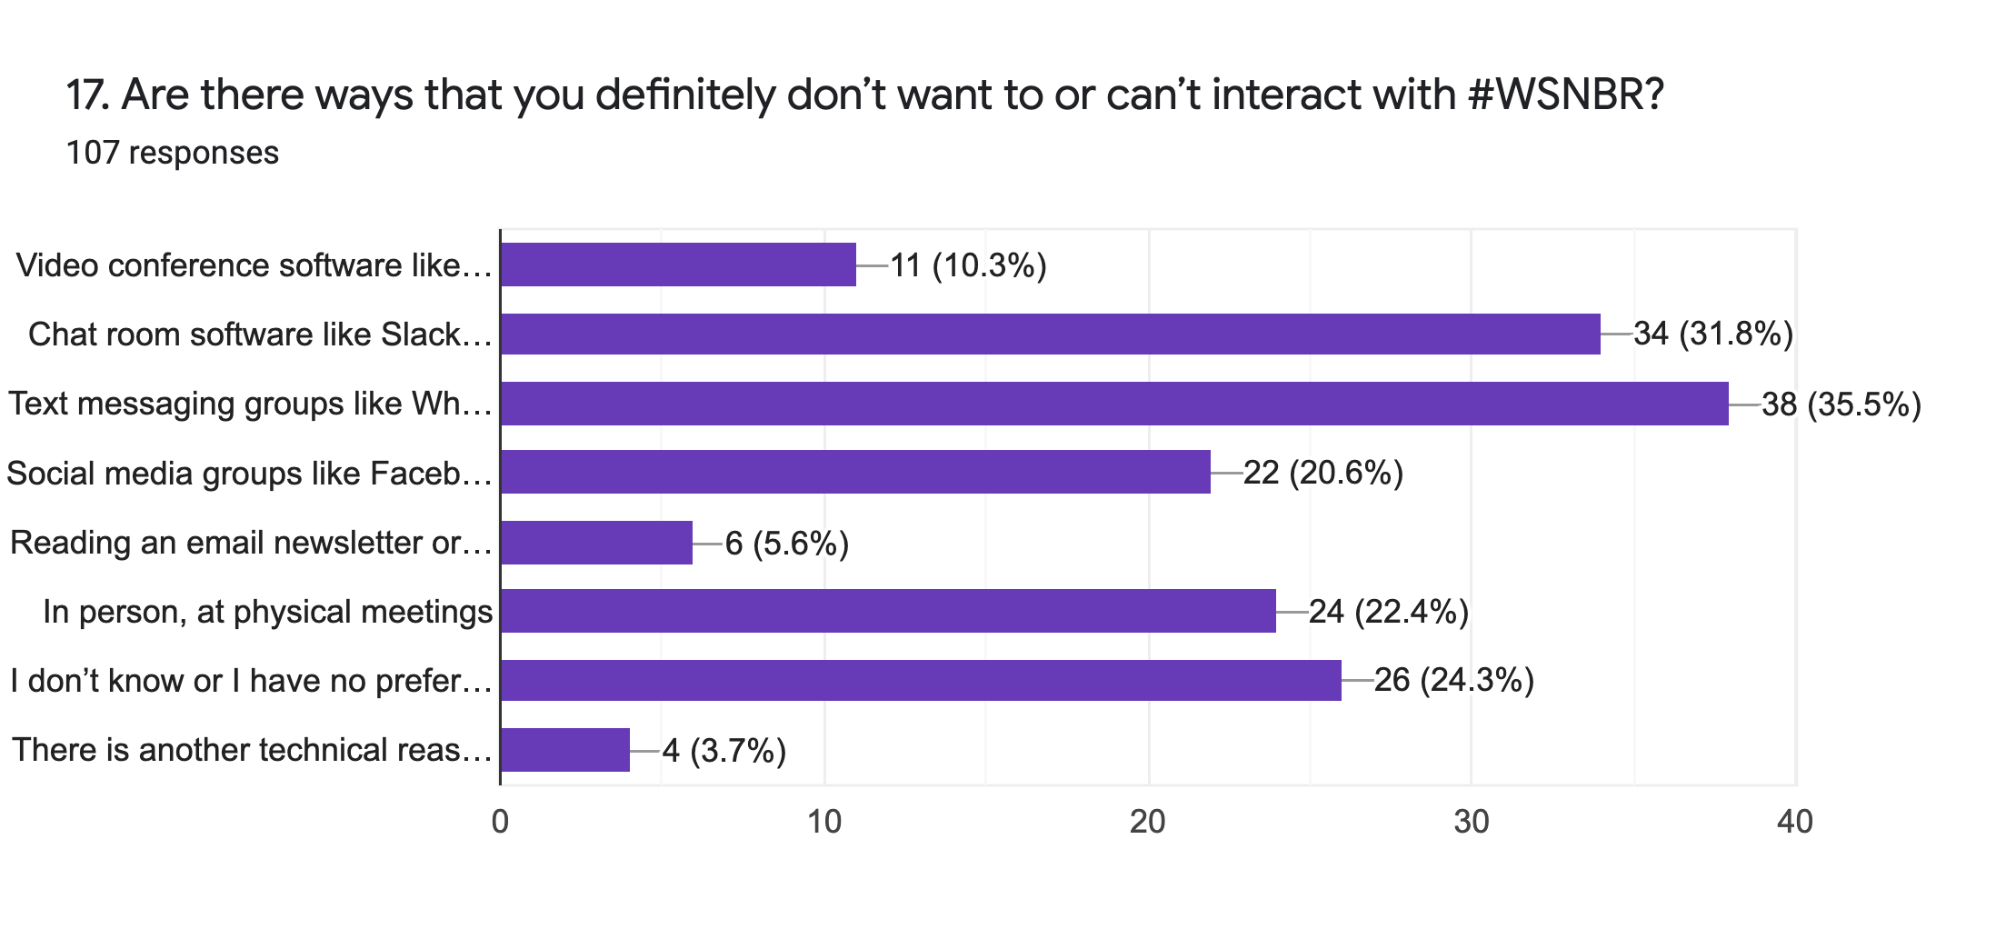
Unpopular services: The least wanted methods of engagement are text messaging (e.g. WhatsApp groups, 35% of respondents dislike) and chat rooms like Slack or Discord (32%). The next largest cohort (24%) is people who don’t know or have no strong disinclination, according to this question.
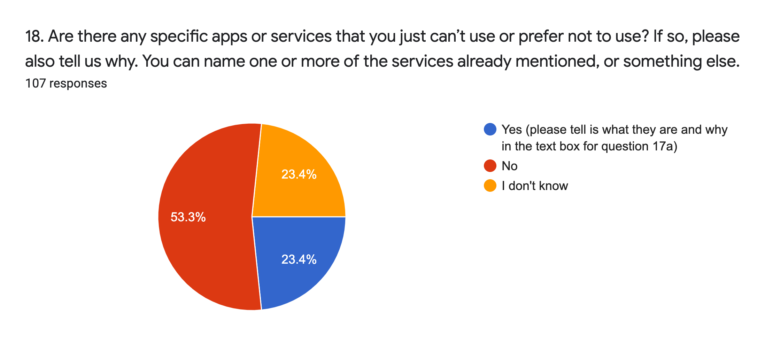

General tech disinclinations: This confirms that 24% of respondents have no preference or don’t know, and over half of the rest, in theory anyway, don’t object to any means of engagement.

Technical barriers to participation that were suggested: Slack and Discord specifically; informal mailing lists; WhatsApp and other Facebook products for ethical reasons; Zoom and Teams, separately and under the heading of video conferencing software or video calls in general; group chats; slow internet connections.

PART TWO: DISABILITY ARTS & CULTURAL ORGANISATIONS
a. KEY FINDINGS

- Further evidence of the fragility of the disability sector is provided in this section. 80% of respondent organisations have received Emergency Response Funds during the pandemic from the UK arts councils or elsewhere. 38% of organisations said this funding was essential to their survival, 42% adding it was extremely helpful.

- Of those organisations who did not receive financial support, only about one in five (4% of all respondents) said it was extremely damaging. Clearly some organisations in genuine need missed out, but four fifths of those who didn’t receive funds claim not to be unduly hindered by it.

- During the pandemic 58% of organisations have used up all of their financial reserves, or a small or moderate quantity of them. 13% had no reserves to start with.

- Nearly 60% of respondents said their organisation was delivering its work in a totally different way as a consequence of the pandemic, with one third telling us working practices have not changed.

- 46% of salaried respondents (definitely or possibly) worry they will have to leave the creative industries due to lack of work. One in five organisations responding to this survey said their organisation had already made people redundant, not renewed contracts, or not taken on new staff because of the pandemic.

- The main concern expressed for the reopening of the cultural sector mirrors the response of individuals i.e. continuing access for disabled people in general (92% of all respondents)

- 50% of organisations expressed concern about the arts sector becoming dependent on so-called “vaccine passports”.

- Support, hopes and ambitions for #WSNBR’s Seven Inclusive Principles are very high with most respondents confident that their organisation could adopt and abide by them.

- At least 50% of organisations surveyed have disabled people leading decision making at board, senior management and/or strategic levels. 50% of them also regard their organisation as inclusive of disabled people. All respondents felt they were able to influence or lead policy and change in their organisation.

- Two thirds of respondents representing organisations identified as disabled, neurodivergent, a person with access requirements, or as a person with a long term health condition.

b. WHO RESPONDED?
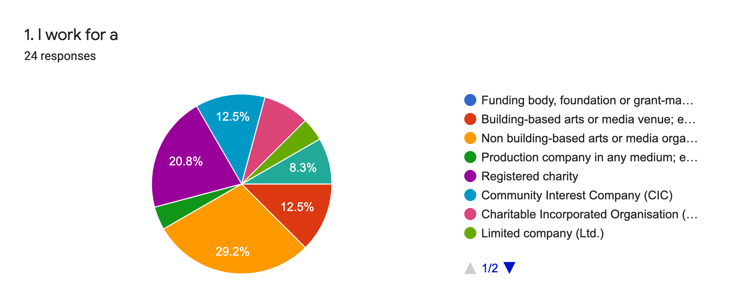
Types of organisation: One third of respondents represented a non building-based arts or media organisation. The second most common employer is registered charities (20%), followed by CIC and building-based arts or media organisations (both 12%). Others are: production company, CIO, Ltd., local authority and not for profit Constituted Community Organisation.
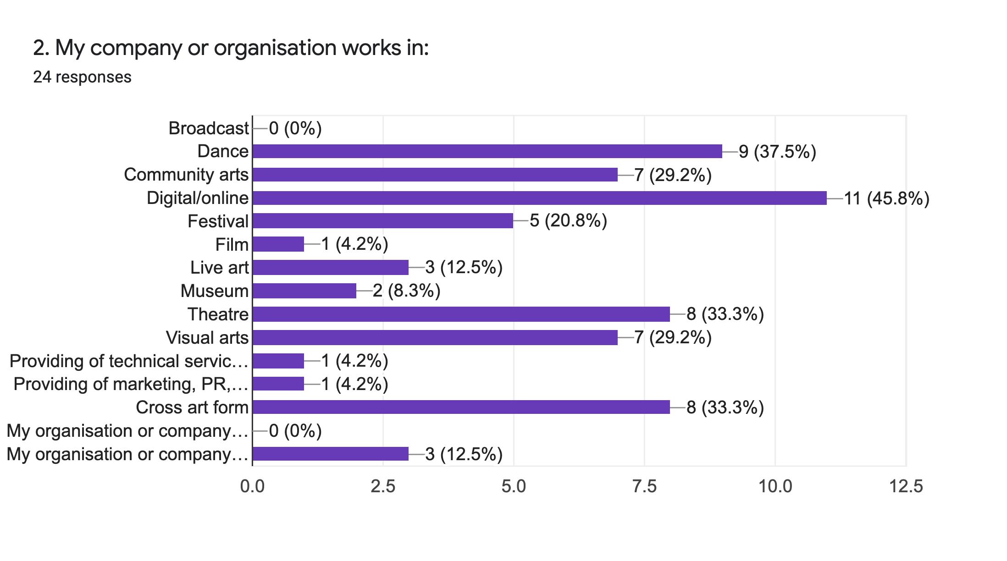
Creative subsector: Our respondents represent a broad cross section of the cultural sector with the highest number focused in Digital/Online (46%), followed by Dance (36%), Theatre and Cross Art Form (both 33%). Free text answers that did not fit an existing category were: producing opera company, disability arts organisation company, music, programmes, sector development and funding.

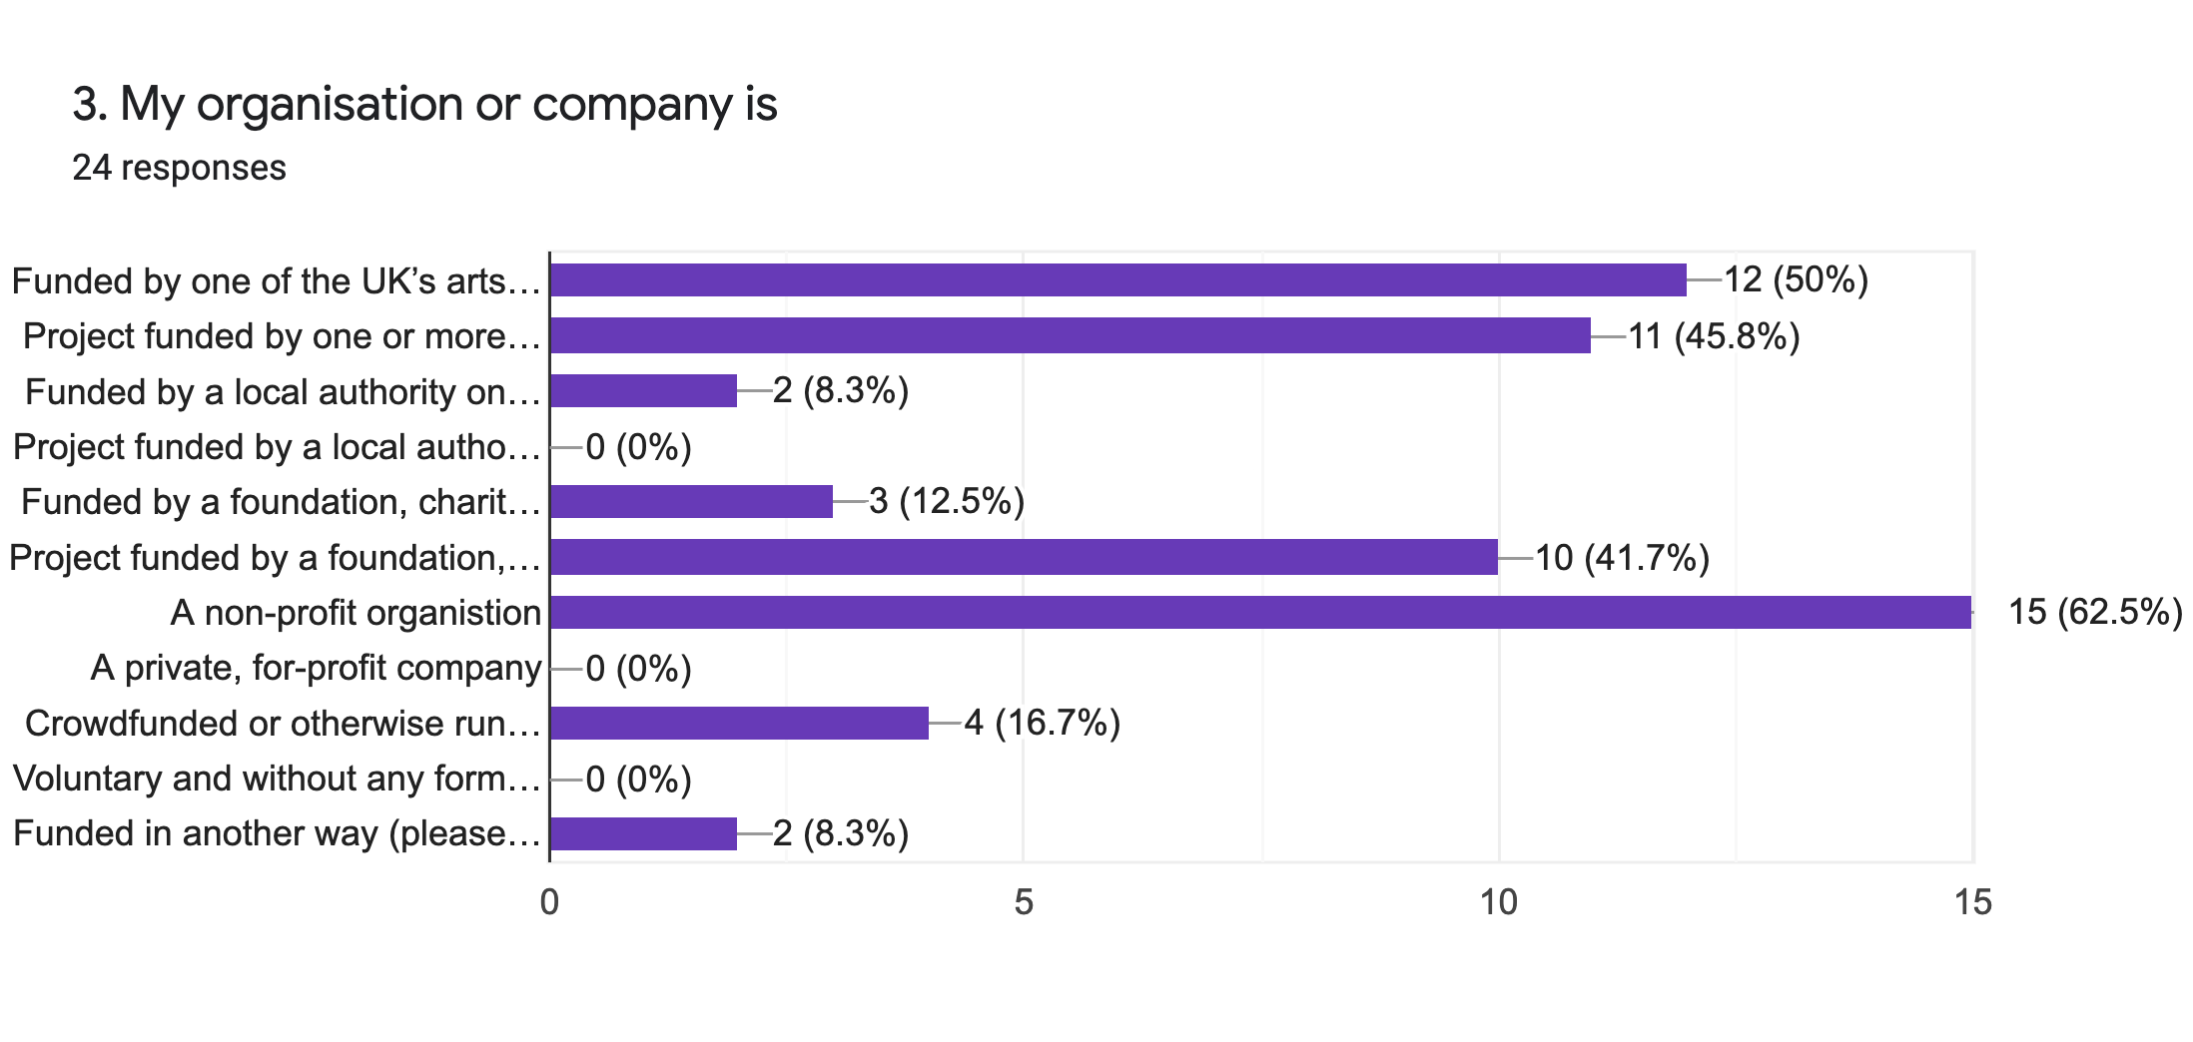
Funding: The three most common sources of funding were the UK arts councils on a regular/NPO basis, project funding by a UK arts council, and project funding from a foundation or charity. 63% of respondents’ organisations are run as non-profit organisations. Others mentioned were: Sport Lead funding, business and commercial partnerships, statutory, EU and project funding, and earned income.

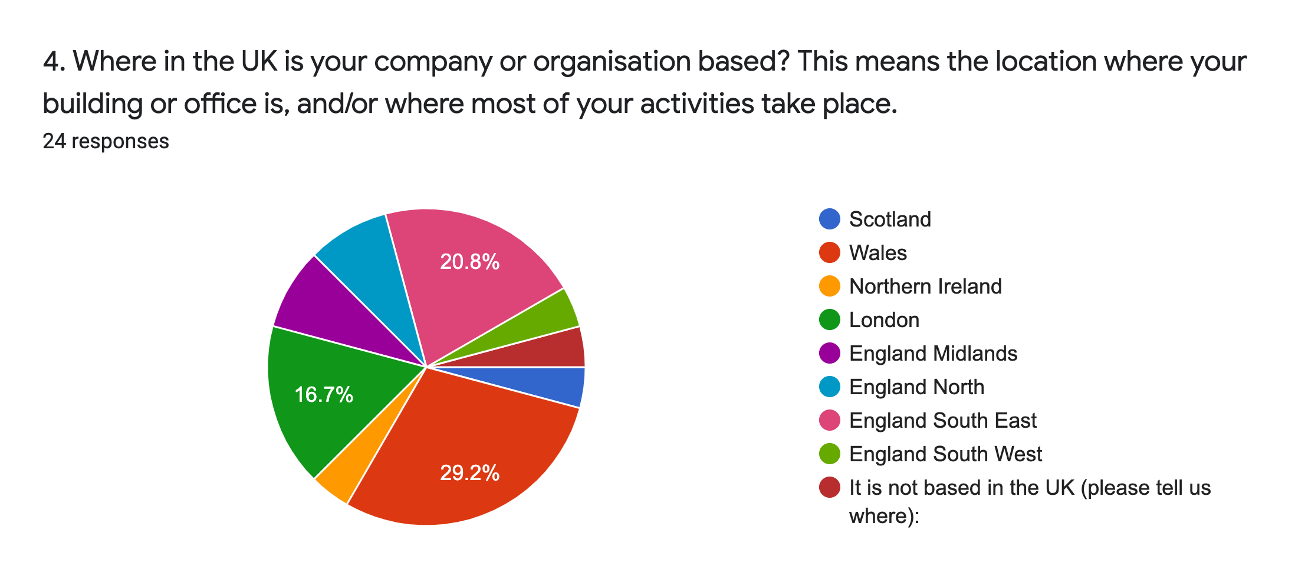
Location: Nearly one third of organisational respondents are based in Wales. The next most common base is South East England, followed by London. Others are based in England North, Midland, South West, Northern Ireland, Scotland, with one based outside the UK.

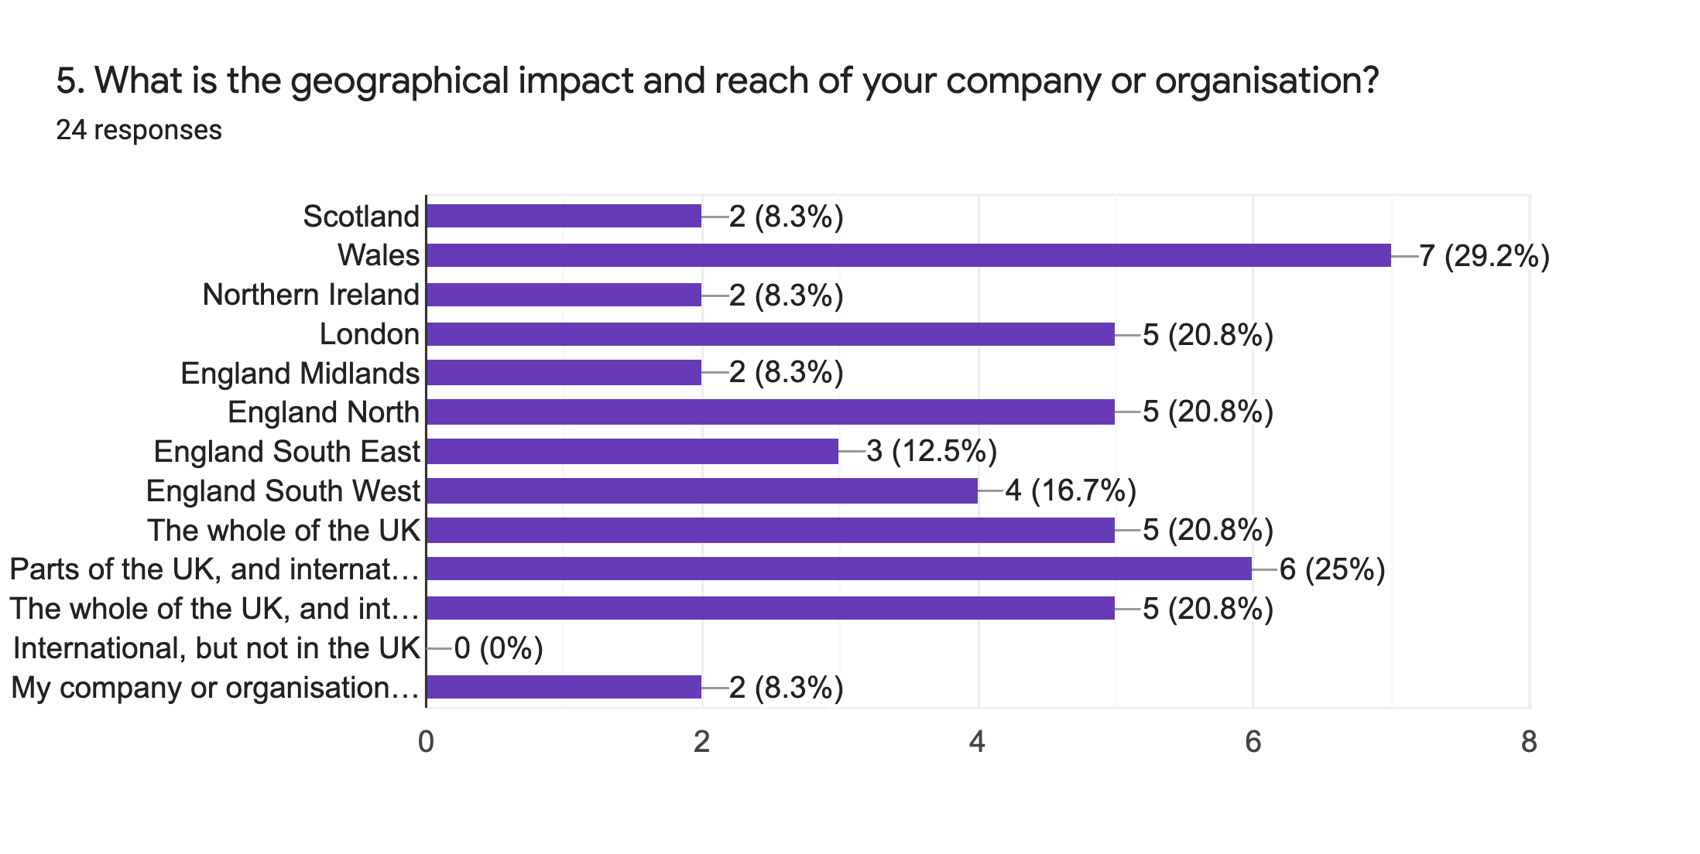
Geographical Reach: One fifth of respondents’ organisations have a UK-wide reach and one fifth have a UK-wide and international presence.

(The following two questions explore slightly different definitions of the term “disabled-led” with regard to organisations.)
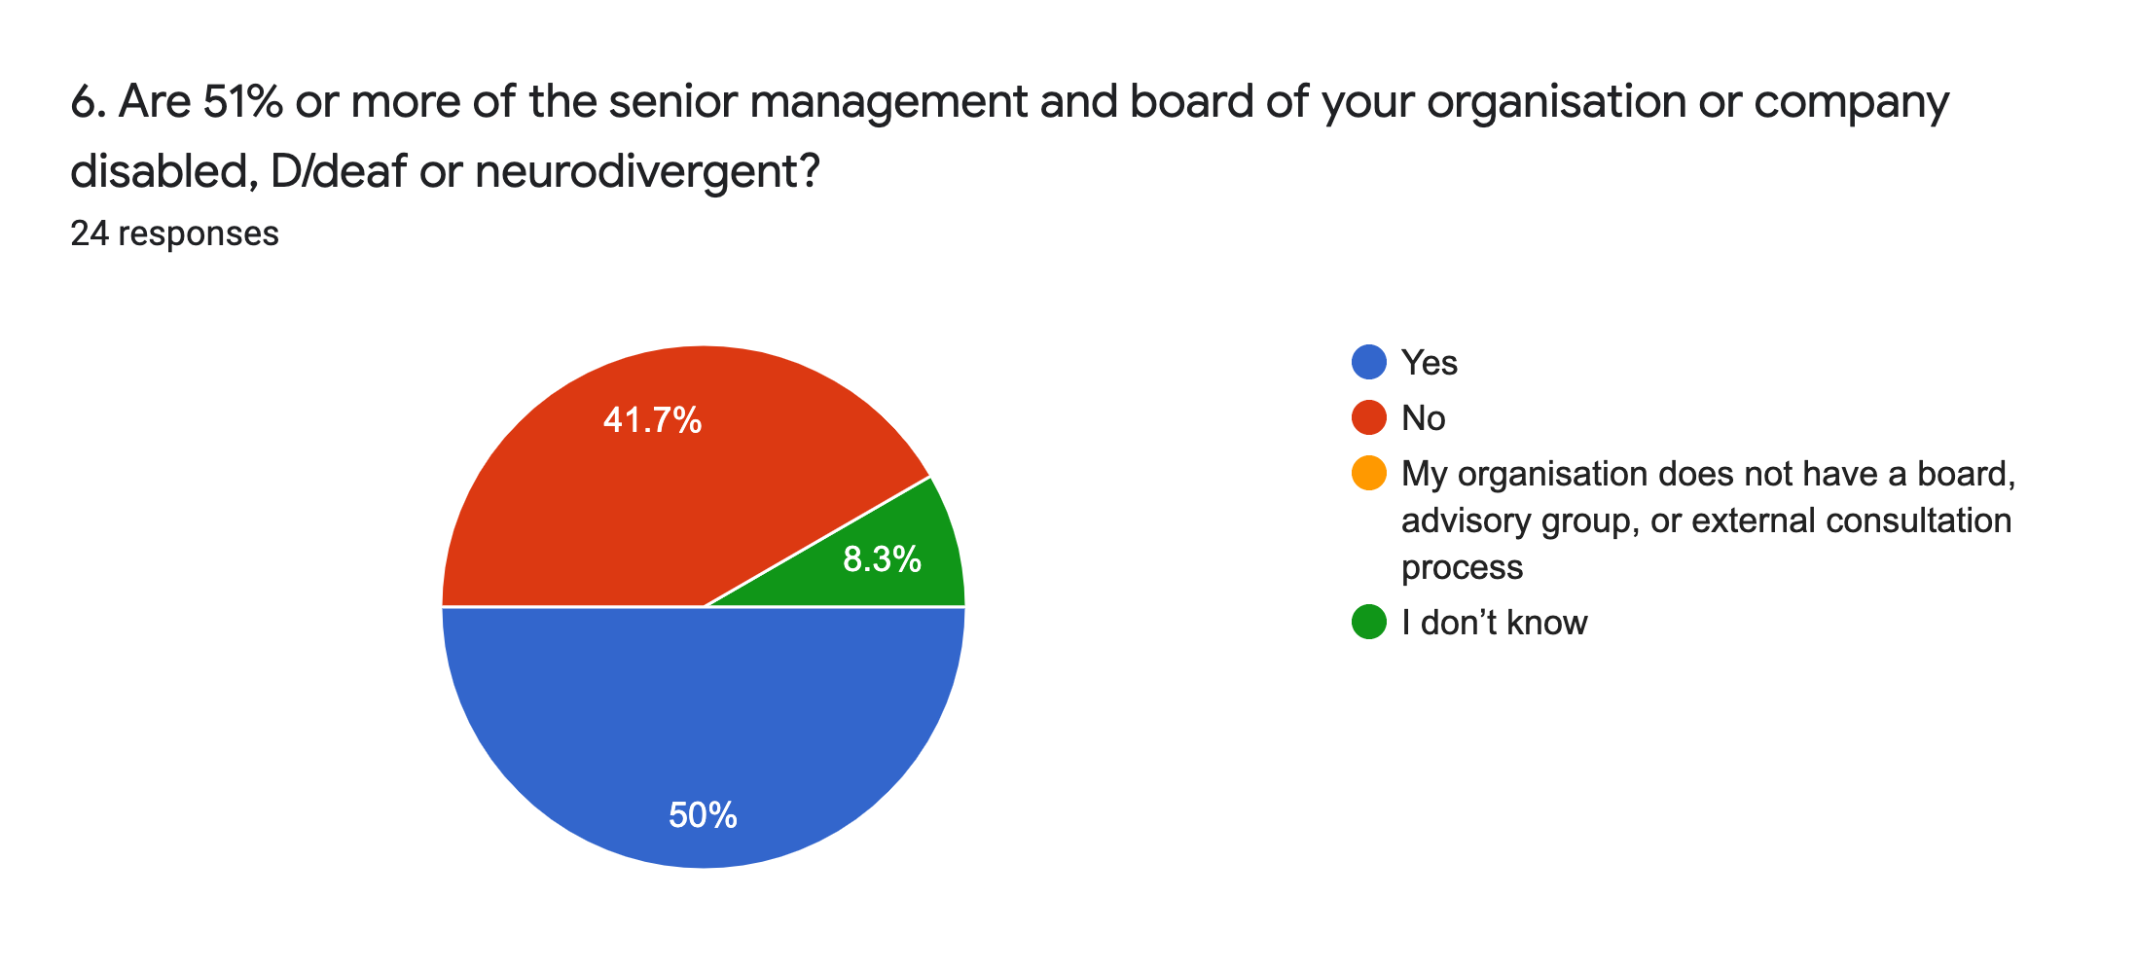
Disabled-led management: Half of respondents’ organisations have senior management and/or a board with over 50% representation of disabled people.

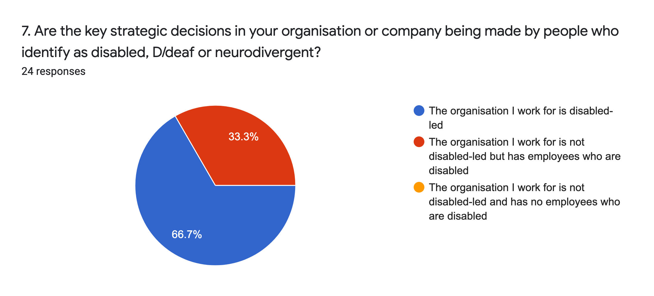
Disabled-led decision making: Two-thirds said that disabled, D/deaf or neurodivergent people led their organisation’s decision making. All respondents have disabled people working in their organisation.

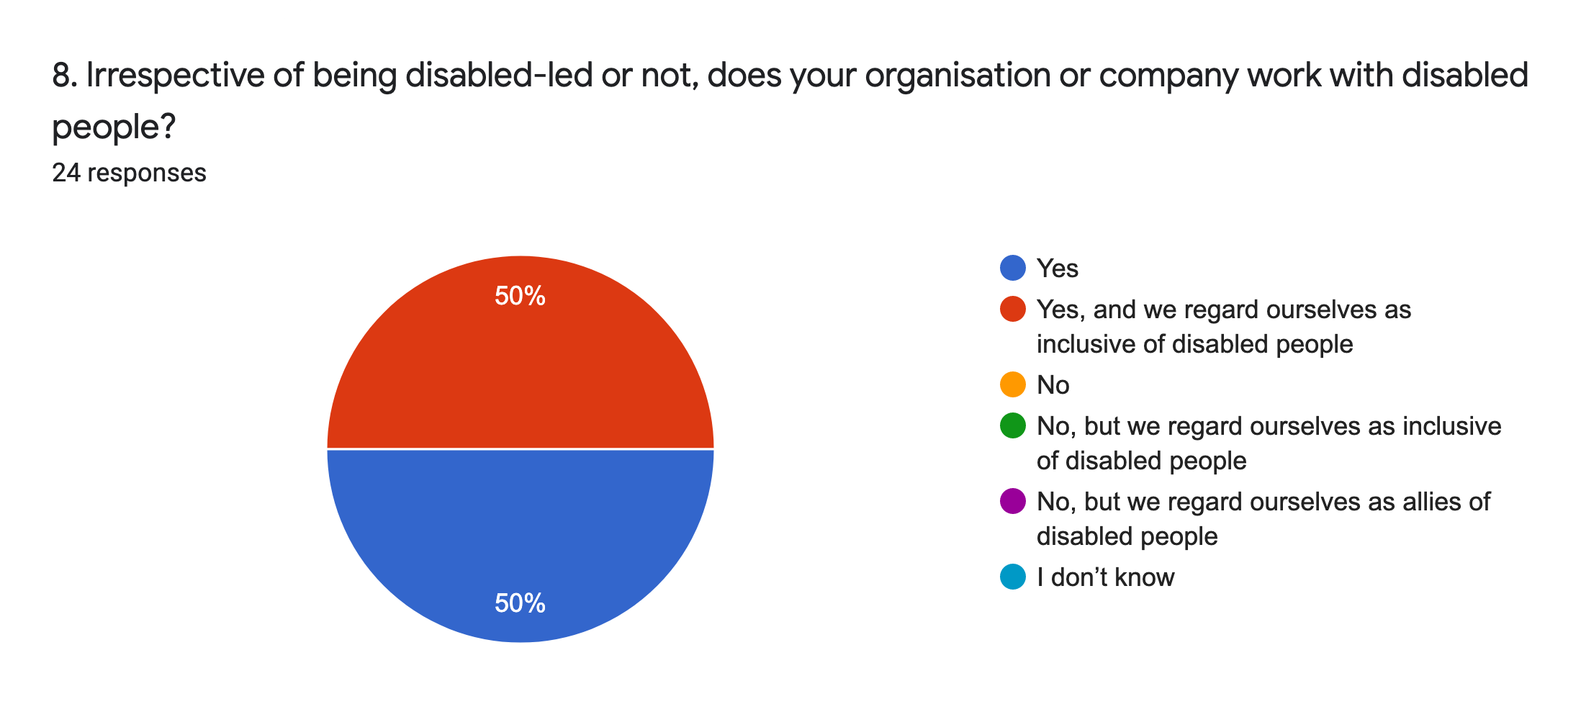
Working with disabled people: Every respondent worked with disabled people in some way, and half of them both work with disabled people and regard themselves as inclusive of them.

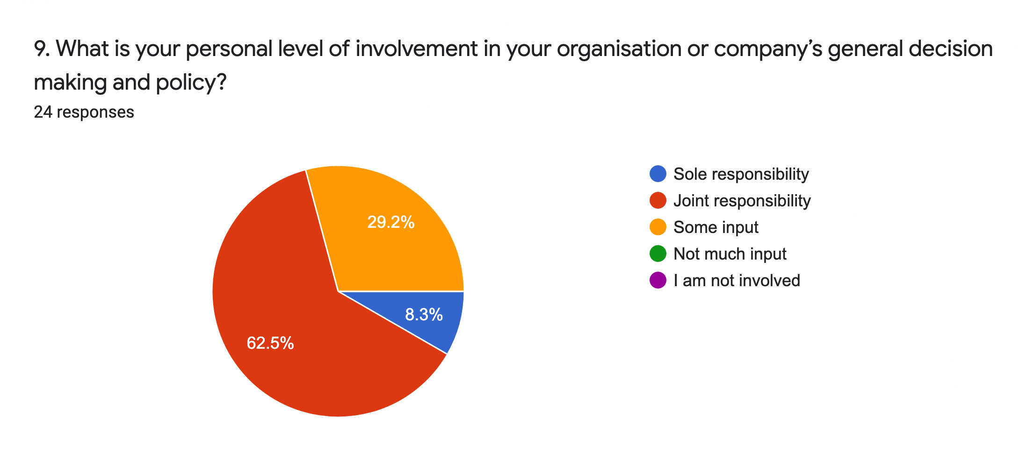
Personal impact: There were no respondents who felt that they had no impact on their organisation’s policy, with 71% saying they had sole or joint responsibility for it.
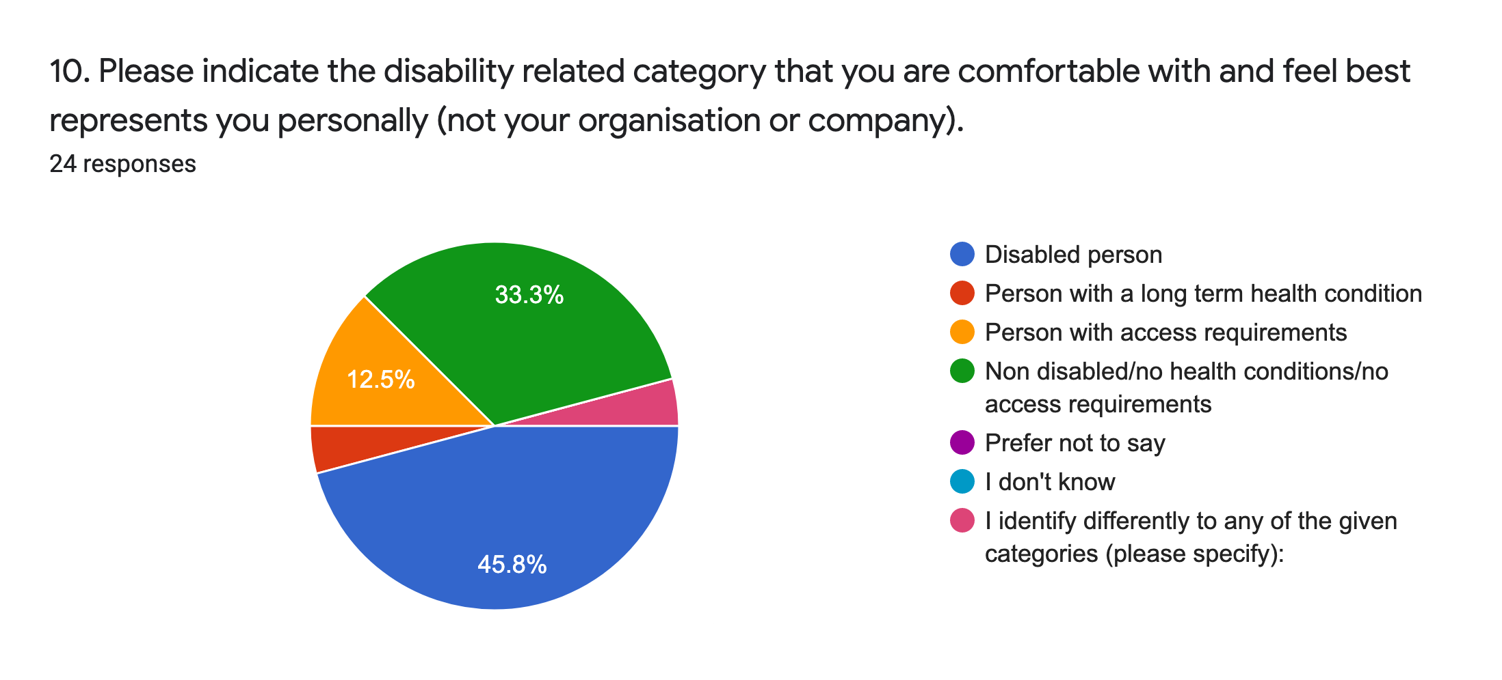
Disability: In our survey of individuals, about half of the respondents identified as disabled, followed by identifying as a person with access requirements, or a person with a long term health condition. By contrast here, one third of this survey’s respondents do not identify as disabled, but nearly half of this survey’s respondents do, rising to two-thirds if we include people with long term health conditions, neurodivergent people, and people with access requirements.

c. PANDEMIC IMPACTS
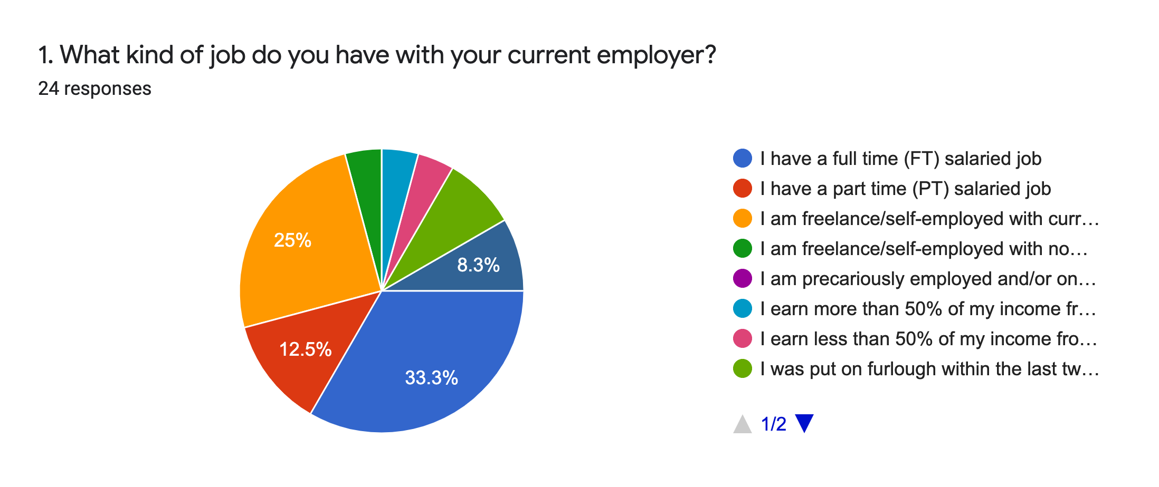
Employment type: As expected given the focus of this survey, more people are employed on full time, salaried contracts compared to the survey for individuals (33% here versus 7%). A quarter are freelancers. 13% have a part time salaried job. 8% were placed on furlough but have now returned to work.

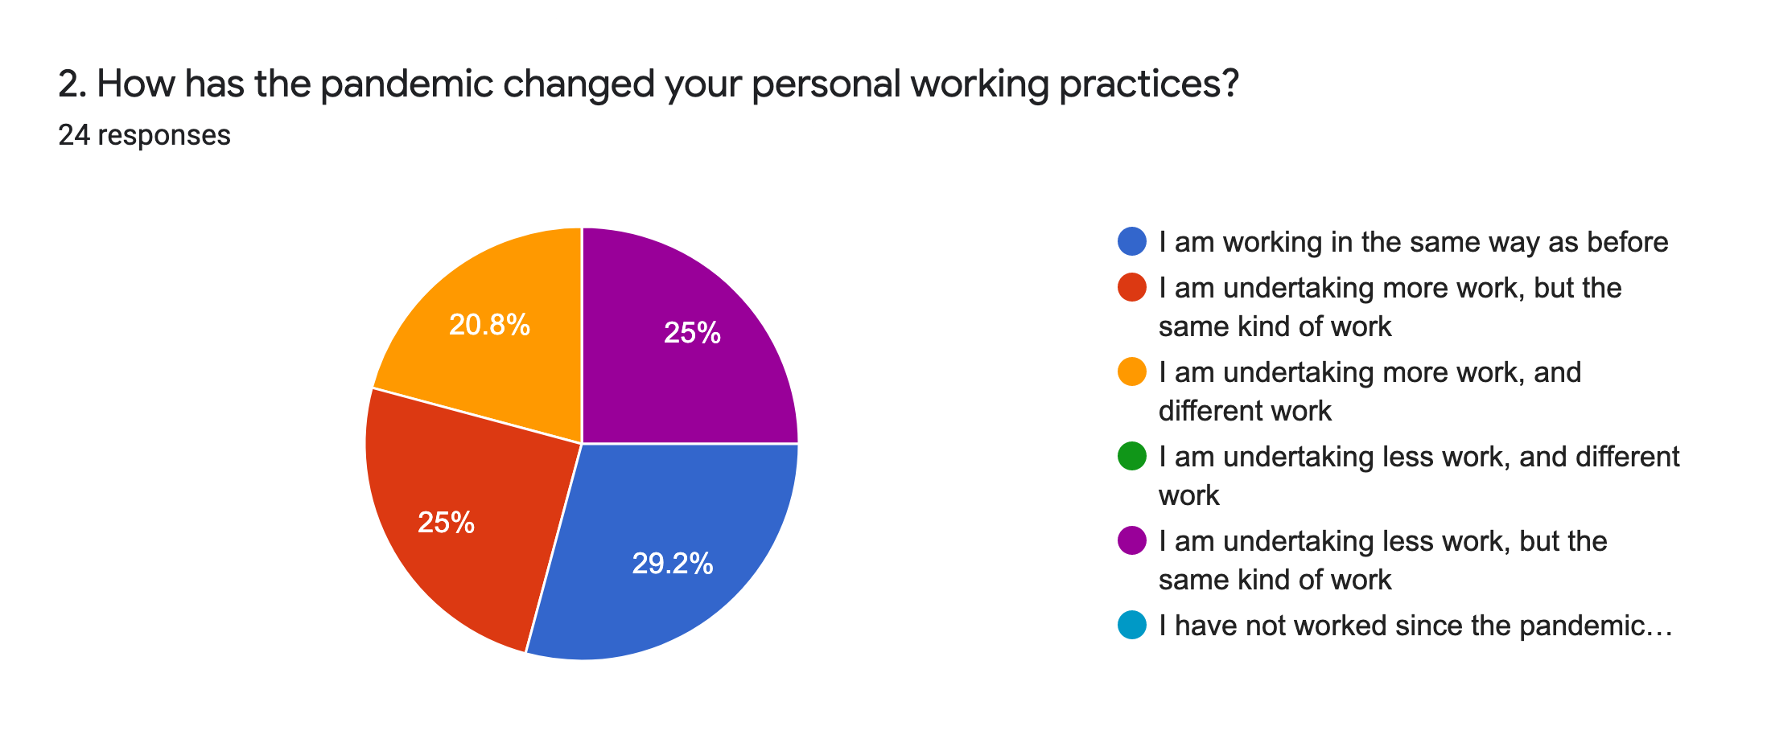
Effect of the pandemic: Outcomes are fairly evenly split into four categories, with people working in the same way as before narrowly leading, followed by exactly equal numbers of people doing less of the same work and more of the same work. One fifth are doing more, and different, work.

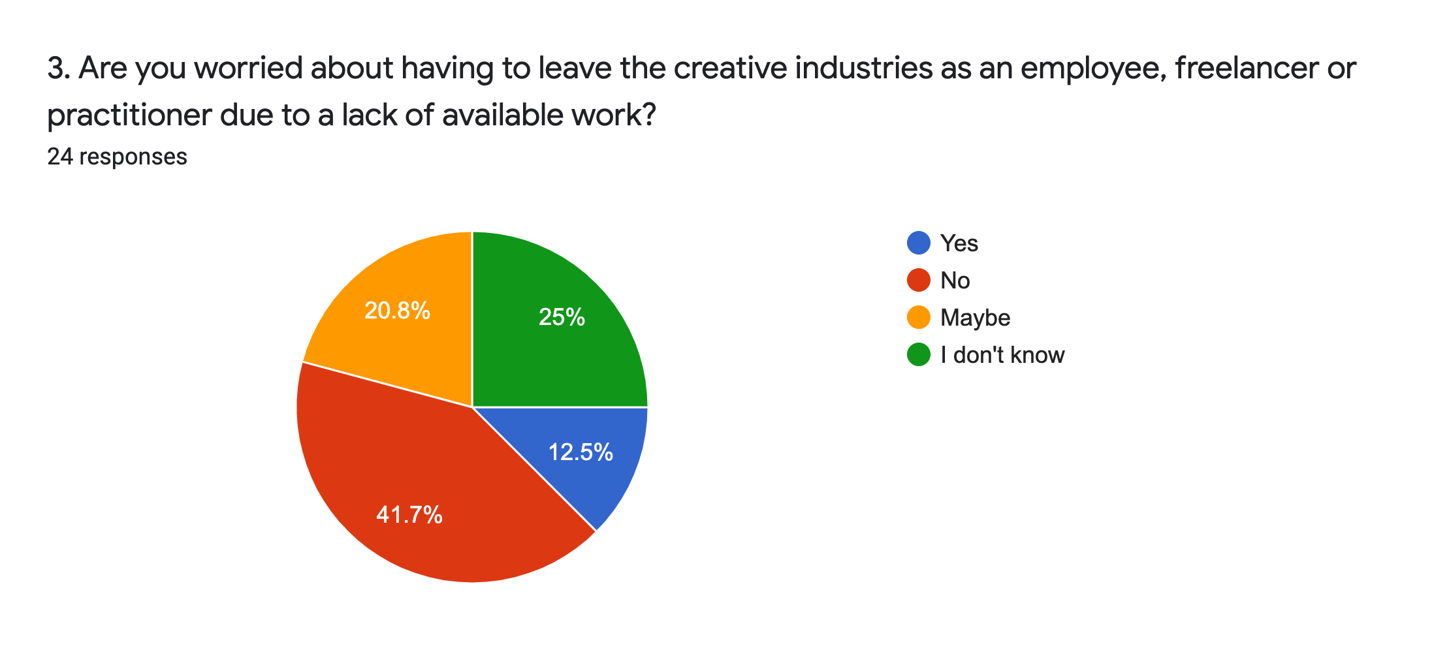
Job security: 46% of respondents definitely or possibly worry they will have to leave the creative industries due to lack of work. The equivalent figure was 59% for the individuals survey, of whom 29% were not worried by job security, versus 42% here.
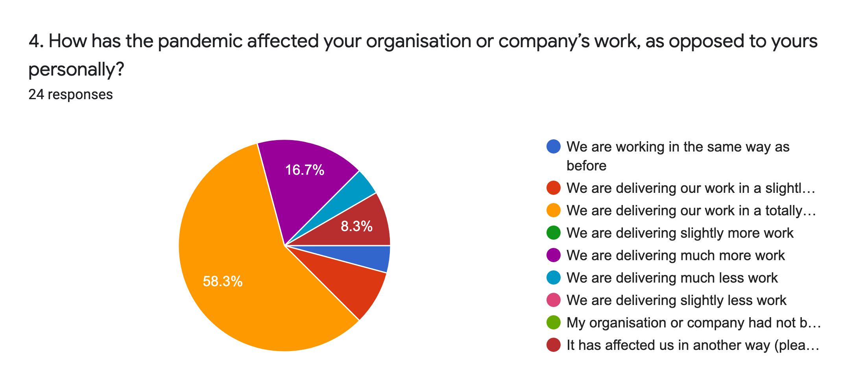
Organisation’s work: The headline here is that 59% are delivering their work in a totally different way since the pandemic began with 17% doing more work. 8% gave other answers: delivering more but not what they had started with; distributing funds to others; company formed during pandemic; moving online, though this last description could arguably fall under working in a different way as mentioned above.
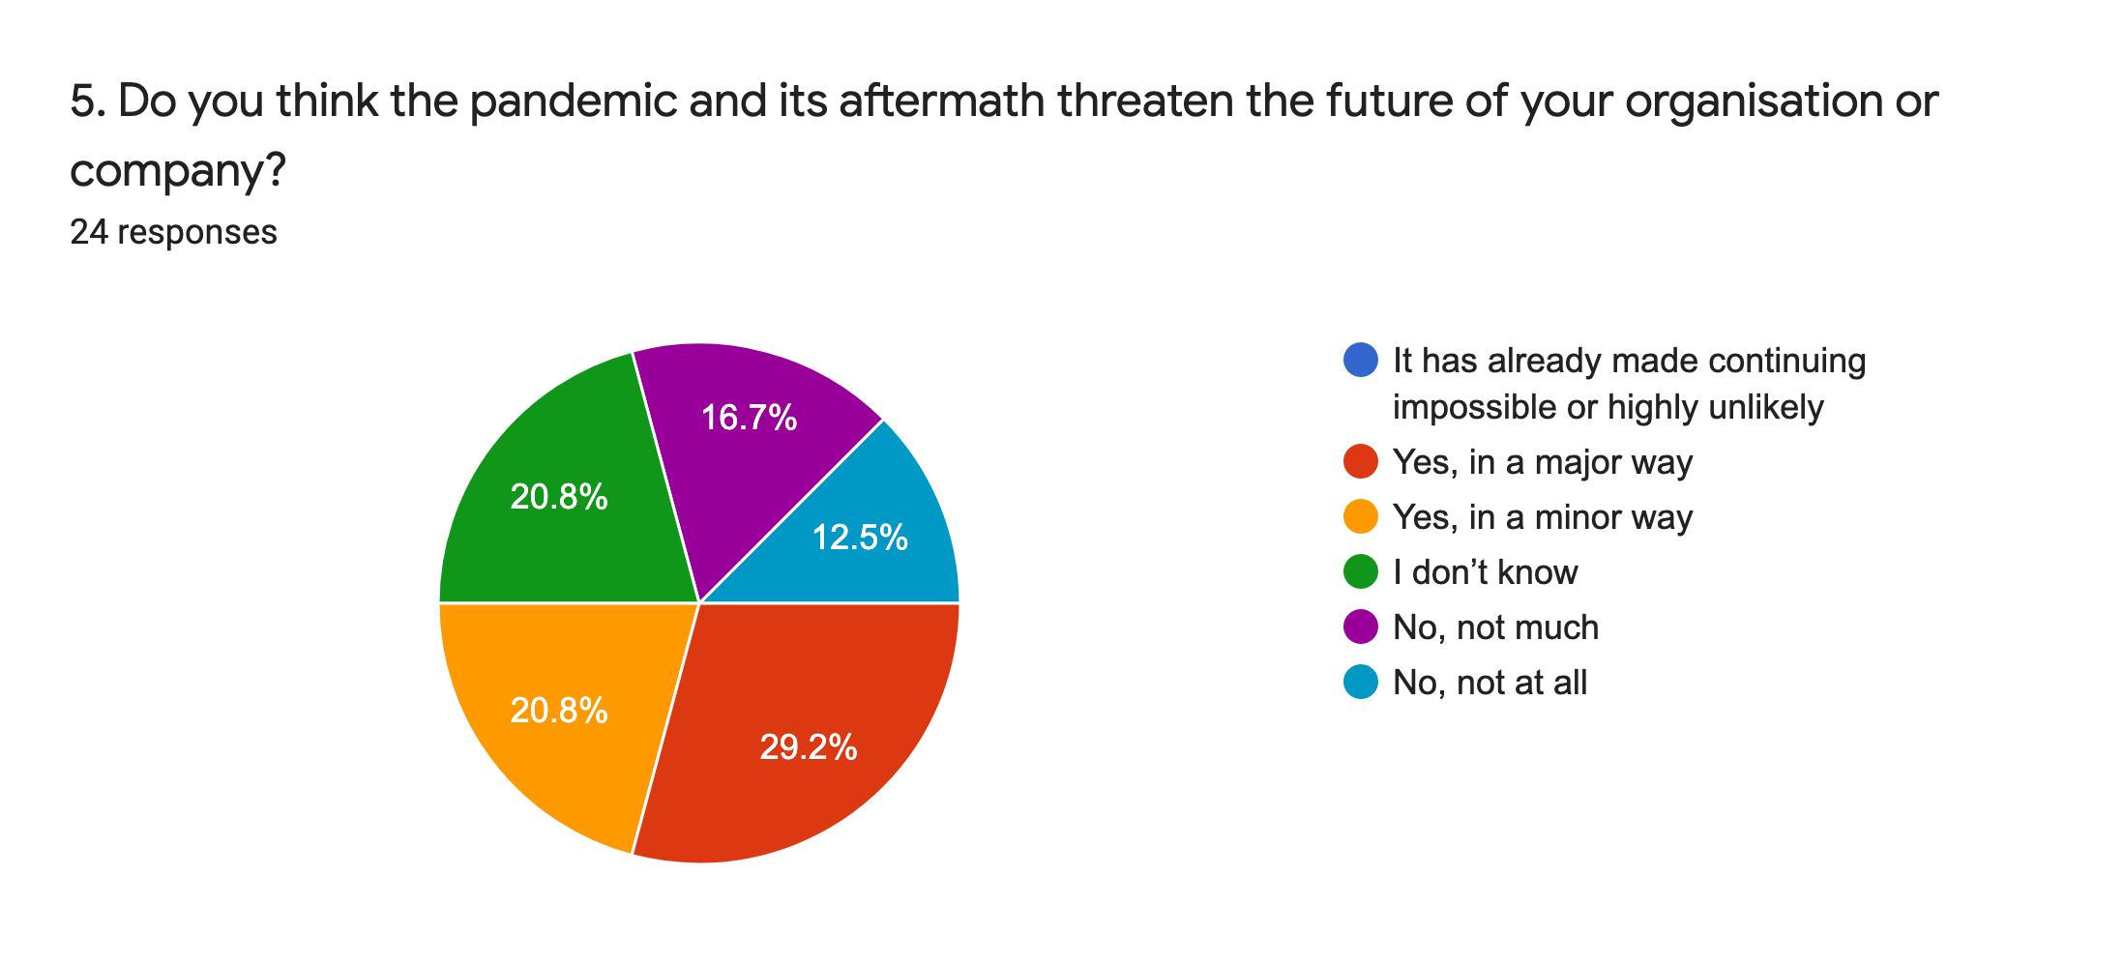
Organisational security: 50% of organisations have been impacted by the pandemic with one third threatened in a major way. Whilst one third said their organisation had been hardly or not at all impacted.
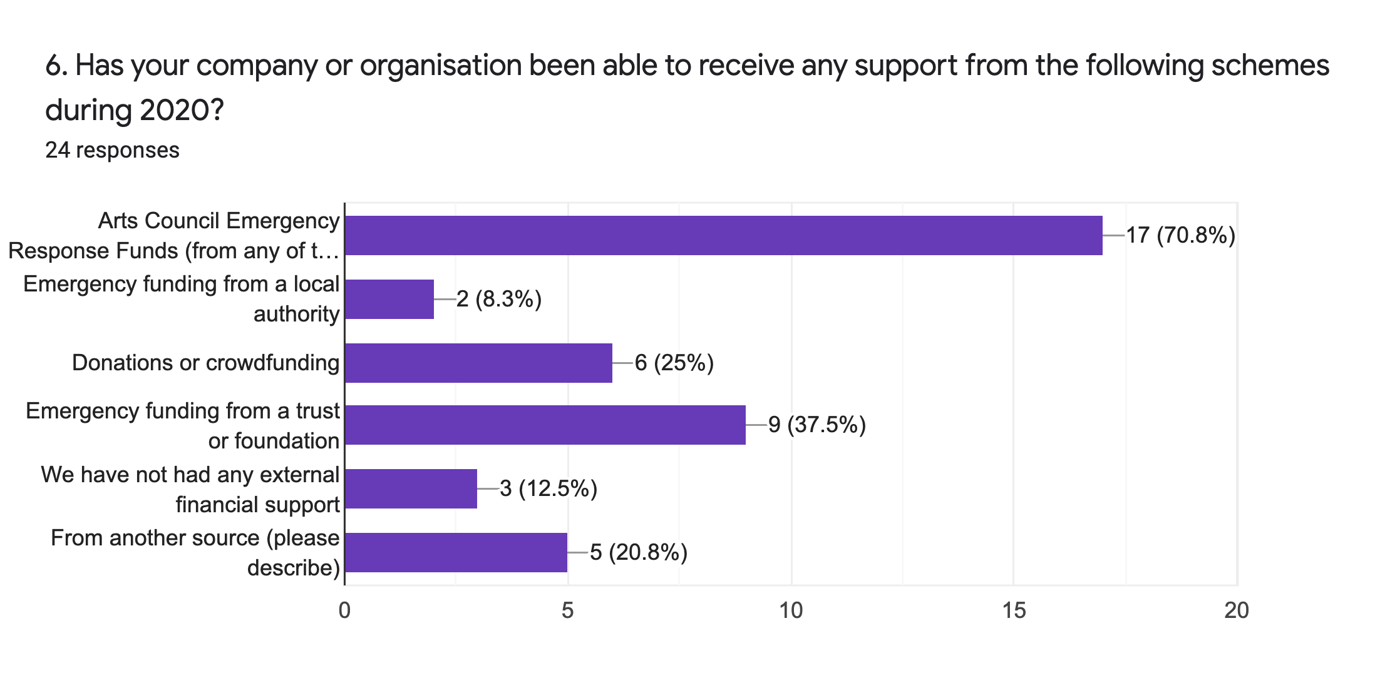
Financial support: The leading sources of pandemic support were UK arts council Emergency Funds and emergency funding from other trusts or foundations. Other sources of funding include: DCMS Culture Recovery Funding, government job retention scheme and Comic Relief.

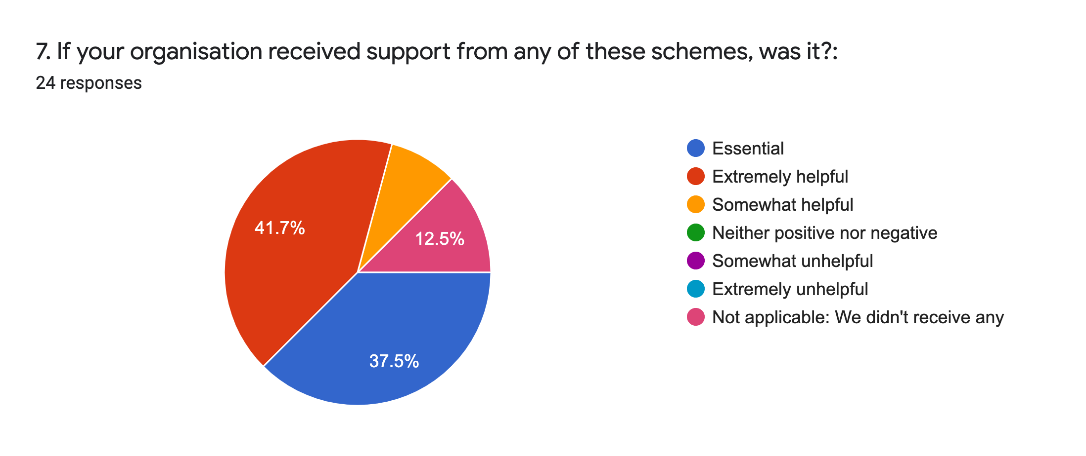
Funding impact: Over one third (37.5%) regarded this support as essential, and a total of 50% regarded it as extremely or somewhat helpful. 12.5% did not receive any.

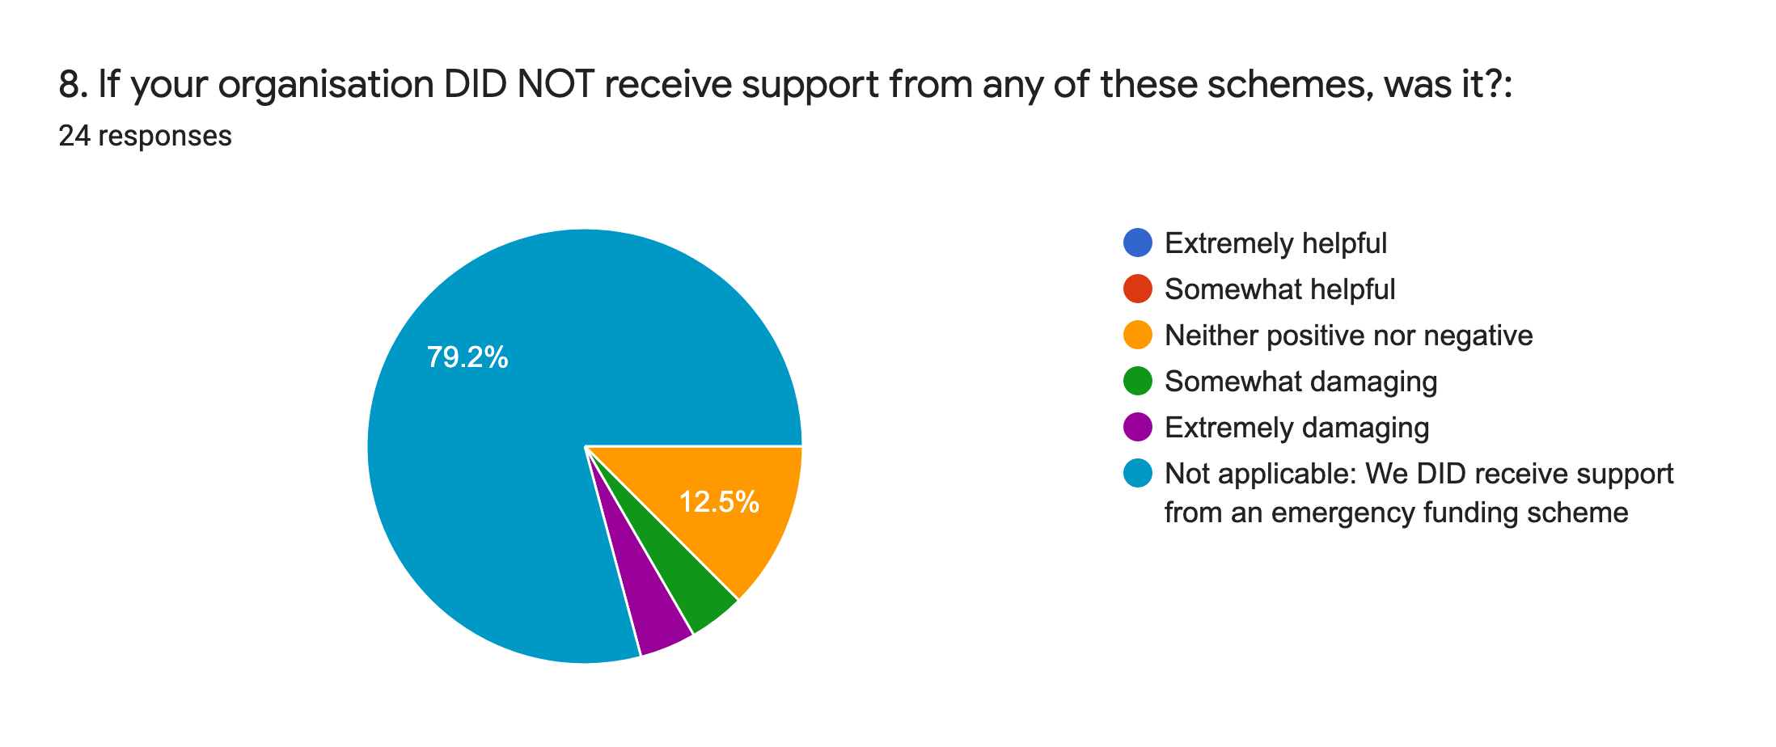
Impact of failing to obtain support: In line with the somewhat surprising findings of the survey for individuals, only a minority of organisations who did not gain financial support felt that this lack of support was very damaging.
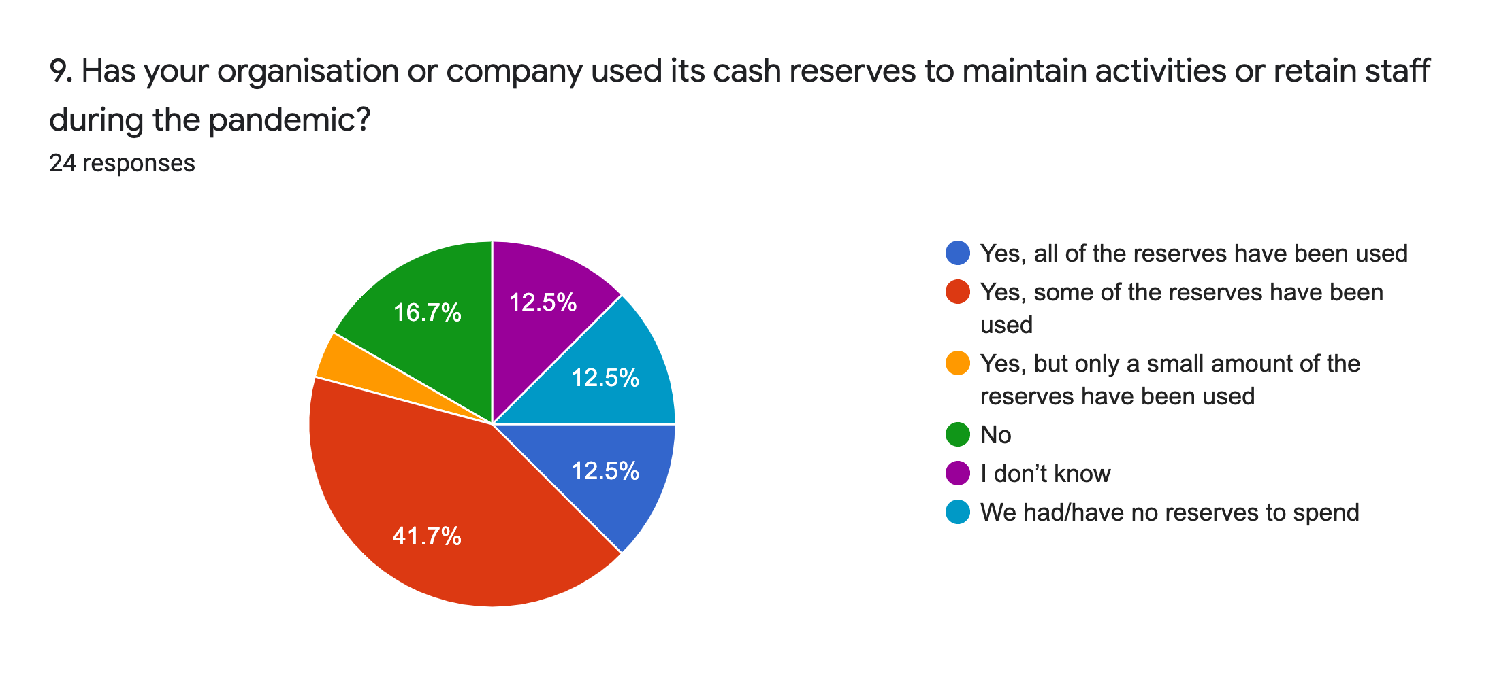
Financial resilience: 42% of organisations have used some of their reserve funds during the pandemic. 17% have not used any, but 13% had none to spend in the first place. The same percentage have used up all of their reserves. In total 58% of organisations have used all of their reserves, or a small or moderate quantity of them.

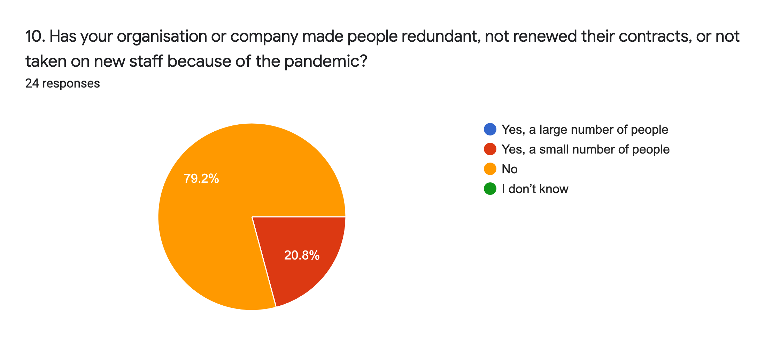
Staffing: One in five organisations have made a small number of people redundant or did not renew contracts, but the majority made no staffing changes demonstrating the full value of arts council and other government support (see Q7).

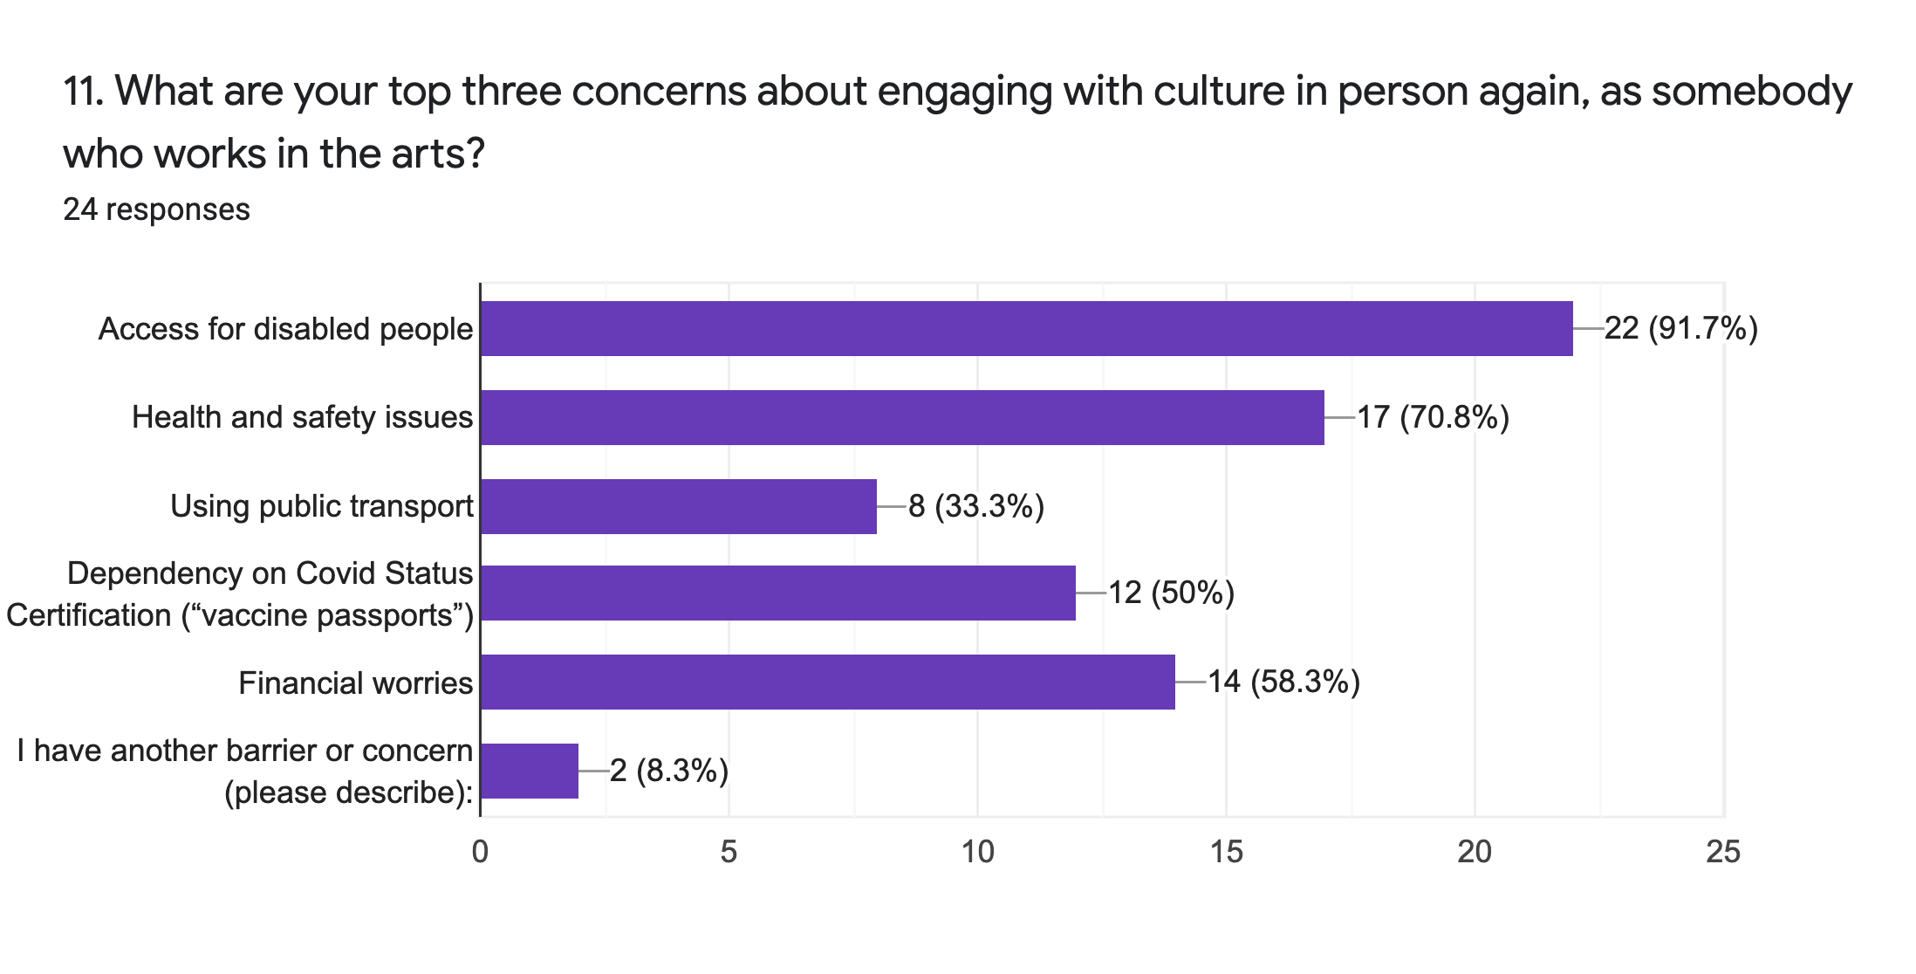
Post pandemic engagement: The top three concerns of organisational respondents to this survey are access for disabled people in general (92% of all respondents), health and safety (71%) and financial worries (59%).

Again, these worries could be attributed to the ableist posturing of some commercial promoters aiming to focus their reopening on the “fit and able” and the initial ban on ‘Clinically Extremely Vulnerable’ people from the Government’s Events Research Test Programme.

But taken altogether, the strength of this response suggests many disabled respondents working in the industry have trust issues with the wider cultural sector prioritising access.

“Vaccine passports” are also a particular concern for half of respondents in this survey. Other reported concerns were: reduced participant/audience capacity, childcare, misplaced confidence over safety, and people’s mental health.

e. THE IMPACT OF THE SEVEN INCLUSIVE PRINCIPLES
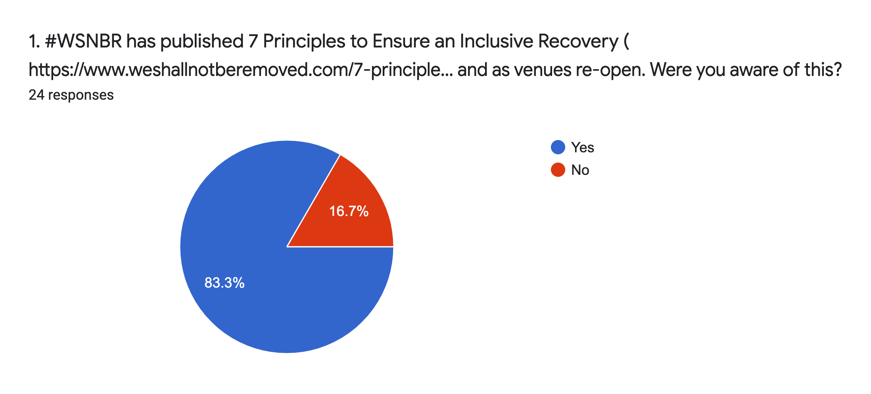

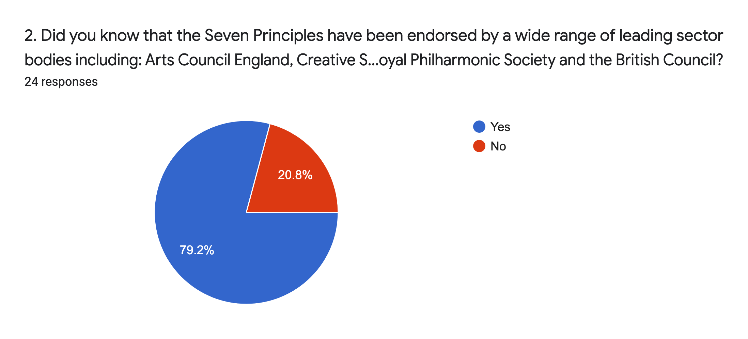
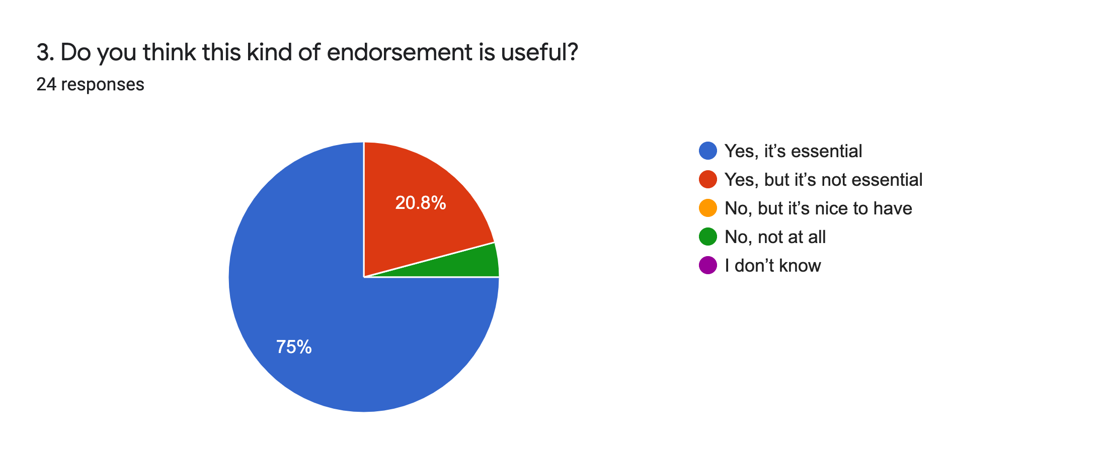
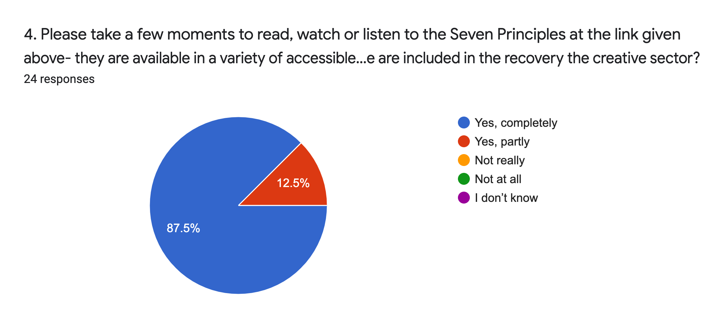

Seven Inclusive Principles: Most respondents had heard of these principles, knew that they had been quite widely endorsed, and thought that this endorsement was useful. All respondents wholly or partly agreed with them to a very high degree.

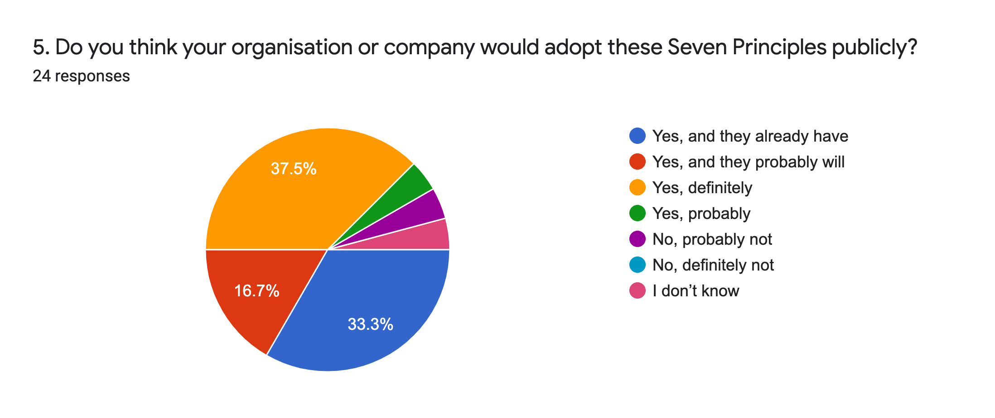
Adoption: Over 85% of respondents felt that the Seven Inclusive Principles could and/or would be implemented to some degree in their organisation. Only one person said they didn't know, and one person said their organisation probably wouldn’t.
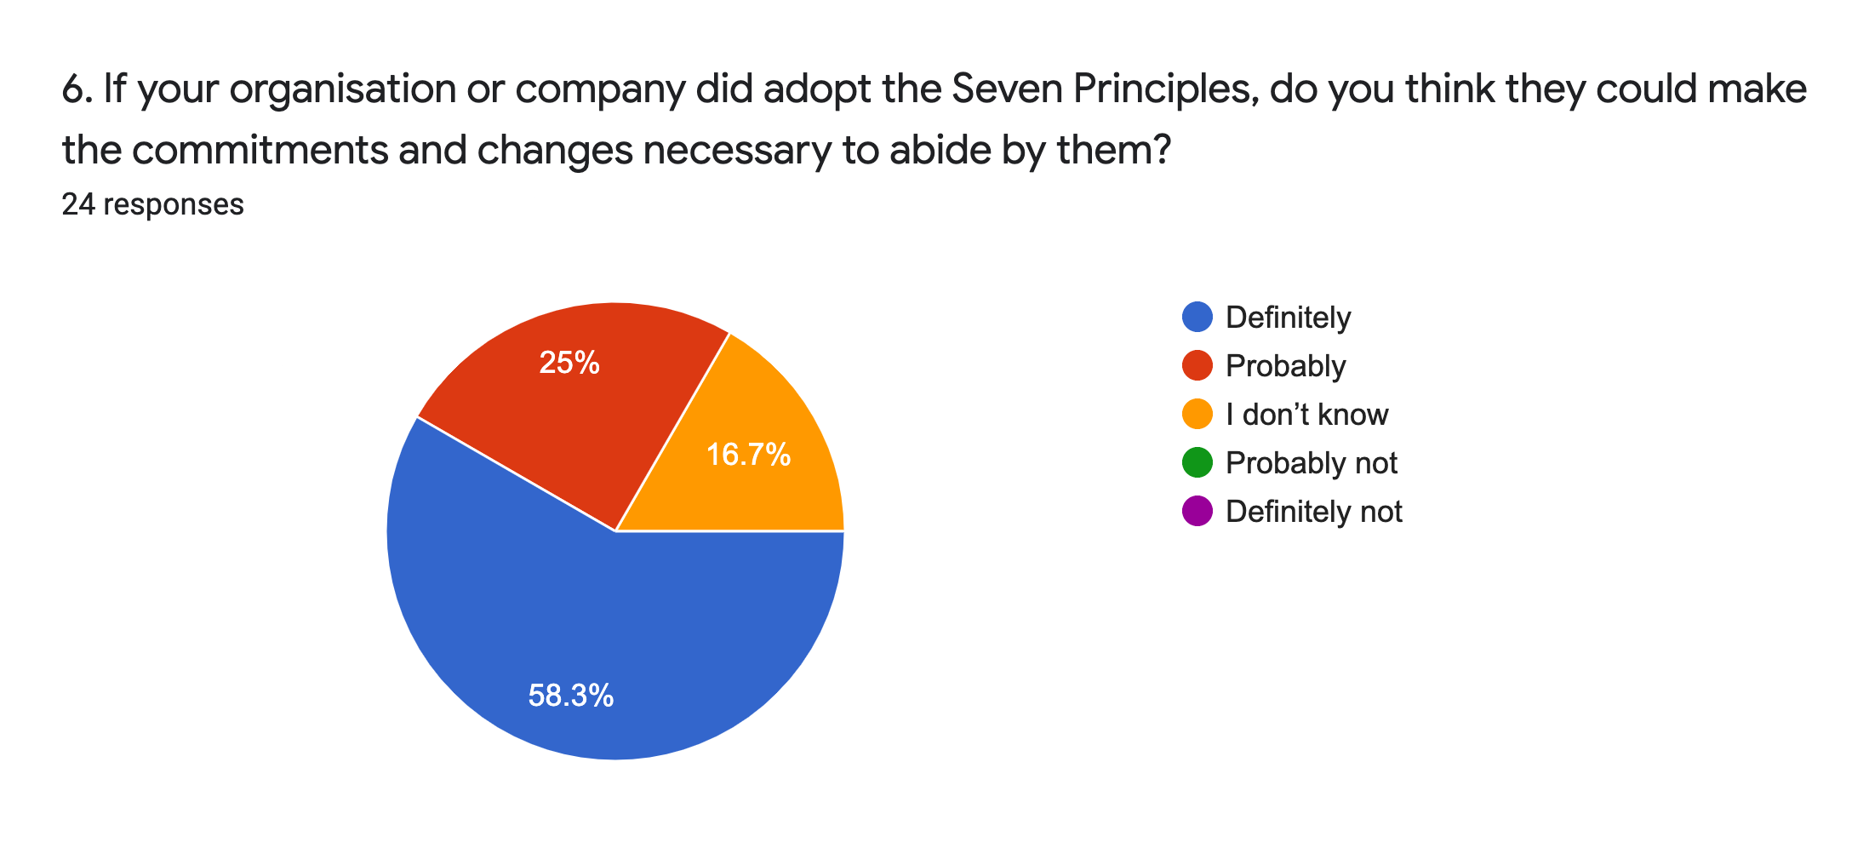
Implementation: A total of 83% thought their organisation could definitely or probably abide by the Seven inclusive Principles. 17% didn’t know, but no negative responses were received.

Q7 offered respondents free text to suggest next steps for #WSNBR. 9 responses were received including the following:

- “I hope a way can be found for WSNBR to continue and be funded to extend its work, support for creatives and orgs, advocacy and influencing. To lose the momentum gained would be a backwards step in a still extremely challenging time”.

- “At the moment I think the most important thing is that it survives beyond June 2021, it is still much needed”.

- “It's great the 7 principles have had support but some of the signatories are among the worst offenders when it comes to Disabled access”.

- “There needs to be a greater push to ensure the Mainstream is fully aware and understands the intersectionality of our community”.

NOTES ON THE SURVEY

- For simplicity all percentage figures in the text are rounded to the nearest whole number, meaning that sometimes these rounded figures will not add up to exactly 100. See embedded charts for more accurate percentages. Bar charts represent multiple choice questions. The percentages given in these represent the percentage of all respondents who answered affirmatively to each option, not a fraction of 100.

- The chart descriptions list all of the options offered by each question, even if these options were not chosen.

- Certain groups or responses are occasionally referred to as significant, insignificant, or similar; this is meant in a statistical sense and does not reflect their worth or their needs as people!

- For all comparisons made here and elsewhere, relevant UK populations in 2019 according to ONS figures in millions were: UK 66.7, England 56.2, Wales 3.1, Scotland 5.4, Northern Ireland 1.8. London 8.9, South East 9.1, East Anglia 6.2, South West 5.6, North West 7.3, East Midlands 4.8, West Midlands 5.9, Yorkshire and the Humber 5.5, North East 2.6.

REFLECTIONS ON THE SURVEY

"As an artist and arts freelancer myself I knew that the vast majority of arts practitioners rely on other jobs, self employed jobs, sometimes multiple jobs to sustain themselves, although they're the lifeblood of arts and culture. Even I didn't expect to find that only 7% of the individuals we surveyed work full-time, or that almost none earn more than half their income from their practice. Even more shocking is that a third of the disabled, D/deaf and neurodivergent people in our survey are precariously employed or on zero hours contracts, and a third have experienced homelessness. Nobody can be productive or creative under conditions like that. No support and respect for freelance artists and arts workers, no arts sector. It's that simple."

Alistair Gentry, Artist and Researcher; Compiler of this survey

"We all knew the pandemic was impacting on disabled people in the arts sector heavily - now we can see just how weighty that blow has been. There is a brief window in which to act if we wish to stop the erasure of disabled people from the place it has taken over 30 years for us to gain in the cultural sector. It is now for the right people to read, share and act on these findings and take immediate action. We Shall Not Be Removed.”

Jo Verrent MBE Senior Producer, Unlimited; #WSNBR Convener

“This survey is the first to reveal the full fragility of disabled people's place in the cultural sector following the pandemic and highlights alarming intersectional inequalities. The impacts on disabled freelancers and disability arts organisations are significant, and will require additional targeted support from funders and a rebuilding of trust with the wider sector to ensure the UK remains a global leader in fully inclusive culture".

Andrew Miller MBE, co-founder #WeShallNotBeRemoved

THE UK DISABILITY ARTS ALLIANCE
The UK Disability Arts Alliance campaign, #WeShallNotBeRemoved (#WSNBR) was founded in May 2021 by a group of leading disabled arts figures, alarmed by the marginalisation of disabled people in cultural discussions during the early stages of the global pandemic.

The aims of the alliance initially were to: amplify the voices of deaf, disabled, learning disabled and neurodivergent creative people; and to campaign for a sustainable future for disability and inclusive arts in the UK. Latterly the alliance has coalesced around pursuing a central advocacy theme of “inclusive recovery”.

During its first year of existence #WeShallNotBeRemoved has:
- issued open letters to UK culture ministers highlighting the issues facing disabled artists and workers in the pandemic
- run social media campaigns celebrating the work of disabled artists,
achieving a UK top 3 trending hashtag with #EndAbleism
- delivered a series of fully accessible online meetings for supporters, creating a sense of shared community and providing a safe space
- appeared on numerous cultural industry conference panels including Designing an Inclusive Recovery at the Edinburgh Festival Fringe dedicated to #WSNBR
- achieved vital support and funding from the 4 UK arts councils
- inspired activism and campaigns across the cultural sector including the BFI’s Press Reset campaign and the Audience Access Alliance
- produced the Seven Inclusive Principles in association with partner organisations to support the recovery of the arts sector
- inspired the BBC Arts Culture in Quarantine 2 programme in association with all 4 UK arts councils The Space and Unlimited, commissioning new work from 12 disabled artists
- campaigned against vaccine passports and discriminatory sector reopening test events overturning the DCMS ban on disabled people
- achieved over 700 signed-up disabled supporters, and over 1,000 followers on Twitter

ACKNOWLEDGEMENTS

#WeShallNotBeRemoved offers sincere thanks to Alistair Gentry for the smooth delivery of this survey together with his laser-like analysis.

We also appreciate the time and care devoted to the creation of the survey by our Conveners Working Group: Jo Verrent, Dr Jessi Parrott and Ellie Page; thanks also to Bill Bankes-Jones for proofreading and Andrew Miller for editing the document.

Thank you to all the individuals and organisations who responded to the survey and all our partners who promoted it.

This project was enabled by Unlimited thanks to additional financial support from the Paul Hamlyn Foundation. In addition we are grateful for the support of Graeae Theatre Company, Arts Council England, Disability Arts Cymru and The Arts Council of Wales.

All Rights Reserved, © 2021 #WeShallNotBeRemoved

