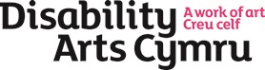and 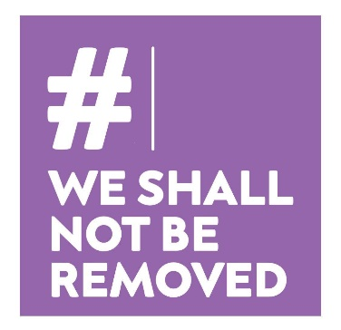
International Women’s Day 8th March 4pm – 6pm.
Disability Arts Cymru https://www.disabilityartscymru.co.uk/ in partnership with #WeShallNotBeRemoved https://www.weshallnotberemoved.com/
are celebrating Disabled and Deaf women from across the UK for International Women's Day.
The theme this year is Choose to Challenge: https://www.internationalwomensday.com/Theme.
A variety of Womxn will get up to all sorts of mischief whilst ensuring vital aspects of our lives are shared through words, sign, music and song, and so much more.
Already confirmed are Julie McNamara as host, Francesca Martinez, Miss Jacqui, Claire Cunningham, Deepa Shastri, Dr Vole and a range of other delectable comrades.
This free event is open to all disabled/Deaf artists, activists and allies
To register for this free event click on: bit.ly/DACCT0803
BSLI and Captioning will be available. If you need any other requirements, please inform us as we register.
Supported with funds from Arts Council Wales Cultural Recovery Funds

Definition of women includes women/womxn identifying as female/femme and 'non-binary’.

