**WARCOP PARISH HALL**

Is holding a music night on

**SATURDAY 12th OCTOBER at 7.30pm**

Live music performed by local band

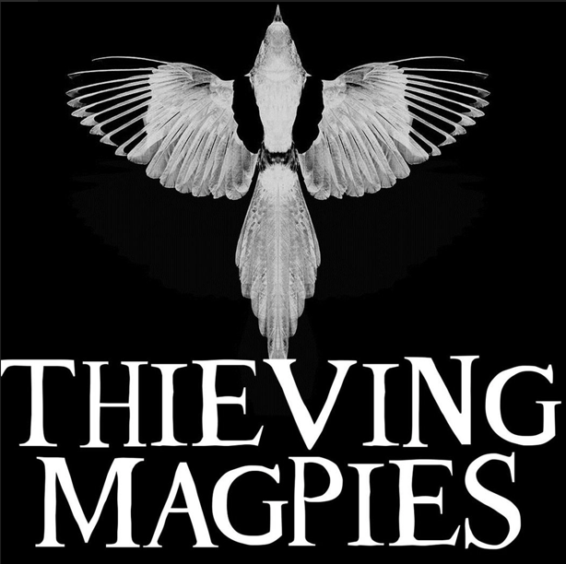

https://www.thievingmagpies.co.uk/

BRING AND SHARE SUPPER

(food served around 8.45pm)

£12 per ticket

Licensed bar Raffle

*To book your tickets, contact Carol on (017683) 53450 or carolwhite1@onetel.com or*

*Pat on (017683) 42188*

***Raffle prizes will be gratefully received and can be left at the hall on Thursday mornings, or with any Parish Hall committee member.***



***ALL PROCEEDS TO WARCOP PARISH HALL***