Contact Point | <title> | Date: | Fri, 2023-Jan-1
 | <title> | Day: | 1 of X
Main Location | <title>
BUas Campus, XR Stage | <title> | Shottime: | 9h00
Map and parking information at the end of CS. | Call Time: | Lunch: | 12h00
 | 8h00 | Est. Wrap: | 18h00
Director | 8h00
 | Check for individual call times | EMERGENCY: | +31 76 533 0112

Action List
Time | SS | Set | Action | Cast/Crew

Cast
#id | Cast | Character | In | SWHF | Make Up Time | Special Instructions

Crew
#id | Position | Name | In | Contact | Special Instructions
1 | Director
2 | Producer
2 | Producer 2
3 | DoPhotography
4 | Gaffer
5 | Production Design
6 | Digital Assets
7 | Make Up
8 | Wardrobe
9 | Audio
10 | Tech Support
11 | Script Supervisor
12 | Behind the Scenes

Contact Point | Greenhouse Insanity  Example | Date: | Fri, 2023-Mar-17
Carlos, +31 684 000 000 | Greenhouse Insanity  Example | Day: | 2 of 3
Main Location | Greenhouse Insanity  Example
BUas Campus, XR Stage | Greenhouse Insanity  Example | Shottime: | 9h30
Map and parking information at the end of CS. | Call Time: | Lunch: | 12h30
 | 8h30 | Est. Wrap: | 18h30
Director | 8h30
Annie, +31 684 111 111 | Check for individual call times | EMERGENCY: | +31 76 533 0112

Action List
Time | SS | Set | Action | Cast/Crew
9h00 | S1s5,7,9 | GH Labdesk 1 | Dialog Liz side | 1,2
10h30 | S1s6 | GH Labdesk 1 | Drop of lab flask | 1,2
12h30 |  |  | Break / Lunch
13h30 | S1s3 | GH corridor | Liz screaming with Emil for him to go away | 1
15h00 | S2s1 | GH corridor | Liz carrying some heavy plants | 1
15h45 | S2s3 | GH corridor | Liz runs away scared and falls hard | 1
18h00 |  |  | Exp. Day Wrap

Cast
#id | Cast | Character | In | SWHF | Make Up Time | Special Instructions
1 | Elise Rika | Liz | - | W | 8h30
2 | Coen Maas | Emil | - | WF | 9h00 | Goodbye Lunch

Crew
#id | Position | Name | In | Contact | Special Instructions
1 | Director | Annie | - | +31 684 111 111
2 | Producer | Ella | 8h00 | +31 684 000 000
2 | Producer 2 | Boyana | 8h00 | +31 684 000 001
3 | DoPhotography | Robin | 8h00 | +31 684 000 002 | Pick up the Anamorphic filter
4 | Gaffer | Teddy | 8h00 | +31 684 000 003
5 | Production Design | Joey | - | +31 684 000 004
6 | Digital Assets | Niels | - | +31 684 000 005
7 | Make Up | Bas | - | +31 684 000 006
8 | Wardrobe | Carlos | - | +31 684 000 007
9 | Audio | Jens | - | +31 684 000 008
10 | Tech Support | Phil | - | +31 684 000 009
11 | Script Supervisor | Stephen | - | +31 684 000 010
12 | Behind the Scenes | Robbert | - | +31 684 000 011

Location Information
Breda University of Applied Sciences  Monseigneur Hopmansstraat 2,  4817 JS Breda, Netherlands  Please, download NS application if you are coming by train to Breda:  https://www.ns.nl/en/travel-information/ns-app  Other public transport: 9292.nl/en - 9292 app: plan & buy tickets all public transport in the Netherlands  Train Station: Breda  Bus Stop: St. Ignatiusstraat  BUas General Phone: +31 765332203 |  | 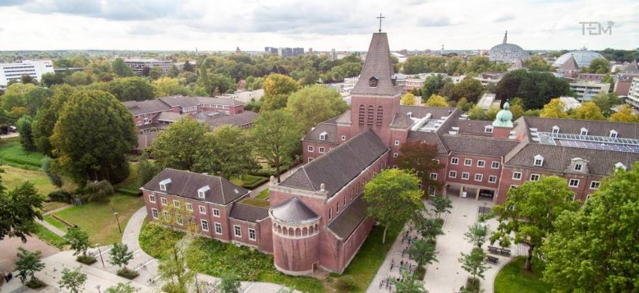
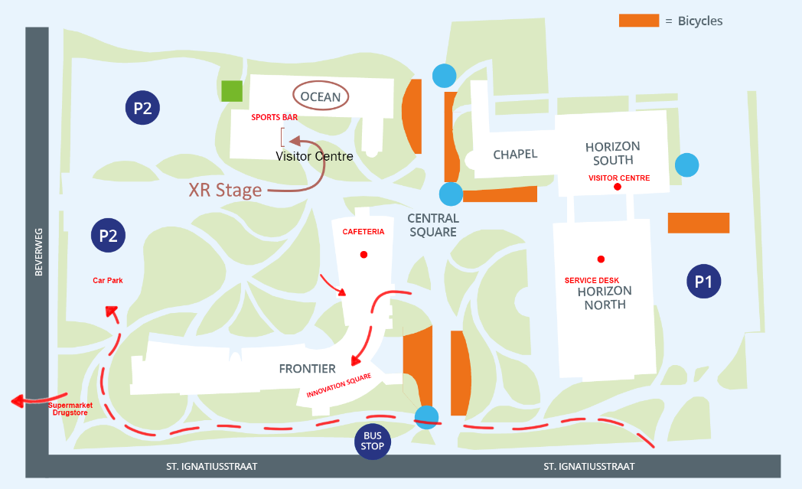 |  |  | Advised Parking  Parking is available P2, Buzz in, reference XR Stage
Campus Services

Cafeteria |  | Frontier Building
Sibelicious  Closed during educational holidays |  | Ocean Building | Lunch Mon-Fri 12h – 14h00  (walk-in till 12.30 hrs.)  Dinner Tue-Thu 18h-21h00 (walk-in till 18.30 hrs.)
Close by services
 | AH Brabantplein  Supermarket | Brabantplein 24  4817LR Breda  +31 76 531 0300 | 5 minute walk  08h00-21h00
 | Teurlings Confectionery  Bakery | Brabantplein 10  4817 LR Breda  +31 076 521 2014 | 5 minute walk  08h30-18h00
 | Kruidvat  Drugstore | Brabantplein 25-27,  4817 LR Breda  +31 318 798 000 | 5 minute walk  08h30-19h00

