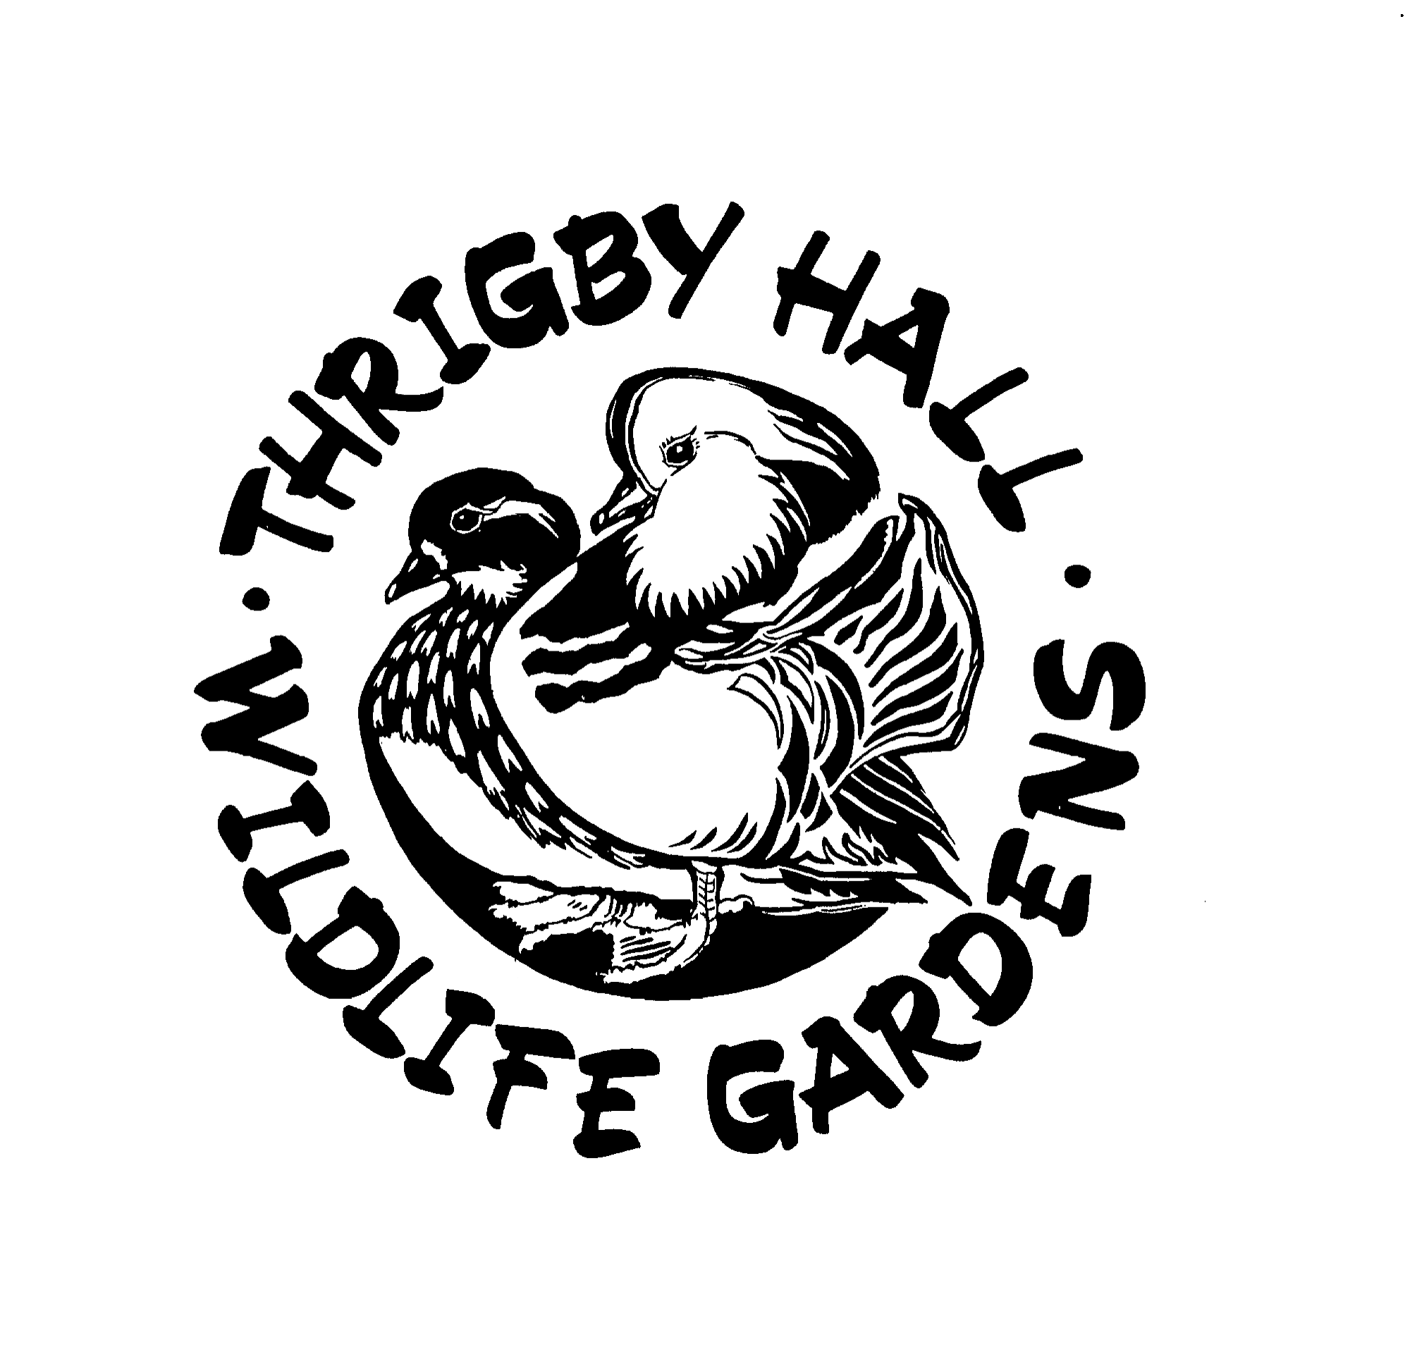**Thrigby Hall Wildlife Gardens.**

**Sustainability policy.**

Effective management of safety, health, environment, quality, energy, carbon reduction, and responsible sourcing is of key importance to the sustained success of our business. We have a single sustainability policy, which will be regularly reviewed and communicated to employees, visitors, and our supply chain to inform and promote wider adoption of responsible practices.

As a minimum, we comply with all applicable legal and regulatory requirements. Co-operation in the effective implementation of the policy is a condition of employment, partnership and supply.

* Thrigby Hall Wildlife Gardens is committed to establishing, promoting, maintaining and improving a culture of sustainability and environmental responsibility by staff, our supply chain, and broader stakeholders.
* Thrigby Hall Wildlife Gardens is committed to monitoring and reviewing our sustainable business operating procedures and practices. We commit measure our performance of the implementation of sustainability practices with a commitment of continual improvement in these areas.
* As part of our larger commitment to sustainability in the operational and procedural practices of Thrigby Hall Wildlife Gardens, we are also committed to providing the best, most sustainable products and services possible for our customers.
* Energy Efficiency: we are working to improve our energy efficiency in all areas of our facilities, including consideration of renewable energy generation (such as solar). We have a plan of regeneration across the park to improve the energy efficiency of our older buildings.
* Responsible Sourcing: we remain committed to ensuring that sourcing throughout our supply chain remains environmentally and socially responsible.
* Packaging / Plastics Elimination: we continue to seek the elimination of use of single use and non-biodegradable forms of plastics.

Thrigby Hall Wildlife Gardens are committed to being a positive influence by communicating and sharing our sustainability values with fellow members, stakeholders and the wider community through evidenced promotion, education and facilitation.