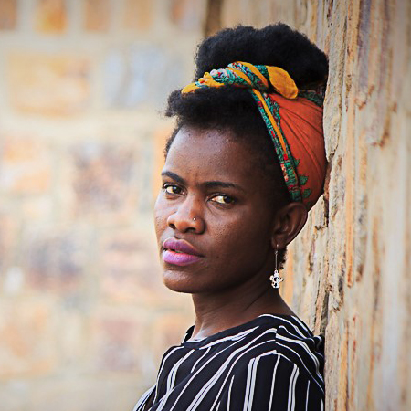

Rashida Namulondo is a youth worker, actress, award winning performance poet and co-founder of an all woman theatre group Afroman Spice.

Her works seek to use narratives and stories as a source of social healing and development. She is the founder of **The Sophie Muwanika Institute of Art for change**, a social venture that uses theatre modules to provide psycho social support and alternative education to vulnerable communities.

Her work has been appreciated on both national and international stages including festivals like MASA, Zinduuka, Ubumuntu Arts Festival and conferences like One Young World Summit, UNAOC Global Youth Forum where she has shared her works with various practitioners on using theatre for change.