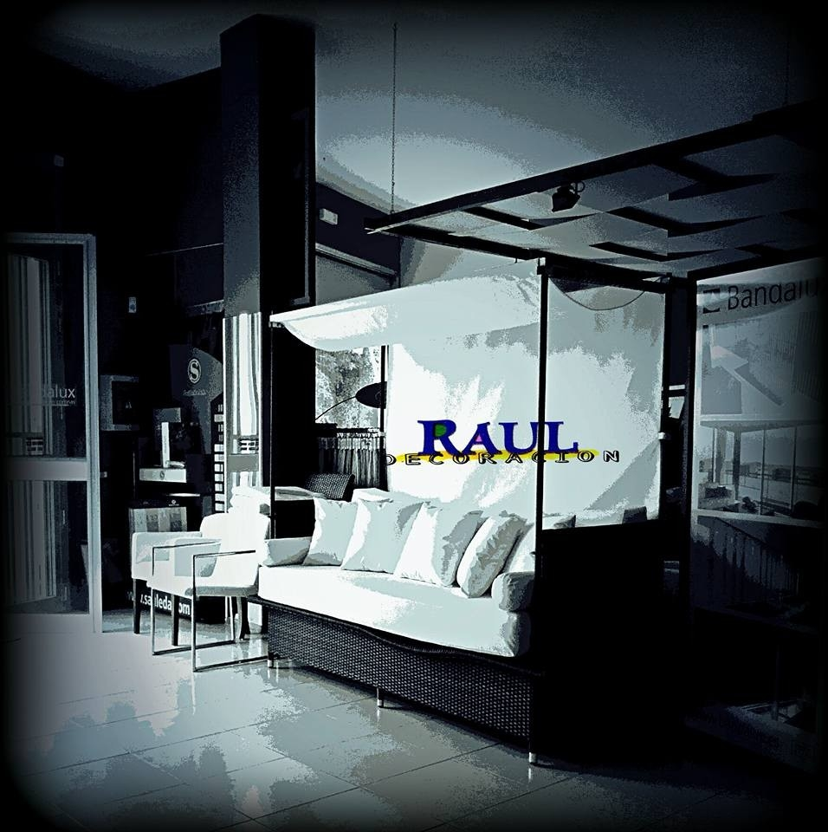
ORGANIGRAMA
RAUL DECOR TFE., S.L.

