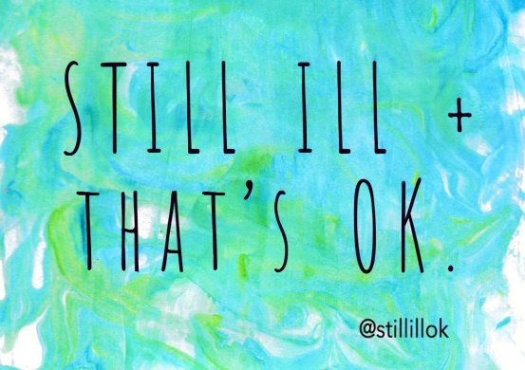
STILL ILL OK
ZINE ISSUE #1 CALL-OUT
We are accepting submissions in all formats for the zine, so please do send us your art, poems, stories, photos and thoughts! If you aren’t feeling particularly creative but want to be involved, please feel free to send your answers to the following questions, as these will be used as part of a bigger piece in the zine.
This document has some question prompts. Submitting this means that your answers will be included in the first issue of the Still Ill OK Zine.
You can choose whether to submit anonymously or with your name and chosen social media handle.

NAME: ________________________ // ANONYMOUS
SOCIAL MEDIA: @
Please delete the words in capitals as appropriate in the following two sentences:
I am happy for my NAME / SOCIAL MEDIA / NEITHER to be attributed directly to my answers.
I am happy for my NAME / SOCIAL MEDIA / NEITHER to be printed in a generalised list of contributors.
Please email submissions to holla@stillill.uk by 30th August.
If you don't feel particularly creative or arty-farty, then feel free to email me your answers to the following question-prompts.
These are available in other formats via the initial blog post: https://www.stillill.uk/?p=6751

QUESTION PROMPTS
- The thing people say about my disability/health condition that annoys me the most:

- The thing people say about my disability/health condition that I hear most often:

- What I wish they would say instead:

- The most irritating thing that friends say in relation to my illness/disability:

- What I would like my friends to say instead:

- Overall, what are your initial responses to the following...

1. What NOT to say:

2. What to say INSTEAD:

Thank you so much!
Please feel free to share with your pals!

Ellie Page / ellie@stillill.uk
@stillillok / 07539371070
www.stillill.uk

