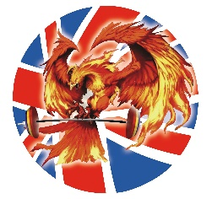

Code of Conduct for Coaches coaching junior lifters

Must be a minimum age of 18 years of age and registered with BWL and must have CRB clearance
Will carry out the following:
• Positive role model and atmosphere in training and competitions.
• Act with courtesy, respectfully and politely to all lifters, parents, other coaches and officials.
• Ensure all lifters attain as high a level of competency for the sport as they are capable, with all players gaining development of technical awareness which they will be able to carry on beyond junior levels.
• Do not consume alcohol beverages in the presence of your young players or come in contact with them while under the influence of alcohol.
• Act in a responsible moral manner in the presence of young lifters .
• Use appropriate language at all times.
• Be punctual and organised. Actively encourage fair to every one and good behaviour. Discourage bad behaviour.
• Coaches will work and develop with other weightlifting club coaches.
• All coaches must sign this code of ethnics to coach for BWLA and any violation of this code may result in disciplinary sanctions.
Coach Responsibilities:
• Develop in all lifters interest in weightlifting.
• Develop each lifter’s maximum potential.
• Encourage and deliberately boost the confidence of all lifters.
• DO NOT ridicule or over criticise.
• Ensure each coaching session is well prepared with the coaching emphasis being placed on the development and acquisition of skill, decision making and an understanding of the exercise .
• Maintain the highest standards of personal discipline and courtesy during competitions irrespective of the result.

