FOR PRESS COVERAGE
ABOUT SIGNE SNEH DURHOLM

Short Version: About Signe Sneh Durholm:

Signe Sneh Durholm is a trained opera singer from the Royal Opera Danish Academy at the Royal Danish Opera. She is a versatile lyric-coloratura soprano with a voice that ranges from the Queen of the Night in The Magic Flute, to Mimì in La Bohéme and Lulu in Alban Berg's opera of the same name. Signe has performed on most Danish opera stages and been a guest soloist in numerous places outside of Denmark. In addition, she has appeared on several occasions for HM Queen Margrethe II and the Royal House.

Signe Sneh Durholm has received many recognitions, singing and competition awards, honorary scholarships and great reviews, as well as qualified for the "Final Rounds" in the Hans Gabor Belvedere Singing Competition.

With a desire to make opera more accessible to both children and adults, Signe work as an idea developer, librettist and singer on various projects.

Longer Version: About Signe Sneh Durholm:

Signe Sneh Durholm is a soprano with a wide repertoire. She has sung the Queen of the Night in Mozart's The Magic Flute, Musetta in Puccini's La Boheme, Lulu in Berg's opera of the same name, Giolietta in Bellini's I Capuletti ed i Montecchi, Adina in Donizetti's Love Potion, Cunégonde in Bernstein's Candide, Lucia in Donizetti's Lucia di Lammermoor, Mimi in Puccini's La Bohème and Donna Anna in Don Giovanni, just to mention a few.

Signe Sneh Durholm has performed with several orchestras in Denmark and abroad and has appeared numerous times on TV and at entertainment shows. Signe has been a soloist for HM Queen Margrethe II many times, for example at the Danish Parliament Ball in 2018 and HM Queen Margrethe II's 40-year regency jubilee.

Signe Sneh Durholm graduated in 2016 from the Royal Danish Opera Academy at the Royal Opera House, Denmark, where she studied with Anne Margrethe Dahl. Before that, she achieved a bachelor's degree in classical singing at the Royal Danish Academy of Music and was trained as a church musician at Zealand't Church Music School - both completed with the highest grade. Signe has since participated in several master classes at home and abroad.

Signe Sneh Durholm has worked with several Danish and foreign conductors, among these Giuliano Carella, Christian Badea, Michael Schønwandt, Giordano Bellincambi, Peter Spissky, Frans Rasmussen, Michael Bojesen, Per Enevold, Maria Badstue and Martin Nagashima Toft. Signe has been a soloist with many of the country's leading symphony and harmony orchestras.

Signe Sneh Durholm has received numerous recognitions, talent awards, competition awards and honorary grants, such as Betty Beval's Opera Scholarship, first place in the "Opera's Friends Singing Competition", Martha Hansen Memorial Fund, The Roager Foundation's Talent Prize and honorary grant, Aarhus Summer Opera's Friends' Prize and grant.

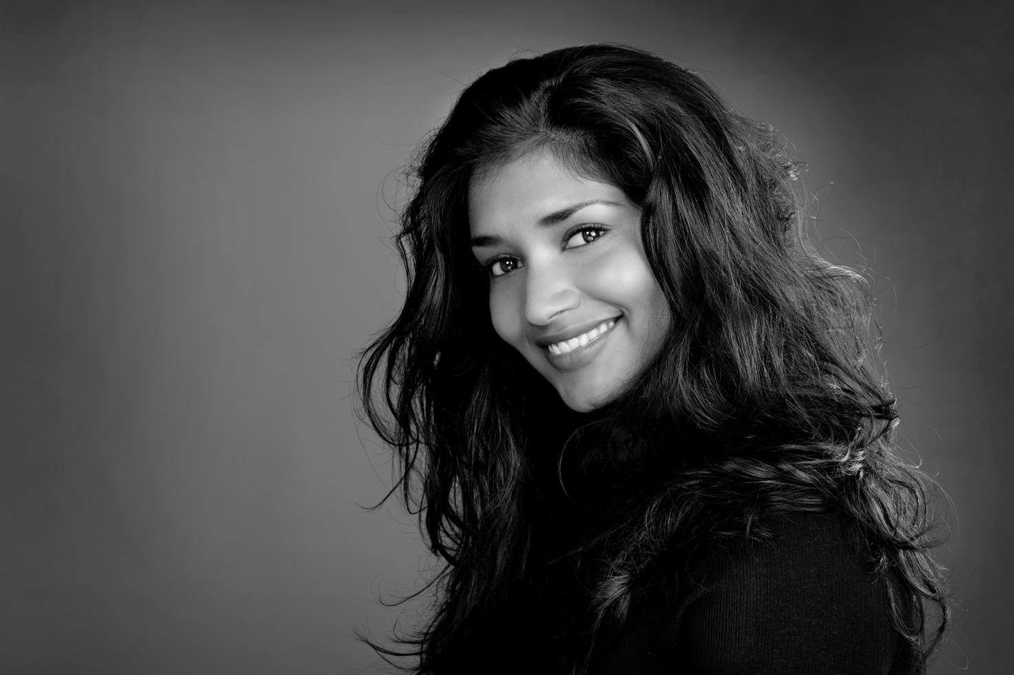
Foto: Ida Wang

