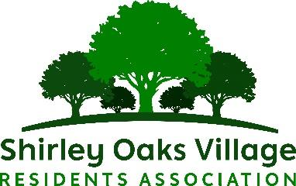
contact@shirleyoaksvillage.co.uk

SOVRA QUIZ NIGHT
SATURDAY 13th June 2026 @ 7 pm for 7:30 pm Start
AT SHIRLEY GUIDE & SCOUT CENTRE
REAR OF 81 WICKHAM ROAD, SHIRLEY CR0 8TB (BEHIND SHIRLEY PARISH HALL)

Dear All

We are pleased to announce our annual Quiz Night coming up on Saturday 13th June 2026

Why not make up a team and come along for a great night out with family and friends. If you would like to join us, but don’t have enough for a team, just let us know and we will put you with others who are in the same position to make up a team (Still have to book a place please).

Ticket Price: £4.00 for SOVRA Members & £6.00 for Non-Members.

Please state the number of food items required below

Please bring your own drinks and glasses. We will be providing free tea and coffee in the break.

Please pre-order and prepay if ordering food by 30th May 2026

Maximum 6 people per team.

If you have any questions, please email us on contact@shirleyoaksvillage.co.uk or ring Doug on 07950 462331
_ _ _ _ _ _ _ _ _ _ _ _ _ _ _ __ _ _ _ _ _ _ _ _ _ _ _ _ _ _ _ _ _ _ _ _ _ _ _ _ _ _ _ _ _ _ _ _ _

SOVRA MEMBERS: No. of Tickets @ £4.00 Each....................

NON-MEMBERS: No. of Tickets @ £6.00 Each....................

Please state No of Fish & Chips & Mushy peas @ £10.00 Each: ........... &/or No of Veggi Burger & Chips @ £8.00 Each ...........

TOTAL PAID: £...........

NAME OF TEAM: .................................... NAME OF CAPTAIN: ....................................
NAME OF INDIVIDUAL (if on your own): ....................................
EMAIL: TELEPHONE No:

Please return the slip with payment to Doug Fletcher at 4 Iris Close by end of 30th May 2026 Payment can be made by cash or cheque made payable to SOVRA
You can also pay on-line Bank details below
Lloyds Bank Ltd sort code 309089 SOVRA ac no 41631760
If paying online please make sure that Doug receives the booking form by 30th May 2026

