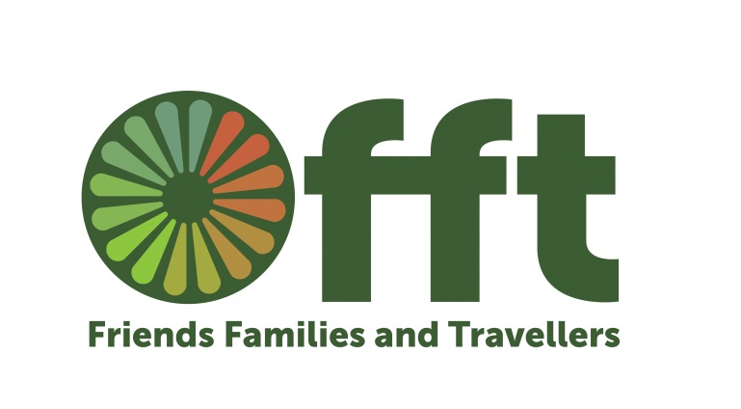
Friends Families & Travellers
Community Base
113 Queens Road
Brighton
BN1 3XG
Telephone: 01273 234 777
Fax: 01273 234 778
www.gypsy-traveller.org
fft@gypsy-traveller.org

Research on the five year supply of deliverable Gypsy and Traveller sites in the South East.
In May and June 2016 Friends, Families and Travellers (FFT) undertook a piece of research to ascertain if local authorities were meeting their requirements under the Department for Communities and Local Government’s (DCLG) Planning Policy for Traveller Sites (PPTS) to identify a supply of specific deliverable sites¹ sufficient to provide 5 years’ worth of sites against their locally set targets. We carried out this research because the government does not currently collect this data centrally.
We asked the following questions, under the Freedom of Information Act, to the 66 local authorities in the South East of England:
- What is the need identified by your authority’s Gypsy and Traveller Accommodation Need Assessment for new pitches, and what period does this GTANA cover?
- What is the figure identified by your authority for its up to date 5 year ‘supply of specific deliverable sites’?
- Please provide copies of the relevant extract of your authority’s Local Plan and/or any other documentation in which the up to date 5 year ‘supply of specific deliverable sites’ is identified.
The research found that:
Only 10 local authorities had identified a 5 year supply of specific deliverable sites.
5 local authorities had no identified need for new sites.
The research found that up to 2033 a total of 1745 additional pitches are needed in the South East of England.
This research clearly highlights the mechanism to ensure more sites for Gypsies and Travellers are provided in the immediate future is not working. In the meanwhile Gypsies and Travellers continue to be evicted from one place to the next. This has a huge impact on Gypsies and Travellers and means families cannot access healthcare, education and other services. These chronically excluded communities become even more vulnerable as a result of the constant cycle of evictions.
FFT recommends that the government monitors compliance with the requirement in PPTS to have a 5 year supply of deliverable sites and acts to ensure the requirement is met.
FFT also recommends that the government re-introduce targets, and a statutory duty to meet the assessed accommodation need of Gypsies and Travellers, as introduced in Wales in March 2016 (section 103 Part 3, Housing (Wales) Act 2014).

In terms of a quick update..

The Housing and Planning Act reached Royal Assent in July – meaning the specific Gypsy and Traveller Accommodation Needs have now been scrapped. There is now a duty to assess the accommodation needs of ‘caravan dwellers’. DCLG have failed to produce the guidance to local authorities on conducting these assessments, this was due out in July and no news, despite asking, when that will be produced. In the meanwhile contracted companies such as ORS are conducting assessments using the new definition which is seeing the identified need for more pitches slashed. You’ve seen our leaflet on this.
We have just conducted research on the 5 year supply of pitches in the South East, attached.

Hate Crime Awareness Week 8th-15th Oct
We will be using this time to promote the reporting of race hate incidents and crimes experienced by the Gypsy and Traveller communities. The True Vision reporting website will be launching it’s dedicated Gypsy and Traveller page on that week.

