Cleaning Materials and Personal Protective Equipment (PPE)

This document is aimed at providing some advice on equipment and cleaning materials to be used by SGBs and venues in the reopening of training spaces.

It is important to remember the overarching public health messages

- Wash your hands regularly
- Clean common surfaces regularly
- Maintain physical distancing as per Scottish Government guidance
- Use face coverings where appropriate
- Isolate and seek testing if you develop COVID-19 symptoms

Cleaning

Personal cleaning

o Access to soap and water to maintain hand hygiene
o Access to alcohol gels (> 60% strength)
o Prominent reminders to wash hands regularly

Space cleaning
o Surface cleaning done regularly during a session
o Common touch points prioritised (e.g. door handles)
o Product must comply with EN 14476 standard
o Use of appropriate PPE during cleaning process
o Examples of products that fulfil these standards
▪ Clinell detergent surface wipes
▪ Response Beta spray

Additional Online Resources related to space cleaning https://www.gov.uk/government/publications/covid-19-decontamination-in-non-
healthcare-settings/covid-19-decontamination-in-non-healthcare-settings

o Daily Symptoms check
▪ NHS Inform website has symptom check facility NHS Inform symptom checker

o Temperature check
▪ Can be done by automated heat tracking technology in certain sites
▪ Can be done by PPE-protected training venue personnel
▪ ISO 80601-2-56:2017 standard applies to the basic safety and essential performance of a clinical thermometer
▪ IEC IEC 80601‑2‑59[4] standard applies to the requirements for screening
thermographs intended to be used for the individual non-invasive human
febrile temperature screening of groups of individual humans under indoor environmental conditions

PPE equipment

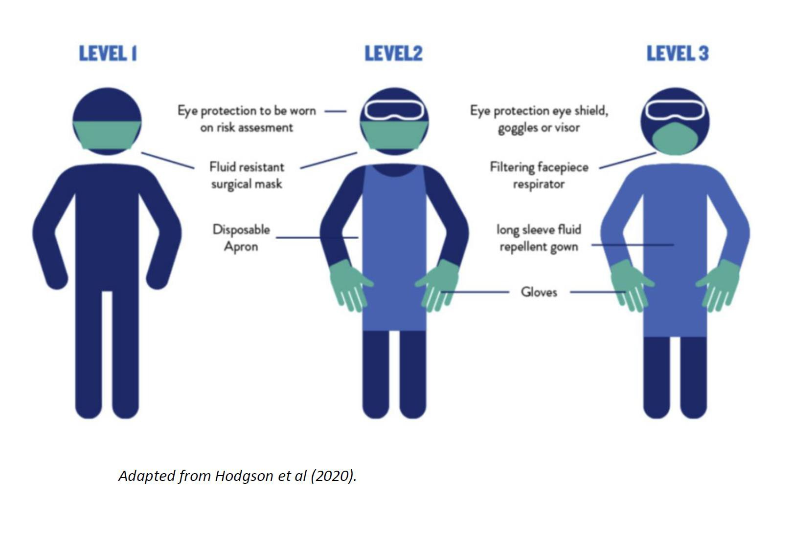

PPE guidance linked to sport role

Role | Outdoor  environment  with less than 2m between athlete  / staff | Outdoor  environment with more than  2m between athlete / staff | Indoor  environment  with less than 2m between athlete  / staff | Indoor  environment with more than 2m between athlete / staff
Clinical  Practitioners | Level 2 | None required | Level 2 | None required
Performance  Practitioners | Level 1 (if no  physical contact | None required | Level 1 (if no  physical contact | None required.  Level 1 if in communal areas
Administration staff | Level 1 | None required | Level 1 | None required
Sports  Coaches | Level 1 (if no  physical contact | None required | Level 1 (if no  physical contact | None required.  Level 1 if in communal areas
Athletes | Level 1 | None required | Level 1 | None required.  Level 1 if in communal areas

Level 3 PPE is reserved for clinical situations or exercise physiology sessions where there is the risk of aerosol generating procedures or emergency medical care.

Recommended sources of PPE and Cleaning Materials

Campbell Medical Supplies (Glasgow)
0141 889 3500

