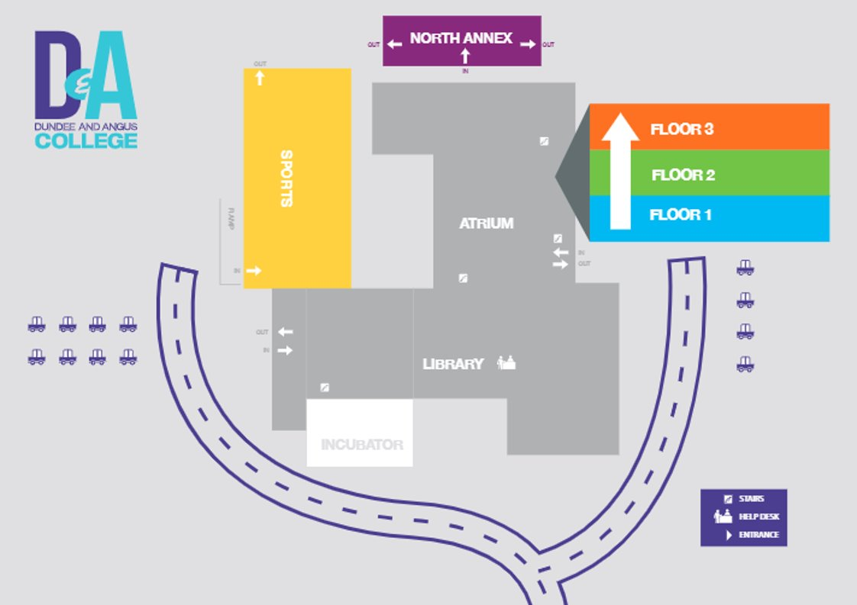

Temperature testing

* All athletes and staff will enter through the ramped entrance directly to the Sports Hall
* All athletes should maintain 2m space between all others inside and outside of the venue
* Players will be required to attend the testing station at the ramp before entering the venue
* All athletes and staff will exit through the fire exits directly connected to the training area