MINI-MAXI-TOERNOOI HOOGLAND INTERNET, 30 DECEMBER 2024
1.
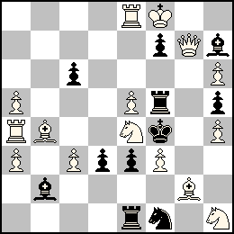
#2 15 + 11
2.
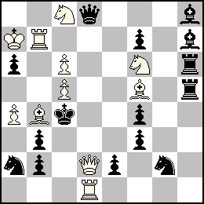
#2 11 + 15
3. 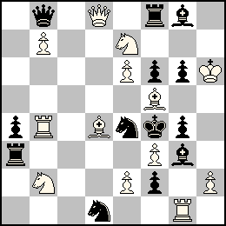
#2 13 + 13
4. 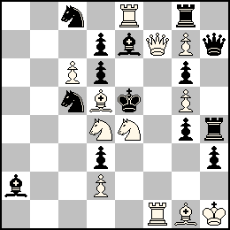
#2 12 + 14
5.
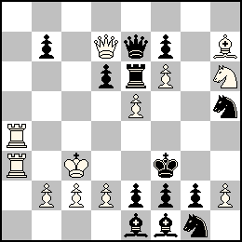
#2 12 + 13
6.
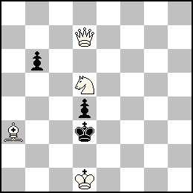
#3 4 + 3

7.
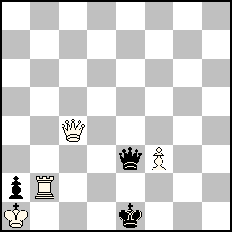
#4 4 + 3
8.
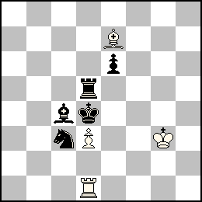
H#2 3 solutions 4 + 5
9.
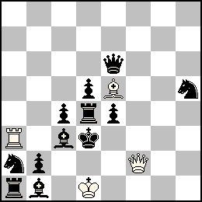Z#2 4 + 12

