
SUPPORT TRUST FOR AFRICA DEVELOPMENT

Tel: +256 (0) 0772485387
Email: stadug.org.gmail.com
Website: www.s-t-a-d.org
Twitter: http://twitter/stad63429022
Abele Cell, Abele Ward
P.O. Box 218, Koboko Municipality
Koboko District, Uganda.

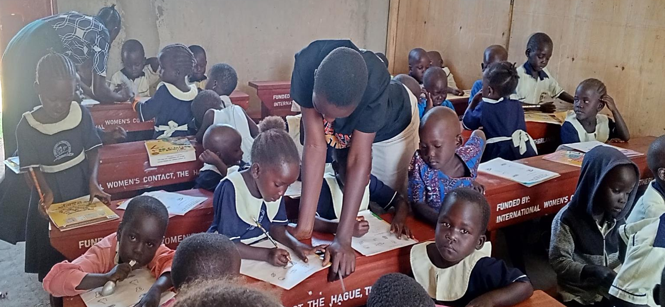
ANNUAL REPORT 2025
Teachers helping learners of top class during a lesson at St.AN&PS
 | Name and Title | Signature
Compiled by: | Data Amule - Program Officer & Education Coordinator | 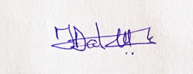
Submitted to: | Florence Andrew ( Executive Director)
Submission date: | 9th Feb 2026

Project overview
This report covers projects implemented between January and December as per STAD’s 2025 Annual Plan, key steps in achieving its five (2025- 2030) years strategic which outlines the main priorities, activities, challenges and recommendations in achieving STAD’s vision and mission of empowering the most vulnerable, disadvantaged and underprivileged groups through community development initiatives for economic and sustainable development self-reliance .
Major interventions and beneficiaries from January to December 2025 were:
SN | Project | Activities | Location (s) | Beneficiaries
1 | Education | Support for refugees & national students Imvepi Senior Secondary School | Imvepi Refugee Settlement, Terego District. | 30
1 | Education | Support for refugees & national urban students | Koboko, Arua, Entebbe and Mukono Districts | 9
1 | Education | Support for St. Andrew Nursery and Primary school (StAN&PS) learners and staff | Ayimini, Degiba Parish, Media sub-county, Koboko District | 205
1 | Education | Constructions of block of 3 classrooms and 2 staff offices - St.AN&PS | Ayimini, Degiba Parish, Media sub-county, Koboko District | 200 learners
1 | Education | Distribution of Jolly Phonics and reading development books donated by Biblionef | Koboko Municipal and District | 16 primary schools
1 | Education | Procurement of furniture and equipment (desks, tables, cupboards, radio, etc.) | Ayimini, Degiba Parish, Media sub-county, Koboko District | 200 learners
1 | Education | Play materials ( merry-go-round, sea saw, swing and slid) St. Andrew Nursery and Primary school | Ayimini, Degiba Parish, Media sub-county, Koboko District | 200 learners
1 | Education | Provision of school materials & a wheel chair to a primary school boy with disabilities | Ogo village, Koboko District | 1
1 | Education | Provisions of school uniforms to StAN&PS | Ayimini, Degiba Parish, Media sub-county, Koboko District | 200 learners
1 | Education | Donor monitoring and evaluation of STAD’s projects by Dr. Debbie Yip | Imvepi Refugee Settlement, Terego & Koboko Districts | Imvepi Students staff, STAN&PS & Community
2 | Capacity building | Lower-class primary school teachers and STAD staff on Jolly Phonics by Learning for all Foundation the Netherlands | Ayimini, Degiba Parish, Media sub-county, Koboko District | 45 teachers
2 | Capacity building | Training of staff and volunteers on Quick books accounting system.  _______________________________  Training the staff and volunteers in monitoring and Evaluation ( M&E)  ___________________________________  Training on parenting education | STAD office, Abele Cell, Koboko municipal  ____________________________  STAD office, Abele Cell, Koboko municipal  ___________________________  Ministry of gender, labour & social development Arua District | 10  ____________  12  3 staff
3 | Well-being & Food Security | Case-by-case support to family with disabilities (PWDs) with food items & medical | GOCU Village, Koboko District | 1
4 | Peace building & Social cohesion | STAD Children Initiative (SCI) Easter & Christmas & Celebrations | Koboko District and Municipal | 985
5 | Personnel, Recruitment | Supporting staff -security guards and a cleaner | Koboko District | 3
6 | Economic & Food security | Cultivation of ground nuts at STAD demonstration farm | Midia sub-county Koboko District

Project methodology
- STAD’s projects implementations involve beneficiary participatory approach right from project initiation, implementation, monitoring and evaluation.
- Use of verification tools to identify vulnerable beneficiaries for education support.
- Use community structures to support STAD’s project implementation.
- Involvement local stakeholders, especially government officials, for approval of project documents
Key activities implemented.
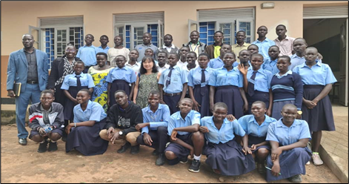
- Education
STAD supported 30 students. Twenty five (25) refuges ( (M-16, F-9) and five ( 5) nationals/ Ugandan (M-3, F-2) students in Imvepi Secondary school with Parents and Teacher Association ( PTA) payments, Exams fee, food items such as beans, maize flour and cooking oil and sanitary pads for the girls. And about nine (9) (M-6, F-3) of the students completed S,4 (ordinary level ) and will join S.5 in 2026. while two (2) male completed S.6 (advanced high school level and will join tertiary institution/University depending on their performance and funds. Guidance and counseling were provided during the termly students verification &t meetings with the school administration.

Dr. Debbie and beneficiaries Imvepi students
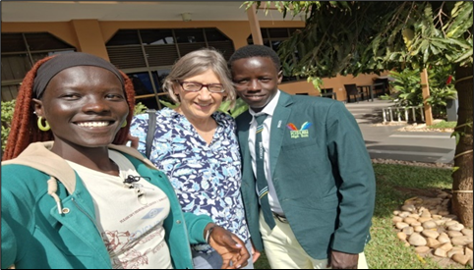
STAD also supported nine (9) urban students in primary, secondary and university Institutions. One (1) male pupil in P.4 with physical disability, three ( 3) (1M, 2F) in Uganda Christian University, one male) in Muni University, four (4) (3M,1F) in various secondary schools. All the 9 urban students were fully supported with school and exams fees, feeding, accommodation, utilities, transport and stationery. The primary pupil with disability was supported also with a wheelchair to facilitate his movements.

Urban students with donor Dr. Jos van Linden

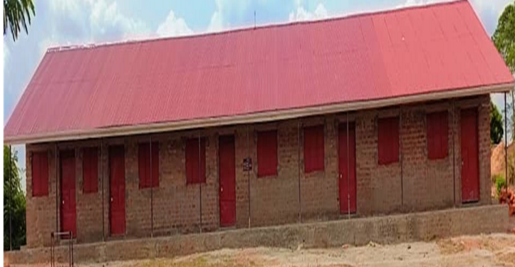
The newly established St. Andrew Nursery and Primary School (STAN&PS) constructed the current one block of three (3) classrooms and two (2) staff offices funded by St. John and St. Philips (STJSTP) Church the Hague. The school had over 200 leaners. STAD anticipates 250- 300 enrollment of learners in year 2026

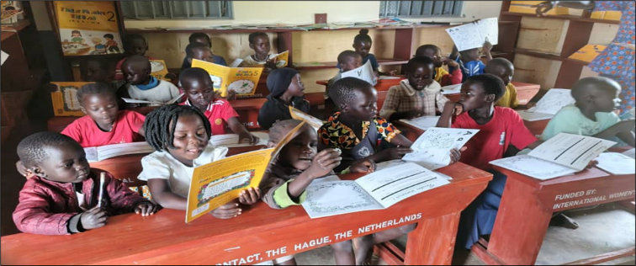
The school is also equipped with about seventy (70) (3-seater desks), even (7) teachers tables and I metallic and wooden cupboards funded by International Women Contacts (IWC), the Hague. The Netherlands providing a conducive learning environment and secure storage of school items. Bookshelves and two tables were procured and the library is fully stocked with varieties of books donated by Bilionef Netherlands.

The school is equipped with play materials - Merry Go round and sea saw balance, funded by “We Play - Foundation, the Hague the providing access to different play materials, to their learning process through play.
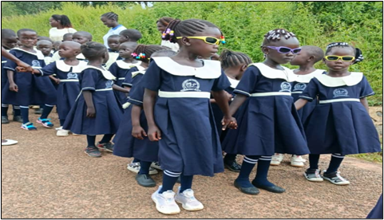
Another most important achievement was the School Uniform Project. With financial support from individual contributions and St. John and St. Phillips Church, the project was triumphantly completed, achieving its core mission of practical support and informaity among the pupils.

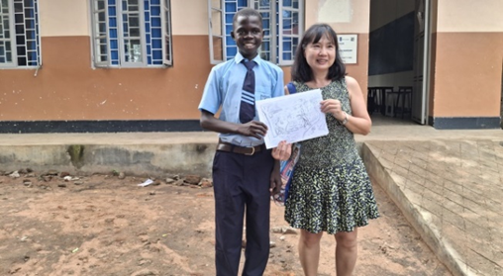
Another significant achievements last year under Education, was Dr. Debbie Yip, one of STAD’s main donors and an Ambassador’s monitoring and evaluation visit in July. Key program activities included meetings with the District and Municipal Government officials in Koboko district, direct engagement and interactions with stakeholders like Office of the Prime Minister (OPM) and Windle International Uganda officials in the Education sector, in Imvepi refugee settlement in Terego District, STAD sponsored students/ beneficiaries in higher institutions of learning and in Imvepi refugee settlement, inspection of STAD’s projects and assets.

- Capacity Building
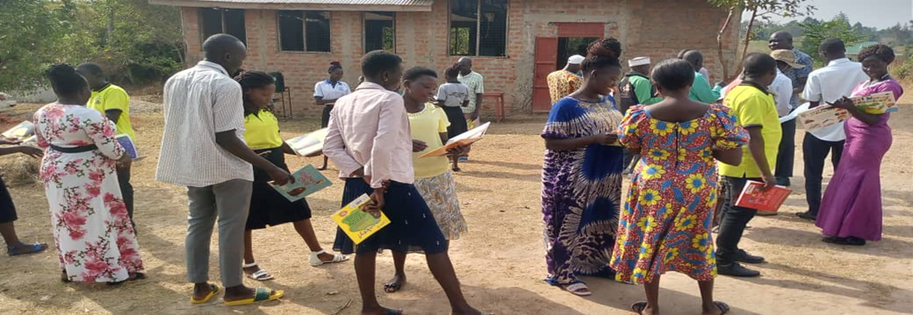
STAD in partnership with Biblionef and Learning for All Foundation organized a two (2) days training for forty five (45) from ten (10 )selected primary schools lower and upper classes teachers in Koboko Municipal. This was second training on Jolly Phonics and reading development funded by Biblionef and facilitated by Ineke Bloemendal of “ Learning for All Foundation” The Netherlands. The main of the training was to provide teachers with modern pedagogy, promote and foster culture of collaborative teaching teachers and introduce new educational resources tools to improve literacy and reading development skills for children.
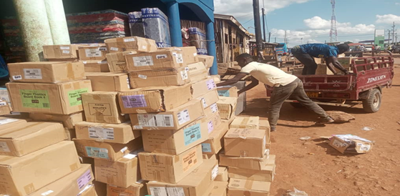
The training was followed by distribution of over 8,912 assorted text books to sixteen (16) primary schools with 557 pcs) within Koboko municipal and District. STAD’s library at school is fully used by the learners during reading time guided by the caregivers and the librarian. STAD plans to lobby more books to cater for all classes and ages and make it accessible to other schools and the public. A follow up visits were made to the schools, beneficiaries of the books to assess and monitor the usage of the books and if the trained teachers were supporting the children in developing reading skills. About 70% of the learners from the schools visited were using the books and supported by the teachers. Hence there is high hope of improved academic performances of those schools in two years or by 2027.
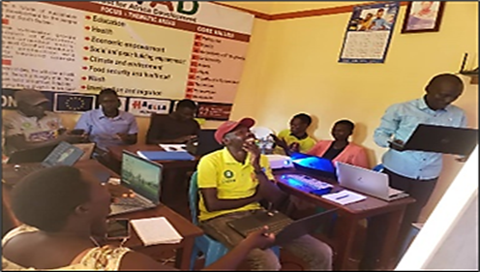
Organized capacity building training on QuickBooks accounting software system strengthen the capacity of the Staff on financial management among others. About 12 staff regardless of their financial backgrounds and positions benefited from this training . The accountant now uses the new accounting software which makes it easy to track financial records.

Three (3) STAD staff benefited from training on parenting education organized by Ministry of gender, labour and social development in Arua for Refugee led organization (RLO) and Community based organization (CBO) from West Nile Region. STAD will implement a one year project on parenting education targeting 500 nationals and refugee parents in 2026.
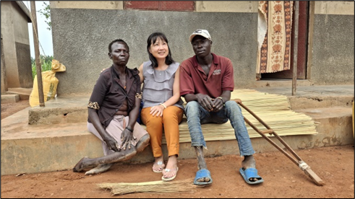
- Well-being & Food Security support for vulnerable individuals
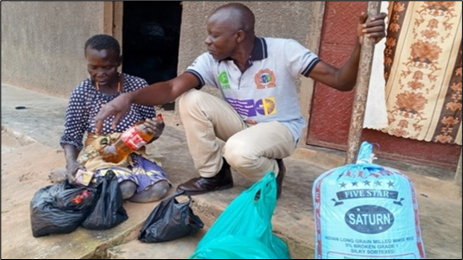
STAD has been supporting Ms. Bako Ariye, whose family all have disabilities (PWD) since 2019 with food and non -food items funded by Dr. Debbie Yip from Singapore. A livelihood strategy meant to improve her well-being and sustainability purposes was set up. Follow-ups and monitoring conducted by the staff showed that the five of 5 goats and the chicken died due to diseases outbreaks. The other challenge is lack of sufficient piece of land for cultivating more crops. However, the house and the solar power installed in house are functioning well.
- Peace building for Social cohesion.
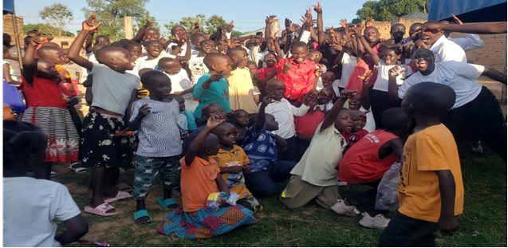
STAD organizes Children's Initiative (SCI) annually, with the aim of creating awareness within the community with focus on promoting peaceful co-existence among and between refugee and host community. The 2025 Easter Children's Initiative celebration was held at STAD’s office with the theme: “Hope renewed. Extend God’s love to others.” The theme focused primarily on hope, renewal and joy that comes with the gospel of resurrection of Jesus Christ embodying the victory of life over death. Over 488 participants mainly children were reached. STAD’s Children Initiative Christmas 2025 Celebration was held at Atuneta Orphanage centre under the theme “Nurturing God fearing future leaders “Be brave together” (Bishop Mariann Budde) - A clear cry for “Social Cohesion and Peace in a world where many children are orphans, unsure of the future. They all need communal spaces where they can draw strength and courage and not have to face the unknown alone. Over 407 participants mainly children were reached. The children’s initiative program successfully reached over 985 beneficiaries .

- Recruitment of Personnel
STAD recruited two (2) more security guards and a cleaner. The security guards were provided with gumboots, touches, bows and arrows and rain coats while cleaner was provided with gloves and facemasks.
- Economic Empowerment & Food security
STAD has rented a piece of land to establish gardening farm used to demonstrate/train the local farmers , children with the most sustainable farming practices and through awareness raising for sustainable agricultural practices and environmental protection. STAD planted some ground nuts due to late planting and changes in the weather, one bag of groundnuts was secured .
7.0 Other activities implemented.
7.1 STAD bought one motor bike . The acquisition of the 2nd motor cycle has eased movement to the field especially to Imvepi Refugee settlement to monitor students and handling of multiple activities . Nevertheless, a major challenge still remains - the termly transportation of food items to Imvepi Secondary School, monitoring and attending stakeholders meetings especially during rainy season. Hiring bikes and cars are very costly and thus affect budget lines and STAD’s active participation in stakeholder meetings.
7.2 Partitioning of the main hall to create more rooms for learning when primary one was added that require a separate classroom. In 2024, all the children were lumped together in the community hall irrespective of their ages and levels. But as the number of children kept growing, there was need to create more classrooms to accommodate the children according to their ages and levels for ease teaching.
7.3 The community participated in preparing soil for laying 25,000 bricks for construction of one block of a VIP latrine four (4) stances. The school currently has one latrine block with 3 stances used by all the learners, teachers and others. Thus, the need for one block of a latrine with 4 stances for the learners. The work is done collectively by both women and men as seen in the picture. Women participate in all school activities more than men.
7.4 St. Andrew Nursery & Primary school successfully participated in the sixty-three (63) Ugandan Independence celebration through marching, reciting poems and riddles. As a newly established new school, their participation though shocked the public but helped advertise and market the school in the sub-county.
Achievements
- Successfully paid the termly school fees and procured food and non-food items for the thirty (30) STAD supported students in Imvepi Senior Secondary supported by supported solely by Dr. Debbie.
- Successfully paid school fees and other requirements for the nine ( 9) urban students in the various learning institutions (primary, secondary and university) supported by various donors .
- One of the three (3) former Mvara science students joined Muni University as an ICT student.
- Successfully built three classrooms and two staff offices funded by STJ&STP Church the Hague providing a proper and healthy learning environment.
- Procured seventy (70) desks, seven (7) tables, one metallic and one wooden cupboards, blackboards, and a radio for StAN&PS funded by International Women Contact (IWC) the Hague, the Netherlands.
- Procured and installed play materials funded by WE PLAY Foundation, the Hague the Netherlands enriching children’s learning through playing.
- In partnership with Biblionef trained forty-five (45) lower primary teachers on jolly phonics and language development funded by Biblionef Netherlands.
- Distributed eight thousand nine hundred twelve (8,912) books donated by Biblionef to sixteen (16) primary schools in Koboko municipal and District, respectively.
- Successfully organized STAD Children Initiatives (SCI) Easter and Christmas celebrations with main of peace building and social cohesion among and between refugees and host community. About 985 people were reached, respectively.
- STAD staff were trained in Quick books accounting system and monitoring and Evaluation ( M&E) and parenting education to improve and build their capacities in implementing activities/ projects.
- Two (2) security guards and one cleaner were recruited, respectively.
- Provided continuous monitoring support to Bako Ariye (PWDs) with food & non-food items with funding from Dr. Debbie,.
- St. Andrew Nursery & Primary school successfully participated in the sixty-three (63) Ugandan Independence anniversary celebration.
Challenges Faced During Projects Implementations
- Low monitoring and Evaluation of Imvepi students due to long distances and bad roads during heavy rain periods..
- Constant increment in school requirement resulted to reduction of Imvepi SS supported students from 50 to 30 students only.
- Delay by the engineer in approving construction site plan from the district.
- Low male participation in most of the community meetings and engagements in Ayimini.
- Lack of structural funds to pay staff salaries resulting to staff and volunteer turnover.
- The concept of community ownership is not fully understood and embraced by majority of the men in the community.
- Lack of long term donors and depends on one off donations hence sustainability of the projects is not guaranteed eventually.
Recommendations
- Need to lobby for a better means of transport to easy implementation of projects.
- Engage in local fundraising drives to enable sustainability of the organization.
- Lobby for projects at the local government ear marked for community schools.
- Lobby for structural funds to facilitate staff salaries for effective implementation of projects.
- Distributions of RFQs to many service providers to create competitive negotiations, sensitization on Value Added Tax (VAT) and withholding taxes paid by the organization to URA.
- Continuous awareness raising & capacity building especially of the men & youth to improve their active engagements &participation for sustainability of the community led &owned projects.
Planned activities for 2026.
- Installation of solar power at St. Andrew Nursery and Primary School.
- Plastering and painting the constructed school block.
- Construction of one block of a latrine with 4 stances for girls and female teachers.
- Verification and school requirements payments for Imvepi SS and the urban students.
- Implementation of parenting education project targeting 500 parents in Abele village in Municipal and Ayimini Village in Midia sub-county
- Procurement and installation of more play materials
- Laying 25,000 bricks by the community for construction of a latrine and classroom block.
- Election of a new CMC and PTA members for the school management
- Review of the updated constitution and other policy documents and Annual plan for 2026
- Registration of STAD with the new name: Source Transcend Advocacy for Development – (STAD -F) Foundation at the district and Municipal levels.
- Building ramps & steps in the classroom block to provide easy accessibility by people with disabilities

Conclusion
Despite the challenges, especially of limited funds to implement the activities planned for in the annual plan 2025, STAD registered numerous success as outlined in this report. However, these registered successes continues teamwork, and involvement and strive together stakeholders efforts to ensure successful implementation of the thematic interventions outlined in its five (5) years strategic plan. STAD management and the beneficiaries extend sincere gratitude to all their stakeholders, donors and well-wishers for their generous support and instilling hope and courage above in instilled hope among many vulnerable, disadvantaged or underprivileged children and community.

Some Success Stories
My name is Yakani Robert. I am 23 years and an old beneficiary of STAD in Imvepi SS. Honestly, I am thrilled to be supported by STAD who enabled me to complete O level (S.4) this year 2025. I would not have reached this far without your tirelessly guidance and support. My words are not enough to show my deepest gratitude to STAD, especially to our beloved donor Dr.Debbie. Thank you so much for resurrecting my dream and hope. I also thank the staff of STAD especially Alex Jangara, the Education Officer and the team, for your guidance and support that enabled me to complete my O level. I have started seeing my dream come true and I pray that God opens doors to our donor and all STAD staff so that many who are needy are also supported. I will forever remember STAD wherever I go as the light of my life.
My Name is Minisale Elizabeth. I am 16 years old and in senior three (3). I can attest to the life changing impact of STAD's support. In S1 and S2, the school dues were affordable, and it became easier for me since am the one paying my school fees, but when we resumed this year, it became hard to me as an orphan, I lost hope and even thought of dropping out of school because things were really hell on my side and the worst part of it was that my follower also joined senior one. It wasn't easy to resist the stress that came my way and lost hope. But things changed when I was called for an interview by STAD. I couldn't believe that among the blind, I became the one eyed girl , because so many students wanted that support, but they failed to get the chance. After joining the STAD family, I ranked myself the luckiest person on earth, and to be honest with the support of STAD, dreams seemed achievable all of a sudden

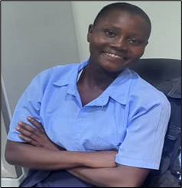

Yakani Robert & Minisale Elizabeth- STAD beneficiaries.
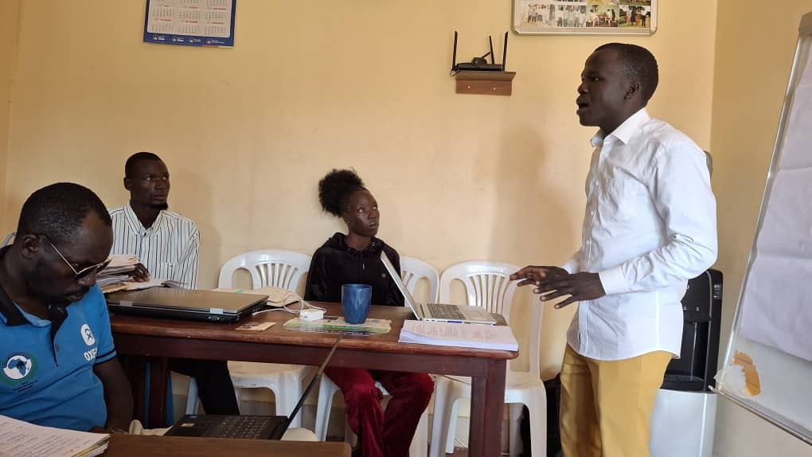
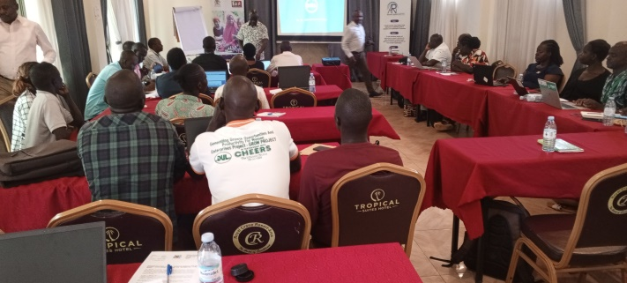

Staff trained on in M&E STAD staff trained on parenting education
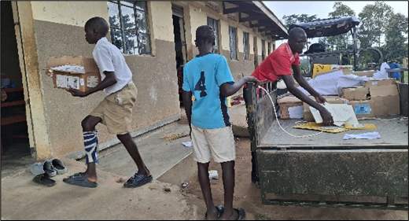
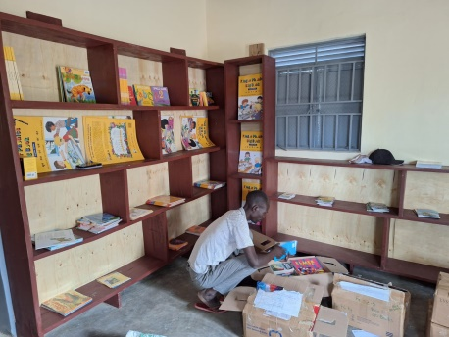

Birijaku P/S receiving Biblionef books from STAD Librarian arranging books at St.AN&PS
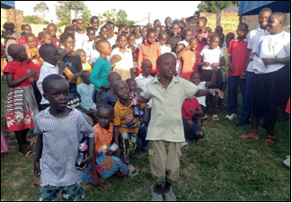
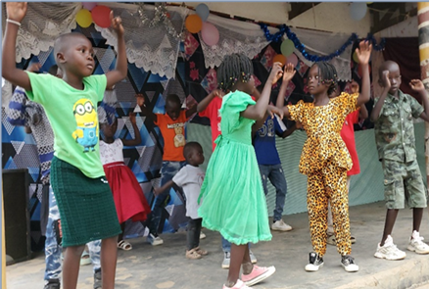
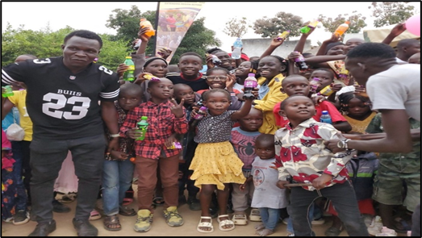
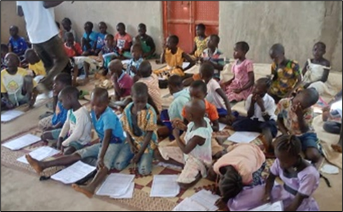
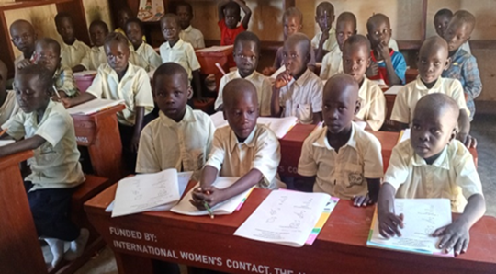
STAD’s children’s initiative Christmas & Easter celebrations
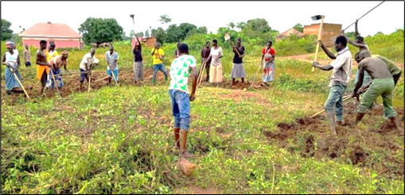
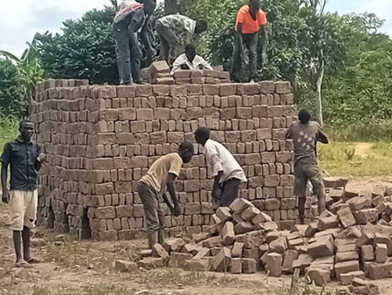
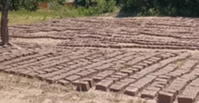
Before the desks After the new desks

Community digging soil for brick laying


Compiled and presented by

Data Amule
Program office and Education Coordinator
STAD

