Equatorial Women Organization (EWO)

E-Mail: kubako78@yahoo.com / ewosdug@gmail.com / kubakojohn@gmail.com

HQS Yei Southern Sudan & Koboko Uganda

(+211922306580 / +256773687541 )

What’s App +256 773687541
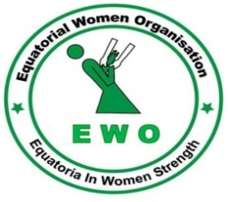

EWO is an Organization for local women NGOs formed on the 9th July, 2003 in a conference held in Yei, attended by over 300 women representatives from greater Equatoria region in South Sudan and the Diaspora as a National Organization fully registered by south Sudan Government under the ministry of foreign affairs in 2007 with registration NO: 160 AND in 2017 incorporated in Uganda by Uganda NGO Board with It is an indigenous, nongovernmental and nonprofit making Organization which seeks to promote human right with focus on women’s right, women participation in governance, access to information on basic services like health, water, education, gender related issues, food security and improved livelihood, institution capacity development of its coordination branches, Rule of law and access to justice, relief and recovery support, in the community of which has to be enacted through effective and efficient collaboration and coordination with Donors, CSOs/NGO and other stakeholders working on related focus for sustained response to Women empowerment.
++++++++++++++++++++++++++++++++++++++++++++++++++++++++++++++++++++++++++++++++++++++++++++++++++++++++++++++++++
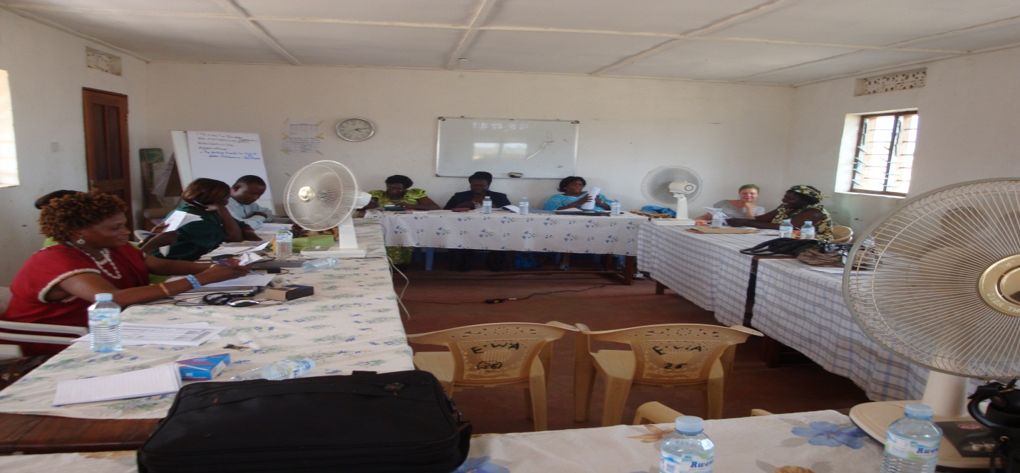
EWO GENERAL ASSEMBLY MEETING

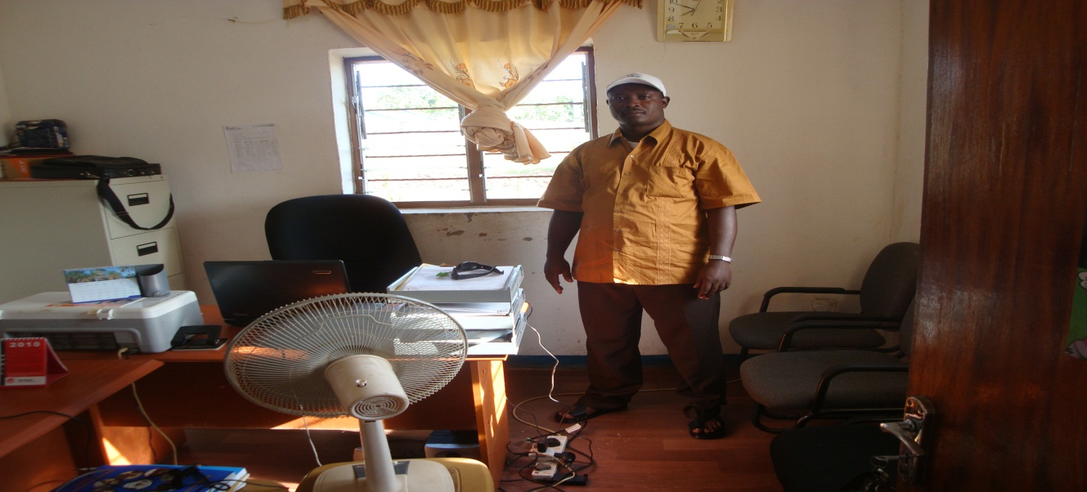
EWO HEAD OFFICE SOUTH YEI SUDAN

INTRODUCTION
EWO is an Organization for local women NGOs formed on the 9th July, 2003 in a conference held in Yei, attended by over 300 women representatives from greater Equatoria region in South Sudan and the Diaspora as a National Organization fully registered by south Sudan Government under the ministry of foreign affairs in 2007 with registration NO: 160 AND in 2017 incorporated in Uganda by Uganda NGO Board with It is an indigenous, nongovernmental and nonprofit making Organization which seeks to promote human right with focus on women’s right, women participation in governance, access to information on basic services like health, water, education, gender related issues, food security and improved livelihood, institution capacity development of its coordination branches, Rule of law and access to justice, relief and recovery support, in the community of which has to be enacted through effective and efficient collaboration and coordination with Donors, CSOs/NGO and other stakeholders working on related focus for sustained response to Women empowerment.

OUR PHILOSOPHY
The worldview of EWO hinges on the premise that any investment in the women is an investment for the nation. We believe that empowering women is advancement to building a firm foundation for positive change and society growth. EWO contributes to humanity by supporting initiatives with all partners and actors that are committed to peace and development. EWO aspires towards fair, just, equal, inclusive and sustainable positive change.

VISION:
A society where both women and men are regarded as equals with full rights as human beings under all circumstances of life.

MISSION:
Equatoria women organization strives to strengthen the capacity of its women to play a central role in good governance and development through their mobilization to work under one umbrella in both South Sudan and Uganda respectively.

OBJECTIVE OF EWO:

- To strengthen the unity of all women in diversity to understand the concept of human rights as women rights and which must be demonstrated in their ability to equally involve in community decision making and other related developmental affairs in South Sudan and Uganda
- To build the capacity of women to acquire knowledge and skills that can enable them to fully understand their duty right and obligation as citizens of the country in support of their government in terms participating in good governance.
- To ensure that there is Gender equality in all aspect of life among people of south Sudan and Uganda which has to be referred to as a society where both women and men are regarded as equals without any kind of discrimination
- To ensure that there is increased access to information by women so as to provide favorable conditions for their levels of participation in community good governance.
- To empower women to actively be involved in effective business enterprises for undertaking productive cooperative and business ventures

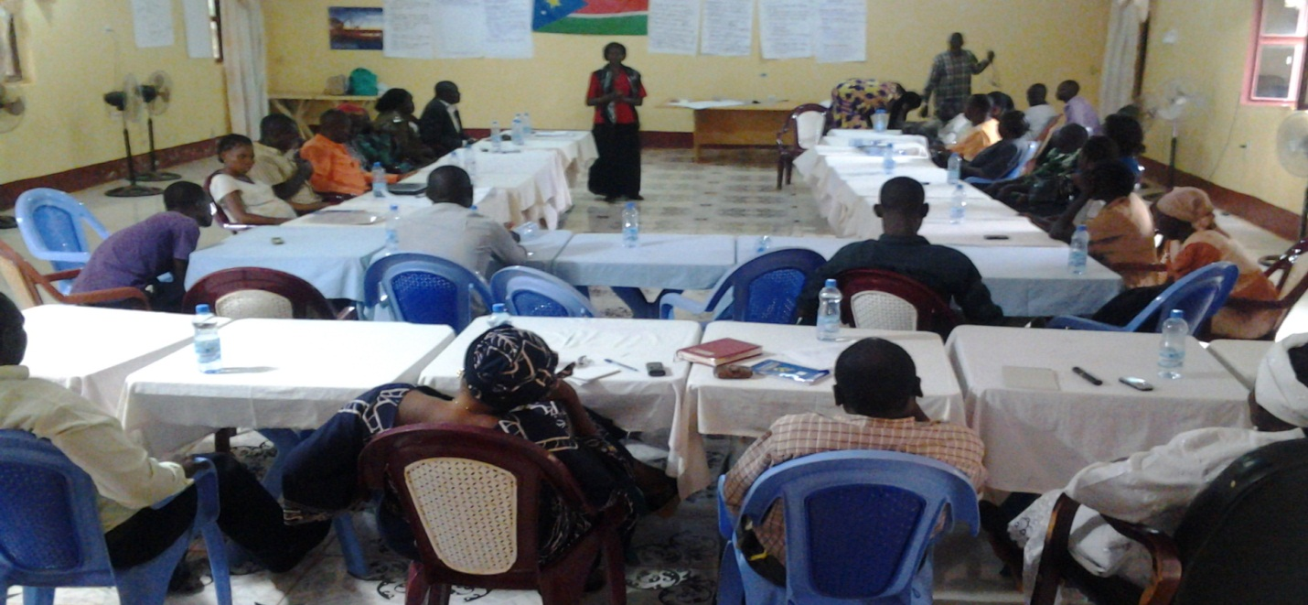
EWO Human right and Gender Training at EWO main Hall YEI
CORE VALUES

- Transparency and accountability
- Honesty C. Self-development
- Equality and Caring
- Unity and Solidarity
- Humility and Respect
- Integrity
- Creativity and Innovative thinking.

THEMATIC AREAS OF FOCUS
EWO promote, Empower women & Community in:
- Human rights and gender
- Psycho-social support to survivors of GBV
- Equal participation in governance
- Implementation of the UNSCR 1325 in both south Sudan and Uganda
- Access to information on basic health services issues (Water & Sanitation)
- Education with focus on civic education and adult learning engagement
- Rule of law and access to justice
- Food security/relief support
- Advocacy & lobby
- Improved livelihood program for youth and vulnerable group in the community
- And institutional capacity enhancement for our coordination offices in the three states of equatorial region and Uganda
This is through ensuring effective and efficient collaboration, coordination with CSOs/NGOs, donors and stakeholders working on related focus for sustained response to women empowerment.
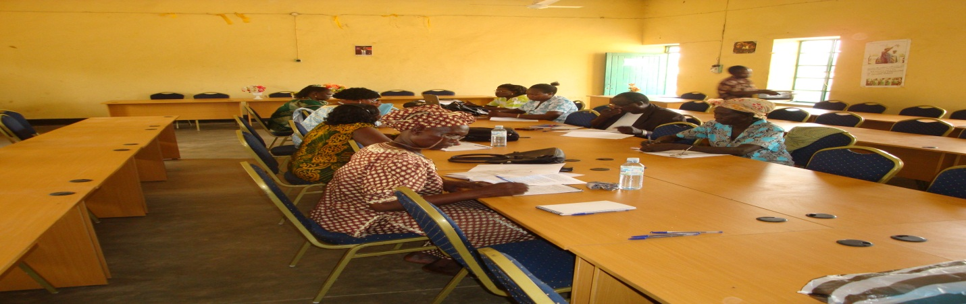

EWO BOARD MEETING IN JUBA
The Organization has seven Board members four female Board members and 3 male Board members and is supposed to be meeting annually for their board meetings.

STRENGTH
- NGO recognition in both south Sudan and Uganda by legal Authority
- Our presence in all our operational areas
- Recognition by supporting donors
- Recognition of our work by the community
- Our ability to deliver the community required services
- The available Board for the Organization
- Long period of serving in the community as a civil society organization 14 years
- A member of a civil society network both south Sudan and Uganda

WEAKNESS

- Much as we have our presence in all our operational areas, some other parts within this areas are not yet covered due to Lack of enough financial
- Lack of funding for some other un funded programs from our Thematic areas of focus
- High levels of staff turnover due to lack of long term project funding
- Voluntary work constraints
- Lack of website
- Lack of sustainable independent source of funding as an alternative source of funding means

OPPORTUNITIES

- Operation as a Legal entity in both Countries
- Some Support from the donors
- Ability to have offices in both operational areas
- Good relationship with donors and government
- Community willingness to support our program
- Committed organization management team
- A civil Society network member.

THREAT

- High level of staff turnover due voluntary service
- Lack of long term projects and Withdrawal of donors after short funded projects
- Insecurity situation in some countries like south Sudan
- Funding problem
- Staff sustainability challenge

EWO MEMATHIC AREAS:
- Human Rights and Gender
- Rule of Law and access to Justice
- Education (Adult Literacy and Civic Education)
- Health ( HIV/AIDS and Maternal health care and WASH)
- Livelihood / Relief support
- Advocacy and Lobbying
- Conflict and peace building program
- Governance / Institutional Capacity enhancement

METHODS OF IMPLEMENTATION
- Awareness raising and Sensitization activities
- Workshop / training program
- Dialogues, Meetings, discussions and Interviews
- Public lectures
- Registration and Distribution
- Women group networking and Mobilization
- Project development and Management

THE ROLE OF EWA IN THE SOCIETY

EWO is obliged to strengthen the unity of Women in diversity to understand their duty rights and obligations to participate in political decision making on national developmental affairs. We facilitate women to fully participate and play central role in good governance of their nation.

EWO tries to increased access to information through basic learning process by women to promote conditions favourable for increased women participation in community good governance, Capacity building of women groups together with monitoring and evaluation of activities to ensure effectiveness and efficiency in their program implementation (institutional and Organizational Development of Women’s groups in South Sudan and Uganda operational areas) , Also EWO empowers Equatorial women enterprises to effectively participate in undertaking productive cooperative and business ventures plus Registration together with data collection on the situation of women in the states and lobby for support to address their situations.

OUR ACHIEVEMENTS

The works of EWO over the years have resulted in several life-transformation moments for women and this is demonstrated in the community ability to start despite the negative culture and traditional norms allow women equal opportunities in terms of rights. The Strategic plan/framework for women development and participation in good governance in South Sudan and now to follow the same approach in Uganda.

EWO ability to Organize a conference in 2004 which brought about a total of 300 women and men both from within and outside South Sudan for discussing issues affecting women in the greater Equatorial region, EWO contributes to humanity by supporting initiatives with all partners and other actors efforts that contributes towards peace building and development.

EWO aspires for peaceful co-existence, fair, just, equal, inclusive and sustainable positive change and by so doing trained women leaders in various aspects of life-skills, leadership, management and income generation activities, EWO has also been able to ensure mobilization of women in the region to get united and work together advocating for their rights and in south Sudan Acquired a piece of land and constructed an office premises and resource center.

EWO has maintained good working relations with donors like CHRISTIAN AID Human right and Gender project, MS SUDAN Civic education project, UNDP civic education project, OXFAM NOVIB Human right and governance project, WORLD FOOD PROGRAMME relief project, GIZ Gender based violence project, and FHI HIV/AIDS Project, ICCO on 1325 UNSCR Project, NUFFIC support for Institutional Capacity development, DRC office extension support, EU Governance project and government based convincing records.
Equally, we have worked with other local NGOs as well as liaised with the secretariat for women, gender and child welfare in the government ministries wherever we work, also empowered more than 5000 women and 3000 men and reached many through the media coverage and has achieved high reputation as a reliable organization mobilizing women to involve in the development of South Sudan.

Organization Donors

Since 2003 to date, EWO has worked with different partner organizations or donors coordinating different program among whom were Christian Aid, OXFAM NOVIB, NPA, UNDP, MS South Sudan, FHI, NUFFIC, DRC, GTZ, Cord-Aid, STAD, OSIEA, ICCO, EU, Plan International and PAX with Funding from Dutch Ministry of foreign Affairs
OPERATIONAL AREAS
EWO has its main Office in Yei, with its Sub-office in Koboko Uganda targeting west Nile Region Refugees & Host community support, Plus south Sudan Coordination offices; one in Western Equatorial states for the whole of Gbudueh, Tombura and Maridi states and second coordination Office in Eastern Equatorial for the whole of Lomulunyang and Imatong states respectively. So far our activities have reached all this state’s although at a very small pace in other state
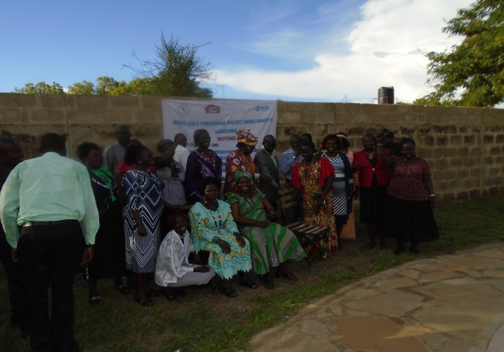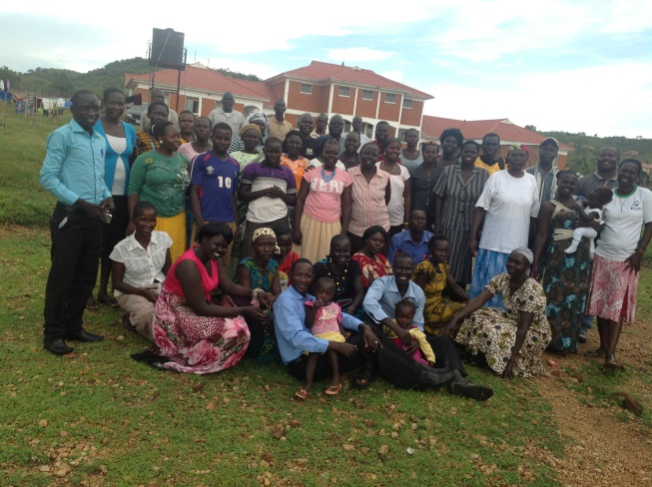
LAUNCH THE UNSCR 1325 IN TORIT IMATONG STATE SOUTH SUDAN IN 2016 -2018
In Uganda Equatoria Women organization is targeting supporting the refugees in the refugee camps focusing on some areas of conflict like, Relief, WASH, Human right and gender related issues, conflict and peace building program, Psycho-social support to make work on Gender based violence a complete cycle. The attached are the current major challenges faced in terms of water for survival and Domestic violence in the camps of Bidibidi, Rhino camp and envepi respectively, looking at this situation and back in south Sudan, as a women organization, we need to extend our support to our suffering women through support from other willing women support organization and other organization who work on our related areas of focus
EWO MANAGEMENT

