
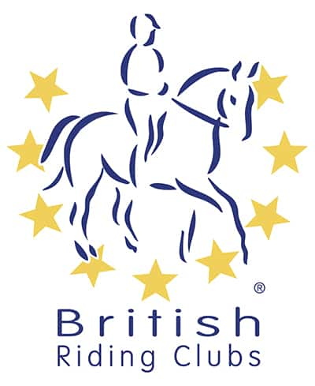
BRC AREA 17
Winter
Show Jumping Qualifier
WITH OPEN SECTIONS FOR ALL
organised by New Forest Riding Club
Section A of each class at this event are Area qualifiers for the BRC Winter Showjumping Championships at Arena UK on 5-6 of April 2025

Saturday 22nd February 2025
at
Crofton Manor Equestrian Centre, Stubbington, Fareham. PO14 3EW

Official Steward: Penny Towers
Course Builder: Zoe Pyatt
Paramedic: Collingwood
Photographer: Simply Event Photos
Vet on Call
Catering: Crofton

ORGANISER and ENTRIES SECRETARY:
Amy Robbins
07803537369 (after 6pm only)
amy.robbins@hotmail.co.uk

PRELIM entries to BRC for qualifying sections close on Friday 31st January via the online portal: British Riding Clubs - Login (bhs.org.uk)
AREA and open entries close Friday 14th February via MyRidingLife
NFRC Open and Area 17 Showjumping Qualifier - Driven by MyRidingLife

Times will be emailed to Team Managers and will be available on the
Area 17 website by 7pm Thursday 20th February
http://www.area17-brc.org.uk/
Course walk, warm up and start times will be clearly stated when the rider times are published

Passport copies of all horses in qualifying classes must be up to date and held on the Area 17 Database by entry closing date. Flu vaccination record must comply with the 2025 updated policy in section G7.1 of the handbook, currently only needing annual vaccinations (plus the initial three). This will be checked to ensure that each horse is on the shared drive and accepted by 31st January 2025
PLEASE REMOVE AND TAKE HOME ANY LITTER AND ALL DROPPINGS/HAY LEFT BY YOUR HORSE AROUND YOUR VEHICLE

Schedule
All competitors will jump one round (SJ1.0.1: QUALIFIER FORMAT - Option 1- 1 round following straight onto a jump-off, with all competitors going forward to the jump-off section.). Heights will run consecutively to allow competitors to enter two heights on the same horse if they wish (full rule below). All classes to run inside, warm up outside.

Class 1 |  | 60cm MIXED TEAMS
Section A |  | Qualifying Junior or Senior competitors (mixed class)
Section B |  | Non-Qualifying open  Qualifying teams are either junior or senior, no combinations
 |  | Entry Fee £60 Team, £15.00 individual.
Class 2 |  | 70cm JUNIOR & SENIOR CLASSES
Section A |  | Qualifying Junior or Senior competitors
Section B |  | Non-Qualifying open
Qualifying teams are either junior or senior, no combinations.
Entry Fee £60 Team, £15.00 individual.
Class 3 |  | 80cm JUNIOR & SENIOR CLASSES
Section A |  | Qualifying Junior or Senior competitors
Section B |  | Non-Qualifying open
Qualifying teams are either junior or senior, no combinations.
Entry Fee £60 Team, £15.00 individual.
Class 4 |  | 90cm MIXED TEAMS
Section A |  | Qualifying Junior or Senior competitors (mixed class)
Section B |  | Non-Qualifying open
Qualifying teams are either junior or senior, no combinations.
Entry Fee £60 Team, £15.00 individual.
Class 5 |  | 100cm MIXED TEAMS
Section A |  | Qualifying Junior or Senior competitors (mixed class)
Section B |  | Non-Qualifying open
Qualifying teams may be any combination of seniors or juniors
Entry Fee £60 Team, £15.00 individual.
Teams must either be all in Section A or all in Section B – There can be no mix of qualifying/non-qualifying members within the same team. MUST STATE SECTION ON MY RIDING LIFE.
When you enter via “MY RIDING LIFE” please ensure that in the COMMENTS BOX you put PURBECK TEAM & either SRN or JRN
Please let Bob Mael know what classes you have entered and your horse’s passport name email :- r.mael@btinternet.com
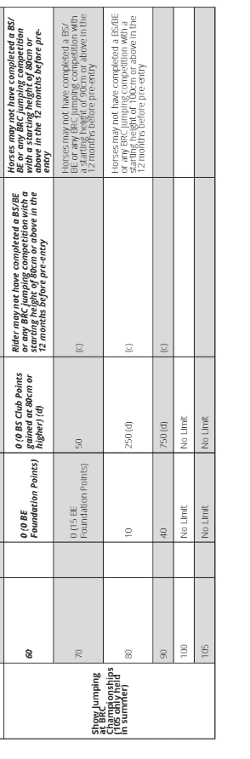
ELIGIBILITY REQUIREMENTS – ONLY APPLIES TO SECTION A

“HORSES BEING USE TWICE” in SHOWJUMPING
Refer to CR Appendix 3, page 100 of the BRC 2025 Handbook under Show Jumping.
A horse may now compete at consecutive heights in Show jumping, (For Example NOT 80 & then 100)
- 60 and 70
- 70 and 80
- 80 and 90
- 90 and 100
Horses may only compete TWICE in show jumping classes. Horses may compete in teams OR as an individual in each height. Horses can only compete ONCE at a height except for a senior and junior sharing a horse at a competition.

TACK CHECK
All riders should present to the Tack Check Steward a minimum of 20 minutes before their time. It is the responsibility of the rider to ensure their tack and equipment conform to the rules. Full details are in the current BRC Handbook.

COMPETITOR NUMBERS
Competitors must provide their own back number or within a number bib clearly displayed on the back of the rider.

HELPERS
Each participating Club entering a team or multiple teams will be required to provide names and contact details of 1 helper (full day) or two helpers (half day). The Relevant form will be sent to each participating Club and must be returned with the area entry form.

ENTRIES
PRELIM entries to BRC for qualifying sections close on Friday 31st January via the online portal:- British Riding Clubs - Login (bhs.org.uk)
AREA and open entries close Friday 14th February entry forms found attached completed via MY RIDING LIFE
NFRC Open and Area 17 Showjumping Qualifier - Driven by MyRidingLife

SUBSTITUTIONS
In the event of withdrawals, substitutions will be allowed. The deadline for complex substitutions will by 12pm Thursday 20th February. Late simple substitutions, can be made in writing up until 21st February, an on the day change should be verbalised on the day but substitution horses must have PASSED the passport check. A complex substitution is one where teams are re-arranged, or horse and rider combinations are moved from one team to another. Simple ones are where a horse and/or rider replace(s) the withdrawn one in the same team and position.
RULES

Dogs must be kept on short leads and under close control at all times.

This competition will be run in accordance with the official rules for all British Riding Club Competitions 2025. Area 17, New Forest Riding Club, and persons acting on their behalf, do not accept any liability for any loss, accident or damage to any person, animal, vehicle or goods occurring in connection with this event. It is a condition of entry that each competitor indemnifies the organiser against any claim.

To qualify for the relevant British Riding Club Championships, entries must be made through clubs on the official forms.
Competitors only are allowed to ride their horse on the showground. Everyone mounted must wear a hard hat with the harness adjusted and fastened.
Under BRC rules, any rider who has a fall from their horse anywhere on the showground must see the paramedic before remounting and follow their instructions. The paramedics decision is final. Any breach of this rule will be reported to the Official Steward. Team managers are responsible for making sure all riders understand and accept this rule.

The Passport/Vaccination Certificate must, under penalty of elimination, accompany the horse to all official competitions. The competitor is responsible for producing it on demand.

The Organisers of this competition have taken reasonable precautions to ensure the health and safety of everyone present. For these measures to be effective everyone must obey the instructions of the Organisers, Officials and Stewards and take all reasonable precautions to avoid and prevent accidents occurring. A Paramedic will be available, and the event will be run in line with BRC First Aid Rules.
It is a condition of entry that neither the Organisers nor Landowners nor their agents shall be held responsible for any loss, injury, damage to competitors, onlookers, their property, horses or ponies, howsoever caused.
The Organisers reserve the right to cancel the event, alter classes, judges, times or any other published information. In the event of cancellation, a proportion of entry fees will be retained for administration purposes.
No refund for withdrawals after entries close, open section have the option to Transfer to another NFRC event.
Protective headwear for all classes must comply with BRC rules 2025. All competitors in the qualifying classes must ensure their hat has been tagged by the Official Steward and carries the PINK tag. Accepted hat standards:
