**RESIDENTIAL FIELD EXCURSION**

**(included with all course choices)**

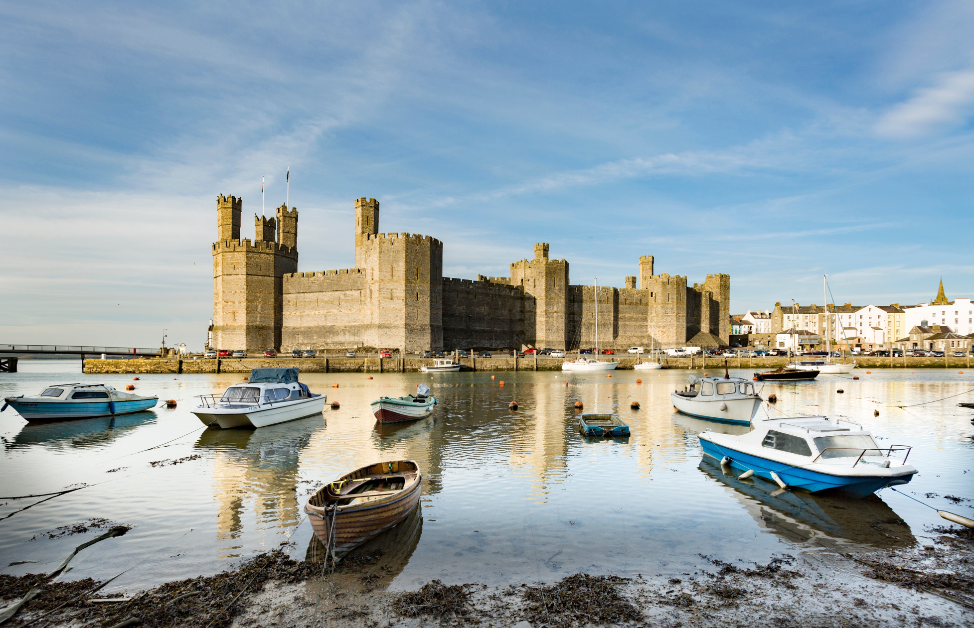

**LED BY DR RICHARD GROVE**

***Caernarfon Castle, North Wales***

*Built by Edward I from 1283 AD to protect the imperial power of the English state after its annexation of Wales. Its medieval walled town also survives, built on the seaward side of the Roman fort of Segontium. This site shift demonstrated Edward's dependence on sea power to maintain his castles (10 of which ring the natural mountain fortress of Snowdonia and his clear grasp of the strategic geography of the region) and inability to depend on land-based military power against Welsh guerilla action. Caernarfon’s architecture strikingly resembles the Theodosian wall of Constantinople; Constantine himself is linked romantically with Caernarfon. Implantation of Caernarfon in an alien landscape typified an irrevocable alteration of Welsh society and landscapes in general, whose political drive affords a 13th century scaled version of the problems posed by insurgency in states bordering the super-powers today.*

The Field Excursion will examine the complex mosaic of Landscapes and landscape forces generated by changing human perceptions of the utility of diverse and dynamic physical environments, and aided by technological innovations ranging from the use of stone and bone tools thousands of years ago to the contemporary power of nuclear energy and the microchip.

The ability to interpret evidence of past influences on Landscape is invaluable in our assessment of its contemporary forces, now that we are becoming increasingly aware of the fragility of many of Earth's systems and the ability of human societies to generate inadvertent or deliberate rapid environmental change.

  Britain's small size is misleading. Many tracts of the earth's surface of similar area (150,000 km2, or roughly the size of Michigan) possess monotonously uniform or poorly developed physical and cultural landscapes. Amongst those forces which have created some of the earth's richest and most diverse landscapes here, we can list geology, climate, the long time span of human occupation and the wealth of cultural influences which in various historical periods have been imperiously imposed or peacefully diffused into the lives of inhabitants.

  Successive waves of human migrations began with the retreat of ice sheets 11,700 years ago and settled temporarily or permanently here, exchanging ideas and artefacts with other societies through diffusion rather than occupation. The strong imprint of late-Mesolithic, Neolithic, Bronze and Iron Age societies (spanning the period 5,000 BC to the 1st Century AD) on British Landscapes is augmented by language, customs, legal and land-tenure systems *etc.* of later societies from the Roman period through Anglo-Saxon times to the Norman Conquest and Medieval and Modern periods.

 All of this will be examined by direct experience of a wide range of British cultural and physical landscapes through a 4-Day itinerary in Wales and west-central England, designed to draw together threads from the Course Options ~  and other Courses in the Summer School ~ and led by an experienced academic.

***ITINERARY***

Principal themes driving the Field Programme for the *Environmental Studies* and aspects of the English Literature and Medieval Studies Courses (4-Day + single-day excursions based in Oxford) are set out here. A full itinerary & information pack is provided at the start of the Excursion. Actual sites visited depend on travel & weather conditions. Themes are identified in historic sequence, rather than route order, with sites in italics.

***Ice Age and Recent Physical Landscapes  (125,000 – 11,500 yrs ago & more recently)***

  The effects of the last Ice Age have been obscured but not lost in the past 11,500 years. Welsh landscapes in particular possess a more obvious physical foundation and Ice Age landscapes survive *(Cwm Idwal)*. Idwal is a National Nature Reserve and site of Charles Darwin's earliest scientific work. Others are dominated by their record of postglacial environmental change *(Mid-Wales Coast, Severn & Mawddach Estuaries, Morfa Dyffryn)*.

***Mesolithic & Neolithic Landscapes (c. 9,500 – 7,500 yrs ago and thereafter)***

Mesolithic proto-farmers opened landscapes before the Neolithic agricultural revolution. Early deforestation occurred in the mountainous landscapes of North Wales *(Nant Ffrancon, Cambrian Mountains)*; permanent Neolithic field systems, megalithic monuments and burial chambers are found there *(Morfa Dyffryn)* and, especially, on chalk downlands of south-central England *(Avebury District)*.

***Bronze & Iron Age Landscapes (4,500 – 800 yrs ago and thereafter)***

These periods were marked by an enrichment of material culture, although extensive landscape changes probably also occurred as a result of more durable, metal tools. Extensive field systems, burial mounds and fortified settlements are indicative of societies in contact and conflict *(Avebury District, Great Orme)*

***Roman & Romano-British Landscapes 2,000 – 1600 yrs ago)***

The Romans made considerable landscape changes over 4 centuries, embracing elements of military conquest, imperial power, peaceful settlement and cultural diffusion. The north-west frontier of the entire Roman Empire lay 50-70 miles west of Oxford and is explored at a number of sites, including the garrison towns of Imperial legions in Wales *(Caerleon, Segontium)* where Roman settlement was limited, extensively settled agricultural landscapes of the Cotswold Hills with farms and villas, civilian towns in the disputed Welsh borderland *(Caerwent)* and administrative cities such Glevum *(Gloucester)*  and recreational centres *(Aquae Sulis - Bath)*.

***Anglo-Saxon & Danish ‘Dark Ages’ Landscapes & Early Medieval Britain (1,600 – 1,000 yrs ago)***

The substantial development of early English villages and the continuity of rural settlement dates from this period. The Cotswold hills and southern chalklands provide extensive evidence, as part of the Anglo-Danish kingdom of Mercia *(Bibury, Yanworth, Burford)* and Saxon kingdom of Wessex *(Winchester, Uffington)* whilst frontier landscapes of the Welsh Borderland yield evidence of more turbulent episodes *(Offa's Dyke)*.

***Landscapes of the Norman Conquest & Later Medieval Britain 1,000 – 400 yrs ago)***

The Norman Conquest of 1066 promoted major changes in land tenure and management and new politico-economic systems. *Domesday Book* (1086 AD) is one of the earliest landscape chronicles. Feudal State and Church emerged as Britain's first multi-national landowners and their impact is evident throughout Wales in its castles *(Chepstow, Caerfilli, Harlech, Conwy and Caernarfon)* and planted administrative towns *(Caernarfon & Conwy).* Ecclesiastic power and land management is charted by abbeys, some now surviving as cathedrals *(Winchester, Gloucester)*, or others dissolved by Henry VIII *(Tintern)*. Landscapes were extensively managed *(Gwent Levels)*. Black Death in the 14th Century and institutional clearances led to wholesale desertion of medieval villages *(Cotswold Hills)*. Revival by the *Agricultural Revolution* and pre-Industrial era, typified by prosperous country towns *(Marlborough and Shrewsbury)* and country estates.

***Industrial Landscapes (300 yrs ago and thereafter)***

Industrial landscape evolution is traced from sites marking its earliest development *(Forest of Dean, the* World Heritage Site *of Coalbrookdale & Ironbridge Gorge)*, through cycles of major expansion, decline and dereliction *(South Wales Coalfield)*. The significance of changing technology and resource potential of a variety of landscapes and the consequential spread of urbanisation is explored.

***Post-Industrial Landscapes (from now onwards !)***

Landscapes undergoing rapid change today reflect many often-conflicting interests. Upland management responds to agricultural, recreational and conservation pressures *(Elan Valley, Brecon Beacons & Snowdonia National Parks, Morfa Harlech and Severn Estuary)* whilst urban recycling *(Telford New Town)* and new business & economic systems alter urban landscapes *(South Wales Coalfield)* ~ with a strong European Union influence.

***PARTICIPANTS***

The Field Excursion **is included for all Summer School participants** as it is likely to benefit in either a specific (academic discipline-related) or general, culturally immersive way. An interest in field-based study and ability to develop the companionship of the group is desirable.

***DAILY SCHEDULE & EXCURSION FORMAT***

 The Excursion covers 650 miles over 4 days by private coach (group size 25-35). Maximum distance travelled in one day is 260 miles (return day) with an average of 130 miles on the other days. Full use is made of the long summer days, with Breakfast from 0800 for departure at 0900, and Evening Dinner at 2000. Lunch breaks and other refreshment & comfort stops provide interludes between site visits and travel. Site visits vary in duration and purpose; some are long enough (2-3 hours) to explore in reasonable depth whilst other, shorter, visits may simply mark definitive sites or photo-opportunities. All sites are placed in context through an accompanying illustrated information pack and on-site verbal introductions with points to look for.

Thereafter, participants' time is theirs to explore actively on impulse or reflect quietly on people and events important to the site. Full use of that time is encouraged. The Excursion spends long periods outdoors. Although there is much walking, including mountain paths, it is not physically arduous. In summary, the 4-Day Excursion aims to balance access to a wide range of interesting and relevant heritage sites with time to assess their character and significance. Participants will see much more on this focused, guided tour than would be possible independently in the same time; you should feel stretched but fascinated by the experience!

***ACCOMMODATION***

Three nights of accommodation is provided in small hotels or guest houses in Chepstow, Mid-Wales and Llandudno. The accommodation is comfortable and in order to keep costs down most students will be expected to share twin-bedded rooms. All meals are provided, including a packed lunch each day.

***DATES, FEES & EXPENSES***

The Excursion fits into the full programme of the Summer School, departing from Oxford on Wednesday 9th July and returning in mid-evening on Saturday 12th July in 2025. The cost of the Field Excursion is inclusive of your total summer school fee. This includes all costs of tuition, accommodation & meals, travel, meals, entrance fees at Heritage sites *etc.*, resource pack and academic fees. Participants therefore only have to cover their own incidental expenses.

***SPECIAL REQUIREMENTS***

Participants are asked to notify the Excursion Tutor of any particular special requirements (related to diet, disability, *etc.*) upon arrival in Oxford. They should travel with lightweight baggage and suitable all-weather clothing and good walking shoes. The latter should take account of mean July temperatures in Britain of *c.* 18o C although temperatures of 21o-28o C (70o-82o F) are common. Evenings may be cool, especially at the coast and on higher ground. A camera and hard-covered field notebook are essential. The Excursion is intended to be enjoyable and not an expedition!

***COURSE CREDITS***

Credits are awarded for the Seminar as follows:  *Environmental Studies* students receive 8 credits for their overall programme of study, for which they are required to engage fully in the fieldwork and develop issues raised during the Excursion in later papers. *Medieval Studies* and *English Literature Studies* students receive 6 credits for their overall programme of study and participate in the Excursion without the automatic extra credit. However, they can choose to add 2 additional credits free of charge (making 8 overall) for which they are required to write an additional *c.*2500-word paper on a subject of their choice relating to the Excursion (with potential links to their Tutorial option) and approved by the Academic Director, submitted by 30th September following the Summer School.

Please note:  In all cases, the student’s home institution may vary the number of credits attributed to their students, taking into account the basis of the credits awarded in Oxford.

**© Ox-Academic Summer-School Tours 2025**