Paninnguaq Pikilak  Cultural Actor and Mediator, Tunniit Practitioner, Freelance Artist, Film Producer, Director, Writer | Sarfaarsuit 12,002 3905 Nuussuaq, Greenland  PaninnguaqPikilak@gmail.com (+299) 297222
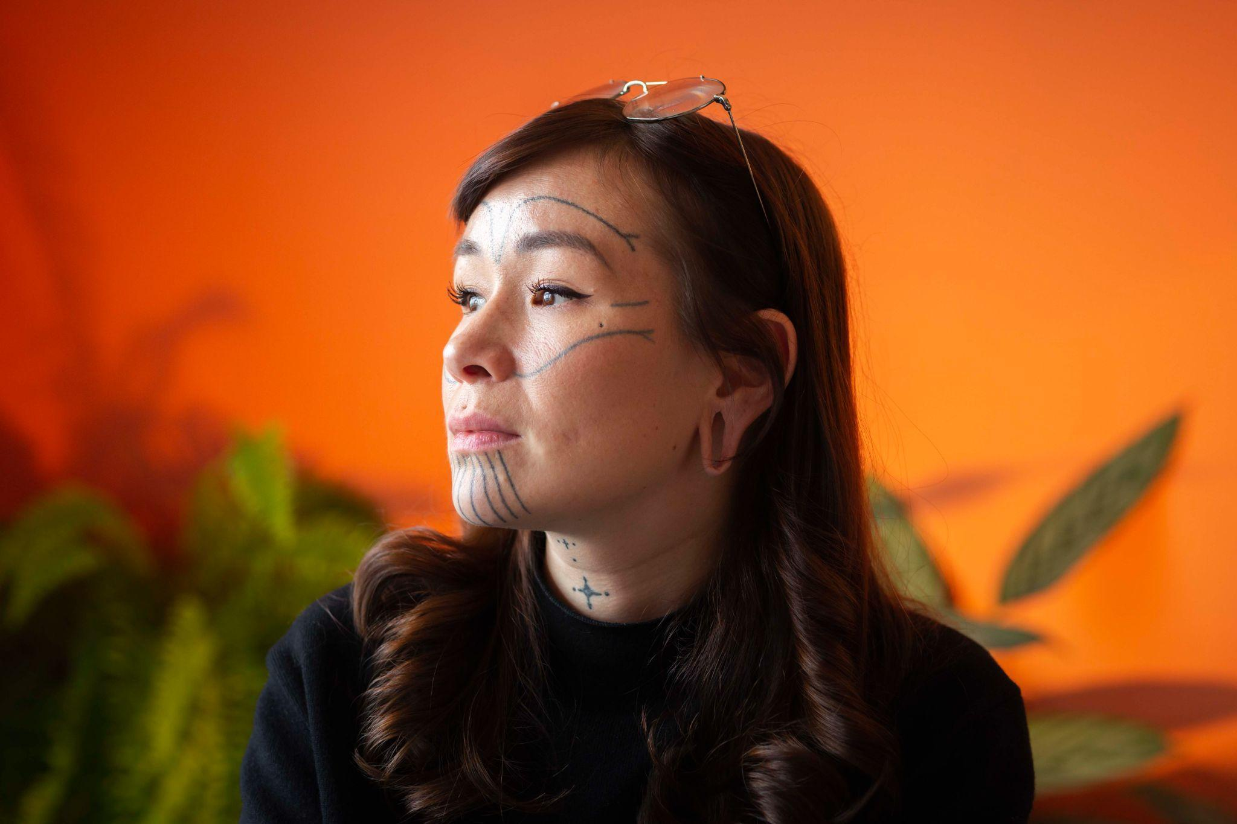  BIO RESUME  Paninnguaq Pikilak was born in 1990 and grew up in Narsaq, South Greenland. She is a mother of 2 daughters, Hinata Pikilak(12) and Ukaleq Pikilak(1) and are based in Nuuk, Greenland.  She started her career as a Western tattoo artist in 2012 and as an independent self-employed freelance artist in 2014. Her artistic self-explore journey led her to connect more with Inuit culture and tattooing in 2016, which Paninnguaq has been researching since and conveyed through her work with traditional tattooing, Workshops and talks, book writing and filmmaking.  In 2021 Paninnguaq had her debut as a book writer with “Arnaaleq - A West Greenlandic Story” and filmmaking with her documentary “”.  She is currently co-writing “Tunniit - The art of Inuit tattooing” and “Decolonization Anthology” while producing her second documentary “Stitch By Stitch” and 2 shortfilms “Inuk Cage” and “Culture Tree”.  JOINT EXHIBITIONS  Art school graduation Exhibition, Katuaq, Nuuk  2014  Woman Exhibition, A21, Narsaq  2016  KIMIK Joint Exhibition, Katuaq, Nuuk  2017  KIMIK Joint Exhibition, Katuaq, Nuuk  2018  I vores Levetid, Nordatlantens brygge  2019  I vores Levetid, Nuuk kunstmuseum  2020  A Thousand years kind of badass, Anchorage  2020  EXHIBITIONS  Movements, Nuuk Kunstmuseum  July 2014  Movements, A21, Narsaq  August 2016  Lights and Hybrids, Katuaq, Nuuk  2016  Sealskin canvas, Qaqortoq katersugaasivia  2017  Sealskin Canvas, Narsaq Museum  2019  UDDANNELSER & KURSER  Gymnasial Uddannelse, Qaqortoq  2010  Western Tattoo Apprentice, Black Cat Ink, Aalborg  2012  Nuuk Kunst Skole, Nuuk  2014  Tunniit Practitioner  2016  Tattoo and Piercing Scandinavia, København – Health and safety course - 2018 | CURRENT PROJECTS  - Tunniit - The Art of Inuit tattooing (Book) With Alethea Arnaquq-Barild  - Documentary: Stitch by Stitch  - Afkoloniserings Antologi  - Revitalizing the Qulleq  - Inuk Cage  - Culture Tree  PUBLISHED BOOKS  Arnaaleq: A West Greenlandic Story, 2021  Pivik Learns From Takannaaluk 2023  PRODUCED FILMS  Producer: Akornatsinniittut - Kiinappalik, 2021  White Paper Documentary 2021  Imajuik 2021  Aliortuaatiga  WORKSHOPS  2016: Arctic Winter Games  2017: Nuuk Nordisk  2018: Knud Rasmussens Højskole  2020: Kommune Sermersooq fritid  Talks  2017: Nuuk Culture festival: Amulets  2018: Landsbibliotekket: Inuit Tattoo Traditions  2018: Taseralik, Sisimiut: Inuit Tattoo Traditions  2018: GU Sisimiut: Inuit Tattoo Traditions  2018: Sisimiut Kvinde Højskole: Inuit Tattoo Traditions

