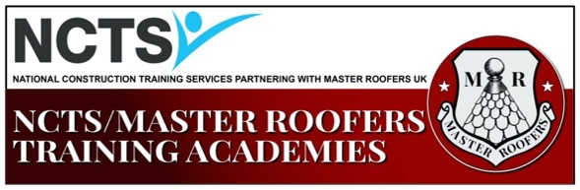
Accommodation
Training Centre Post Code: EN11 0NT
10-mile radius of Hoddesdon

- Travelodge Cheshunt Post Code: EN8 8EU https://www.travelodge.co.uk/hotels/339/Cheshunt-hotel

- Roydon Marina Village Post Code: CM19 5EJ
http://roydonmarinavillage.co.uk/

- Holiday Inn Express Harlow Post Code: CM20 1NB
https://www.ihg.com/holidayinnexpress/hotels/gb/en/harlow/lonhu/hoteldetail

- If you want to bring your own accommodation (tent, camper van, caravan)
https://www.visitleevalley.org.uk/en/content/cms/where-to-stay-and-short-breaks/dobbs-weir-caravan-park/

- Woodland Lodge Post Code: EN11 8SN
bookings@woodlandlodge.co.uk

- Please find more accommodation options at https://www.trivago.co.uk/

