SPONSORSHIP PRESENTATION FORM Code No - 171
Name of the Institution : Mahila Haat
Name of the Children : Ankush Kumar
Name of the Father : Late Bablu Prasad
Name of the Mother : Reba Devi
Address : Gram Okali, Takula, almora
School : small kid not going school
Date of Birth :18/02/2021 2 years 11 months

Boy :Boy  Girl : | Has Father :No  Has Mother : Yes | Father’s Salary per month : Nil  Mother’s Salary per month: Nil
No. of brothers: 1  No. of Sister : 2 | Evt. Handicap :No | Father’s Occupation:- no  Mother’ Occupation: Housewife
Information about the Children :  V.Clever :  Clever :  Good : Good | Child’s hobbies –  Hobby: Playing | 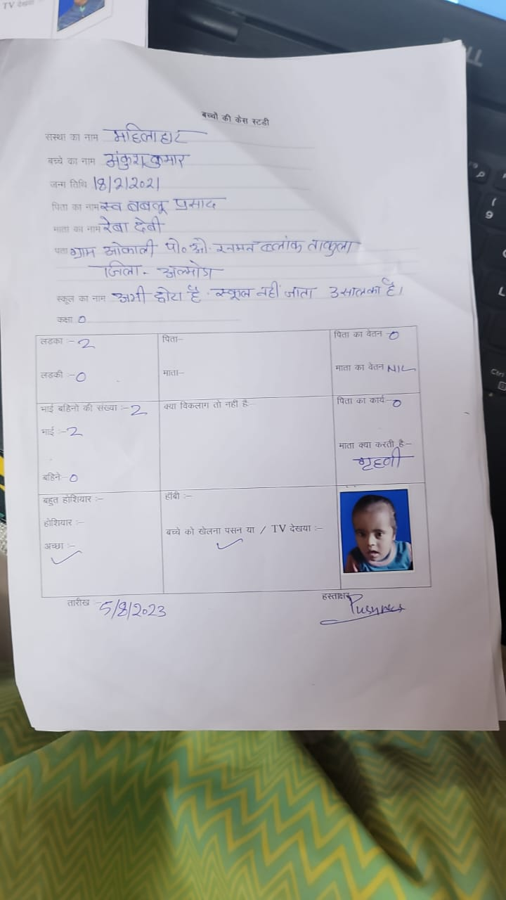  Photo

Date:11/12/2023 Signature: Ankush

Child Information

Name of the Child : Ankush
Sex :Male
Date of Birth : 18/2/2021
Standard : not go to school as he is very small

Case Study
His father died of cancer. In his family there are5 members His mother, one brother and two sister. Economic condition of the family is very poor. His mother is the sole bread earner. She does laboury. She will be very thankful if her son will get sponsorship. It will help in his studies.

