SPONSORSHIP PRESENTATION FORM CODE NO -202
Name of the Institution : Mahila Haat
Name of the Children : Mayank Arya
Name of the Father : Late Lalit Ram
Name of the Mother : Kanta Devi
Address : Village- Pokhre Post off . Ranman Block Takula, Almora
Class : 8th
School : Dev Deval Public School Ranman
Age & Date of Birth : 05-08-2016

Boy : 2  Girl : | Has Father : no  Has Mother : yes | Father’s Salary per month : 0  Mother’s Salary per month: 0
No. of brothers: 1  No. of Sister : | Evt. Handicap :No | Father’s Occupation:0  Mother’ Occupation: Housewife
Information about the Children :  V.Clever :  Clever : Clever  Good : good | Child’s hobbies – Likes to play  Hobby: | 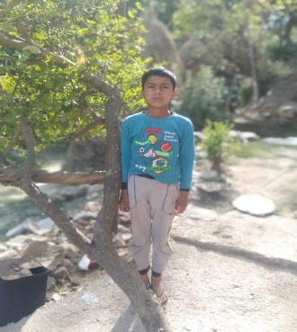

Date: 30-03-2026 Signature: Mayank

Child Information

Name of the Child : Mayank Arya
Sex : Mail
Date of Birth : 05- 08-2016
Standard : 8th

Case Study

Mayank's father died due to heart attack. His mother is the sole bread earner of the family. She does laboury but she does not get work all day. It's very difficult for her to run a family with low earnings. If Mayank will get sponsorship it will be a great help for his mother.

