SPONSORSHIP PRESENTATION FORM Code no - 197
Name of the Institution : Mahila Haat
Name of the Children : Nitya
Name of the Father : Rakesh Ram
Name of the Mother : Mamta Arya
Address : Gram Bamantilari, block Bhaisiachanna
School : Aganwadi
Age & Date of Birth : Aganwadi (Play school)

Boy :  Girl : Girl | Has Father :yes  Has Mother : yes | Father’s Salary per month : Nil  Mother’s Salary per month: Nil
No. of brothers: 1  No. of Sister : 1 | Evt. Handicap :No | Father’s Occupation:- Labourer  Mother’ Occupation: Housewife
Information about the Children :  V.Clever :  Clever :  Good : Good | Child’s hobbies –  Hobby: Playing | 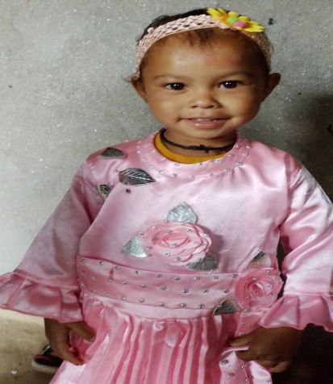

Date: 11/03/202 Signature: Nitya

Child Information

Name of the Child : Nitya
Sex : Female
Date of Birth : 21/9/2020
Standard : Aganwadi

Case Study

Economic condition of the family is very poor. There is no earning source. There are 5 members in the family .Parents will be highly obliged if their kids get sponsorship.

