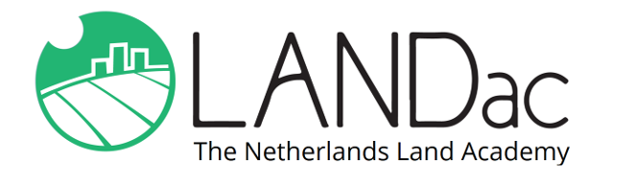
LANDac Annual
International
Conference
2021

30 June – 2 July

ABSTRACT SUBMISSION FORM
Deadline for abstract submission: 16 May 2021

Land, Crisis and Resilience

The 2021 conference is taking place ONLINE!

Only use this form to submit your abstract. Submit your abstract to the contact person of your preferred session, with landac2021@gmail.com in CC. You will be notified about acceptance of your abstract by 31st May 2021. Also please make sure you register in time for the conference (deadline: mid-June).
Title of the session you want to submit your abstract to:

Title of your abstract:

Name(s) and affiliation(s) of the authors:

Contact details of the presenting author:

Abstract (max. 250 words):

Alternative conference session of your choice (if this session is full):

