Lådfabriken – creative seaside accommodation –
Rooms & Prices 2021
high season June 1 – August 30 and December 20 - January 3
2 nights minimally June 21 – August 30 and December 20 - January 3

South room
small Double or Twin Room, 11m2 Individually styled room
situated at the south side of the house with balcony facing south and private bathroom
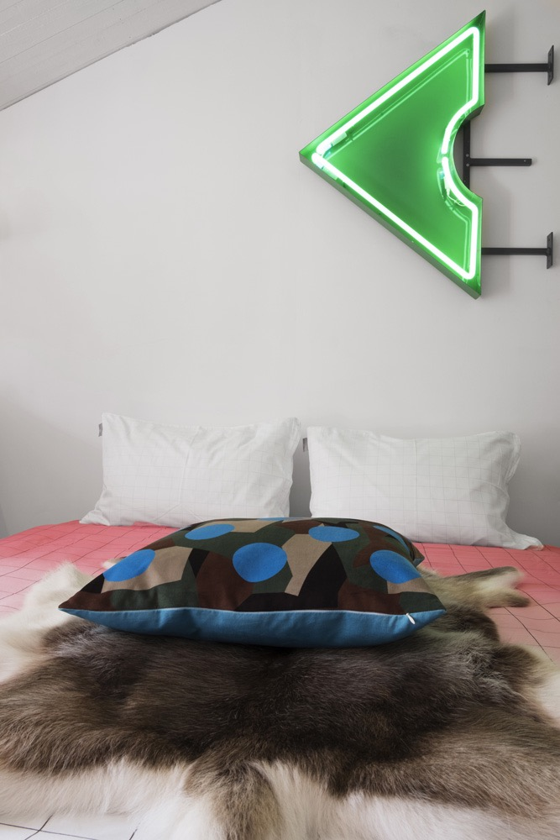
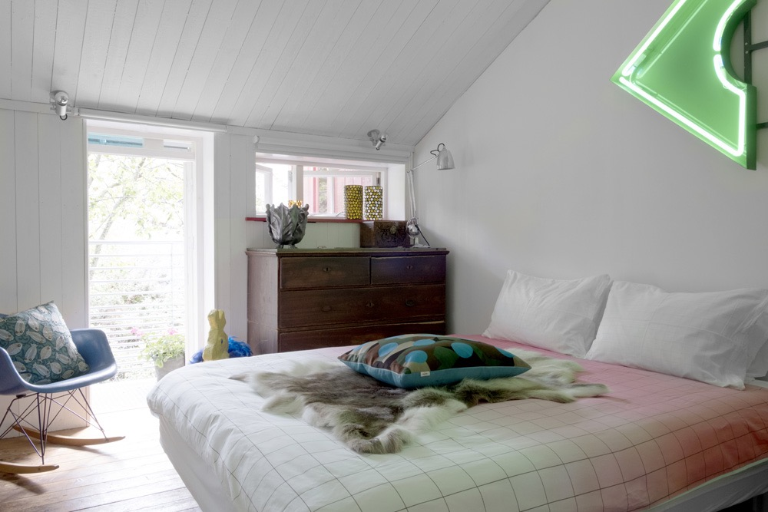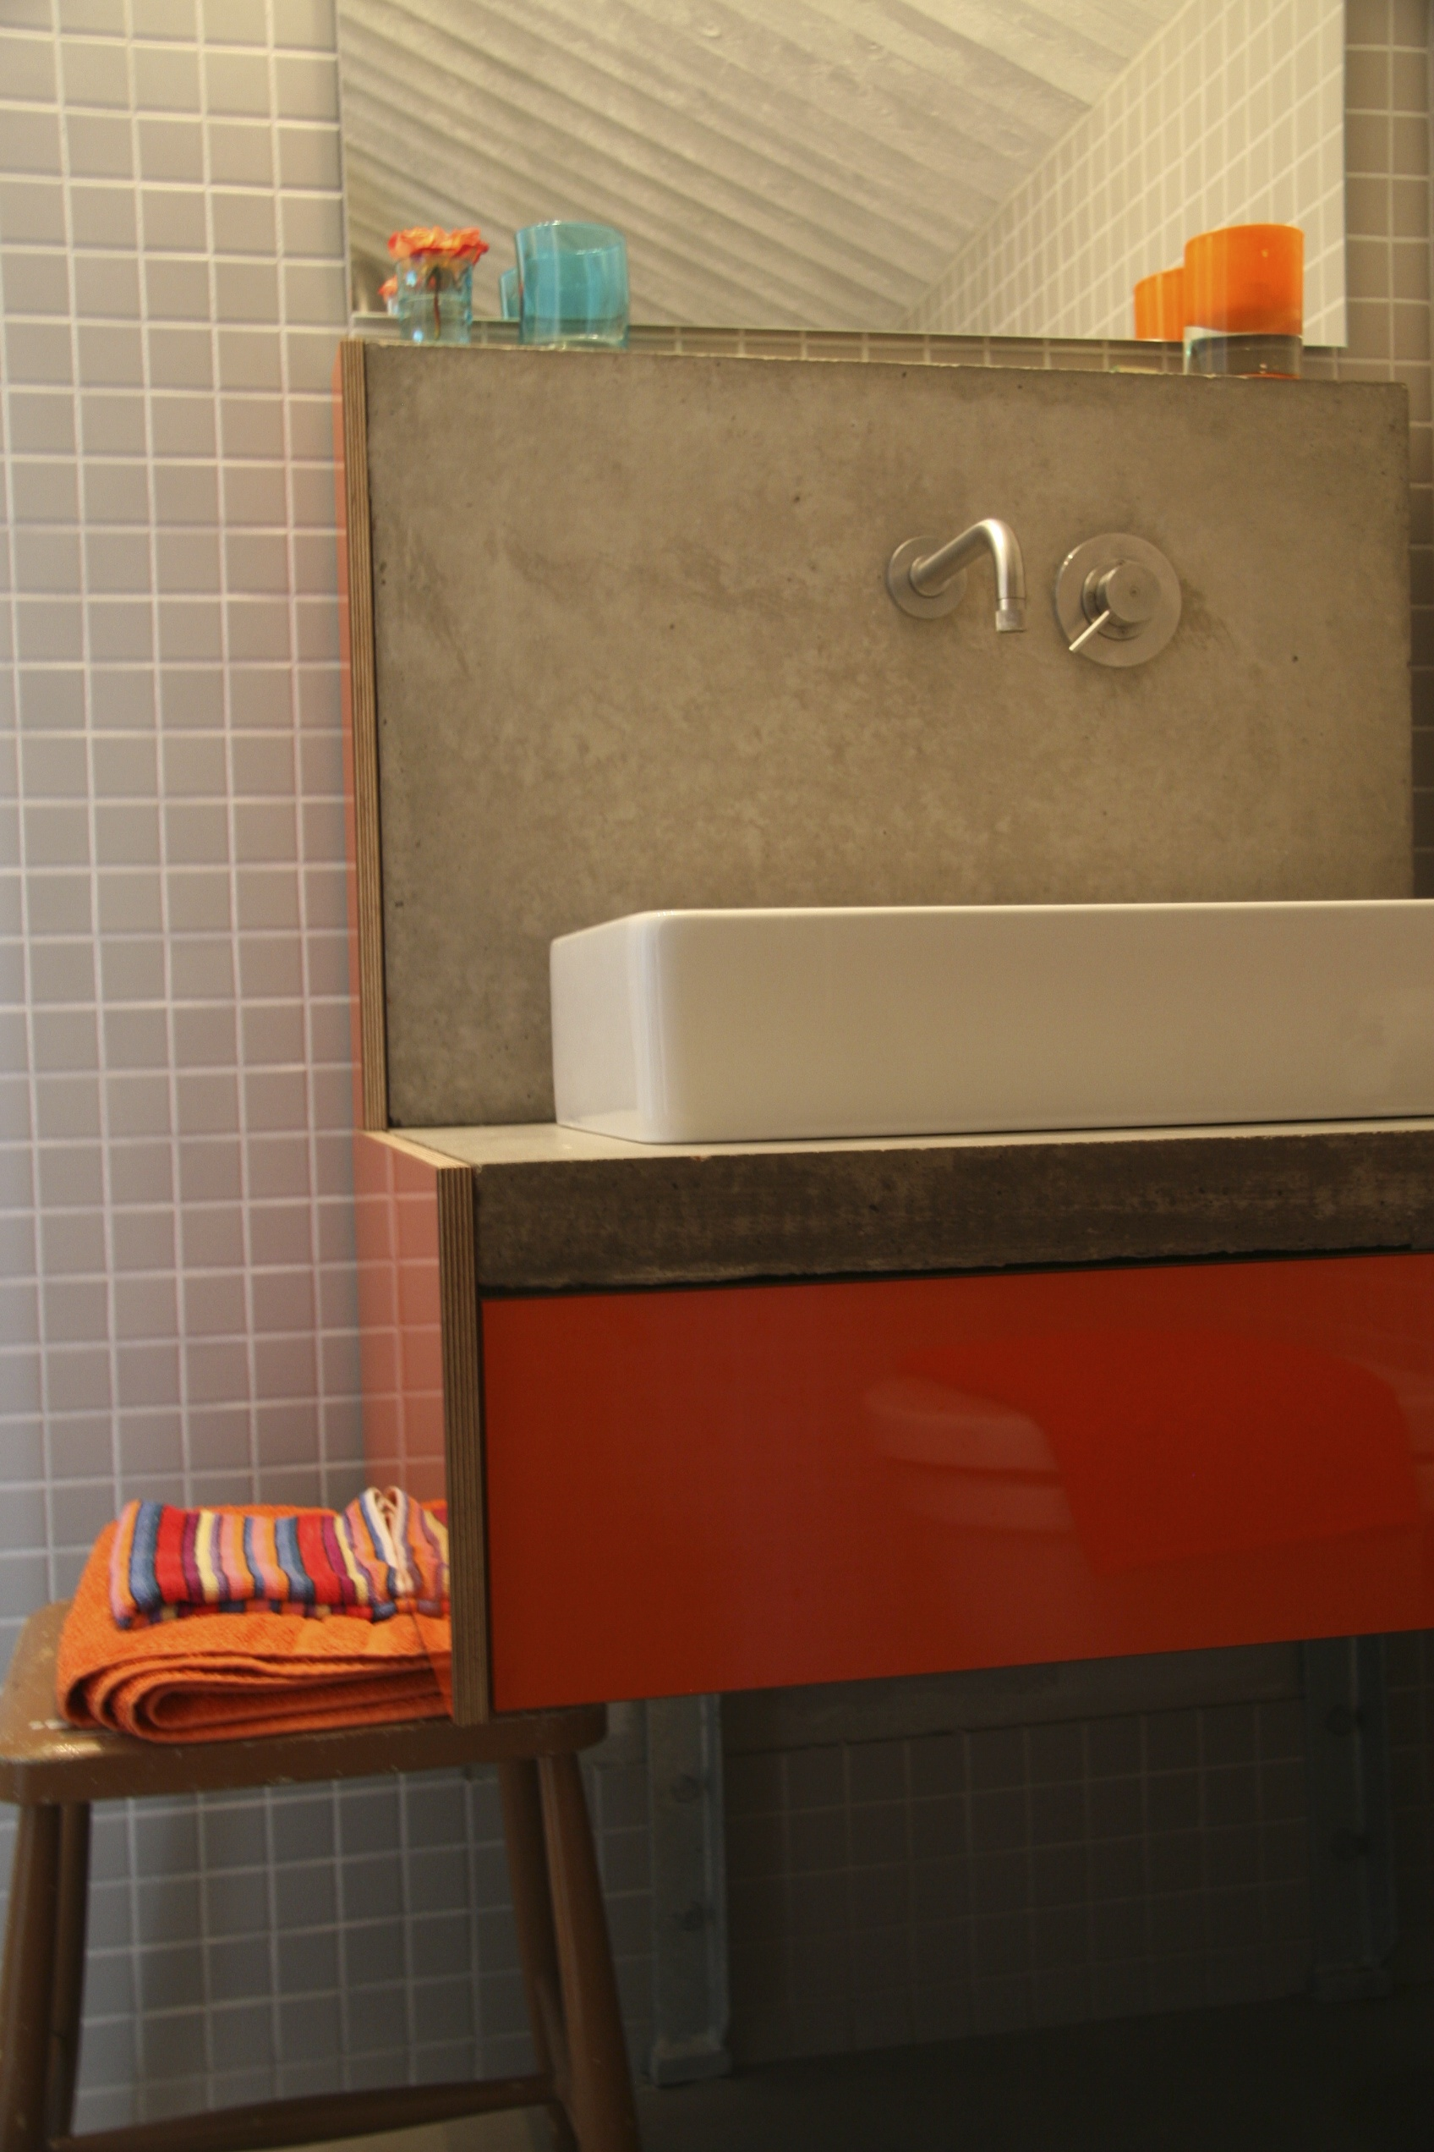

Large Double Bed (queen size 1.60 cm wide) or 2 singles, high quality bed linen, free Wi-Fi, floor heating and wardrobe. Private bathroom is located along the other side of the hall at 3 meters distance; it includes Boffi fittings, floor heating, toilet, shower, sink, beach- and regular towels as well as complimentary care products.

regular season: 1.800 SEK high season: 1.950 SEK

Atrium room
Small Double Room, 12m2 Individually styled room
separate from the house, next to main entrance with own entrance
private bathroom en suite
the room has space for a children's crib

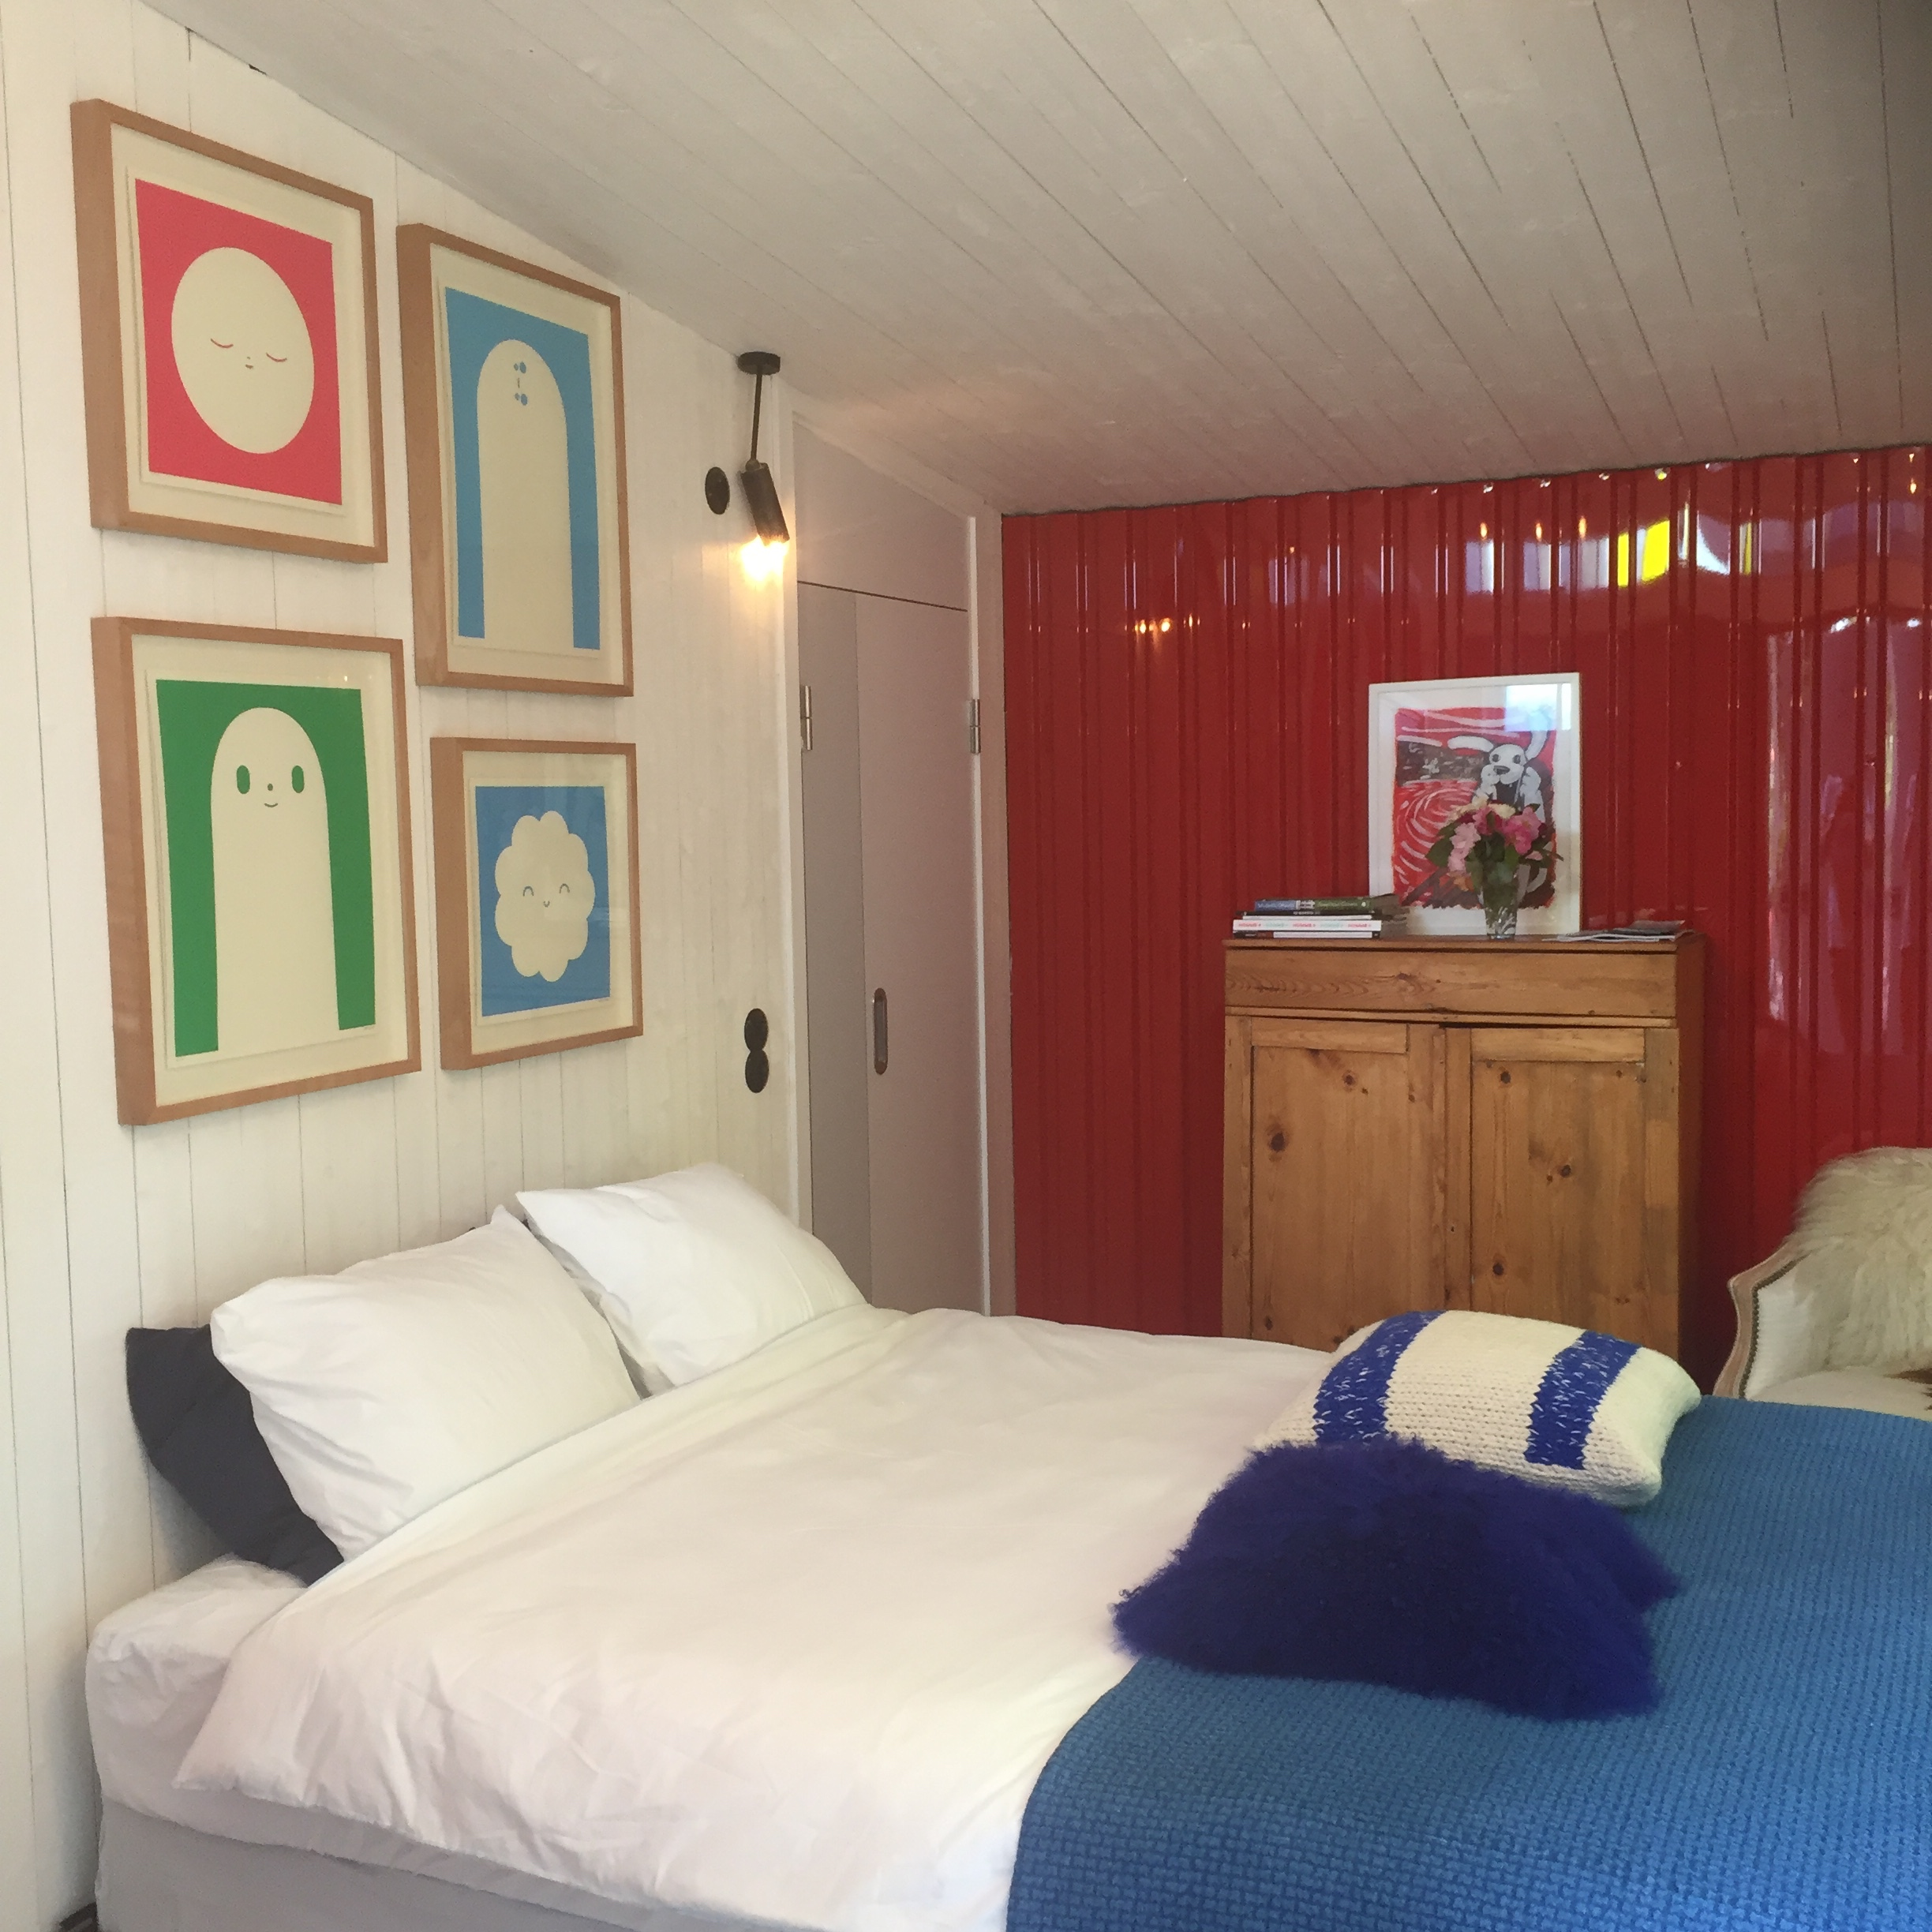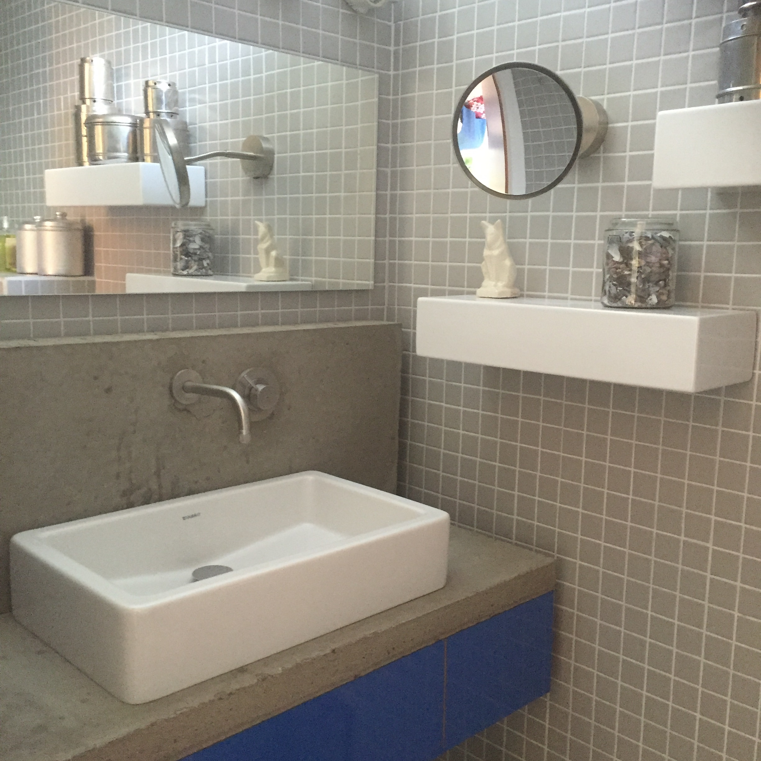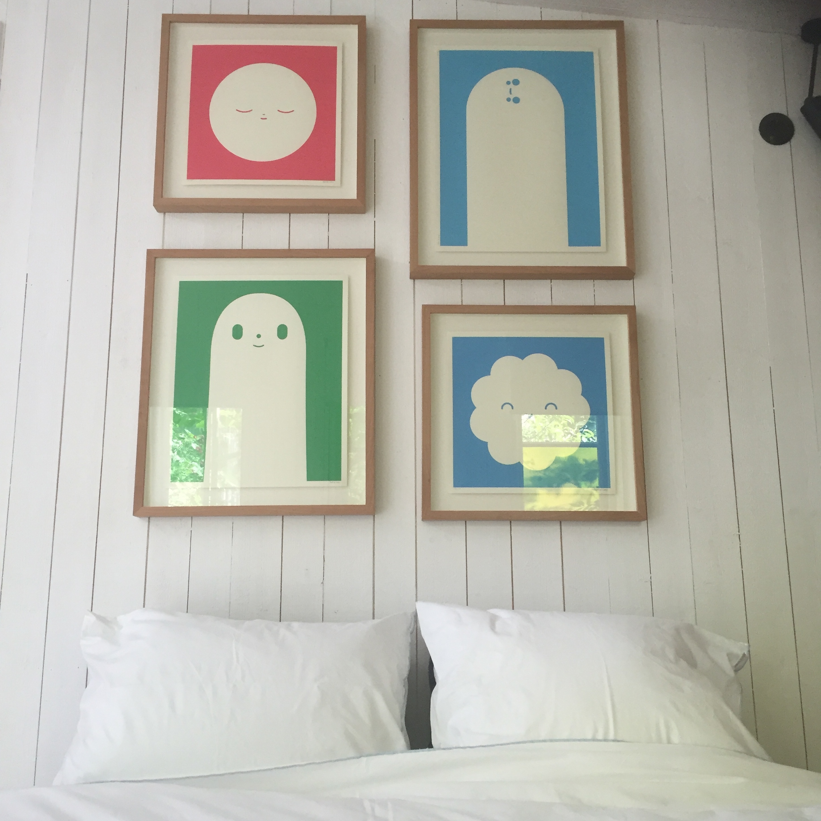

Double sized bed (1.50 cm wide) high quality bed linen, free Wi-Fi, floor heating and clothes rack. Private en suite bathroom includes Boffi fittings, floor heating, toilet, shower, sink, beach- and regular towels as well as complimentary care products.

regular season: 1.950 SEK high season: 2.100 SEK

East room
Standard Double or Family Room, 22m2
Individually styled room situated at the front (east side) of the house
The room has 2 Murphy beds and sufficient space for a children’s crib

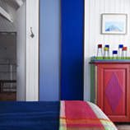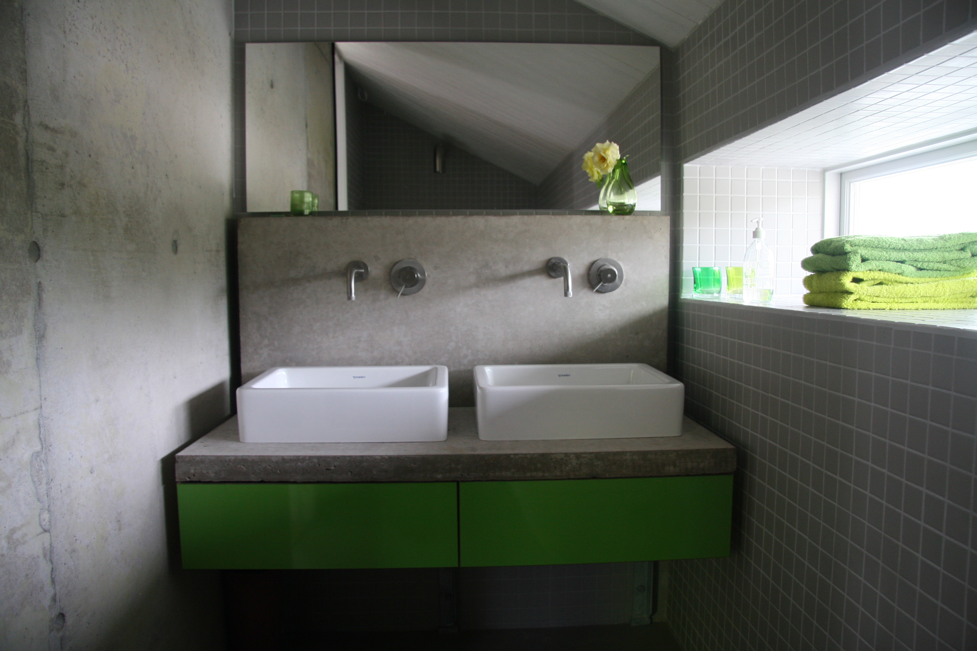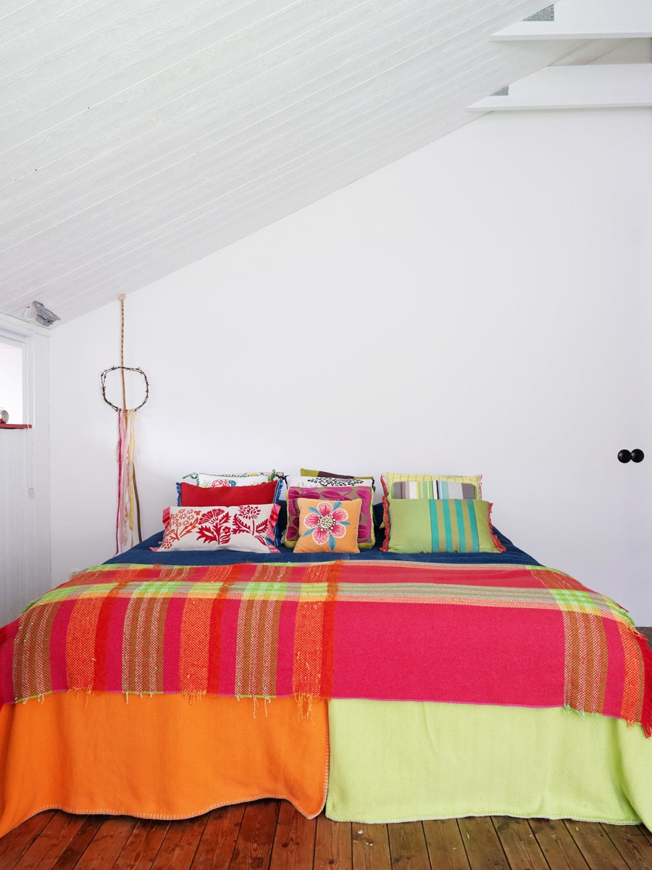

Large Double Bed (king size, 1.80 cm wide) or 2 singles, high quality bed linen, free Wi-Fi, floor heating and wardrobe. Private Bathroom is located along the other side of the hall at 3 meters distance; it includes Boffi fittings, floor heating, toilet, shower, double sink, beach- and regular towels as well as complimentary care products.

regular season: 2.100 SEK high season: 2.250 SEK

West room
Large Double Room, 25m2
Individually styled mezzanine room with French doors overlooking the living room situated at the west side of the house with lots of daylight and sea view
the room has space for a children's crib and an extra bed
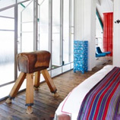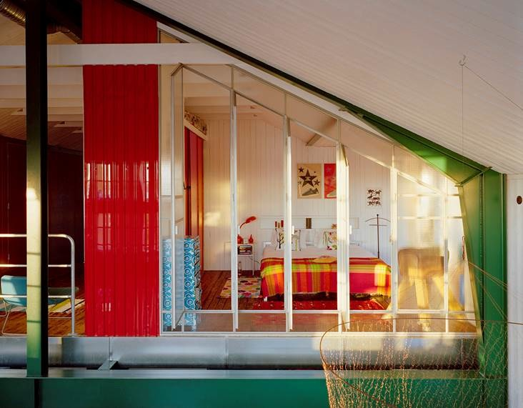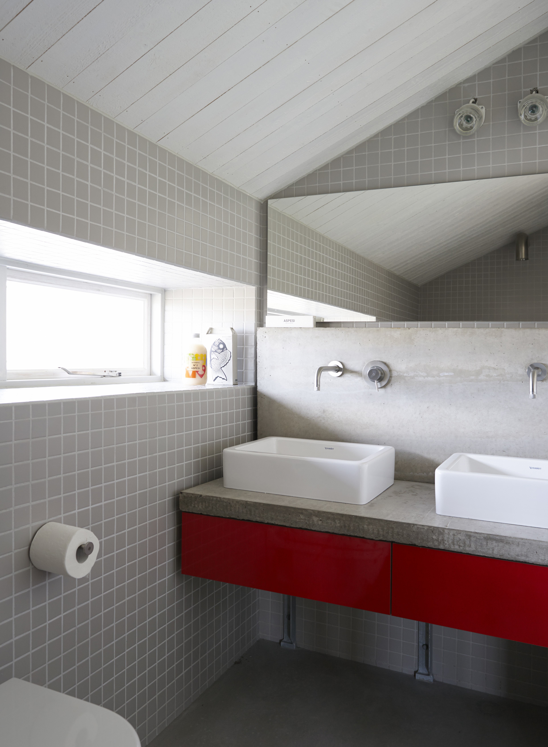

Large Double Bed (king size, 1.80 cm wide), high quality bed linen, free Wi-Fi, floor heating and wardrobe. Private Bathroom is located along the other side of the hall at 3 meters distance; includes Boffi fittings, floor heating, toilet, shower, double sink, beach- and regular towels as well as complimentary care products. There is space for a children's crib and an extra bed.

regular season: 2.250 SEK high season: 2.400 SEK

PRICES & SERVICES

Prices are in Swedish Kroners (SEK) and based on 2 persons in one room, use of double bed
Prices include breakfast and 12 % VAT (as well as towels, bed linen, toiletries and cleaning)
Single use of a double room costs 200 SEK less, an extra bed costs 650 SEK per night

Children aged 5 years and older are advised, we do not recommend children younger than 5 years in our accommodation. Parents are liable for damage caused by children of all ages.

4 kayaks available for use by adult guests and free of cost, after consultation
more kayaks and/ or a guide can be arranged at additional costs

4 bikes available for use and free of cost, after consultation
more bikes can be obtained at additional costs

Parking is available on the premises, charging the car battery is possible at cost

WIFI present and free of charge

We welcome dogs if notified on forehand. The dogs should be well behaving, can't lay on the beds nor be present at the dining table (unless all other guests agree). At no extra costs

Prices for smaller groups (max 12 – 14 persons), suggestions for activities and special events, upon request. Please contact us: info@ladfabriken.eu or call +46 304 52100

Lådfabriken offers a 'private hotel'-concept, where you rent the whole Lådfabriken and receive a customized full service including all meals. That is full pension, with the possibility to influence the menu, decoration and table settings as desired.

FOOD & ALCOHOL

Lådfabriken -seaside accommodation- has open all year round and offers culinary experiences to its guests during all seasons, if ordered at least one day in advance. See website page https://www.ladfabriken.eu/special/

We have a fully licensed serving permit, so we can’t allow anyone to bring his or her own alcoholic drinks.

UPDATED BOOKING CONDITIONS due to Covid-19 and valid while pandemic lasts:

- guests can rebook for free if one is not allowed to travel or to check in with us due to Covid-19 measures;
- a cancellation is free of charge done up to 14 days before arrival, in such case shall we refund the (pre-) payment;
- we shall only refund the (pre-) payment if we manage to find new tenants in case of cancellation within 14 days before arrival;
- we will always refund all payments in the event of an infection with the Covid-19 virus. At all time. We do require proof of the test results. The refund applies to the payments made for the contaminated person and the roommate;
- in case of a refund, administration costs of 350 SEK will apply.

March 2021,

-creative seaside accommodation-

Sollid 398
47494 Edshultshall
Sweden
tel +46 304 52100
www.ladfabriken.eu

