1. Editorial
Thinking outside the Box and Looking beyond It
Executive Summary
- The UK's declining healthy life expectancy calls for an outward-looking approach—one that seeks complementary resources, expertise and wisdom from beyond our borders.
- A case study of herbal medicinal products (HMPs) reveals striking heterogeneity across Europe. By the end of 2016, European countries had registered hundreds of HMPs with well-established clinical evidence of efficacy; the UK had registered just one.
- We do not claim a causal link between HMP availability and population health outcomes. Nevertheless, this disparity invites reflection: what accounts for these divergent regulatory and cultural attitudes towards HMPs across otherwise comparable European health systems? Could cross-cultural exchange—including around HMPs—offer an opportunity for better health?
- In line with the WHO's Global Traditional Medicine Strategy 2025–2034, we propose an NHS task force to review the clinical evidence for HMPs and assess their suitability for NICE guidelines. We also advocate for cross-cultural learning to harness the potential of diverse medical traditions in shaping tomorrow's medicine.
- We do not claim that HMPs and other products offer a panacea for the UK's health challenges. Rather, we argue that the regulatory disparity and the growing evidence base warrant serious, systematic evaluation, and that it is time to integrate complementary approaches for innovation.
Introduction
In the lead editorial of the King’s CICM Newsletter from May 2026, we called for action to ‘widen the lens’—to look beyond the UK for resources and expertise in confronting the pressing decline in healthy life expectancy (Figure 1 A & B).^{1,2}
A B C
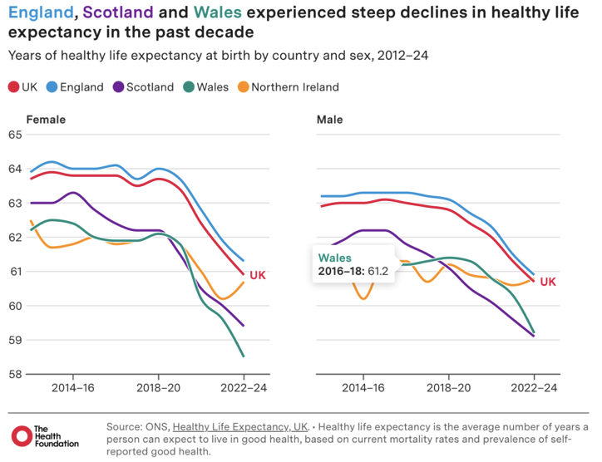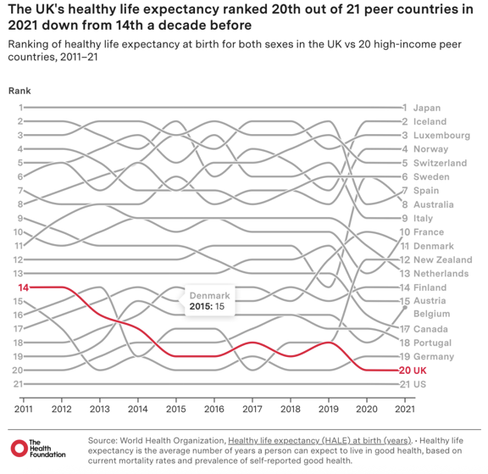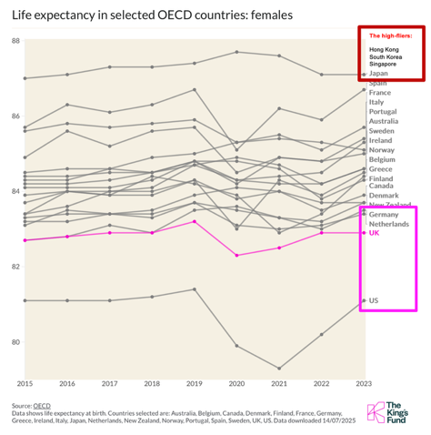
Figure 1. Healthy Life Expectancy and Life Expectancy: The UK vs Selected Countries & Regions.
(A) Healthy life expectancy in the UK declined from 2014 to 2024 (The Health Foundation). ²
(B) By 2021, the UK ranked 20th of 21 comparable countries (The Health Foundation). ²
(C) Life expectancy: the UK and US perform poorly versus top-performers—adapted from the reference.³ Top- and low-performers are highlighted in red and pink rectangles, respectively.
Much of the subsequent discourse, notably in the BMJ, has remained inward-looking. Hiam and McKee’s opinion piece convincingly identifies austerity as a primary driver, arguing that Britain’s low public spending and attenuated welfare state have exacerbated health decline since the early 2010s.⁴ Meanwhile, Sally Howard’s news analysis scrutinises the reliability of this trajectory and proposes damage mitigation through resource reallocation.⁵
Yet for all their merit, these internal critiques represent what we might term looking inside—examining our own systems, policies and resources through the very frameworks that generated the present difficulties. This is, in essence, thinking inside the box. The danger is two-fold: such approaches risk creating a self-reinforcing feedback loop of critique and incremental tinkering; they may even precipitate an internal competition for scarce resources when budgets are constrained.
In this editorial, we build on our earlier call by arguing that we must not only look outward for resources and expertise but also adopt fundamentally different modes of thinking, i.e., think outside the box. To reverse our health decline, we call for exchange with our European neighbours who have outperformed us and can offer complementary approaches, as well as learning from Far Eastern exemplars (e.g. Hong Kong, Japan, South Korea and Singapore) that have integrated Western and Eastern wisdom into their systems (Figure 1C). Senior health and care leaders from England and Singapore recently met to explore mutual learning.⁶ Dialogues should go deeper and broader.
A Case Study on External Resources: HMPs
In the same issue of the King's CICM Newsletter, we also highlighted a striking difference between the herbal medicine landscape in the UK and Germany, from a pharmacist's perspective.^{1,7}
We now broaden our lens to compare the UK with more European neighbours. Under the regulatory framework of the European Medicines Agency (EMA), the Committee on Herbal Medicinal Products (HMPC) defines EMA regulatory criteria for HMPs registered under the Traditional Use Registry (TUR) and Well-Established Use Marketing Authorisation (WEU MA). The UK has registered the most HMPs under TUR, which lack robust clinical evidence of efficacy, limiting their applications to minor disorders. In contrast, many other European countries have embraced a more evidence-based and integrated approach, resulting in hundreds of HMPs registered under WEU MA, supported by evidence on clinical efficacy, allowing these products to be used for the prevention and treatment of major diseases. By December 2016, Germany had registered 286 WEU-MA HMPs; the UK, just one. Austria, Slovenia, Sweden, Croatia, Czechia and Spain each had more than 30 WEU-MA HMP registrations, while 14 other European countries had 10 to 29 (Figure 2).⁸
A B
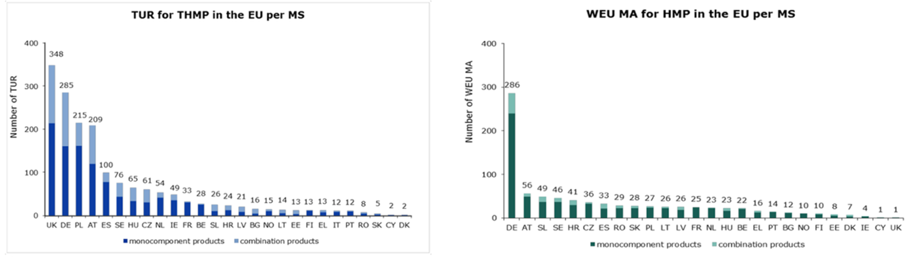
Figure 2. Herbal Medicinal Products in the European Union by the End of 2016.⁸
(A) The landscape of Traditional Herbal Medicinal Products (THMPs) registered under the Traditional Use Registry (TUR) scheme in European Union (EU) Member States (MS)
(B) Herbal Medicinal Products (HMPs) under Well-Established Use Marketing Authorisation (WEU MA).
This pre-Brexit European Medicines Agency dataset captures products that meet European standards for quality and safety (both TUR and WEU MA) and efficacy (only WEU MA). It offers a valuable baseline for examining the relative contributions of the United Kingdom (UK) versus other EU MS to the total HMP portfolio. DE, Germany; AT, Austria; SL, Slovenia; SE, Sweden; HR, Croatia; CZ, Czechia; ES, Spain.
This disparity reveals a fundamental difference in regulatory philosophy among European neighbours. One legitimate interpretation is that regulators in high-use countries prioritise patient access and autonomy, while the UK adopts a more precautionary stance, viewing its primary duty as avoiding harm. These are defensible positions, but the divergence invites reflection on whether the UK's approach may now be unduly restrictive.
Amid growing unmet medical needs in the UK, it is worth asking whether the hundreds of WEU MA-authorised HMPs across Europe—products expected to meet established clinical evidence standards for both safety and efficacy—could have value in addressing our health challenges. We are not advocating for deregulation, nor do we assume that these products will prove effective or that the evidence base is uniformly robust. Nevertheless, the regulatory disparity warrants formal evaluation. We propose an NHS task force to assess the quality of their clinical evidence, identify products that meet NICE standards, and flag promising candidates for further validation.
This call for a proactive review extends to other medical traditions, including traditional Chinese Medicine (TCM)—the primary research focus of King's CICM. As a research-led initiative within King's Health Partners (KHP) and primarily led by King's College London, the Centre aims to catalyse innovation by delivering patient-centred, evidence-based, safe and effective healthcare to the UK. It does so by integrating the complementary resources, expertise and wisdom of TCM with those of conventional medicine, science and technology.
We recognise that the evidence base for TCM is not yet sufficiently robust. Accordingly, what we seek at King's CICM is not simply a fusion of two medical systems. Rather, we adopt a research-driven, evidence-based approach to help shape the future of medicine, addressing health challenges through cross-cultural and interdisciplinary collaboration, innovation and rigorous inquiry.⁹
To this end, we have compiled a summary of promising clinical evidence accumulating in leading medical journals, supporting the safety and efficacy of TCM products and techniques in preventing and treating major diseases and common disorders.¹⁰ We do not assume that this evidence is sufficient, nor that it meets the standards required for NICE guideline inclusion. However, it does, in our view, warrant systematic evaluation. We propose that the NHS establish a formal mechanism for this purpose. Such a task force could: (a) assess which HMPs and TCM products or devices already meet NICE standards, (b) identify the most promising candidates for jointly funded validation trials, and (c) help set research priorities to address evidence gaps. This would create a transparent pathway for evidence-based integration, distinct from the current system where lack of engagement perpetuates lack of evidence. Research into HMPs and TCM herbal medicines also offers a promising avenue for discovering novel natural chemical structures that could inform new drug development, as our own research has demonstrated.¹¹⁻¹⁴
Thinking Beyond the Box: The TCM-Inspired Research at King's CICM
At King's CICM, we emphasise not only the expertise and resources of TCM,¹⁰ but also its distinct modes of reasoning: a holistic view of human–nature harmony; the interconnection of body and mind; dynamic functional equilibrium; intrinsic self-healing capacities; personalised syndrome-based strategies; and an integrated preventive-therapeutic approach.⁹ This is where thinking outside the box becomes truly transformative.
The Xu Lab exemplifies this approach not by rejecting conventional science, but by using ancient concepts to generate testable modern hypotheses. Guided by TCM concepts of healthy qi (defensive mechanisms) and yang qi (metabolic function), its research does not simply seek to validate TCM remedies. Instead, it leverages these ancient concepts to generate novel biological hypotheses—for example, elucidating kidney defence mechanisms against injury and their dysregulation in disease. This TCM-inspired search for endogenous defenders explores the roles of the collecting duct and glomerular parietal epithelial cells in renal protection, as well as the regulatory role of retinoic acid signalling in these specialised kidney cells.¹⁵⁻¹⁸ Meanwhile, proteomic studies of fibrogenesis—mechanisms underlying scarring and chronic failure of kidney and other organs—have pinpointed multiple metabolic pathways and enzymes as potential therapeutic targets, which are regulated by antifibrotic herbal and non-herbal treatments.^{14,19} Finally, by applying bioimaging, photoplethysmography (measuring blood volume in the peripheral circulation), pulse wave velocity and AI to TCM inspection, tongue and pulse diagnostics, our research promises innovation in cost-effective diagnosis, as well as stratified intervention and prognosis.
An Invitation to Be Inspired
This editorial draws inspiration from three sources: the wisdom of TCM, the heterogeneity of European herbal legacies, and the lecture series of Professor Sir Robert Lechler, a long-standing supporter and enabler of King's CICM. His lectures—Looking Back (10 advances that changed the world), Looking In (the good, the not so good and the questionable), and Looking Ahead (more of the same will not suffice)—are thought-provoking.²⁰⁻²² These lectures serve as a powerful reminder that looking ahead requires not just more resources, but fundamentally different thinking. Beyond looking back for historic lessons and looking in to assess our strengths and weaknesses, it is time to transcend conventional paradigms and embrace cross-cultural learning.
In private correspondence, Professor Sir Robert Lechler has insightfully observed that many alternative and traditional therapies may generate benefit through stress reduction, with some of this likely attributable to placebo effects, where belief in the product is itself beneficial. For conditions such as COVID-19 and its sequelae—where, for much of the pandemic, no conventional medicine could offer effective intervention—a holistic, functionally oriented diagnosis and intervention may work through a range of mechanisms, including stress reduction. Stress is a well-established contributor to many of the acute and chronic conditions driving the UK's declining healthy life expectancy, including some core research programmes of King's CICM (e.g. cardiovascular, kidney and metabolic disorders, cancer, and mental health conditions).
At King's CICM, we see this not as a limitation but as an opportunity. TCM's holistic framework, with its emphasis on mind–body interconnection and dynamic functional equilibrium, offers testable hypotheses about stress pathways that could be investigated through rigorous research. Whether through the physiological effects of specific compounds, the neurobiological mechanisms of acupuncture, or the psychological benefits of mindfulness practices derived from TCM, this is precisely the kind of cross-cultural learning we advocate. We invite collaboration in designing studies that could advance this evidence base.
As Einstein observed, 'We cannot solve our problems with the same thinking we used when we created them.' In the context of healthcare, this means questioning not only our resource allocation but also our frameworks for evaluating evidence and our assumptions about what constitutes legitimate therapeutic knowledge. Integrative medicine embodies this principle, exploring innovative solutions for human health through cross-cultural learning and collaboration. We must embrace the substantial opportunities that such an integrative approach affords, not just by looking beyond our shores, but by welcoming the new ways of thinking that other cultures and disciplines can offer.
We invite you to engage with Professor Sir Robert's lectures, reflect on his comments, and join us in this endeavour. We do not claim that TCM or other traditional systems offer ready-made solutions to the UK's health challenges. Rather, we argue that their distinct frameworks, the substantial clinical experience they embody, and the growing evidence base for specific interventions warrant serious, rigorous and open-minded investigation. The goal is not to replace conventional medicine but to enrich it through evidence-based integration.
The King's CICM team is ready for the challenges ahead. We cordially invite you to join our journey.
Acknowledgements
We sincerely thank Professor Sir Robert Lechler (Emeritus Senior Vice President at King's College London), Professor Andrew George MBE (Chair of the Health Innovation Network South London), Professor Tanya Shaw (Head, Department of Inflammation Biology, King's College London) and all King's CICM team members for their insightful comments.
References
  - King's CICM. The King's CICM Newsletter May 2026.
https://usercontent.one/wp/www.kingscicm.org/wp-content/uploads/2025/05/Kings-CICM-Newsletter-May-2026.pdf?media=1769029197 [accessed 22 June 2026]
  - Mooney A, Alarilla A, Cavallaro F. Healthy life expectancy trends in the UK: a watershed moment. Health Foundation, 2026. https://www.health.org.uk/reports-and-analysis/analysis/healthy-life-expectancy-trends-in-the-uk-a-watershed-moment [accessed 22 June 2026]
  - Raleigh V. Does the government’s 10 Year Health Plan measure up to the current state of population health? The King’s Fund, 16 September 2025. https://www.kingsfund.org.uk/insight-and-analysis/blogs/governments-10-year-health-plan-measure-up-current-state-population-health [accessed 22 June 2026]
  - Hiam L, McKee M. We can't explain the UK's declining healthy life expectancy without talking about austerity. BMJ 2026;393:s923.
  - Howard S. The UK is getting sicker, sooner—how do we reverse falling healthy life expectancy? BMJ 2026;393:e665842.
  - Collins B, Walsh N. What can England and Singapore learn from each other on neighbourhood health?
https://www.kingsfund.org.uk/insight-and-analysis/long-reads/england-singapore-learn-from-each-other-neighbourhood-health?utm [accessed 22 June 2026]
  - Heinrich M, et al. Herbal medicine use in the UK and Germany and pharmacy practice—A commentary. Res Social Adm Pharm. 2023;19:535-540.
  - European Medicines Agency. Uptake of the traditional use registration scheme and implementation of the provisions of Directive 2004/24/EC in EU Member States.
https://www.kingscicm.org/wp-content/uploads/2026/06/Uptake-of-the-traditional-use-registration-scheme-by-December-2016.pdf [accessed 22 June 2026]
  - King's CICM. Homepage.
https://www.kingscicm.org/ [accessed 22 June 2026]
  - King's CICM. Evidence-Based Integrative Chinese Medicine for the Prevention and Treatment of Major Diseases and Common Disorders.
https://www.kingscicm.org/?page_id=71#Evidence [accessed 22 June 2026]
  - Xu Q, et al. The hunt for anti-fibrotic and pro-fibrotic botanicals. Science 2014;346 (6216 Suppl):S19-20.
  - Hu Q, et al. In vitro anti-fibrotic activities of herbal compounds and herbs. Nephrol Dial Transplant 2009;24:3033-41.
  - Bunel V, et al. Herbal medicines for acute kidney injury: Evidence, gaps and frontiers. Would Journal of Traditional Chinese Medicine 2015;1:47-66.
  - Zhou S, et al. Antifibrotic activities of Scutellariae Radix extracts and flavonoids: comparative proteomics reveals distinct and shared mechanisms. Phytomedicine 2022;100:154049.
  - Xu Q. The Renal Collecting Duct Rises to the Defence. Nephron. 2019;143:148-152.
  - Papadimitriou A, et al. Collecting duct cells show differential retinoic acid responses to acute versus chronic kidney injury stimuli. Sci. Rep. 2020;10:16683.
  - Liu WB, et al. Single-cell RNA sequencing data locate ALDH1A2-mediated retinoic acid synthetic pathway to glomerular parietal epithelial cells. Exp. Biol. Med. 2024;249:10167.
  - King's CICM. Integrative Chinese medicine research shines again at UK Kidney Week. https://www.kingscicm.org/?p=1588 [accessed 22 June 2026]
  - Zhou S, et al. Proteomic landscape of TGF-β1-induced fibrogenesis in renal fibroblasts. Sci. Rep. 2020;10:19054.
  - Lechler R. Looking back – 10 advances that changed the world. https://www.youtube.com/watch?v=pMO_t9KtsEs [accessed 22 June 2026]
  - Lechler R. Looking in – the good, the not so good and the questionable. https://www.youtube.com/watch?v=QmEfbfxP5ZQ [accessed 22 June 2026]
  - Lechler R. Looking ahead – more of the same will not suffice.
https://www.kcl.ac.uk/events/looking-ahead [accessed 22 June 2026]
2. Team Development
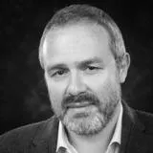
Welcome Professor Federico Turkheimer and Dr Alessandra Borsini joining the faculty of the King’s CICM initiative! They will lead the development of our Body-Mind Integration Theme of research and teaching.
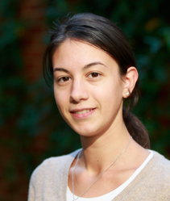
Prof. Federico E Turkheimer: Professor of Neuroimaging, Director, The KCL Institute for Human and Synthetic Minds; Deputy Head, Neuroimaging Department; Lead, Neuroimaging, Maudsley NIHR-BRC, Institute of Psychiatry, Psychology and Neuroscience, King's College London. Research interests: Neuroimaging; Human and Synthetic Minds; and Body-Mind Integration.
Prof. Federico Turkheimer
Dr Alessandra Borsini: Lecturer in Psychoneuroimmunology and Programme Leader, MSc in Psychology and Neuroscience of Mind-Body Interface, Institute of Psychiatry, Psychology and Neuroscience, King's College London. Research interests: Psychoneuroimmunology; Body-Mind Interface.
3. King's CICM Activities:
Dr Alessandra Borsini
3.1. Prof Graham Lord on turning strategy into impact. Talking about the new way of working together for King's College London (KCL) and our NHS partners (teaching hospitals), Professor Graham Lord, Senior Vice President (Health), KCL, and Executive Director of the KHP, noted in a recorded video released on May 5, 2026: 'We are seeing rapid advances in life sciences, digital technologies and personalised medicine. That combination makes it essential that we use the strength of our partnership to deliver the greatest possible impact for patients, communities, and staff and students.'
In keeping with this vision, as stated in the King’s CICM Plan for Strategic Growth & Impact (2025-2029), which was agreed at a meeting between Prof Graham Lord and his team and the King's CICM Directorship Team at a meeting on 8 October 2025, King’s CICM will support KHP priorities and will present an impact case in the next round of REF exercise.
3.2. Integrative medicine in the UK: one year after the new WHO Traditional Medicine Strategy. In response to the opinion article “We can’t explain the UK’s declining healthy life expectancy without talking about austerity” published in BMJ, Dr Qihe Xu, Professor Yanzhong Wang and Dr Min Zhang submitted a rapid response on May 22, 2026, entitled "Integrative medicine in the UK: one year after the new WHO Traditional Medicine Strategy". They propose that evidence-based traditional, complementary, and integrative medicine (TCIM) approaches be more systematically embedded in healthcare education and professional training. Furthermore, they recommend establishing an NHS evidence review board for TCIM to assess efficacy and safety for specific conditions, support high-quality research and develop clear clinical guidance.
3.3. Dr Qihe Xu met with Professor Andrew George MBE (profile), Chair of the Health Innovation Network South London (HIN) (HIN homepage) on June 3, 2026. At the meeting, they discussed potential collaborations between King’s CICM and HIN, an NHS network that connects and fosters collaboration across the NHS, academia, industry, and investors to accelerate the adoption of proven health technologies and pathways—ultimately improving health outcomes, increasing productivity, and generating economic growth.
3.4. A full list of our activities can be found here:
- King's CICM activities: https://www.kingscicm.org/?p=1476
- 中心活动与动态：https://chinese.kingscicm.org/?p=1563
4. Visit our updated homepage:
4.1. English homepage: https://www.kingscicm.org
- Explore a series of King's CICM Introductory Presentations (The 40th edition), outlining our theoretical foundation, track record, team structure, research focus and development timeline;
- Download the King’s CICM Handbook (The 108th edition), a comprehensive guide detailing the initiative’s background, strategic blueprint, team and leadership structure, fundraising campaign and future priorities.
4.2.Chinese homepage (中文官网): https://chinese.kingscicm.org
- 浏览中心简介幻灯稿，了解我们的理论与实践、团队构架、研究重点与发展时间表
- 下载中心手册，它全面阐述中心的背景、战略蓝图、组织结构、发展计划与优先领域
5. We Are What We Share: shared with King's CICM Friends
5.1. Hirohama D, et al. The proteogenomic landscape of the human kidney and implications for cardio-kidney-metabolic health. Nat Med. 2025 Nov;31(11):3917-3929.
Editor's note: This paper illustrates how integrating multiple cutting-edge methodologies can deepen our understanding of cardio-kidney-metabolic (CKM) health and disease—the focus of our CKM research programme. Combining whole-genome sequencing, RNA sequencing and proteomic analysis of human kidney samples, together with AI-aided Bayesian co-localisation, Mendelian randomisation and drug target discovery analyses, the study identified 873 protein quantitative loci (pQTL) in 325 human kidney cortical tissues, among which metabolic pathways (169 pQTL, 21% of the total) and defence pathways (88 pQTL, 10% pQTL) are the predominantly enriched pathways among all pQTLs. This finding is important because, at a functional genomics level, it has bridged modern personalised medicine with TCM understanding of personalised differences in yang qi (metabolism) and healthy qi (defence). Further, the study identified 151 kidney pQTL proteins associated with at least one CKM-related trait, among which 22 showed associations across multiple CKM categories, while most were linked to only one trait, reflecting the heterogeneous yet interconnected nature of CKM conditions. Finally, the study prioritised relationships that may underpin this interconnectedness and uncovered multiple targetable mechanisms for CKM diseases.
5.2. Wang XB, et al. Best practice in reporting guidelines for Chinese herbal medicines research: A review. Chinese Traditional and Herbal Drugs 2026;57: 3261-3273 (汪选斌, 等。中药研究的国际最佳报告指南综述.中草药2026;57:3261-3273
🔗 Access the article (中文): https://www.tiprpress.com/zcy/article/abstract/20260901
Editor's note: Editor's LinkedIn post on this paper has attracted over 1,200 impressions, 13 likes and aroused warm discussions: https://www.linkedin.com/posts/qihe-xu-1484736
5.3. From pharmacy to philosophy: data-informed insights into Chinese medicinal cuisine for emotional well-being and holistic health (Hongye Zheng and Amily Wang Guénier. Asian Journal of Medical Humanities, 2026;5: 20250049), shared by Dr. Amily Wang Guénier, a King's CICM Friends Circle Member.
Read the open-access article: https://doi.org/10.1515/ajmedh-2025-0049
WeChat in Chinese (中文): https://mp.weixin.qq.com/s/O6mOiptwdpb0R8Jeo7tQNg
Editor's note: Editor's LinkedIn post on this paper has attracted over ~500 impressions, 17 likes and aroused warm discussions: https://www.linkedin.com/in/qihe-xu-1484736/
5.4. A Retrospective Pharmacovigilance Disproportionality Analysis of Possible Nephrotoxicity and Natural Products Using Data from the FDA Adverse Event Reporting System (Lukan CJ, et al. J Integr Complement Med. 2026; PMID: 42274044), shared by Prof. Pierre Duez, a member of the King's CICM Honorary Advisory Board.
Read the article: https://journals.sagepub.com/doi/epub/10.1177/27683605261456017
Editor's note: Disproportionality analysis is a pharmacovigilance method signals possible adverse effects. Enhanced reporting systems, global data sharing, and AI applications could increase its power, enabling better safety monitoring of herbal medicines.
5.5. Patient-focused Drug Development (Martin A, Paulsen R. Nat Med 2026;32:1952-3)
5.6. We are what we share: https://www.kingscicm.org/?page_id=71

分享塑造你我: https://chinese.kingscicm.org/?page_id=71
6. Our JustGiving Campaigns:
- The King's CICM Fund–honouring unsung heroes & advancing core research: https://www.justgiving.com/page/kings-cicm-fund
- The Peter Houghton Award–supporting young herbal medicine scientists: https://www.justgiving.com/page/prof-peter-houghton-award
- The Peter Hylands Award–supporting young tech-driven TCM researchers: https://www.justgiving.com/page/peter-hylands-award
- The Man Fong Mei Award–supporting truly cross-disciplinary projects: https://www.justgiving.com/page/man-fong-mei-award
- The Boying Ma Award–supporting medical history & humanities: https://www.justgiving.com/page/boying-ma-award
With warm regards,
Dr Qihe Xu & Professor Yanzhong Wang
Co-Directors, King’s CICM, King’s College London.
https://www.kcl.ac.uk/research/kings-cicm
This Christmas card was created with the aid of AI: https://elevenlabs.io/app/image-video

