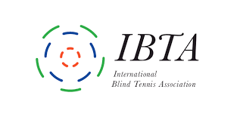

**Player survey**

**B3-B4 prototype balls**

Dear Player,

You are being given the chance to take part in a test to evaluate a new blind tennis ball which has been developed by Shoei Industries in Japan.

We would also really welcome your views and comments on any other balls which you have tried. In trying to arrive at an “ideal” ball we will need to see what works and doesn’t work with all the various options on offer.

The survey is anonymous. We will only collect details of the sight category and country.

Some questions can be answered with yes or no, but most of them are based on a 6 point scale. 1 being the lowest and 6 the most positive evaluation. The questions for each type of ball are identical, to help us compare your opinions.

After you have completed the survey, please send it back to your country representative, and copy to this e-mail address: [technical@internationalblindtennis.org](mailto:technical@internationalblindtennis.org)

Thank you very much for your feedback!

Martin

Martin Etheridge

Head of Technical

**SURVEY FORM – PLAYERS**

Country:

Sight Category:

Are you internationally classified?

How many hours a week do you train?

What is your level of play? Beginner/National/International

**What did you think about the new trial ball?** 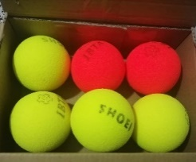

Please score from 1-6 (1 being lowest & 6 the most positive) and add any comments.

|  |  |
| --- | --- |
| Visibility: |  |
| Speed: |  |
| Bounce: |  |
| Sound: |  |
| Durability |  |
| Overall play: |  |
| How many weeks did you test? |  |
| General Comments: |  |

**How do these compare with other balls?**

Have you used any of the following balls?

If so how do they compare with the new trial balls?

Any comments on the other balls below would also be welcomed.

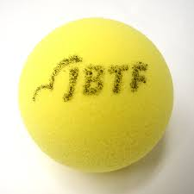 **Current official Shoei blind tennis ball**

|  |  |
| --- | --- |
| Visibility: |  |
| Speed: |  |
| Bounce: |  |
| Sound: |  |
| Durability: |  |
| Cost/Availability: |  |
| Overall play: |  |
| General comments: |  |

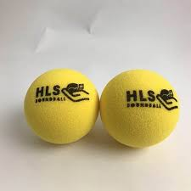 **HandiLife Ball (Denmark)**

|  |  |
| --- | --- |
| Visibility: |  |
| Speed: |  |
| Bounce: |  |
| Sound: |  |
| Durability |  |
| Cost/Availability |  |
| Overall play: |  |

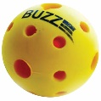 **Buzz Ball (UK)**

|  |  |
| --- | --- |
| Visibility: |  |
| Speed: |  |
| Bounce: |  |
| Sound: |  |
| Durability |  |
| Cost/Availability |  |
| Overall play: |  |

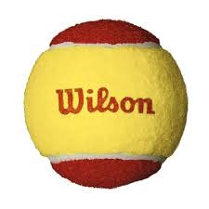 **Low pressure red ball:**

|  |  |
| --- | --- |
| Visibility: |  |
| Speed: |  |
| Bounce: |  |
| Sound: |  |
| Durability |  |
| Cost/Availability: |  |
| Overall play: |  |

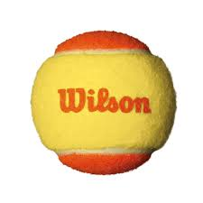 **Low pressure orange ball:**

|  |  |
| --- | --- |
| Visibility: |  |
| Speed: |  |
| Bounce: |  |
| Sound: |  |
| Durability |  |
| Cost/Availability: |  |
| Overall play: |  |

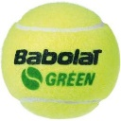 **Slower green ball:**

|  |  |
| --- | --- |
| Visibility: |  |
| Speed: |  |
| Bounce: |  |
| Sound: |  |
| Durability |  |
| Cost/Availability: |  |
| Overall play: |  |

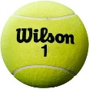 **Standard tennis ball:**

|  |  |
| --- | --- |
| Visibility: |  |
| Speed: |  |
| Bounce: |  |
| Sound: |  |
| Durability |  |
| Cost/Availability: |  |
| Overall play: |  |

**Any other balls?**

**Name:**

|  |  |
| --- | --- |
| Visibility: |  |
| Speed: |  |
| Bounce: |  |
| Sound: |  |
| Durability |  |
| Cost/Availability: |  |
| Overall play: |  |

**Name:**

|  |  |
| --- | --- |
| Visibility: |  |
| Speed: |  |
| Bounce: |  |
| Sound: |  |
| Durability |  |
| Cost/Availability: |  |
| Overall play: |  |