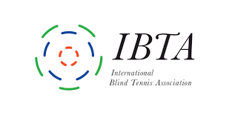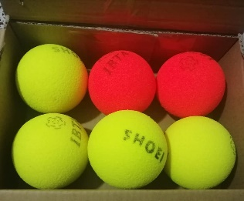
19th March 2021
Dear Country Representative,
TRIAL OF NEW PROTOTYPE BALLS – B3/B4
Your country was one of ten to be selected to test the new prototype B3-B4 balls developed by Shoei Industries. Thank you for volunteering and for agreeing to collect feedback from players and coaches.
To get the full picture it is important that as many B3 and B4 players from all levels of play are able to test the prototype ball along with their coaches.
The data will be collected anonymously so please encourage players and coaches to be open and honest with their feedback. If we could have one form per person – rather than a summary version – this will be helpful in picking up trends and ensuring nothing gets missed.
These forms can then be sent through you or to me direct by the player/coach at technical@internationalblindtennis.org.
When providing feedback on the new balls it would also be helpful to compare them with the full range of balls that B3/B4s are currently using.
If you also a player or coach, as well as country representative, please fill in the relevant coach/player survey separately. There are a small number of summary questions for you as country representatives below.
Appreciate Covid restrictions are delaying a return to play so please respond as soon as possible and ideally by 19th June 2021.
Thank you
Regards

Martin

Martin Etheridge
Head of Technical

B3/B4 – New Ball Trial (2021) - Country Representative Summary

Name:

Country:

Number of coaches involved in the test:

Total number of B3 players involved in the test:

Total number of B4 players involved in the test:

How did you carry out the test?

Any comments including what you would change in future tests?

