

IBTA Classification Rules and Procedures

This document sets out the latest IBTA Classification Rules & Procedures, which will take effect from the date of this document.
The Rules were designed in order to strengthen classification processes, to enable IBTA International Classifiers to perform classification assessments to a consistently high standard in every location, and to give reassurance to players that Classification will be conducted fairly and equitably, in full recognition of their rights as players.
IBTA is working towards full compliance with the IPC Classification Code and IBTA Classification Rules – in instances where these Rules are silent, the Rules contained in the IPC Classification Code and/or IBTA Classification Rules will apply.
It is relevant to point out that these Rules will be subject to further changes as IBTA moves towards full compliance with the IPC Classification Code.

Alistair Li Wan Cheun
Head of IBTA Medical Research & Development
20th November 2019

Section | Topic | Page
1 | Introduction | 3
2 | Eligibility Criteria | 4
3 | Player Evaluation | 6
4 | Sport Class Status | 7
5 | Blindfold requirements | 9
6 | Classification Not Completed | 10
7 | Intentional Misrepresentation | 11
8 | Classification Personnel | 13
9 | VI International Classifier Profile | 14
10 | Codes of Conduct | 15
11 | Protest Policy and Procedures | 18
12 | Classification Equipment and Environment | 20
13 | Medical Diagnostics | 22
14 | Photographs - VI Classification Equipment | 26

1 – INTRODUCTION
Classification provides a structure for Competition. Classification is undertaken to ensure that the player competes equitably with other players.
Classification has two important roles:
- To determine Eligibility to Compete
- To group players for Competition
Classification provides a systematic method for grouping players, according to their visual abilities, into "classes" which act as the framework for competition.
Prior to competing in IBTA-sanctioned Continental or World Championships, players must undergo Classification, carried out by an IBTA Classification Panel.
It is important to state that the IBTA Classification Rules and Procedures relate only to Blind Tennis, for which IBTA is the International Federation.

2 – ELIGIBILITY CRITERIA
Vision Impairment arises from a variety of conditions - genetics, prenatal developmental issues, or from illness or trauma.
Vision Impairment occurs when there is damage to one or more of the components of the vision system, which can include:
- impairment of the eye structure/receptors
- impairment of the optic nerve/optic pathways
- impairment of the visual cortex
Players are required to present a fully completed Medical Diagnostics Form (MDF) prior to classification; Players who do not present a fully completed medical diagnostics form will not be classified.

2.1 – Definition of Visual Classes
The determination of visual class will be based upon the eye with better visual acuity, whilst wearing best optical correction using spectacles or contact lenses, and Visual Fields that include central and peripheral zones.
B1: Visual acuity poorer than LogMAR 2.60
B2: Visual acuity ranging from LogMAR 1.50 to 2.60 (inclusive)
B3: Visual acuity ranging from LogMAR 1.0 to 1.40 (inclusive) OR Visual fields less than 10 degrees diameter and Visual acuity better than 0.5 (B4)
B4: Visual acuity ranging from LogMAR 0.5 to 0.9 (inclusive) OR Visual fields less than 40 degrees diameter and Visual acuity better than 0.5 (B4)

2.2 – Simultaneous acuity and field loss
Visual field loss present with acuity loss will also be compensated as follows:
Visual field constricted to a diameter of less than 40 degrees moves the player to one Class above e.g. B4 to B3 or B3 to B2, except for B2 which will NOT move into B1.
As an example, if a player has 1.4 LogMAR and 35 degree diameter visual fields, he is classified as a B3 through visual acuity and his visual field loss will move him one class up i.e to B2.
Visual field constricted to a diameter of less than 10 degrees moves the player to two Classes above e.g. B4 to B2, except for B2 and B3 which will NOT move into B1.
As an example, if a player has 0.9 LogMAR and 8 degree diameter visual fields, he is classified as a B4 through visual acuity and his visual field loss will move him two classes up i.e to B2.

2.3 – B1 class
B1 classification is through visual acuity ONLY. This is fair because B1 players have light perception at best. So it is unfair to have them play against players who have remaining functional visual acuity.
B1 players will play with blindfolds, but other classes cannot compete in B1, even if they wear a blindfold.

3 – PLAYER EVALUATION
The player must appear for Classification at the appointed time, prepared to be fully assessed by the Classification Panel, with their passport or other acceptable photographic evidence for identification purposes.
- Players must sign the Consent to be Classified Form prior to classification.
- The player’s photograph may be taken for Classification education purposes.
- If players have a health condition that will impair their ability to be classified, the Chief Classifier may, at their discretion and time permitting, re-schedule the evaluation. Ultimately, if players do not have a Sport Class and a Sport Class Status, they will not be eligible to compete at the competition.
- Players may appoint one person to accompany them during classification. This person should have an understanding of the player’s impairment and sport performance. If required, the person may be asked by the classifiers to assist with communication.
- Should the player require the presence of a translator, such individual (provided by the player) will also be permitted to attend.

4 – SPORT CLASS STATUS
The purpose of the Sport Class Status model is to assist Classifiers to identify those players whose visual ability is consistent over time, and those whose visual ability may change over time.
As a result, the following Statuses have been established, informed by the above factors:

4.1 – Confirmed (C)
Confirmed is a designated Status for players who have completed an IBTA Classification evaluation. Confirmed Status implies that the player’s visual ability is not likely to change over time. This Status will be assigned to players with a permanent, unchangeable condition. The player with a C status needs not undergo any classification in future.

4.2 – Review (R)
Review is a Classification Status for players who require:
a. Re-evaluation; or who
b. Have a fluctuating or changing condition that affects their vision, requiring them to be re-assessed at a later stage. If their vision does not change significantly after a prolonged period, and their sight class does not change, the players may be assigned confirmed status.
c. Are assessed for the first time as a New (N) Player. However, if in the opinion of the Classification Panel, the eye condition of a New (N) player will not change over time, they may be assigned the Status of Confirmed (C).
If the Status of Review is assigned, the player may compete at the event where the Classification took place; however, they must be reassessed before any subsequent competition.
Where a player is assigned Review with a year (e.g. Review 2018), it means they must be reassessed at their first event in that calendar year.
Review (R) Status may be assigned to players whose diagnosis has not been proven by the evaluation process. In such cases, the player will be expected to present the results of further diagnostic tests (e.g. Electrophysiology; Visual Fields; Computer Tomography), before the next classification opportunity for a sport class status to be assigned. Once the diagnosis has been verified, further re-evaluation may be necessary in order to verify stability of the condition.
Review Status is at the discretion of the Classification Panel, depending on fluctuating or variable conditions.

4.3 – New (N)
New Status is for players who have never been Classified before.

4.4 – NE
Not Eligible – Visual acuity better than LogMAR: 0.5 (6/19)
This Class is assigned to a player who does not meet the minimum visual impairment criteria. NE players are not permitted to compete in IBTA sanctioned competitions.
Players with a degenerative condition, and who do not currently meet the eligibility criteria, may do so at a future date. It is the responsibility of the relevant player, National Representative or National Federation to provide medical documentation showing a change in the level of vision of the player and submit a request for the player to be re-evaluated subsequently.

4.5 – Ineligibility Re-Evaluation
When a Sport Class Status of Not Eligible is assigned to a player by a Classification Panel, the player will be required to undergo examination by a second Classification Panel. Should that Classification Panel confirm the original status (NE), the player will not be permitted to compete at that competition and will have no further opportunity to Protest; the verdict of the second Classification Panel is final.
If a player is deemed ineligible for competition under the IBTA Classification Rules, this does not question the presence of a genuine impairment. This is solely a ruling on the eligibility of the player to compete under the Sport Rules of IBTA.

5 – BLINDFOLD REQUIREMENTS
Players competing in the B1 sport class are required to wear a blindfold as mentioned in section (2.3). Only proper blindfolds or eyeshades providing ample cover around the eyes, support and light obstruction will be accepted. Makeshift or non-sport specific blindfolds will not be accepted (Example: Sleeping masks). Similarly, damaged beyond functionality blindfolds (allowing the player to peek through or under) will also be rejected. Tempered blindfolds will be ground for disqualification.

6 – CLASSIFICATION NOT COMPLETED
If at any stage of Classification, the Classification Panel is unable to allocate a Sports Class to a player, the Classification Panel may designate that player as Classification Not Completed (CNC).
The designation Classification Not Completed (CNC) is not a Sport Class and is not subject to the provisions in these Classification Rules concerning Protests. The designation Classification Not Completed (CNC) will however be recorded for the purpose of the Classification Master List.
A player who is designated as Classification Not Completed (CNC) may not compete in that particular tournament.

7 – INTENTIONAL MISREPRESENTATION
A player who, in the opinion of the Classification Panel, is intentionally misrepresenting their level of visual ability will be considered to be acting in violation of the IBTA Classification Rules.
The player, and possibly support personnel, will be counselled by the Classification Panel of the need to try their best, and that they must not misrepresent their abilities, or the Classification will be terminated.
If a player intentionally misrepresents their abilities, the player will not be assigned a Sport Class or Sport Class Status and will not be permitted to compete at that competition.
In addition:
- The player will not be permitted to undergo further evaluation in that sport for a minimum of two years from the date on which the player intentionally misrepresented their abilities.
- The Chief Classifier will remove the Sport Class and Sport Class Status assigned to the player from the IBTA Classification Master List.
- The player will be assigned the Status of IM (Intentional Misrepresentation) in the IBTA Classification Master List.
- The player will not be permitted to undergo any further evaluation for any IBTA sanctioned tournament for a period of two years from the date on which the player intentionally misrepresented their abilities.
- A player, who on a second and separate occasion, intentionally misrepresents their abilities, will receive a lifetime ban from all IBTA sanctioned competitions and will be subject to other sanctions deemed appropriate by IBTA.

6.1 – Consequences for player Support Personnel
Player Support Personnel who assist or encourage a player to fail to attend player evaluation, to fail to cooperate, to intentionally misrepresent abilities, or disrupt the evaluation process in any way, will have sanctions imposed by IBTA.
Those who are involved in advising players to intentionally misrepresent abilities will be subject – at a minimum - to the same level of sanctions as those imposed on the offending player.
In these circumstances, reporting the Player Support Personnel immediately to the IBTA Head of Classification is a vital step in deterring intentional misrepresentation by a player.

6.2 – Consequences for Teams
If a player (who is taking part in a team sport such as for example Davies Cup format) is deemed Not Eligible/IM to compete, in violation of sections above, they may not be replaced by a substitute.

8 – CLASSIFICATION PERSONNEL
7.1 – IBTA International Classifier
An International Classifier is a person authorised by IBTA to evaluate players, whilst serving as a member of a Classification Panel.
International Classifiers are trained and certified by IBTA.

7.2 – Classification Positions
Head of Classification
The Head of Classification is a Classifier with responsibility for the direction, administration, co-ordination and implementation of Classification matters in IBTA.
Chief Classifier
The Chief Classifier is a Classifier responsible for the direction, administration, co-ordination and implementation of Classification matters at a specific Competition.
Classification Panel
A Classification Panel is a team of Classifiers appointed for a particular competition to determine Sport Class and Sport Status of players.
Each Classification Panel must include a minimum of two Classifiers, in order to ensure that IBTA has the capacity to deal with potential Protests, in addition to its Classification responsibilities. In the event of two panels not being available at a competition, there will be one panel consisting of two classifiers and the Head Classifier. The Head Classifier will review all Protests and Non Eligible.
During the competition, members of the Classification Panel must decline to undertake responsibilities that are not directly connected with Classification.

9 – IBTA International Classifier Profile
Acknowledging the uniqueness of the skills inherent in each practitioner, the following recommendations are made:
Prospective Classifiers must be either:
A. Ophthalmologist (with experience in low vision)
Or
B. Optometrist (with experience in low vision)

A prospective Classifier, having successfully performed Classification training under the guidance and supervision of a Certified IBTA International Classifier (and having successfully completed an official IBTA Classification Training Course), will then be recognised by IBTA as an official IBTA International Classifier.

10 – CODES OF CONDUCT
Introduction
This section outlines the specific requirements of players, Player Representatives and Classifiers during the classification process.
The specific requirements acknowledge the rights of all players to a fair, proper and respectful process for Classification in accordance with the level of their disability.
The purpose of the Codes of Conduct is to ensure that the process is carried out in a friendly, efficient, non-confrontational atmosphere - and is as unobtrusive as possible for the player.
Privacy is essential, and the results of the examination process are confidential.
Sport Class and Sport Class Status will be published shortly after the Classification process is over and before the start of competition.

9.1 – Player Code of Conduct
The player should appear for classification in clothes suitable for wearing during the examination process.
The player must be honest and provide complete and accurate information when presenting the history of their impairment, and in response to questions from members of the Classification Panel.
The player must acknowledge that they have signed the Classification Consent Form as part of their entry to the Classification process.
The player must co-operate willingly in the Classification process at all times.
The player must be aware of the consequences of their being either uncooperative or of demonstrating that they are minimising, disguising or distorting their level of visual ability.

Where such behaviour is displayed during the Classification Process, the player will be requested to take some time out for reflection, and to return within the following 30 minutes. If, during the subsequent evaluation, the player continues to refuse to cooperate, they will be assigned the Class of Intentional Misrepresentation (IM) and will not be permitted to compete at that competition (refer to section 5 Misrepresentation, for further details).

9.2 – Player Support Personnel Code of Conduct
One support person or coach is permitted to accompany the player during the Classification process.
At appropriate times, representatives may be involved in discussions with members of the Classification Panel. These discussions may include the history of the player’s impairment.
Player Support Personnel will be requested to sign an agreement indicating that they will promise:
- Not to disclose confidential medical information about the player, which they become aware of during Classification;
- That they will conduct themselves appropriately; that they will not, and have not, encouraged the player to misrepresent in anyway;
- That they are not aware of anyone who has counselled the player to misrepresent;
- That if they become aware or suspicious that the player is misrepresenting, or not showing their full ability during the Classification process, they will notify the Classification Panel;
- To counsel the player to provide full and accurate information, and co-operate fully with the Classifiers; Player Support Personnel must conduct themselves in a professional and appropriate manner at all times. Aggressive behaviour is never acceptable and will not be tolerated.

9.3 – Classifier Code of Conduct
Classifiers must wear appropriate identification at all times, particularly in the Classification Area and at the Competition Venue.
Within the examination rooms, Classifiers will wear either uniforms provided, or clothing appropriate for performing their responsibilities as Classifiers.
It is never permissible to wear national uniforms, pins, or any identification related to any specific country.
Only in exceptional circumstances will a Classifier be permitted to classify a player from their country.
The Classification process must be conducted in a professional and efficient manner, and the assessments must be respectful of the player.
The approved Classification Result Form will be completed after the Classification of each player. The player and their support personnel will be informed of the result in writing, and will also be informed of their right to Appeal.
The information gathered at the time of Classification will be made available to the Chief Classifier. Games officials will also have access to information required for the purpose of organising the sport specific competition. The list of Classifications from each session (of Classification) will be published in a manner that has been already announced to the Chef de Missions of all teams at the Competition.
Players will be informed of the right of their National Federation or National Representative to Appeal the decision.

11 – Protest Policy and Procedures
10.1 – Protest
The term “Protest” refers to the procedure by which a formal objection to a player’s Sport Class is made, and the method by which the Protest is subsequently resolved.

10.2 – Protest Procedure
Protests concerning the Classification of an individual player may be lodged, by their National Federation or National representative, by another National Federation or National representative competing at the event or by the Chief Classifier, under exceptional circumstances. A Protest will be subject to prior payment of a fee of €100, payable by the party lodging the Protest. Should the Protest be upheld, this fee will be reimbursed; should it be rejected, the fee will be forfeited.
The Chief Classifier will receive the protest form and review its merits, including discussions with the relevant Classification Panel. The protest may be either accepted as valid, or rejected as being without merit.
During the Protest Procedure, the player will be reassessed by an official Classification Panel (composed of Classifiers who did not take part in the original Classification process of that player or composed of the Head Classifier only in the event of only one Classification panel operating).
The player undergoing Classification must be accompanied by one more person of their choice, from their own delegation. This person may only participate in the Classification process when requested to do so by the Classification Panel. Should the player require the presence of a translator, such individual (provided by the player) will also be permitted to attend.
Players must cooperate at all stages during the Classification Procedure. Failure to cooperate fully during the classification process will result in a player being disqualified from the competition.
The decision of the Protest Panel is final.
A Protest during the Classification Evaluation period must be lodged within one hour of the end of the session during which the player was classified.
In the event of a Protest being lodged, IBTA will ensure that the Protest Procedure is put in place, and that the player involved is classified as soon as possible, in order to minimise impact on competitions. The outcome of the Protest Procedure will be deemed by all parties involved to be final, binding and not subject to further Protest (except by the Chief Classifier).
Protests “Out of Competition” will not be permitted.

12 – Classification Equipment & Environment
11.1 – Classification Equipment
The following Specified Classification Equipment is required on site for the duration of the Player Evaluations; items are required per Classification Panel (photos of equipment shown in Section 12):
- Berkeley Rudimentary Vision Test set (or STEs - Single Tumbling Es)
- LogMAR Test Chart (with illiterate E for distance visual acuity testing)
- Auto refractometer
- Box of Lenses with Frame
- Lensometer
- Ruler/Rod (30cm)
- Slit lamp (with +90D or 78D Volk Lens)
- Ophthalmoscope (direct)
- Tangent Screen, Targets and Patch (preferably white)
- Drops
  - Dilating (Tropicamide 0.5%)
  - Topical Anaesthesia (Proparacaine 0.5%)

In addition, the classification venue must possess one separate room containing the following Specified Classification Equipment (along with technical support):
- Automated Perimetry (either Goldmann VF Perimeter, Humphrey Field Analyser or Octopus Interzeag)
- Gonioscope (e.g. Sussman, Zeiss 4 mirror)
This room must be equipped with 2 tables and 4 chairs (two of which should be vertically adjustable).
11.2 – Classification Environment
One room must be provided for each Classification Panel.
One room, to act as a waiting area for players and support personnel, must be provided.
One separate room, designated as the Classification Office, must be provided. This room must contain a desk, three chairs, internet access and printing facilities.
Only one player, one support person, one translator (if required and provided by the player) and the Classification Panel (plus Chief Classifier), will be permitted inside the Classification Room.
Each room must be a minimum of 3mx7m in size physically (Not through mirrors)
There must be no great variation in luminosity between the waiting area and the classification room.
It must be possible to control the luminosity (brightness of the light source) in the room being utilised for classification.
The Classification Room and Waiting Room should have no natural light. Windows must be adapted to fully obscure outside light. Lighting should be of normal room illumination.
Players must arrive 30 minutes before Classification is due to take place, and remain in the Waiting Room until the Classification process commences.
Players are required to complete the first section of the Classification Form before entering the Classification room. The consent section must be signed by the player and, if underage, the Coach/Supervisor must countersign.
Only one individual may accompany the player during Classification. Such individual must remain out of sight of the VA charts. However, should the player require the presence of a translator, such an individual (provided by the player) will also be permitted to attend.

13 – Medical Diagnostics
Visual Classification, for the purpose of competing in Sport, is NOT a diagnostic procedure; however, supporting evidence relating to the type and nature of the impairment is vitally important and must be provided to IBTA in advance of the classification assessment.
The player is required to be assessed by an ophthalmologist or optometrist depending on local availability and to have the results of such assessment recorded on the Medical Diagnostics Form.
Medical Diagnostics Form for players with Visual Impairment (see below)

MEDICAL DIAGNOSTICS FORM FOR PLAYERS WITH
VISUAL IMPAIRMENT

The form is to be completed in English and by a registered ophthalmologist or optometrist.
All medical documentation required on pages 2-3 needs to be attached.
The form and the attached medical documentation may not be older than 12 months at the time of the Player Evaluation.

Player Information

Last name:
First name:
Gender: | Female  | Male  | Date of Birth:
Sport: |  |  | IF registration ID  (if applicable):
Country:

Medical Information

Diagnosis:

Medical history:
Age of onset:
Anticipated future
procedure(s):
Player wears
Player wears |  yes |  no | Correction: | Right:
glasses: |  |  |  | Left:
Player wears |  yes |  no | Correction:
 |  |  |  | Right:
contact lenses: |  |  |  | Left:
Player wears eye |  right |  left
Player wears eye |  right |  left |  no
prosthesis:
Medication:
Eye medications
used by the player:
Ocular drug allergies:

Player’s name:

Assessment of visual acuity and visual field
Visual Acuity _{(LogMAR)}

 |  |  |  | Right eye | Left eye
With correction
Without Correction
Type of correction:
Measurement Method:
Visual Field:
In degrees (radius) |  |  | Right eye |  | Left eye

Attachments to the Medical Diagnostic Form
1. Visual field test

For all players with a restricted visual field a visual field test must be attached to this form.

The player’s visual field must be tested by full-field test (120 degrees) and a 30 degrees, 24 degrees or 10 degrees central field test, depending on the pathology.
One of the following perimeters should be used for the assessment: Goldmann Perimetry (Intensity III/4), Humphrey Field Analyzer or Octopus (Interzeag).
2. Additional medical documentation

Please specify which eye condition the player is affected by.

Eye condition | Additional medical documentation required (see below)
 Anterior disease | none
 | ▪ | Macular OCT
 Macular disease | ▪  Multifocal and/or pattern ERG*
 Macular disease | ▪ | VEP*
 | ▪ | Pattern appearance VEP*
 Peripheral retina disease | ▪ | Full field ERG*
 Peripheral retina disease | ▪ | Pattern ERG*
 | ▪ | OCT
 Optic Nerve disease | ▪ | Pattern ERG*
 Optic Nerve disease | ▪ | Pattern VEP*
 | ▪ | Pattern appearance VEP*
 Cortical / Neurological | ▪ | Pattern VEP*
 Cortical / Neurological | ▪ | Pattern ERG*
disease | ▪ | Pattern ERG*
disease | ▪ | Pattern appearance VEP*

Player’s name:
The ocular signs must correspond to the diagnosis and degree of vision loss. If eye condition is obvious and visible and explains the loss of vision, no additional medical documentation is required. Otherwise the additional medical documentation indicated in the above table must be attached to this form. If the medical documentation is incomplete, the classifiers will not be able to allocate a sport class.
*Notes on electrophysiological assessments (VEPs and ERGs):
Where there is discrepancy or a possible discrepancy between the degree of visual loss, and the visible evidence of ocular disease the use of visual electrophysiology is often helpful in demonstrating the degree of impairment.
Submitted data should include the report from the laboratory performing the tests, copies of the original data, the normative data range for that laboratory, and a statement specifying of the equipment used, and its calibration status. The tests should be performed as a minimum to the standards laid down by the International Society for Electrophysiolgy of Vision (ISCEV) (http://www.iscev.org/standards/).
A Full Field Electroretinogram (ERG) tests the function of the whole retina in response to brief flashes of light, and can separate function from either the rod or cone mediated systems. It does not however give any indication of macular function.
- A Pattern ERG tests the central retinal function, driven by the macular cones but largely originating in the retinal ganglion cells.

- A Multifocal ERG tests the central area (approx. 50 degrees diameter) and produces a topographical representation of central retinal activity.
A Visual evoked cortical potential (VEP) records the signal from produced in the primary visual cortex, (V1), in response to either a pattern stimulus or pulse of light. An absent or abnormal VEP is not in itself evidence of specific optic nerve or visual cortex problems unless normal central retinal function has been demonstrated.

  - A Pattern appearance VEP is specialised version of the VEP used to establish visual threshold which can be used to objectively demonstrate visual ability to the level of the primary visual cortex.
- I confirm that the above information is accurate.
- I certify that there is no contra-indication for this player to compete at competitive level in sport, with the exception of:

Name:

Medical Specialty:

Registration Number:

Address:

City: Country:
Phone: E-mail:
Date: Signature:

14 – Photos of VI Classification Equipment
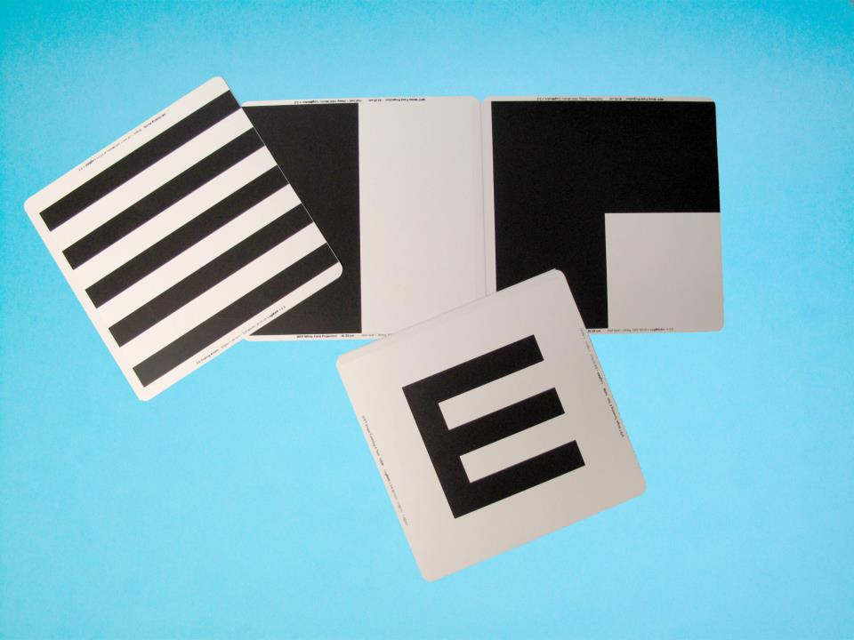
Berkeley Rudimentary Vision

Test charts (“BRVT charts”)

Set includes three small charts:
- Single Tumbling E charts
- Grating Acuity charts (with stripes)
- White Field Projection charts (larger black and white fields)

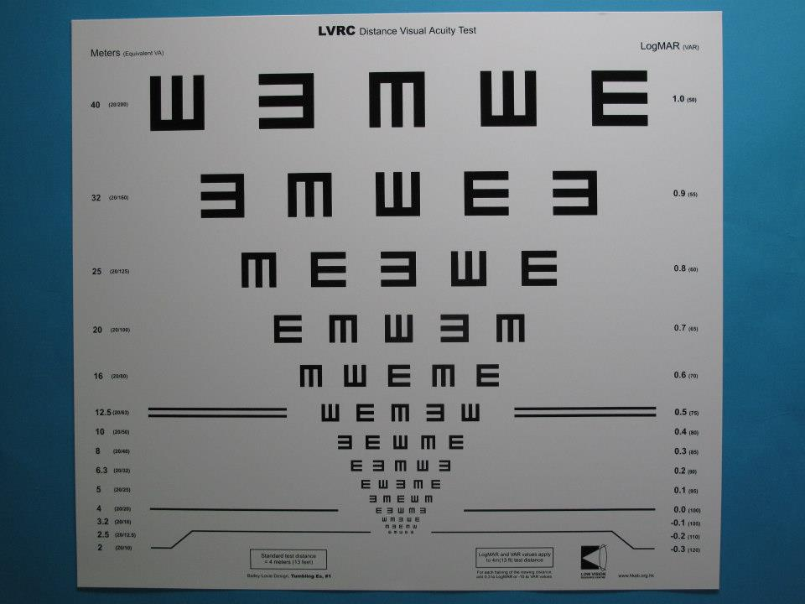
LogMAR Test Chart Illiterate E for Distance Visual Acuity Testing

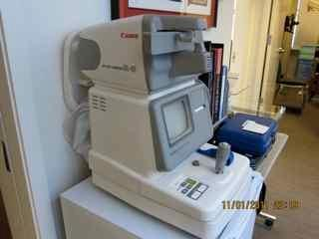
Auto Refractometer

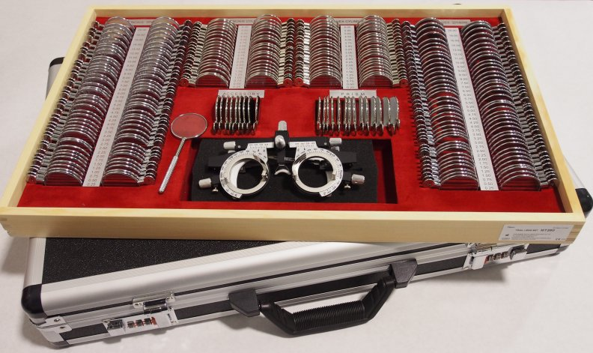
Box of lenses with frame

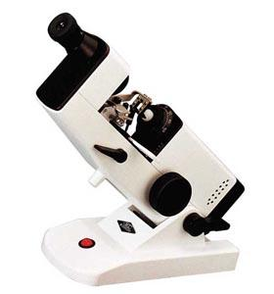

Lensometer

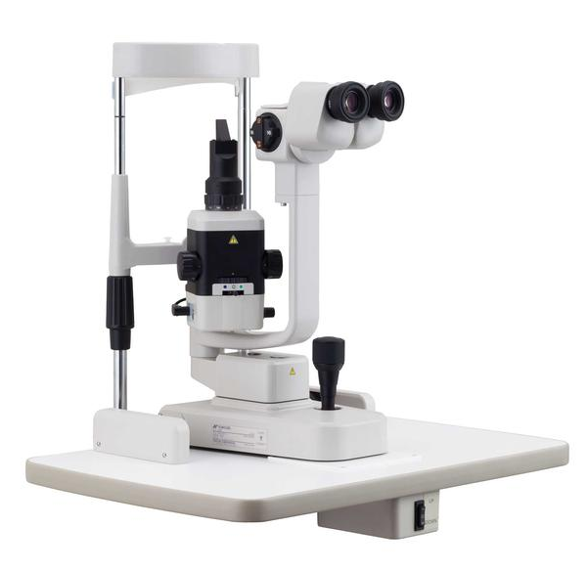
Slit lamp With +90D lens

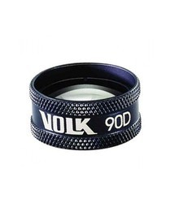
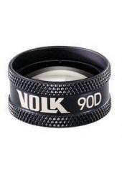

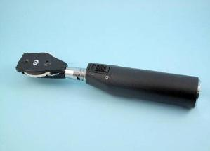
Direct Ophthalmoscope

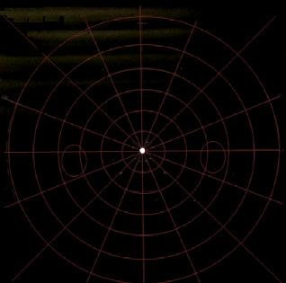
Tangent Screen

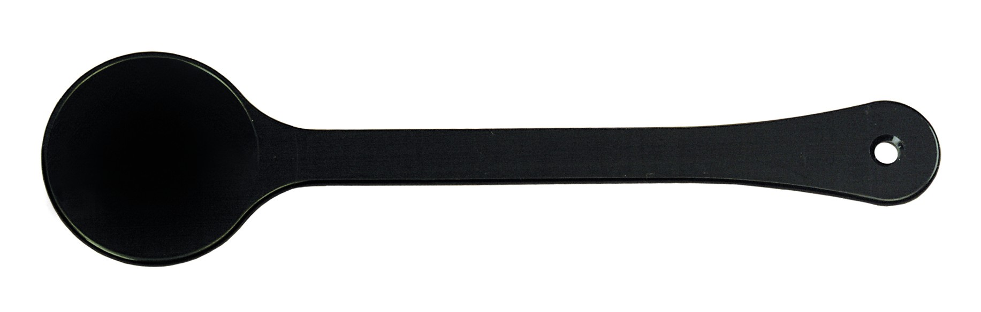
Occluder

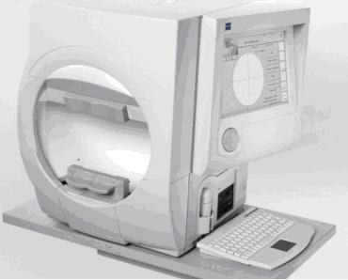
Automated perimeter
(Example: Humphreys)

