ASSUMPTIONS LIST

Identify which assumptions you should focus on verifying

Assumptions | Risk |  | Consequence
 | 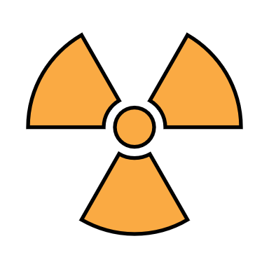
List of Assumptions: | The risk that the assumption does not hold. |  | The consequences if the assumption does not hold.
 | Low  Medium  High | ☐  ☐  ☐ | Low  Medium  High | ☐  ☐  ☐
 | Low  Medium  High | ☐  ☐  ☐ | Low  Medium  High | ☐  ☐  ☐
 | Low  Medium  High | ☐  ☐  ☐ | Low  Medium  High | ☐  ☐  ☐
 | Low  Medium  High | ☐  ☐  ☐ | Low  Medium  High | ☐  ☐  ☐
 | Low  Medium  High | ☐  ☐  ☐ | Low  Medium  High | ☐  ☐  ☐
 | Low  Medium  High | ☐  ☐  ☐ | Low  Medium  High | ☐  ☐  ☐
 | Low  Medium  High | ☐  ☐  ☐ | Low  Medium  High | ☐  ☐  ☐

When you’ve identified your assumptions, you need to test them. Start with the ones that will have the most severe consequences if the assumption doesn’t hold true.
If there’s a medium or high risk that the assumption might not hold, you should work on mitigating actions to reduce the likelihood of it occurring or the consequences.

