Private Day Nursery for children aged
3 months - 5 years

Golden Star Day Nursery

Nursery Prospectus

Dear Parent/ Carers
Thank you for your valued interest in our Nursery which is an integral part of Golden Star Day Nursery.
We believe our Nursery should be at the heart of the community, which is why we work in close partnership with our parents, our junior school, playgroups and the community. We see our parents as the child’s first educator and strive to involve them in all areas of the child’s nursery experience. We aim to settle in every child in our Nursery environment so that we can learn more about them and to give you the opportunity to ask questions, share information and meet us in a familiar setting for your child.
We nurture and care for your child to ensure that their transition from the familiarity of home into our environment allows both you and your child to feel confident in our care. We recognise and celebrate that all children are individuals and we encourage them to become confident, independent and to develop their own sense of self.
We want all our children to:
• have the best possible experience as they start their education and work closely with parents and carers to make this possible.
• be enthusiastic to attend Nursery, love their learning and to be proud of their achievements.
• be healthy and stay safe and to be caring and respectful towards others. Our teachers plan for a wide range of learning opportunities that match the interests and the needs of the children. Tours of the Nursery have been arranged for prospective parents – these are published on the website and can be booked with the office. We hope you will enjoy learning about our Nursery and look forward to welcoming you on one of our tours.
Nursery Manager: Reshma Begum
Golden Star Day Nursery
116 Evelyn Dennington Road
Beckton E6 5YU
Contact No:
Email: Goldenstarnursery7@gmail.com

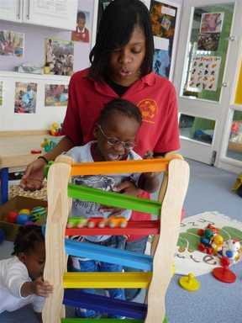

Why should you choose us for your child care? We believe that we offer every child the very best start to their education and success in life. Here are some of the reasons why:
Safeguarding is of paramount importance and we have an excellent record for this.
We offer flexible hours with the option of children staying for lunch or for both Nursery sessions.

Our Nursery children are taught by experienced, qualified teachers supported by qualified Early Years Practitioners.
We offer a fantastic, stimulating indoor and outdoor environment.
Golden Star Day Nursery

We offer a comprehensive transition programme to support children with their move to Reception.
Our Early Years Foundation Stage team has been awarded Gold for the Early Years Standards accreditation.

Our Nursery is fully integrated with the school and the traditions, celebrations and resources it has to offer.
The children are at the heart of all our decision making and practices.

The Structure of a Typical Nursery Session
Arrival at Nursery | The children go to their key worker group and take part in a simple activity to develop their fine motor, literacy or mathematical skills before the register is taken and we sing our welcome songs.
Teacher Learning | Learning Owl shares with each Key Person group what they will be learning to do that day. The teacher works with small groups on an activity related to one of the areas from the curriculum.
Learning  Through Play | The children decide which area they would like to play in and are given time to develop their ideas and pursue their interests.
Snack Time | The children come back together in their Key Person groups to share a drink and a snack. This is also used as a teaching time and for group discussion.
Phonics | The children stay in their Key Person groups for Phonics. They play various games and join in activities designed to develop their phonic knowledge and awareness.
Learning Through Play | Again, our highly qualified practitioners interact with and observe the children in their play, supporting them to develop their skills and understanding.
Story | Typically the session ends with a story before the children sing the ‘Good bye’ song to mark the end of the session.
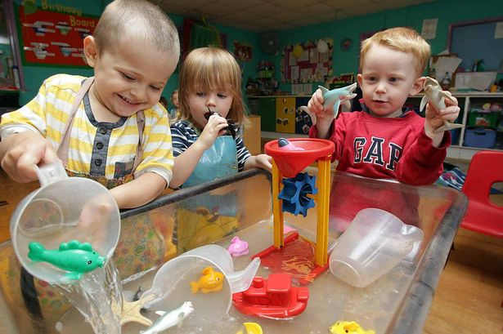

Our Nursery Environment
Our Nursery building is attached to the main school, with its own, large outdoor area which is shared with the Reception class. Risk assessments are carried out daily and our site manager is on hand to address any maintenance issues as they arise.
Outdoor Area We know how important outside space is to all children and that many children learn best when they are outdoors. The children in our Nursery have daily access to the outside area. There are canopies to give shade in the summer as well as shelter from the rain. Our equipment provides the children with many opportunities to develop their skills. These are some of the many fantastic things that our outdoor area has to offer.
Role play shed
Sand Play
Sensory Garden
Digging

Water Play
Bicycle & Tricycle
Boys Den
Mud Kitchen

Planting & Growing
Art area
Climbing wall
Construction area

The Nursery has regular access to the school’s Woodlands area, where the children can benefit from further outdoor learning activities. We are also able to take advantage of the larger school playground with its extensive range of play equipment.
Indoor Area
Our purpose-built Nursery is warm and inviting with a quiet cosy area to relax and where children listen to, or share a story. There are two main carpet areas, where the key worker groups share time together and where the children can have space to build, and engage in imaginative play. The wet area is where the children enjoy exploring the water and sand or producing art work. The role play supports children to re-enact their own experiences and is changed regularly to match the children’s interests. The toilets are just the right size for the children to use, with sinks at an appropriate height to enable independence.
How and What We Teach As a Nursery, we follow the Early Years Foundation Stage Curriculum.
This covers three Prime areas:
• Personal, Social and Emotional Development
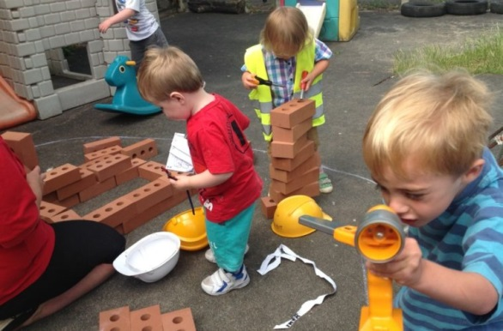
• Communication and Language
• Physical Development

It also includes four Specific areas:
• Literacy 1
• Mathematics
• Understanding the World
• Expressive Arts & Design
Our environment is set up to support children’s learning through all these areas in their play.
Experienced, qualified teachers plan the teaching activities and resources each week so that the children are constantly stimulated and taking their learning forwards. We encourage the children to take ownership of their learning and to talk about their ‘next steps’. Each child has a personalised ‘next step’ to work on.
Meals and Nutrition
A healthy balanced diet is provided in our Nursery all meals are cooked on site by our chef cook lunch at 11am, a light tea at 3pm with snacks provided mid-morning and afternoon. Breakfast is offered to the babies in the Seedlings department as part of their weaning programme and is served between the hours of 8am to 8.45am. Menus operate on a four week rota and all meals are home cooked and nutritionally well-balanced. We are a nut free nursery and all ingredients used in the preparation of food are fresh from the farm shop or sourced as locally as possible.

Nursery Education Funding
Every child is eligible to claim Nursery Education Funding from the term immediately after their 3rd birthday, and we will register your child when the time comes. The grant provides a maximum of 15 hours, which can be offered in several different ways, during term time only. More details of this can be found on a separate letter which you will receive nearer to your child’s 3rd birthday.
After School/Holiday Club
- Picking up from most local schools
- Provides nutritious meals
- Age appropriate exciting activities
- Abundance of outdoor experiences in the park and surroundings
Our Application Process
We will book you for a tour of the Nursery and will talk through the admission process.
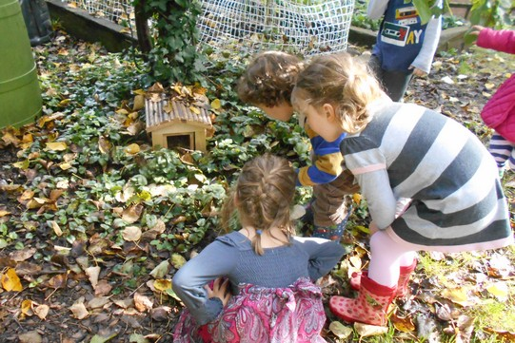
Once a child is booked in we aim to be as flexible as possible and, subject to availability, we may be able to offer extra “occasional sessions” if parents need to work extra days or just enjoy some free time.

How to find us:
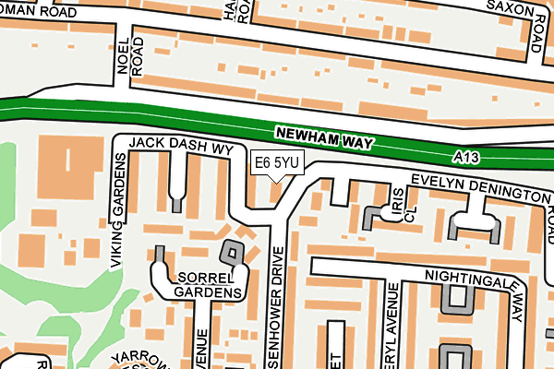

Address: 116 Evelyn Denington, Beckton, E6 5YU

Security;

All parents/carers are requested to use the main door for entry and exit. This door is permanently locked and requires a member of staff to allow entry. NO ONE is allowed entry into the nursery unless they are known by staff members. Golden Star requires an ID photo of anyone who will be collecting your child and we have set up a system of family passwords as a secure system and parent photo board for pick-ups and drops. We ask that you keep Golden Star Nursery up to date with any changes regarding your child and family.
As part of our security policy, it is requested that parents do not open the door for other parents, even if they know who they are.

Safeguarding
The safeguarding of everyone connected with our Nursery and school is of paramount importance. All staff and volunteers must have an enhanced DBS check before they can work with the children. Volunteers are also asked to read, sign and adhere to the points made in the Volunteers Handbook, which relate to safeguarding and health and safety.
We look forward to hear from you for on experimental tour at Golden Star Nursery.

