**6. Preparation of Flongle Flow Cell (R.10.4.1) and Flow Cell Check**

1. **Insert the Flongle Adapter in the MinION (Wear gloves to avoid contaminations!)**

Open MinION and take out the configuration test cell (CTC).

|  |  |  |
| --- | --- | --- |
| Ein Bild, das blau enthält.  Automatisch generierte Beschreibung | Ein Bild, das drinnen, Elektronik, Mobiltelefon enthält.  Automatisch generierte Beschreibung | Take CTC protection out of the Flongle adapter.  Push the Flongle adapter under the stainless steel clip till it snaps in place. |

[](https://www.youtube.com/embed/Wnx59DhrUe8?feature=oembed)

Click on the picture to see a movie about   
the procedure. 🡪

**Alternative:** Open following link in your browser https://www.youtube.com/embed/Wnx59DhrUe8?feature=oembed

1. **Connect MinION with the PC**

|  |  |
| --- | --- |
| Ein Bild, das Text, drinnen, Elektronik enthält.  Automatisch generierte Beschreibung | Connect PC with MinION by USB cable.  🡪 MinION gets access to electricity and LED is shining red. |

1. **Insert Flongle Flow Cell R.10.4.1 in the Flow Cell Adapter**

|  |  |  |
| --- | --- | --- |
| Ein Bild, das Text, drinnen enthält.  Automatisch generierte Beschreibung | Ein Bild, das drinnen, blau enthält.  Automatisch generierte Beschreibung | Push the Flongle Flow Cell in arrow direction under the stainless steel clip of the MinION and press it down on the other side.  🡪 with a click Flongle Flow Cell snapps in. |

1. **By a double click MinKNOW program is started.   
   Log in with your Nanopore account** (Email and password)**.**

|  |  |  |
| --- | --- | --- |
|  | Click the following link to log in Nanopore homepage:  <https://community.nanoporetech.com/support>  Log in with your Email and password. |  |

1. **Select in the Connection Manager the sequencing device which is connected to your PC.**

|  |  |  |
| --- | --- | --- |
|  |  | In the sequencing overview Flongle Flow Cell is shown. |

1. **Navigate to Start and select „Flow Cell Check“**

|  |  |  |
| --- | --- | --- |
|  | Ein Bild, das Text, Elektronik enthält.  Automatisch generierte Beschreibung | Click button Flow Cell Check. |

1. **Add Flongle Flow Cell ID and select Flongle Flow Cell Type R.10.4.1**

|  |  |  |
| --- | --- | --- |
| Ein Bild, das Text, draußen, Schild enthält.  Automatisch generierte BeschreibungEin Bild, das Text, Screenshot, Monitor enthält.  Automatisch generierte Beschreibung |  | Add Flongle Flow Cell ID (3 letters and 3 numbers without a space).  Select Flow Cell type R.10.4.1  Click on **start** Flow Cell Check. |

**Flow Cell Check takes some minutes.**

Click on **Experiments** and the **current** **Flow Cell Check** to see parameters (temperature, voltage, available pores) during the Check:

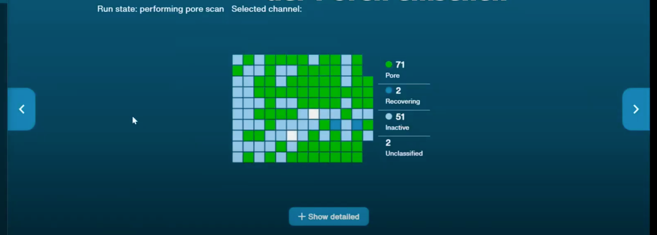

At the end of the Flow Cell Check one of the 3 following results will be shown:

|  |  |  |
| --- | --- | --- |
|  |  |  |

A result of the Flongle Flow Cell check with more than 50 pores abailable is fine.   
**🡪** **The green arrow shows „Ready for sequencing”**

**Next step is priming the Flow Cell.**