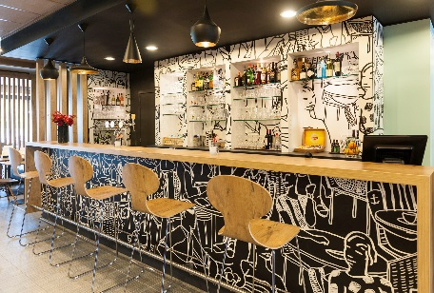
Please send your booking form to : H9958-fo@accor.com

BOOKING FORM – ref EPTA BELGIUM

EPTA – November 21 to 26, 2023

Deadline for registration: no later than October 25, 2023
NAME : Firstname :
Phone number: Email address:
Arrival date: Number of nights:
Departure date:

Type of room :
- Single – Double (1 big bed) – Twin (2 single beds)
- Triple room (1 big bed + 1 single bed)
- Quadruple room (1 big bed + 2 single beds)

Rates per night

- 69 euros per single room with wifi included
- 79 euros per double/twin room with wifi included
- 89 euros per triple* room with wifi included
- 99 euros per quadruple* room with wifi included
*upon availability

- City tax: 1 euro per person per night
- Breakfast buffet : 11 euros per person per night

Payment at the check out

LATE ARRIVAL
Your room reservation must be accompanied by a valid credit card number as guarantee.
Cancellation conditions:
- Any cancellation or change of reservation must be sent in writing (fax or email) directly to the hotel and within 72 hours before the arrival date. Beyond this deadline, the hotel reserves the right to charge the first night of the reservation.
- Cancellations and/or modifications will only be considered valid if they are confirmed in writing by the hotel.
- In case of no-show, the 1st night of the reservation will be charged on the credit card given as guarantee and the reservation will be maintained until the day after the arrival date till 10:00 am. After that term, the room will be considered free and available for sale.

Credit card details expiration date :

VISA
MASTERCARD
AMERICAN EXPRESS

Signature

