

**E - Portfolio Migrants - Supporting migrants in acquiring soft skills to develop employability and** **entrepreurship**

Project no: 2021-1-BE02-K220-ADU-000037789

**Soft Skills Framework**

**Aims & Objectives**

These activities were implemented as a part of Project Result 2: Portfolio for Migrants. Learning for Integration tested two activities, Language Café and Ethics Training activities. Both activities were tested in our weekly language cafes, which provide the perfect environment for the activities due to their informal nature.

The language café activity is an informal way to practice speaking and spoken communication in a second language, which also enhances overall communication skills. It is also a good way of creating social contacts and integrating migrant learners in the home country by meeting locals and learning about the culture.

The Ethics Training is an activity that aims to develop sense of ethics in a community and to explain concepts e.g. respect, honesty, integrity, diversity, professional practices and fairness, and crucial to workplaces ensuring the most successful workplace for employees and a healthy environment.

**Activity 1: Language Cafe**

1. **Name of the method/activity**

Language cafe

1. **Purpose of the method/activity**

To practice L2 language (and languages in general) in an informal way, especially focusing on spoken language and improving conversation and communication skills. The language café is easy to establish, only some preparation work is needed for finding a suitable venue (or it can be organized in the classroom), as well as some tutors for different languages where needed. The language café not only serves as a place to practice spoken language but also for networking and creating social connections in the migrants’ new home country.

1. **Description of the target group (learner group) + size of the group**

The group of learners can vary from big to small – in a big language café, there can be several different groups/tables for different languages, or the same language can be divided into several groups/tables. To ensure effective communication, the groups/tables should be 4-6 persons in size.

1. **Resources (materials needed) for the method/activity**

* Time: 1-2 hours
* Pen, paper, flashcards, games, worksheets, books, texts – different kinds of material can be used to facilitate discussion and provide topics and themes for the language table. These can include flashcards that have pictures or words for basic vocabulary (for beginners), discussion and debate cards with different topics that can be discussed (for more advanced), as well as cultural material, such as topics related to the local culture and language, local people etc. Also games, such as word explanation game (each person explains a word and the others have to guess), name game (each person gets a name of a known person and has to describe them), memory game and many others are good ways to practice the language.

1. **Detailed description of the method/activity**

* **Objectives**

A language café is an informal way to practice speaking and spoken communication in a second language. It is also a very good way of creating community spirit and social relations within a group, for example students on a course can get to know each other better, or migrants can practice the native language of their new home country and a way for locals to practice the languages migrants speak and to teach their native language. It is also a good way of creating social contacts and integrating migrant learners in the home country by meeting locals and learning about the culture.

* **Skills gained**

Improving spoken language skills in a second language and verbal communication skills overall, learning to create social connections in a second language. The learners can also learn about other cultures and learn to connect with people from their new home country as well as from other countries, when speaking with learners from different cultural backgrounds.

* **Step-by-step description of the procedure**

The language café can be organised once a week or several times a week either in a classroom or in a more informal venue, such as a café, restaurant, library, etc. The organiser will have signs for the languages spoken in the cafe, which will be placed on different tables. It helps to be organised, even though the participants should be able to choose freely which languages they would like to speak or teach (depending how many languages there are available).

If possible, there is a tutor at each table who is a native speaker of the language spoken at that table, and they facilitate the conversation by offering topics or providing material, such as picture cards for beginners, or discussion or debate cards on different themes or topics for more advanced learners (as described above). Also different games can be played that require the use of vocabulary, such as word explanation game or memory game.

* **Outcomes**

Strengthening the learners’ skills in speaking and communicating in a second language, improving communication skills overall, as well as creating social connections between a group of learners. The learners will become more confident in using the spoken language in L2. In a group with learners from mixed cultural backgrounds, the learners can also learn about other cultures and share information about their own.

1. **Evaluation of the activity/method**

* **Evaluation criteria**

The method can be evaluated with questionnaires to the participants, using questions such as:

Have your spoken language skills improved?

Do you feel the method is useful for your language learning?

Any improvement/ suggestions?

* **Frequency, levels etc**

The method can be applied with any level of language learners.

1. **Example of worksheet/material (as an annex)**

*Example of flashcards (pictures of fruit)*



**Report 1**

The method was tested with a group of 17-20 language learners who regularly attend language cafés in Helsinki, Finland. The attendees consisted mainly of foreigners living in Finland and wishing to improve their Finnish skills and practice spoken Finnish, but there were some native Finnish speakers practising other languages. There was also a Finnish tutor helping especially those with lower Finnish skills. At the end, we conducted a survey among the foreign participants who wish to learn Finnish and asked them to evaluate how useful attending the language café is for their language development. 12 people answered the survey.

Out of the respondents, all of them evaluated that the language café was either very useful or useful for their language learning. They were particularly happy with being able to practice spoken language with native speakers using real conversations, which improves their speaking skills and also vocabulary. They were also happy with the social aspect of the café and creation connections and friendships with both other migrants and locals.

The suggestions for improvement were to find a more quiet venue, and to separate the groups more into levels, as some of the beginners had trouble following the more advanced groups.

We can conclude that the language café is a good practice with many benefits of using natural spoken language with natives and non-natives, creating social connections and improving confidence in your language skills.

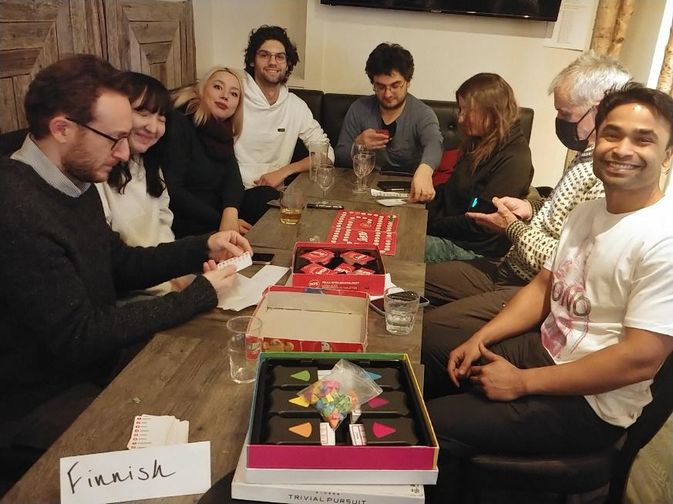

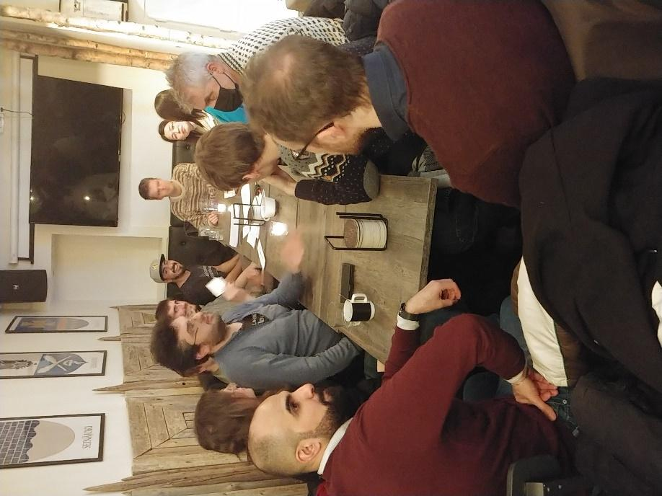

**Activity 2**

1. **Name of the method:** Ethics training
2. **Purpose of the method:**

In order to harmonize and shape the personal behavior/behavioral actions of a person according to specific societal expectations, we have to create this kind of training. Ethics training is important also to explain concepts e.g. respect, honesty, integrity, diversity, professional practices and fairness, and crucial to workplaces ensuring the most successful workplace for employees and a healthy environment.

1. **Description of the target group (learner group) + size of the group**

All members of a specific group e.g. migrants, company. There isn’t a limited number of participants, but it would be ideal to offer this sort of training frequently with not so many participants, so the training feels more personal and so that the training has a meaningful impact in one’s life. In our case, the ideal amount is 15.

1. **Resources (materials needed) for the activities**

* A room for the training;
* Materials prepared by the organizer e.g. slide presentation and role play cards.

1. **Detailed description of the activity**

* **Objectives**

Here the activity is a training, where an organizer will prepare an ethics training with the necessary ethics skills one needs to succeed in a specific society. At the end, the participant should be able to behave ethically and therefore integrate themself easier in the new local.This has also the goal to check off the necessary boxes in terms of reaching ethical compliance.

* **Skills gained**

Skills necessary to evaluate a situation as right or wrong based on decisions, behaviors, or outcomes.

* **Step-by-step description of the procedure**

The organizer of the training should prepare:

* 1. A slide presentation with the content: create a solid foundation of values of Spain in order to successfully articulate the Spain market ethics to the migrants.
  2. (Group collaboration: by splitting the participants into breakout groups to talk, share and work together on the presented material, and then bringing it to light to the organizer./Optional)
  3. Role Play: it’s easy for the organizer to simply explain what behavior is considered good or bad, or to thoroughly explain how to fix a specific problem. But most real-life issues that arise are nestled in an unclear gray area. Role playing a scenario allows participants to work through ethical dilemmas that might arise in one’s life, debating the variables of the situation and best practices in handling it having in mind the 5 principal of ethics: respect, honesty, loyalty, equality, responsibility. The organizer can separate the participants in groups and ask them to role play specific scenarios they might face in their life in the new place. Sequentially, the organizer can ask them to present it to the larger group, which can lead to improving their oral competences and they can learn from the behavior of others. This way the facilitator can focus on the pros and cons of the various decisions of the migrants and this will internalize the lessons learned.

Gamification and role-playing make the learning process more entertaining and makes it easier for the participants to walk away with the required knowledge. Role-playing games can be an effective way to teach and reinforce ethical behaviors in a company. The goal of the role-playing game is to encourage participants to think about the ethical implications of their actions and to practice making ethical decisions in a safe and supportive environment.

* **Outcomes**

At the end of the training the participant should have gained ethics skills, enabling them to judge the moral legitimacy of their decisions and to apply the learnt moral principles in the new local. Furthermore, the migrant should be able to differentiate what is socially acceptable and what isn’t in the environment.

1. **Evaluation of the activities/session/method/**

* **Evaluation criteria:**

evaluation of the group collaboration and role-play activity; the oral presentation part will help them to improve their oral capacities, and at the same time learn from each other.

* **Frequency, levels etc:**

one-time activity or offer a second session to make sure all that was learnt in the first session was fully understood and indeed incorporated into one’s personal and professional life.

1. **Example of worksheet/material (as an annex)**

Example of the Role Play cards the organizer can give the group of migrants.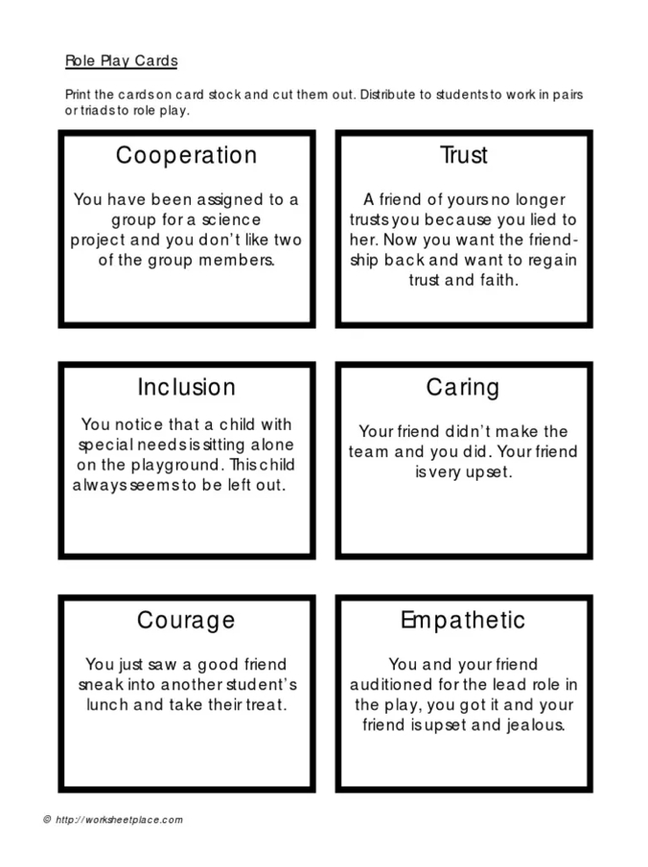

**Report 2**

We tested the Ethics Training activity with a group of 15-17 language learners in one of our language cafes in Helsinki, Finland. The attendees consisted mainly of foreigners living in Finland and wishing to improve their Finnish skills. We divided the group of learners into two groups and distributed the Ethics Cards with role play scenarios between the group members. Then each member had to read their scenario and choose one other member of the group to do the role play with them. At the end, we asked the foreign participants of each group their opinion on the activity and how useful it was for them in terms of learning about ethical questions that may be relevant to living in Finland.

According to the participants’ feedback, the activity was very interesting and due to the fact that there were also Finnish participants in the group, they learned a lot about how ethical questions, such as the ones in the role play cards, are tackled in Finland. This gave them insight into Finnish culture. They said the role play made them think about how to deal with ethical behaviour in certain situations overall, but especially when living in their new home country.

