O-LED
/*
www.E2CRE8.be - Brainbox Arduino - by Bart Huyskens
04/01/2016
This program blinks the 2 leds on the Brainbox Arduino with 300msec intervals
-the BLUE LED at D13
-the RED LED at D17
*/

// these lines make it possible to use pin names instead of pin numbers
// Constants do not change during the program
const int LED_BLUE = 13;
const int LED_RED = 17;

// this setup function runs once when you press reset or power the board
void setup() {
// initialize digital pins 13 and 17 as outputs.
pinMode(LED_BLUE, OUTPUT);
pinMode(LED_RED, OUTPUT);
}

// this loop function runs over and over again forever
void loop() {
digitalWrite(LED_BLUE, HIGH); // turn the BLUE LED on
digitalWrite(LED_RED, LOW); // turn the RED LED off
delay(300); // wait for 300 msec
digitalWrite(LED_BLUE, LOW); // turn the BLUE LED off
digitalWrite(LED_RED, HIGH); // turn the RED LED on
delay(300); // wait for 300 msec
}

O-Buzzer V1 met Delay
/*
www.E2CRE8.be - Brainbox Arduino - by Bart Huyskens
04/01/2016

This program blinks the 2 leds on the Brainbox Arduino with 300msec intervals
-the BLUE LED at D13
-the RED LED at D17
*/

// these lines make it possible to use pin names in stead of pin numbers
// Constants do not change during the program
const int Buzzer = 7;

// this setup function runs once when you press reset or power the board
void setup() {
// initialize digital pin Buzzer as output
pinMode(Buzzer, OUTPUT);

}

// this loop function runs over and over again forever
void loop() {
digitalWrite(Buzzer, HIGH); // make signal High for 1 msec
delay(1); // wait for 1 msec
digitalWrite(Buzzer, LOW); // make signal Low for 1 msec
delay(1); // wait for 1 msec
}

O-Buzzer Siren with delay
/*
www.E2CRE8.be - Brainbox Arduino - by Bart Huyskens
04/01/2016

This program lets the buzzer generate a siren
that alternates between a tone of 500Hz and a tone of 1KHz
Be aware that the 1KHz loop is looped 500 times and that the 500Hz loop is looped 250 times
to generate 500msec of the high tone and 500msec for the low tone

The buzzer is connected at IDE pin D7
A square wave that is high for 1msec and low for 1msec replicates a frequency of 500Hz.

*/

// these lines make it possible to use pin names in stead of pin numbers
// Constants do not change during the program
const int Buzzer = 7;

// this setup function runs once when you press reset or power the board
void setup() {
// initialize digital pin Buzzer as output
pinMode(Buzzer, OUTPUT);

}

// this loop function runs over and over again forever
void loop()
{
for( int x = 250; x>0 ; x = x-1) //repeat this loop 250 times
{
digitalWrite(Buzzer, HIGH); // make signal High
delayMicroseconds(1000); // wait for 1 msec
digitalWrite(Buzzer, LOW); // make signal Low
delayMicroseconds(1000); // wait for 1 msec
}

for( int x = 500; x>0 ; x = x-1) //repeat this loop 500 times
{
digitalWrite(Buzzer, HIGH); // make signal High
delayMicroseconds(500); // wait for 500usec
digitalWrite(Buzzer, LOW); // make signal Low
delayMicroseconds(500); // wait for 500usec
}
}

O-buzzer siren with tone
/*
www.E2CRE8.be - Brainbox Arduino - by Bart Huyskens
04/01/2016

This program lets the buzzer generate a siren
that alternates between a tone of 500Hz and a tone of 1KHz

We now use the tone instruction of the ARduino IDE library
tone(pin, frequency)
tone(pin, frequency, duration)
Parameters:
pin: the pin on which to generate the tone
frequency: the frequency of the tone in hertz - unsigned int
duration: the duration of the tone in milliseconds (optional) - unsigned long

The buzzer is connected at IDE pin D7
A square wave that is high for 1msec and low for 1msec replicates a frequency of 500Hz.

*/

// these lines make it possible to use pin names in stead of pin numbers
// Constants do not change during the program
const int Buzzer = 7;

// this setup function runs once when you press reset or power the board
void setup() {
// initialize digital pin Buzzer as output
pinMode(Buzzer, OUTPUT);

}

// this loop function runs over and over again forever
void loop()
{
tone(Buzzer,500,500); // on Buzzer pin - generate 500Hz signal - for 500msec
delay(500); // wait for 500msec
tone(Buzzer,1000,500);// on Buzzer pin - generate 1000Hz signal - for 500msec
delay(500); // wait for 500msec
}

I-DIG
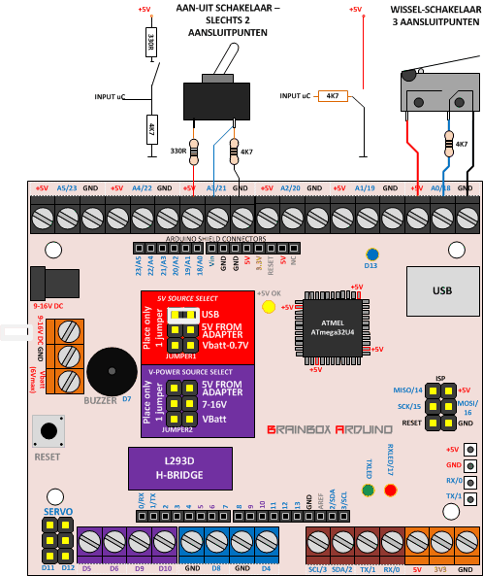
/*
www.E2CRE8.be - Brainbox Arduino - by Bart Huyskens
04/01/2016

This program configures one IO pin (18 in this example) as an INPUT pin
and reads the state (1 or 0) in a variable "VAR_IN"

If the input is high - the blue led at pin 13 will be high
If the input is low - the blue led at pin 13 will be low

Look at the Brainbox ARduino PINOUT diagram.
All the pins with a BLUE marking can be used as digital inputs
(0, 1, 2, 3, 4, 7, 8, 11, 12, 14, 15, 16, 18, 19, 20, 21, 22, 23)

!!the 4 power output pins CAN NOT BE USED as digital inputs- (5, 6, 9, 10)
*/

// these lines make it possible to use pin names instead of pin numbers
// Constants do not change during the program
const int IN_PIN = 18;
const int BLUE_LED = 13;

//this variable named VAR_IN is used to store the state of the input pin
char VAR_IN = 0;

// this setup function runs once when you press reset or power the board
void setup()
{
// initialize digital pin as input or output
pinMode(IN_PIN, INPUT);
pinMode(BLUE_LED, OUTPUT);
}

// this loop function runs over and over again forever
void loop()
{
// read the state of the input pin :
VAR_IN = digitalRead(IN_PIN);

// if the input pin is high
if (VAR_IN == HIGH) {
// turn LED on:
digitalWrite(BLUE_LED, HIGH);
}
else { // if the input pin is low
// turn LED off:
digitalWrite(BLUE_LED, LOW);
}
}

I-AN
/*
www.E2CRE8.be - Brainbox Arduino - by Bart Huyskens
04/01/2016
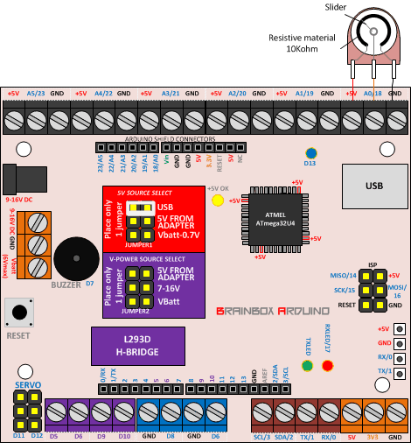
This program is used to demonstrate how Analog inputs work with an ARduino platform
An ARduino uC is a normal AVR microcontroller but is not programmed that way.
The absense of port programming makes that we can't output a certain analog value to 8 leds or so.

The microcontroller will read the analog voltage at pin A0 and
will convert it into a digital 10 bit value between 0-1024

What we can do with an ARduino to somehow visualise this analog value is to:
- output the analog value as a PWM (AnalogWrite) to a led -> we use the BLUE led at pin 13
- Convert the Analog value into a hearable sound and use the buzzer in pin 7 for this
- Send this analog Value via the USB cable back to our computer and use the Serial monitor
of the ARduino IDE to visualise this value

We will demonstrate these 3 methods in this program

The circuit:
* potentiometer connected to analog pin 0.
Center pin of the potentiometer goes to the analog pin.
side pins of the potentiometer go to +5V and ground
* BLUE LED connected from digital pin 13
* Buzzer connected to pin 7

*/

// These constants won't change. They're used to give names
// to the pins used:
const int analogInPin = A0; // Analog input pin that the potentiometer is attached to
const int analogOutPin = 13; // Analog output pin that the BLUE LED is attached to
const int BuzzerPin = 7; // the buzzer on the Brainbox ARduino is connected to pin 7

int sensorValue = 0; // value read from the analog input - set to 0 to start
int outputValue = 0; // value output to the PWM (analog out)- set to 0 to start

void setup() {
// initialize serial communications at 9600 bps:
Serial.begin(9600);
}

void loop() {
// read the analog in value:
sensorValue = analogRead(analogInPin);

// map it to the range of the analog out:
// sensorvalue is a value between 0 and 1024 (10 bit AD)
// PWM or ANalogWrite can only work with values bewteen 0 and 255 (8bit)
outputValue = map(sensorValue, 0, 1023, 0, 255);

// change the analog out value:
// generates a PWM signal on a pin with a duty cycle between 0-255 (0-100%)
analogWrite(analogOutPin, outputValue);

// print the results to the serial monitor:
// Open the serial monitor of the arduino IDE to see the result
Serial.print("sensor = " );
Serial.print(sensorValue);
Serial.print("\t output = ");
Serial.println(outputValue);

// the buzzer converts the sensorvalue into hearable
// frequencies. The sensorValue is a value between 0-1024
// but the lowest frequency that is recognizable as a tone is
// +/- 20Hz. That is why we add 20Hz teh SensorValue.
tone (BuzzerPin, sensorValue+20);

// wait 2 milliseconds before the next loop
// for the analog-to-digital converter to settle
// after the last reading:
delay(2);
}

O-20 = O-500 = O-POWER

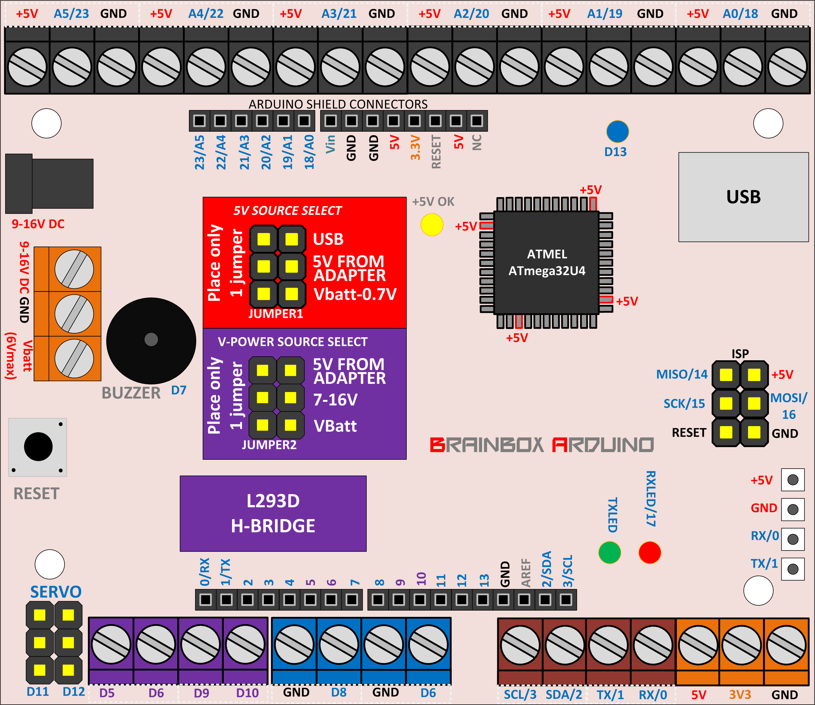
/*
www.E2CRE8.be - Brainbox Arduino - by Bart Huyskens
04/01/2016

This program configures one IO pin (D4 in this example) as an output pin and
alternates between making this pin high or low with 1 sec delays
It can be adapted to drive leds - RGB leds or any device that does not draw current over 20mA

Look at the Brainbox ARduino PINOUT diagram. ALl the pins with a blue marking can be used!

It can be altered to be used at any IO pin available at the Brainbox ARduino (max current 20mA)
(0, 1, 2, 3, 4, 7, 8, 11, 12, 14, 15, 16, 18, 19, 20, 21, 22, 23)

It can also be used at the 4 power output pins - (5, 6, 9, 10) (max current 600mA)
(pins with a purple marking at PINOUT diagram)
Be aware that the voltage at these 4 pins needs to be set by jumper 2
*/

// these lines make it possible to use pin names instead of pin numbers
// Constants do not change during the program
const int OUT_PIN = 4;

// this setup function runs once when you press reset or power the board
void setup()
{
// initialize digital pin as output
pinMode(OUT_PIN, OUTPUT);

}

// this loop function runs over and over again forever
void loop()
{
digitalWrite(OUT_PIN, HIGH); // make pin high
delay(1000); // wait for 1sec
digitalWrite(OUT_PIN, LOW); // on Buzzer pin - generate 500Hz signal - for 500msec
delay(1000); // make pin low
}

O-STEPPER without function
/*
www.E2CRE8.be - Brainbox Arduino - by Bart Huyskens
13/01/2016

This program configires the 4 power output pins (D5, D6, D9, D10) to drive a stepper motor
Connect Phase 1 of the stepper motor between D5 and D6
Connect Phase 2 of the stepper motor between D9 and D10

Look at the worksheet 0-500 on how stepper motors should be connected
Be aware that the maximum output current of 600mA for these 4 power output pins may not be exceeded.

This program makes the stepper motor turn 40x4 steps forward and then 40x4 steps backwards

Be aware that the voltage at these 4 power output pins needs to be set with jumper 2
*/

// these lines make it possible to use pin names instead of pin numbers
// Constants do not change during the program
const int Ph1_Pin1 = 5;
const int Ph1_Pin2 = 6;
const int Ph2_Pin1 = 9;
const int Ph2_Pin2 = 10;

// this setup function runs once when you press reset or power the board
void setup()
{
// initialize digital pin as output
pinMode(Ph1_Pin1, OUTPUT);
pinMode(Ph1_Pin2, OUTPUT);
pinMode(Ph2_Pin1, OUTPUT);
pinMode(Ph2_Pin2, OUTPUT);

}

// this loop function runs over and over again forever
void loop()
{
while(1)
{
for (char x = 40; x>0; x--) // 40 steps forward - WAVE STEP
{
digitalWrite(Ph1_Pin1, HIGH); digitalWrite(Ph1_Pin2, LOW); digitalWrite(Ph2_Pin1, LOW); digitalWrite(Ph2_Pin2, LOW); //sequence 1 of 4
delay(20); // wait for ..msec

digitalWrite(Ph1_Pin1, LOW); digitalWrite(Ph1_Pin2, LOW); digitalWrite(Ph2_Pin1, HIGH); digitalWrite(Ph2_Pin2, LOW); //sequence 2 of 4
delay(20); // wait for ..msec

digitalWrite(Ph1_Pin1, LOW); digitalWrite(Ph1_Pin2, HIGH); digitalWrite(Ph2_Pin1, LOW); digitalWrite(Ph2_Pin2, LOW); //sequence 3 of 4
delay(20); // wait for ..msec

digitalWrite(Ph1_Pin1, LOW); digitalWrite(Ph1_Pin2, LOW); digitalWrite(Ph2_Pin1, LOW); digitalWrite(Ph2_Pin2, HIGH); //sequence 4 of 4
delay(20); // wait for ..msec
}

for (char x = 40; x>0; x--) // 40 steps backward - WAVE STEP
{
digitalWrite(Ph1_Pin1, LOW); digitalWrite(Ph1_Pin2, LOW); digitalWrite(Ph2_Pin1, LOW); digitalWrite(Ph2_Pin2, HIGH); //sequence 4 of 4
delay(20); // wait for ..msec

digitalWrite(Ph1_Pin1, LOW); digitalWrite(Ph1_Pin2, HIGH); digitalWrite(Ph2_Pin1, LOW); digitalWrite(Ph2_Pin2, LOW); //sequence 3 of 4
delay(20); // wait for ..msec

digitalWrite(Ph1_Pin1, LOW); digitalWrite(Ph1_Pin2, LOW); digitalWrite(Ph2_Pin1, HIGH); digitalWrite(Ph2_Pin2, LOW); //sequence 2 of 4
delay(20); // wait for ..msec

digitalWrite(Ph1_Pin1, HIGH); digitalWrite(Ph1_Pin2, LOW); digitalWrite(Ph2_Pin1, LOW); digitalWrite(Ph2_Pin2, LOW); //sequence 1 of 4
delay(20); // wait for ..msec
}
}
}

O-STEPPER with function
/*
www.E2CRE8.be - Brainbox Arduino - by Bart Huyskens
13/01/2016

This program configires the 4 power output pins (D5, D6, D9, D10) to drive a stepper motor
We will drive all the 4 pins with the usage of the stepper motor driver function of ARduino

Connect Phase 1 of the stepper motor between D5 and D6
Connect Phase 2 of the stepper motor between D9 and D10

Look at the worksheet 0-500 STEPPER on how stepper motors should be connected
Be aware that the maximum output current of 600mA for these 4 power output pins may not be exceeded.

This program makes the stepper motor turn 40x4 steps forward and then 40x4 steps backwards

Be aware that the voltage at these 4 power output pins needs to be set with jumper 2
*/

#include <Stepper.h>

const int stepsPerRevolution = 100; // change this to fit the number of steps per revolution
// for your motor

// initialize the stepper library on pins 8 through 11:
Stepper myStepper(stepsPerRevolution, 5, 6, 9, 10);

void setup()
{
// set the speed at 60 rpm:
myStepper.setSpeed(60);

}

void loop() {
// step one revolution in one direction:
myStepper.step(stepsPerRevolution);
delay(500);

// step one revolution in the other direction:
myStepper.step(-stepsPerRevolution);
delay(500);
}

O-PWM

/*
www.E2CRE8.be - Brainbox Arduino - by Bart Huyskens
13/01/2016

This program generates a PWM signal on one of the pins that have PWM functionality
The program generates a PWM signal with this sequence:
1- Rising PWM duty cycle from 0-100% (0-255) over a period of +/-5sec
2- Falling PWM duty cycle from 100% to 0% (255-0) over a period of +/- 5sec

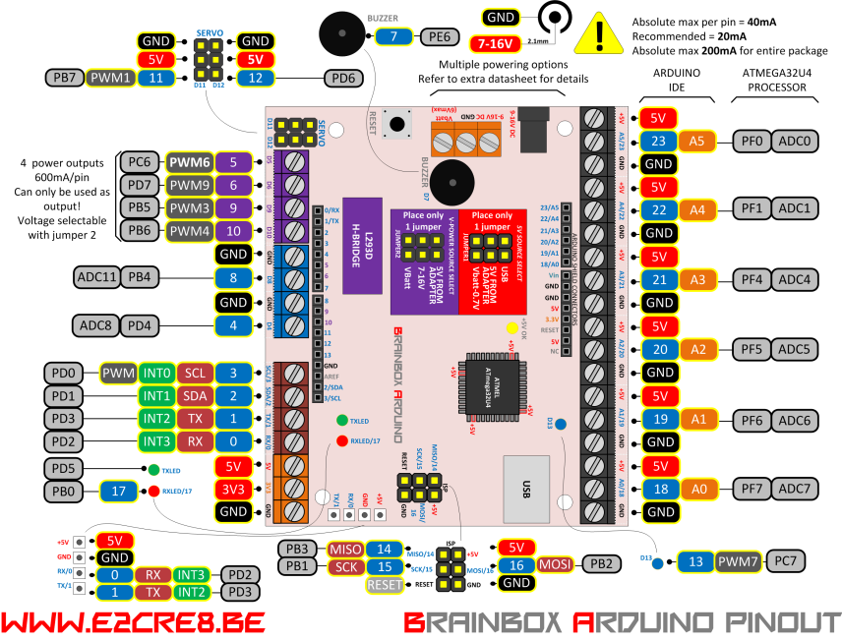
In this case we use pin D5. You could connect a DC motor (600mA max) between D5 and GND
You could also test this with a led (with resistor) between D5 and GND
Be aware that the 600mA power outputs need a jumper to select the output voltage

The pins on the BBA that have PWM functionality are:
D3 20mA max
D5 600mA max
D6 600mA max
D9 600mA max
D10 600mA max
D11 20mA max
D13 20mA max (Blue led)
*/

// these lines make it possible to use pin names instead of pin numbers
// Constants do not change during the program
const int PWM_PIN = 5;

// this setup function runs once when you press reset or power the board
void setup()
{
pinMode(PWM_PIN, OUTPUT); // initialize digital pin as output
}
void loop()// this loop function runs over and over again forever
{
while(1)
{
for (int brightness = 0; brightness<255; brightness++) // loop counter 0 up to 255
{
analogWrite(PWM_PIN, brightness); // PWM output signal
delay(20); // wait for ..msec (255x20msec = 5.1sec)
}
for (int brightness = 255; brightness>0; brightness--) // loop counter 255 down to 0
{
analogWrite(PWM_PIN, brightness); // PWM output signal
delay(20); // wait for ..msec (255x20msec = 5.1sec)
}
}
}

O-SERVO

/*
www.E2CRE8.be - Brainbox Arduino - by Bart Huyskens
13/01/2016

This program generates a SERVO signal on pin D11 and D12
up to 12 servo signals can be generated on any other IO pin of the Brainbox Arduino, but D11&D12 already have standard servo connectors

To generate this specific servo signal we make use of the Servo library of Arduino
Most servo's work with signals between 1000msec and 2000msec. That is exactly what the "myservo.write(pos)" instruction does.

Note that some manufactures do not follow this standard very closely so that servos often respond to values between 700 and 2300.
Feel free to use the "servo.writeMicroseconds(uS)" instruction to increase these endpoints until the servo no longer continues to increase its range. */
#include <Servo.h>
Servo Servo_D11; // create servo object to control a servo
Servo Servo_D12; // create servo object to control a servo
// twelve servo objects can be created on most boards

int pos = 0; // variable to store the servo position

void setup()
{
Servo_D11.attach(11); // attaches the servo on pin 11 to the servo object
Servo_D12.attach(12); // attaches the servo on pin 12 to the servo object
}

void loop()
{
for(pos = 0; pos <= 180; pos++) // goes from 0 degrees to 180 degrees
{ // in steps of 1 degree
Servo_D11.write(pos); // tell servo to go to position in variable 'pos'
Servo_D12.write(pos); // tell servo to go to position in variable 'pos'
delay(15); // waits 15ms for the servo to reach the position
}
for(pos = 180; pos>=0; pos--) // goes from 180 degrees to 0 degrees
{
Servo_D11.write(pos); // tell servo to go to position in variable 'pos'
Servo_D12.write(pos); // tell servo to go to position in variable 'pos'
delay(15); // waits 15ms for the servo to reach the position
}
}

I2C-LCD
/*
www.E2CRE8.be - Brainbox Arduino - by Bart Huyskens
13/01/2016

This program drives an I2C LCD of the type:
16 character 2 line I2C Display
Backpack Interface labelled "YwRobot Arduino LCM1602 IIC V1" (2€ @ aliexpress)

Connect this LCD as follows:
LCD Brainbox Arduino
GND GND
VCC +5V
SDA SDA/2
SCL SCL/3
!! Pull up resistors are required - place 4K7 between SDA and 5V and 4K7 between SCL and 5V

To communicate correctly with this I2C LCD you need to install the <LiquidCrystal_I2C.h> library in the arduino IDE
1- download the "LiquidCrystal_I2C" library as a zip file from https://bitbucket.org/fmalpartida/new-liquidcrystal/downloads
2- do not unzip the file
3- in ARduino IDE: Sketch >> include library >> add .ZIP library - select the downloaded zip file
4- this library is installed under 'mydocs'->Arduino : remove it by deleting it there
*/

#include <Wire.h> // Comes with Arduino IDE

// Get the LCD I2C Library here:
// https://bitbucket.org/fmalpartida/new-liquidcrystal/downloads
// Move any other LCD libraries to another folder or delete them
// See Library "Docs" folder for possible commands etc.
#include <LiquidCrystal_I2C.h>

const int analogInPin = A0; // Analog input pin that the potentiometer is attached to
int sensorValue = 0;
int outputValue = 0;

// set the LCD address to 0x27 for a 20 chars 4 line display
// Set the pins on the I2C chip used for LCD connections:
// addr, en,rw,rs,d4,d5,d6,d7,bl,blpol
LiquidCrystal_I2C lcd(0x27, 2, 1, 0, 4, 5, 6, 7, 3, POSITIVE); // Set the LCD I2C address

void setup()
{

lcd.begin(16,2);// initialize library

for(int i = 0; i< 3; i++) // loop 3 times backlight on and off
{
lcd.backlight(); //backlight on
delay(250);
lcd.noBacklight(); //backlight off
delay(250);
}

lcd.backlight(); //backlight on
lcd.setCursor(0,0); // set cursor to positon x=0, y=0
lcd.print("Brainbox"); // print text on the LCD
delay(500);
lcd.setCursor(2,1);
lcd.print("Arduino");
delay(1000);
}

void loop()
{
sensorValue = analogRead(analogInPin); // read the analog value measured at analog pin AN0 (pin18) - We used a potmeter
outputValue = map(sensorValue, 0, 1023, 0, 100); // rescale the sensorValue (0-1024) to (0-100)%

lcd.clear(); // clear the LCD
lcd.setCursor(0,0); // set cursor to positon x,y
lcd.print("AN0 Value:"); // print text on the LCD
lcd.print(sensorValue); // print the value of the variable on the LCD

lcd.setCursor(0,1);
lcd.print("AN0 %:");
lcd.print(outputValue);
lcd.print("%"); // add a % character

delay(100); // delay of 100msec to avoid flikkering of the LCD

}

USB Serial monitor
/*
www.E2CRE8.be - Brainbox Arduino - by Bart Huyskens
20/02/2016

6 CHANNEL Analog input, serial output

Reads an analog input pin, maps the result to a range from 0 to 255
and prints the results to the serial monitor.

Use the serial monitor built into ARduino IDE to visualise the results

6 analog input channels - A0-A5

Be aware that the serial monitor uses the same USB port as IDE uses to program tne Leonardo
Close the serial monitor program and reset the Leonardo to set it up to receive new programs

*/

// These constants won't change. They're used to give names
// to the pins used:
const int analogInPin = A0; // Analog input pin that the potentiometer is attached to
const int analogOutPin = 9; // Analog output pin that the LED is attached to

int sensorValue = 0; // value read from the pot
int outputValue = 0; // value output to the PWM (analog out)

//Declare the AD variables as int because Arduino always executes a 10 bit AD conversion
int AD_A0 = 0;
int AD_A1 = 0;
int AD_A2 = 0;
int AD_A3 = 0;
int AD_A4 = 0;
int AD_A5 = 0;

// These 8 bit Byte variables are used to downsize the 10 bit AD conversion result into 8 bit
byte ADC_A0 = 0;
byte ADC_A1 = 0;
byte ADC_A2 = 0;
byte ADC_A3 = 0;
byte ADC_A4 = 0;
byte ADC_A5 = 0;

void setup() {
// initialize serial communications at 9600 bps via USB
Serial.begin(9600);
}

void loop() {
AD_A0 = analogRead(A0); // read the analog value measured at analog pin ANx
AD_A1 = analogRead(A1); // read the analog value measured at analog pin ANx
AD_A2 = analogRead(A2); // read the analog value measured at analog pin ANx
AD_A3 = analogRead(A3); // read the analog value measured at analog pin ANx
AD_A4 = analogRead(A4); // read the analog value measured at analog pin ANx
AD_A5 = analogRead(A5); // read the analog value measured at analog pin ANx

ADC_A0 = map(AD_A0, 0, 1023, 0, 255); // rescale the sensorValue (0-1024) to (0-255)
ADC_A1 = map(AD_A1, 0, 1023, 0, 255); // rescale the sensorValue (0-1024) to (0-255)
ADC_A2 = map(AD_A2, 0, 1023, 0, 255); // rescale the sensorValue (0-1024) to (0-255)
ADC_A3 = map(AD_A3, 0, 1023, 0, 255); // rescale the sensorValue (0-1024) to (0-255)
ADC_A4 = map(AD_A4, 0, 1023, 0, 255); // rescale the sensorValue (0-1024) to (0-255)
ADC_A5 = map(AD_A5, 0, 1023, 0, 255); // rescale the sensorValue (0-1024) to (0-255)

// print the results to the serial monitor:
Serial.print("A0 = ");
Serial.print(ADC_A0, DEC);
Serial.print("\t");
Serial.print("A1 = ");
Serial.print(ADC_A1, HEX);
Serial.print("\t");
Serial.print("A2 = ");
Serial.print(ADC_A2, BIN);
Serial.print("\t");
Serial.print("A3 = ");
Serial.print(ADC_A3);
Serial.print("\t");
Serial.print("A4 = ");
Serial.print(ADC_A4);
Serial.print("\t");
Serial.print("A5 = ");
Serial.print(ADC_A5);
Serial.println(""); // start new line

delay(200);
}

