/

**Report prepared by:**

Desmond Harding, BSc MRICS MCIOB Dip project management

**Date:**  17st December 2020

**Expert Witness Report Contents**

1.0 Preliminaries

2.0 Caveats and Limitations

3.0 Description of Building

4.0 Commentary

5.0 Summary

6.0 Qualifications of the Author

7.0 Declaration

8.0 Appendix One

* Supplementary Photographs

9.0 Appendix Two

* Scott Schedule

**1.0** **Preliminaries**

1.1 **The Instructing Party**

I am instructed as an Expert Witness on behalf of Sally Reynolds

.

**Solicitors** acting on behalf of the Claimant TBA

.

1.3 **Claimant(s):**  Sally Reynolds

(Tenant)

1.4 **Defendant** Magna Housing Association **(**Landlord)

1.5 **Type of Tenancy:** Understood to be a tenancy to which the provisions of S11 Landlord & Tenant Act 1985 apply.

1.6 **Length of Tenancy:** To be advised.

1.7 **Issues of Concern**

**The tenant has complained of the following issues: -**

1. There is damp throughout the property.
2. There is damp in the living room.

1.8 **Single inspection undertaken** by Desmond Harding, BSc MRICS, MCIOB on Tuesday 10th December 2020.

1.9 **Weather at time of inspection**: average outside temp 12 degrees C, dry conditions

1.10 **Duration of Repairs:** 1 month.

1.11 **Decanting Required:** yes

**2.0 Caveats and Limitations**

2.1 **This is not a full Building Survey**

2.2 Roof and floor voids were not inspected. Services were only visually examined. The premises were furnished and fitted with floor coverings, and no assessments could be made to any elements which were covered, unexposed or inaccessible.

2.3 Opinions as to dampness are based on a combination of visual inspection and electronic moisture meter readings. No destructive testing was carried out.

2.4 At the time of our inspection, the property was furnished and occupied. Where parts of the property were covered, unexposed or inaccessible and close inspection was not possible we are unable to comment on the condition of such elements. It may be possible therefore that damage arising from woodworm infestation, wood rot and decay or vermin infestation etc. may be present without our knowledge that becomes apparent subsequent to this report.

2.5 We have not carried out any specialist tests to determine whether any high alumina cement (HAC), calcium chloride, wood-wool slabs for permanent shuttering, calcium silicate bricks or fibrous asbestos materials were used in the original construction or any subsequent additions to the building, and as such, we are unable to report that the building is free from any hazard or hazards caused by these materials.

2.6 In accordance with your instructions, we have not tested services or installations such as the drains, sewerage, water, electricity and gas or any heating, ventilation or fire/lighting systems and we are unable to express an opinion as to their suitability, condition, or installation without the benefit of specialist’s advice.

2.7 The premises were inspected so far as fittings, furnishings, floor coverings and stored materials or stock allowed, and no provision was made for the temporary removal of these items.

2.8 We have not made any enquiries with any statutory authority but would point out that Building Regulations and other legislation often have a material effect on the way in which the building is used and upon the cost of consequential works.

2.9 In accordance with our standard practice, we must state that this report is to be used by the party to whom it is addressed only, and no responsibility is accepted to any third party for the whole or any part of its contents.

2.10 Neither the whole nor any of this report nor any reference thereto may be included in any document, statement or circular nor published in any way without our prior written approval as to the form and context in which it will appear.

2.11 The report shall not be regarded as a form of specification and further investigation and measurement will be required prior to the preparation of a specification and description of works.

2.12 **Estimated Costs**

In the Scott Schedule, estimated budget costs are included for each item. These costs are not based on a detailed specification or Bill of Quantities. They are all inclusive figures (including, where appropriate, for such thing as scaffolding, removal of waste, redecoration). They are exclusive of VAT and any fees associated with preparation of a specification or administration of a building contract. They assume the work will be carried out as a single contract by a local jobbing builder. In practice where an Institutional Landlord carries out repairs itself, costs are likely to be reduced from my estimates as such Landlords are able to obtain economies of scale.

2.13 **Lease Covenant**

In the circumstances for the purpose of establishing disrepair, the statutory repairing covenants imputed to the agreement by Section11 Landlord & Tenant Act 1985 have been applied and are shown in full below. The tenancy may impose express repairing or decorating liabilities on either the Landlord or the tenant in areas which lie outside those covered by statute.

2.14 **Repairing Obligations in Short Term Leases**

Section 11 (Landlord & Tenant Act 1985)

1. In a lease to which this section applies (as to which, see sections 13 and 14) there is an implied covenant by the Lessor: -

1. To keep in repair the structure and exterior of the dwelling house (including drains, gutters and external pipes).
2. To keep in repair and proper working order the installations in the dwelling house for the supply of water, gas and electricity and for sanitation (including basins, sinks, baths and sanitary conveniences, but not other fittings, fixtures and appliances for making use of the supply of water, gas or electricity).
3. To keep in repair and proper working order the installations in the dwelling house for space heating and hot water.

1.A If a lease to which this section applies is a lease of a dwelling house which forms part only of a building, then subject to subsection (1B), the covenant implied by subsection (1) shall have effect as if: -

1. The reference in paragraph (a) of that subsection to the dwelling house included a reference to any part of the building in which the lessor has an estate or interest.
2. , Any references in paragraphs (b) and (c) of that subsection to an installation in the dwelling-house included a reference to an installation which directly or indirectly, serves the dwelling-house and which either: -
3. Forms part or any part of a building in which the lessor has an estate or interest, or

2) Is owned by the lessor or under his control.

1.B Nothing in subsection (1A) shall be construed as requiring the lessor to carry out any works or repairs unless the disrepair (or failing to maintain in good working order) is such as to affect the lessee`s enjoyment of the dwelling house or of any common parts, as defined in Section 60 (1) of the Landlord and Tenant Act 1987, which the lessee, as such is entitled to use.

2. The covenant implied by subsection (1) (the lessor`s repairing covenant) shall not be construed as requiring the lessor: -

1. To carry out the works or repairs for which the lessee is liable by virtue of his duty to use the premises in a tenant-like manner, or would be so liable but for an express covenant on his part
2. To rebuild or reinstate the premises in the case of destruction or damage by fire, tempest, flood or other inevitable accident, or
3. To keep in repair or maintain anything which the lessee is entitled to remove from the dwelling-house.

3. In determining the standards of repair required by the lessor`s repairing covenant, regard shall be had to the age, character and the prospective life of the dwelling house and the locality in which it is situated.

3. A In any case where: -

1. The lessor`s repairing covenant has effect as mentioned in subsection (1A) and,

b) In order to comply with the covenant, the lessor needs to carry out works or repairs otherwise than in, or to an installation in, the dwelling-house, and

c) the lessor does not have a sufficient right in the part of the building or the installation concerned to enable him to carry out the required works or repairs, then, in any proceedings relating to a failure to comply with the lessor`s repairing covenant, so far as it requires the lessor to carry out the works or repairs in question, it shall be a defense for the lessor to prove that he used all reasonable endeavors to obtain, but was unable to obtain, such rights as would be adequate to enable him to carry out the works.

4. A covenant by the lessee for the repair of the premises is of no effect so far as it relates to the matters mentioned in subsection (1) (a) to (c), except so far as it imposes on the lessee any of the requirements mentioned in subsection (2) (a) or (c).

5. The reference in subsection (4) to a covenant by the lessee for the repair of the premises includes a covenant: -

1. To put in repair or deliver up in repair,
2. To paint, point or render,
3. To pay money in lieu of repairs by the lessee or,

d) To pay money on account of repairs by the lessor.

6. In a lease where the lessor`s repairing covenant is implied there is also implied a covenant by the lessee that the lessor, or any person authorised by him in writing, may at reasonable times of the day and on giving 24 hours` notice in writing to the occupier, enter the premises comprised in the lease for viewing their condition and state of repair.

Any references in the Scott Schedule to lease covenants are a reference to the covenants reproduced here.

**3.0 Description of Building**

The dwelling is a 2-bedroom flat situated on the ground floor of a 2-story purposed-built brick property with cavity brick walls.

The fenestration is of modern replacement PVCu framed double glazed windows incorporating trickle vents at the head of the windows.

Internally the dwelling comprises, living room, kitchen, one bedroom, bathroom and w/c.

The dwelling has the benefit of a modern gas fired wall mounted boiler providing hot water

and central heating via a network of water filled radiators.

**4.0 Commentary**

Formal instructions have been received which confirms the following allegations of disrepair for which individual comment is provided as follows: -

**Dampness in Property**

**4.1** The survey investigation was carried out in the presence of the tenant Miss Sally Reynolds***.*** Miss Sally Reynoldsasserted that during the entire occupancy of the subject property she has complained to the landlord about dampness and mould growth in the walls and floors of the bedrooms, hallway and living room. Miss Reynolds states that despite repeated complaints to the landlord over a period of 12 years the dampness persisted throughout the tenancy and it damaged her possessions primarily clothing as shown in photographs in the appendix 1. The mould has also affected her health.

**Potential issues relating to rising dampness**

**4.2** After inspecting the bedrooms, hall and living room damp levels above normal range was detected in the floors of the property. As shown on the plan attached average non-contact readings were in the range of 300 to 900 affecting primarily the front and rear bedrooms, and also the living room floor.

**4.3** It is recommended that further investigation be carried to determine the cause of the excessive damp levels in the bedroom and living room floor. Test should be conducted on drains and any pipework encased in the walls/floors should be pressure tested. The works recommended are detailed in the Scott report in appendix 2

**Condensation and mould growth**

**4.6** I have provided a summary of my response to the tenant’s concerns below: -.

1. **Damp throughout the property**

There is extensive evidence of dampness in most of the floor area in the property as recorded on the plan below detailing the damp readings for the floors. There is evidence that this level of dampness has been ongoing for many years. It will be necessary to conduct a number of tests to determine the repairs required as indicated in the Scott schedule. At the time of my inspection extensive mould existed in the front bedroom, cupboards, and wardrobes in the property. Average wall temperature was relatively low in the region of 15 degrees c. This indicates that during periods of high moisture levels condensation is more likely to occur in the wall areas affected by the low temperature. The design of the external wall and disrepair issues detailed in 4.2 relating to the condition of the external wall are factors which may contribute to the low wall temperature, this includes damp CWI in cavity walls or debris in cavity walls in particular at location marked A on the plans below..

1. **Damp in hallway**

There is dampness in the hallway as detailed above.

.

Floor plan of flat showing contact and non-contact meter damp readings.

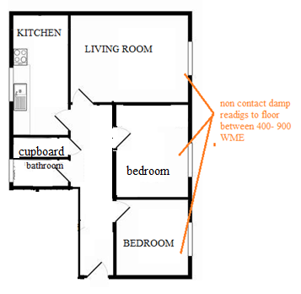

**5.0 Summary**

**5.1** Under section 11(1) (a) of the Landlord and Tenant act 1985, landlords have an obligation to keep in repair the structure and exterior of the dwelling-house. The rising damp issues as detailed in this report are issues Miss Reynolds has been complaining of for approximately 12 years. The length of time the defects persisted indicates a clear breach of the act. In particular the dampness issues have been prolonged, this has caused discomfort, inconvenience and distress to the tenant. The tenant could therefore claim compensation as these issues have been affecting this property for a significant period of time, in my professional opinion exceeding 12 years.

**6.0 Qualifications**

**The Writer**

This report was prepared by Desmond Harding BSC MRICS MCIOB, Dip project management, Chartered Building Surveyor with over 30 years’ experience within the social housing sector diagnosing and resolving disrepair issues along with preparing defect reports of this nature.

Instructions have also been undertaken by the Writer in completing Expert Witness reports on behalf of social housing organisations, in the United Kingdom.

**7.0 Declaration**

I understand that my overriding duty is to the court and I have complied with that duty. I am aware of the requirements of CPR Part 35, its practice direction and the Protocol for Instruction of Experts to give Evidence in Civil Claims.

I confirm that I have made clear which facts and matters referred to in this report are within my own knowledge and which are not. Those that are within my own knowledge I confirm to be true. The opinions I have expressed represent my true and complete professional opinions on the matters to which they refer.

Signature: 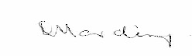

Name in full: Desmond Harding BSC, MRICS, MCIOB Dip project management

Date: 10. Dec 20120

**8.0 Appendix One: Photographs**

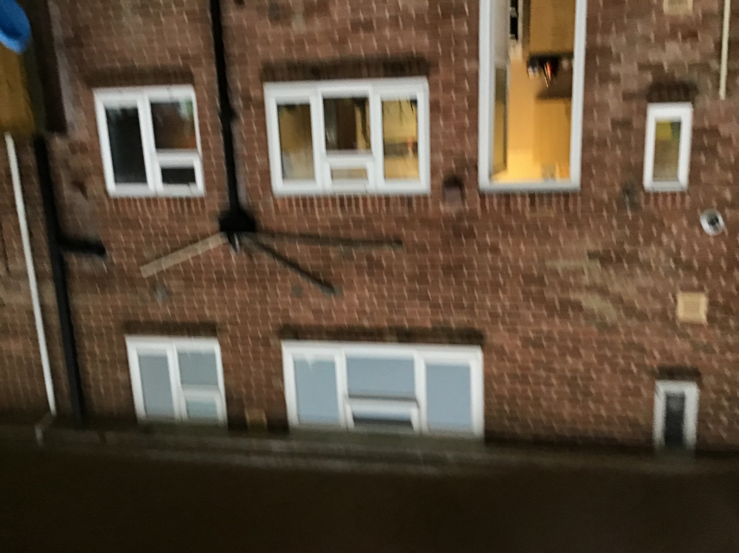

**Photograph 1 – Rear elevation**

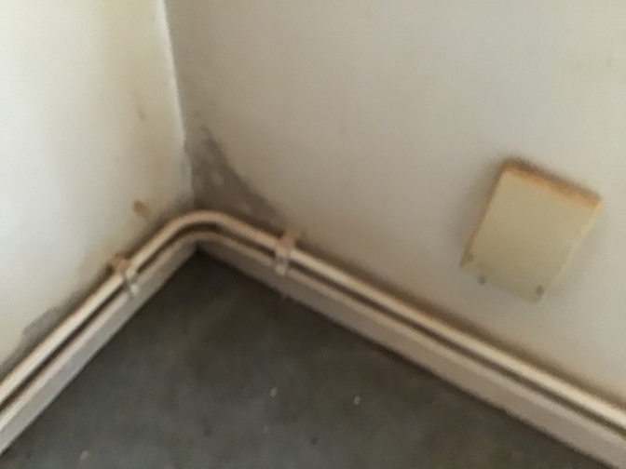

**Photograph 2 typical areas affected by damp and mould in front bedroom**

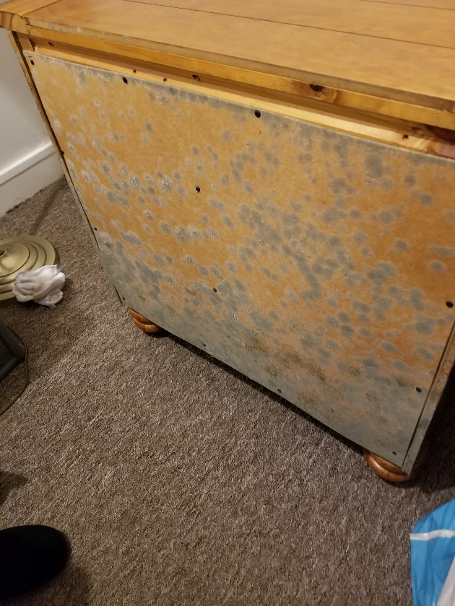

**Photograph 3 –**Furniture and personal belongings affected by mould

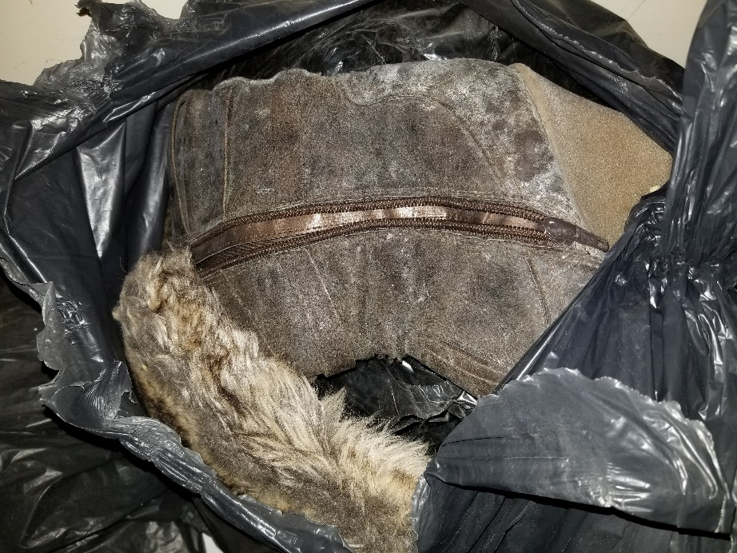

**Photograph 4 –** Furniture and personal belongings affected by mould

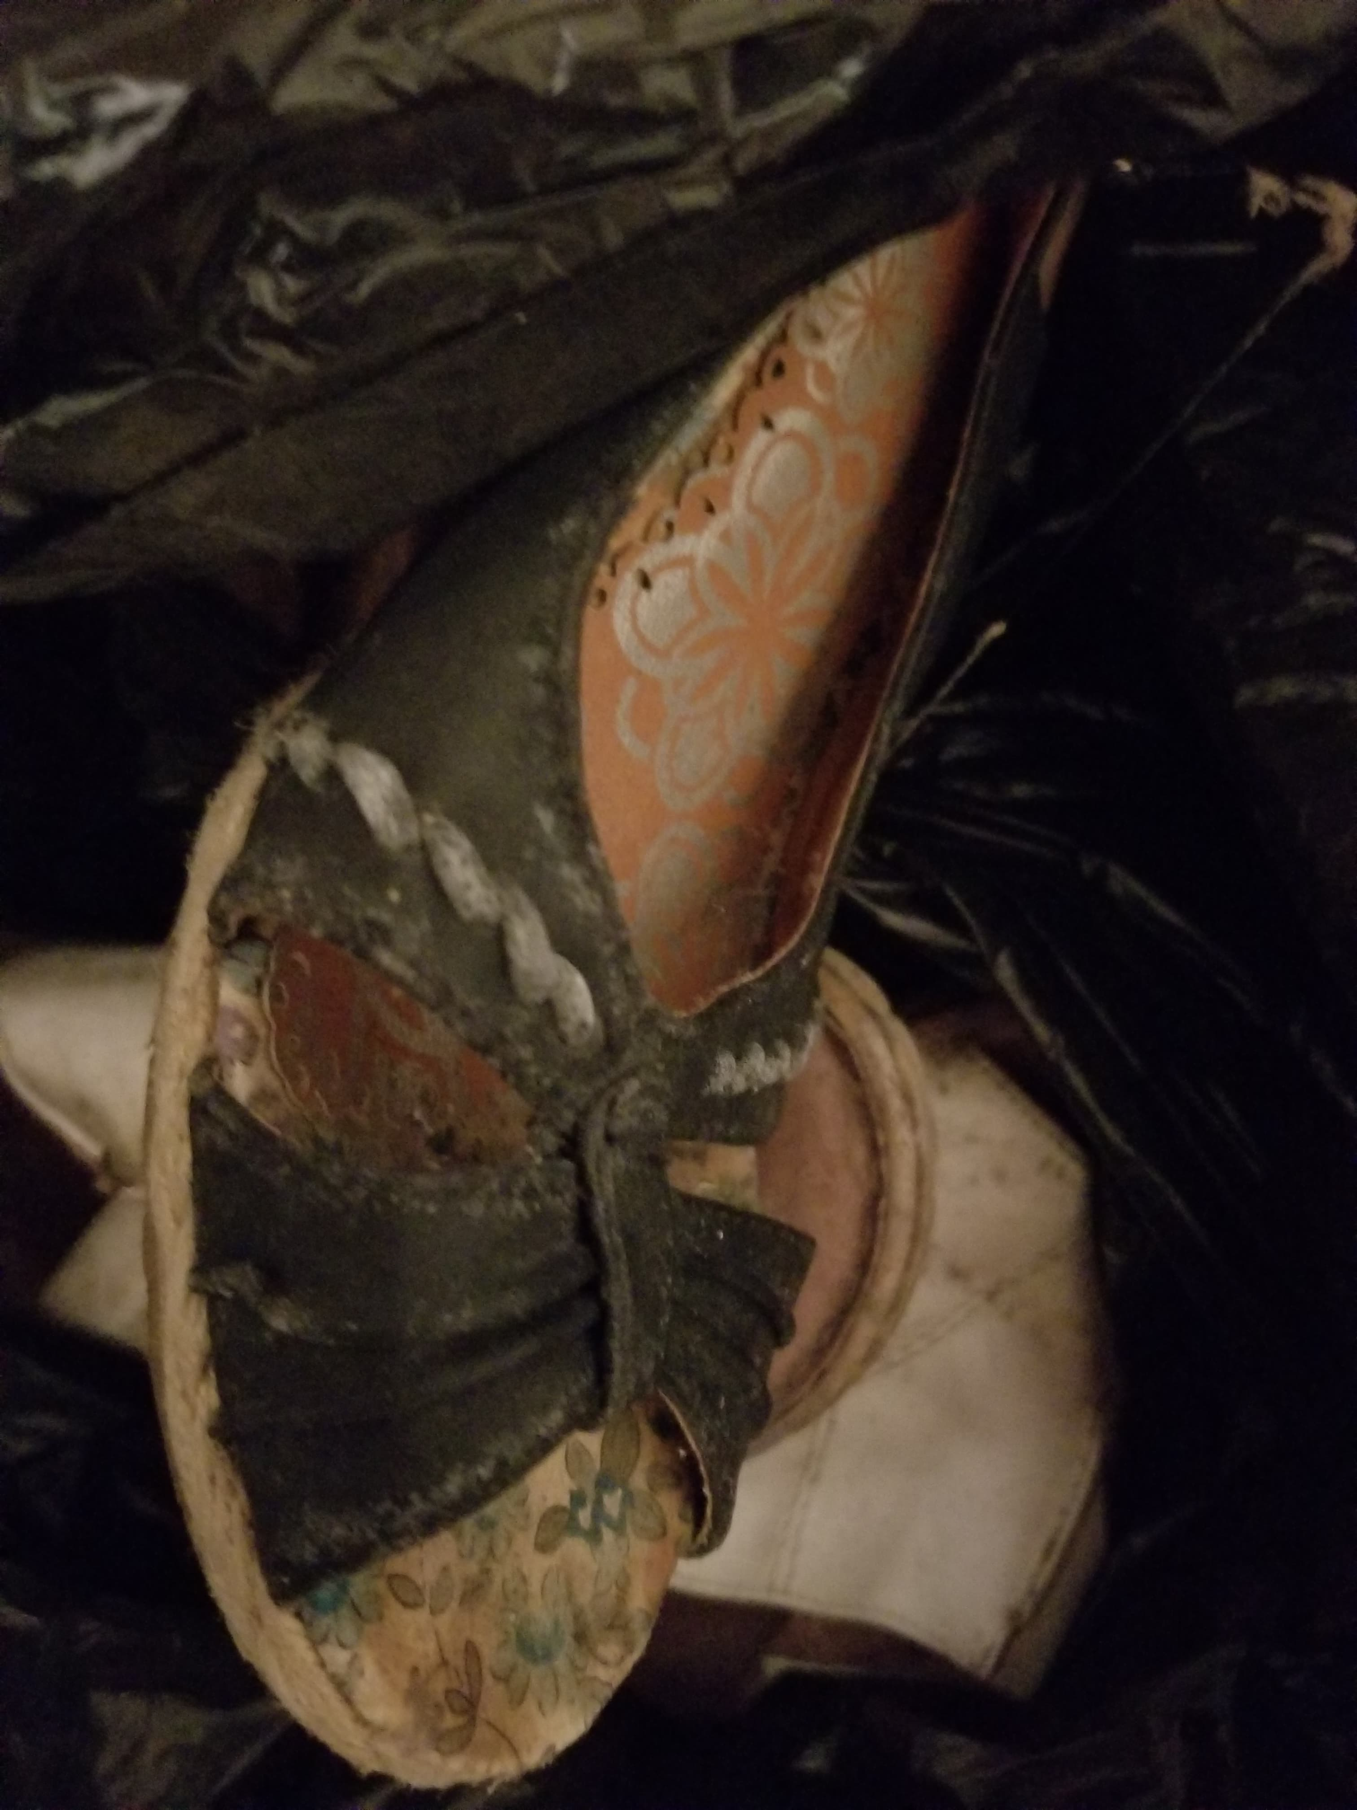

**Photograph 5-** Furniture and personal belongings affected by mould

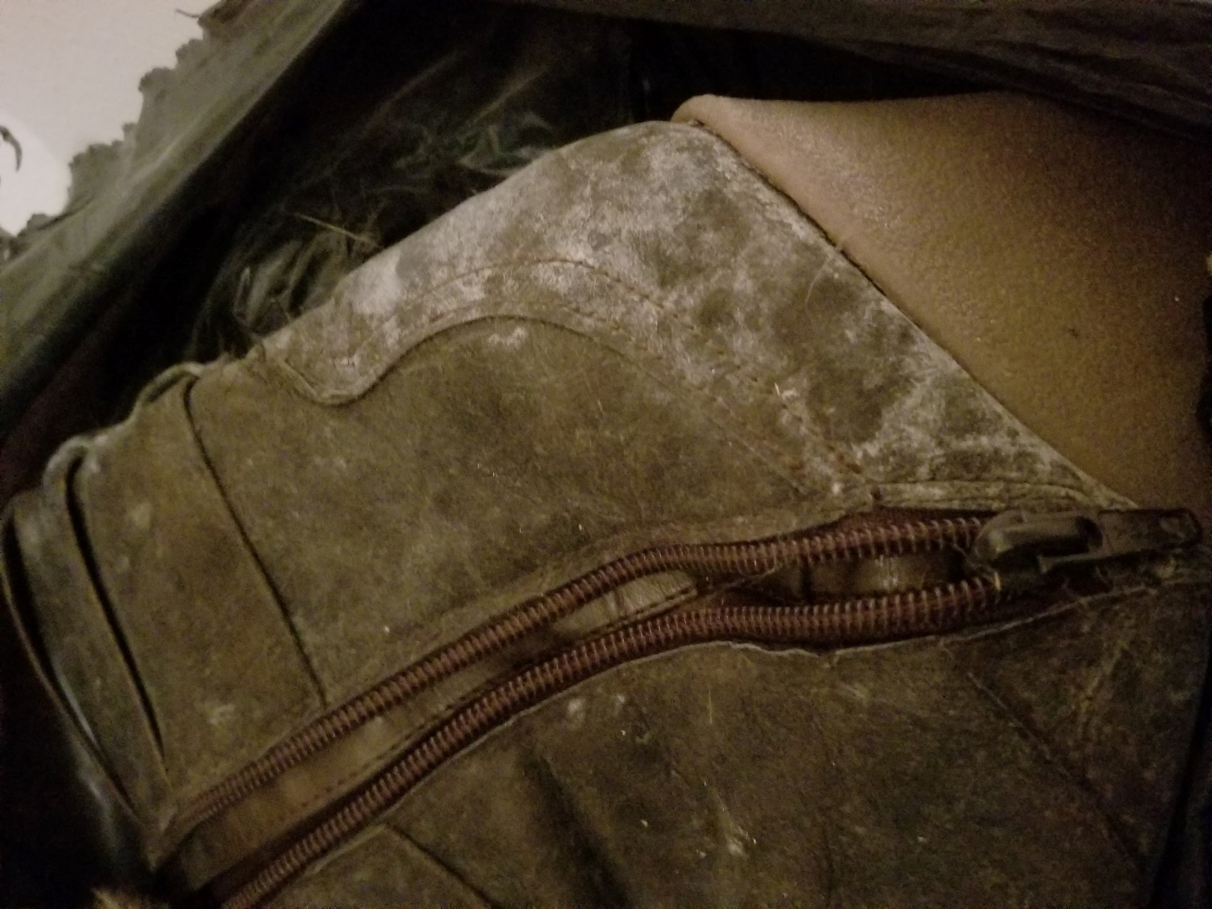

**Photograph 6 -**Furniture and personal belongings affected by mould

**9. APPENDIX TWO: Scott Schedule**

**Claimant:** Sally Reynolds **Address:** 10 Castle Close, Dorchester, Dorset DT1 2JE

|  |  |  |  |  |  |  |  |
| --- | --- | --- | --- | --- | --- | --- | --- |
| **Item no.** | **Assessment of Items of Disrepair** | **Assessment of Repair Works Required** | UOM | Cost of repair £ | **Defendants` Comments** | **Defendants` estimate of costs** | SEC |
| **1.0**  1.1  1.2  2.00  2.1  2.2  2.3  3.0  3.1 | **Section 11 works**  **External repairs**  **Internal/external**  **Internal repairs**  **Internal walls affected by mould**  **Redecoration**    **Bathroom kitchen**  **General Notes**  Project Sign Off  ***It should be noted that costs contained within the Scott Schedule are considered admissible under S11 LTA 1985, unless otherwise stated*** | Carry out CCTV survey of entire drainage system, include air testing drains as necessary. Carry out detailed thermal imaging survey of floor to entire flat. And allow for repairs to any leaks found.  On completion of the above tests and repairs include for repairs to all floors using RIW toughseal dpm or similar in conjunction with application of new latex screed .  Mould treatment to various areas  Standard redecorations to living room, bedroom, bathroom and kitchen  Supply and lay new vinyl tiles  **Sub-total s 11 Works**  **VAT**  **TOTAL**  Include for a Chartered Surveyor to revisit site to sign off the completed works.  **VAT**  **TOTAL Sign off**  Total of all works | £  £  £  £  £  £  £  £  **£**  **£**  £  £ | 700.00          4,000.00                    200.00      1500.00  1000.00  8100.00  1620.00  **9720.00**  400.00  **80.00**  **480.00**  **10,200.00** |  |  |  |