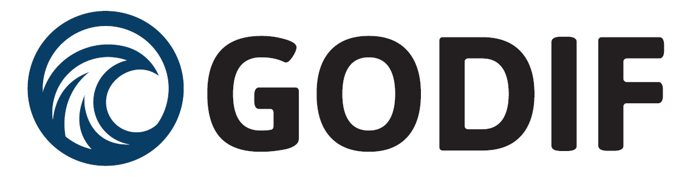

To the patient
Inquiry about participation in a health science research project with early treatment of patients with fluid overload admitted to the intensive care unit.

Title of the study: Goal directed fluid removal with furosemide in intensive care patients with fluid overload – A randomised, blinded, placebo-controlled trial (GODIF).
Introduction
During your admission to the intensive care unit you have become a participant in the GODIF-trial which is a health science research project. You needed acute treatment, and the state you were in made it impossible to ask you directly for your consent before we began. Therefore, we asked two independent trial guardians (physicians) for permission to include you in the trial, and we also gathered consent from your next of kin. Now we are asking for your consent to use the data which we have already gathered. Participation is voluntary, and you can reject the offer without it affecting your current or future treatment.
Before you decide whether you would like to give consent, it is important that you understand what the study is about, and why we are doing it. We encourage you to read this information thoroughly. A study investigator or someone else from the research group will also explain the trial for you and you get the opportunity to ask questions. You are welcome to have a family member, a friend or an acquaintance by your side when you receive the information, and you have the right to think it over before deciding.
If you do not wish to participate in the study the trial treatment and data gathering will be interrupted immediately, but we would like to know if we can keep and use the data we have already gathered. If you do not want this either, all the data we have gathered on you will be deleted.
Aim
We will investigate whether early, goal directed treatment of fluid retention in the body provides a greater chance of survival.

Severely ill patients often accumulate fluid in their body during their admission and treatment in the intensive care unit. Several studies have suggested that fluid retention increase the risk of dying. Therefore, we will investigate whether we can shorten the period during which the body has accumulated too much fluid. Our method for removing the fluid will be the same as usual, but we will begin earlier than we otherwise would.

We do not know whether the link between fluid retention and survival is due to the fact that fluid retention is in itself dangerous, or whether the most severe ill patients who have the worst chance of survival also accumulate more fluid. In other words, we do not know whether it is beneficial to start early treatment of fluid retention, and therefore it is necessary to make this study.

Practical approach
By randomisation (random allocation) you have been selected for one of two treatment groups. In one group (experimental group) diuretic are given, and the other group placebo is given – ie. an inactive substance – here it will be saline. This means that in the first group, patients receive medication that helps with water excretion, and in the second group, the body excretes the excess fluid at its own pace. All healthcare professionals (physicians, nurses and research personnel) who treat you do not know what kind of medicine you have been selected for. This is done to ensure that the results are not affected by the staff’s attitude to the treatment. All other treatment has been and is the same in both groups.

The diuretic drug used in the study is furosemide, which stimulates the production of urine. Furosemide is an approved drug, which has been used for diuretic treatment for over 30 years.

Once all the excess fluid has been removed, treatment with both diuretics and placebo will be reduced and/or stopped in both groups.

Plan for the trial
The entire trial is planned to last for three years and we will include 1000 patients in total. If you give your consent, you will participate in the study during your entire admission to the intensive care unit, but not more than 90 days. Subsequently, we will record data on survival, recovery of your body’s functions and any side effects of the treatment up to 90 days after starting the trial. This data is collected from the hospital’s databases, and thus will not be associated with any additional inconvenience to you.

During the trial we will collect the following data from your patient record: previous illnesses and hospitalisations, blood test results from up to six months before the admission, all blood test results during the current admission, all measurements of heart rate, blood pressure, blood oxygen saturation, temperature, fluid balance, type and amount of medication given, and use of life support (ventilator, dialysis).

All information is treated confidentially and, in the reporting, and publication of the trial results, the patient will remain anonymous. The Danish Medicines Agency, the GCP-unit and the doctors responsible for the trial (sponsor and investigator) will have access to your entire medical record to ensure that the study is being conducted as agreed upon. Every person with access to the record has a duty of confidentiality. The trial has been reported to the Danish Data Protection Agency and consent to participation in the trial includes access to disclosure and processing of necessary information about your health, from the your entire medical record, and other private and confidential information as a part of the sponsor’s and monitor’s quality control and monitoring, as well as to the National board of Health’s division of control.

The gain of the study
We expect that early start of treatment of fluid retention with diuretics can shorten the period during which the body is affected by the excess fluid. This we believe provides a better chance of survival. By participating in the trial, you have had a 50% chance of receiving the trial treatment, which may be better than waiting for the body to excrete the excess fluid by itself.

The results of the trial will provide important information regarding fluid therapy in the intensive care unit. Hopefully it might improve the future treatment of critically ill patients in intensive care units.

Side effects, risks, complications and downsides
Treatment of fluid overload with diuretics is commonly and frequently used for patients who, like yourself, are admitted to an intensive care unit. The type of treatment given in the trial does not differ from our normal practice. Only the time the treatment is started is different, and therefore you will not have any increased risk of side effects by participating in the trial. The most important known side effects to short-term treatment with furosemide are:

The most frequent and not serious side effects from furosemide are disturbances in salt balance, hypovolemia, large diuresis, temporarily increase of triglycerides, creatinine and urate. More severe and rare side effects are allergic reactions, a drop in platelets, red and white blood cells, severe drop in blood pressure, pancreatitis, rash and worsening of kidney function. Very rarely hearing loss may occur.

The treatment with saline has no side effects in the volumes which it is given in this trial.

Other risks from participating the trial we have no knowledge about might occur. We therefore ask you to inform us if you experience problems with your health while the trial is ongoing. If we discover side effects that you have not yet been informed about, you will of course be informed immediately, and you must decide whether you wish to continue with the trial.

Your participation in the trial will not cause additional inconvenience for you.

Exclusion from and interruption of the trial
You cannot participate in the trial if you are allergic to the diuretic medicine (furosemide) or you experience severe side effects to furosemide.

Your participation in the trial ends if you are transferred to a different intensive care unit that does not participate in the trial. The doctors in the intensive care to which you are admitted can also decide to withdraw you from the trial, in which case you will be notified directly of the reason for this.

If many unexpected and severe complications occur because of the treatment, the trial can be interrupted on account of safety issues.

Information on financial matters
The trial was initiated by senior staff specialist, Morten Bestle and the physicians, Rasmus Berthelsen and Theis Itenov, all from Nordsjælland’s Hospital. The trial is funded by the Novo Nordisk Foundation (5.082.1280 DKK), Jakob Madsen and his wife Olga Madsen’s Foundation (100.000 DKK), Grosserer Jakob Ehrenreich and wife Grete Ehrenreichs Fond (200.000 DKK), Svend Andersens Fond (840.000 DKK), and Sygeforsikringen Danmark (5.156.965 DKK). All study sites will receive 400 € for every patient included, to cover the costs of patient inclusion and data gathering.

None of the people responsible for the trial have any economic ties to companies or foundations, that could have potential interest in the outcome of this trial.

You will not receive any financial compensation for participating in the trial.

Insurance
During the trial you will be covered by the public patient insurance. If you wish to complain about something regarding the trial, you can seek guidance by contacting the investigators or the patient counsellor from the region you live in.
Access to the results
The trial is expected to be completed in the end of 2025. Once the results have been processed, they will be published in medical journals and presented at international medical congresses. If you wish to receive information about the results of the trial, you are welcome to contact the investigators.
We hope that this information you have gained gives enough insight into what it means to participate in the trial, and that you feel equipped to decide about your possible participation. We encourage you to read the attached document “Subjects’ Rights Health Science Research Project” from the Central Committees on Health Research Ethics.
If you wish to receive more information, please contact the investigators.

Kind regards,

Sine Wichmann Morten Bestle
Specialist senior staff specialist, ass. professor, Ph.d.

Tel.: +45 4829 6773 Tel.: +45 4829 2017
Mail: sine.wichmann@regionh.dk Mail: morten.bestle@regionh.dk

Nordsjællands Hospital Nordsjællands Hospital
Department of Anaesthesiology, ICU Department of Anaesthesiology, ICU
Dyrehavevej 29 Dyrehavevej 29
DK-3400 Hillerød DK-3400 Hillerød
3400 Hillerød 3400 Hillerød

