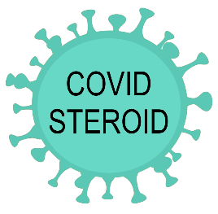
COVID STEROID trial
Low-dose hydrocortisone in patients with COVID-19 and severe hypoxia
Objective: To assess the effects of low-dose intravenous hydrocortisone on the number of days alive without life-support in adult patients with COVID-19 and severe hypoxia.

Inclusion criteria

- Aged 18 years or above AND
- Confirmed SARS-CoV-2 (COVID-19) requiring hospitalisation AND
- One of the following:
  - Invasive mechanical ventilation OR
  - Non-invasive ventilation or continuous use of CPAP for hypoxia OR
  - Oxygen supplementation with an oxygen flow of at least 10 L/min independent of delivery system

If eligible contact tel. ________

Intervention

Active medication: hydrocortisone, powder and solvent solution for intravenous injection, 100 mg
- Continues infusion of hydrocortisone 200 mg (4 ml) mixed with 100 ml isotonic NaCl with infusion rate 4.3 ml/hour OR
- Bolus injection of 50 mg hydrocortisone mixed in 9 ml solution of isotonic NaCl every 6 hours (bolus volume 10 ml)

Comparator

Placebo drug: Isotonic saline, solution for intravenous injection, 9mg/ml
- Continues infusion of 104 ml isotonic NaCl with infusion rate 4.3 ml/hour OR
- Bolus injection of 10 ml isotonic NaCl every 6 hours

Intervention period

Hydrocortisone or placebo for 7 days OR until discharge from participating site OR until death (whichever comes first)

