**C patientl (combinedICU trial: loperidol is administered. The following drugs are not contraindicated when the patient is parti**

13_AID-ICU_Newsletter9_3march2020

Place in Site Master File #13

**AID-ICU newsletter – January/February 2020**

**Thank you for your commitment to the AID-ICU trial!**

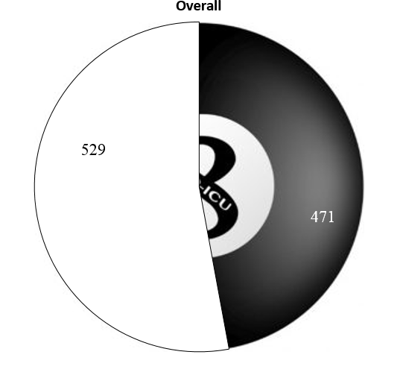

**STATUS**

In January we reached the highest inclusion rate to date with 40 randomisations in one months. This was partly achieved due to initiation of Odense University Hospital that started with a remarkable high inclusion rate which resulted in 7 randomisations within the first two weeks of initiation – this is impressive! We thank PI Louise Gramstrup Nielsen and her colleagues at Odense University Hospital.

We are almost half way! We hope to include patient no. 500 at the end of march. When 90 day follow-up of patient no. 500 is registered, the interim analysis will be conducted. In the Interim analysis we will check for differences in primary outcome and safety parameters (SARs) between treatment groups. The analysis is blinded to the intervention group and will be conducted by the DSMB.

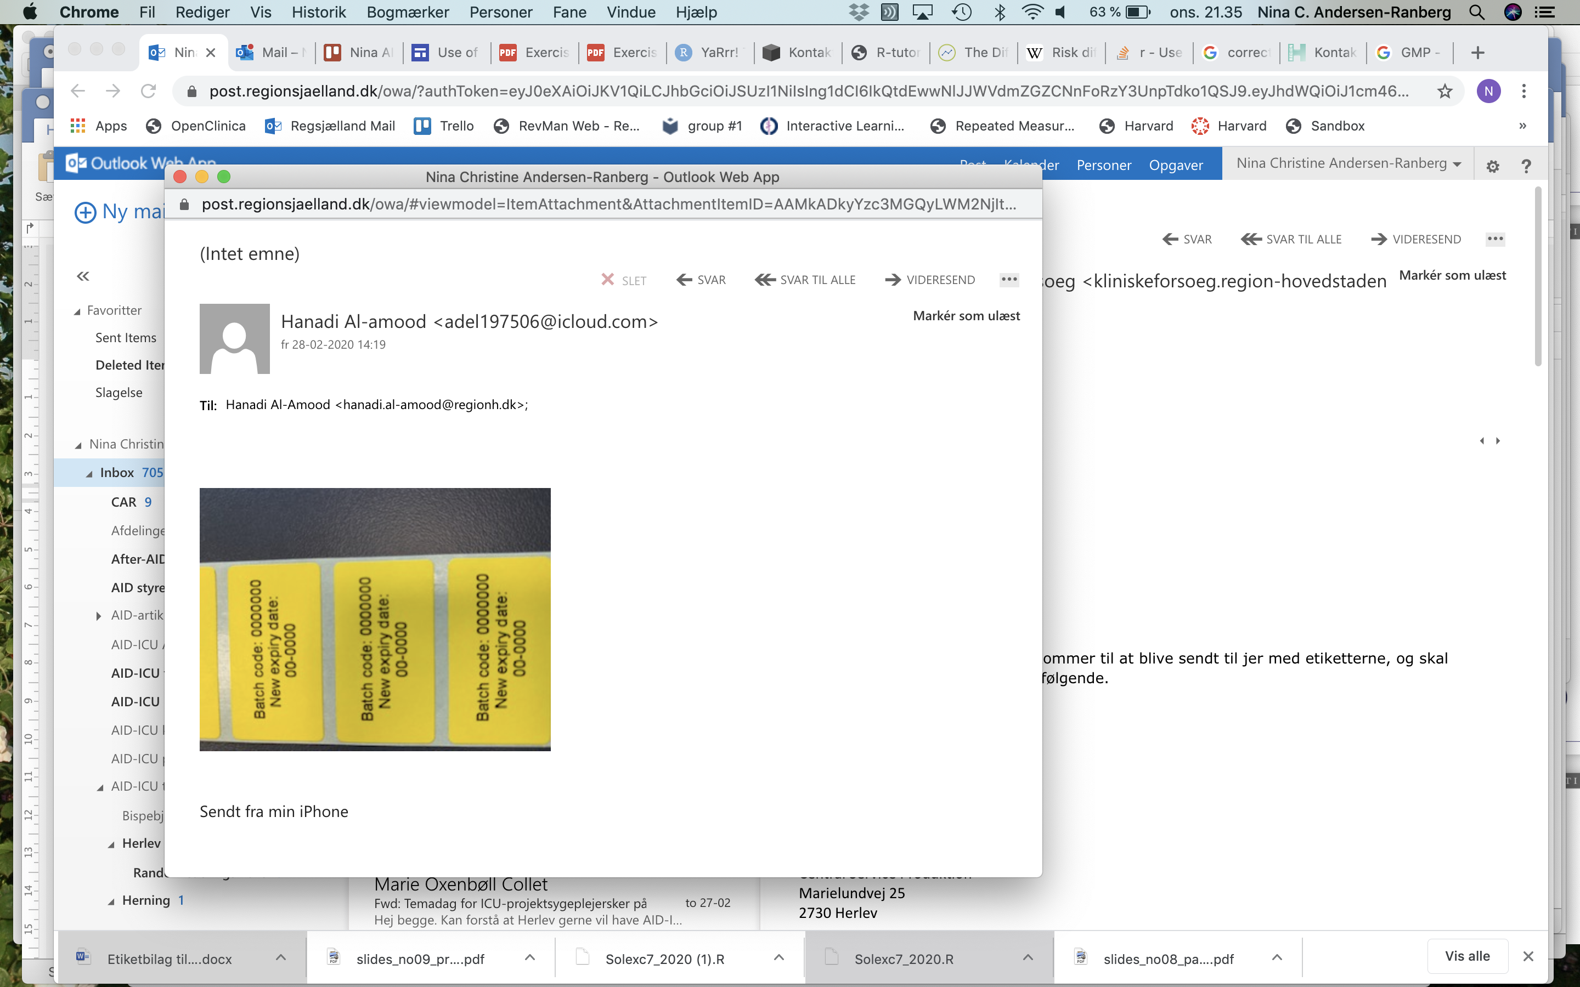

**Important Notice about Trial medication**

Many sites have trial medication stored that will expire at the end of April 2020. The pharmacy who is in charge of the production of trial medication has approved to extent the expiry-date. The conservative durability was set due to the placebo production, haloperidol has a shelf time of 5 years. Since normal saline (placebo) is a very stable product, the expiry extension has been approved by the pharmacy’s quality department. The extension of expiry date is in accordance with GMP legislation. The coordinating investigator will contact PI’s to arrange site visit, where the coordinating investigator or her delegate will label trial medication with the extended expiry date. An example is shown to the right, the label will have information about batch code and the new expiry date which will be the valid expiry date.

For extension of expiry date notification of health authorities are not needed. This is in accordance with GMP legislation.

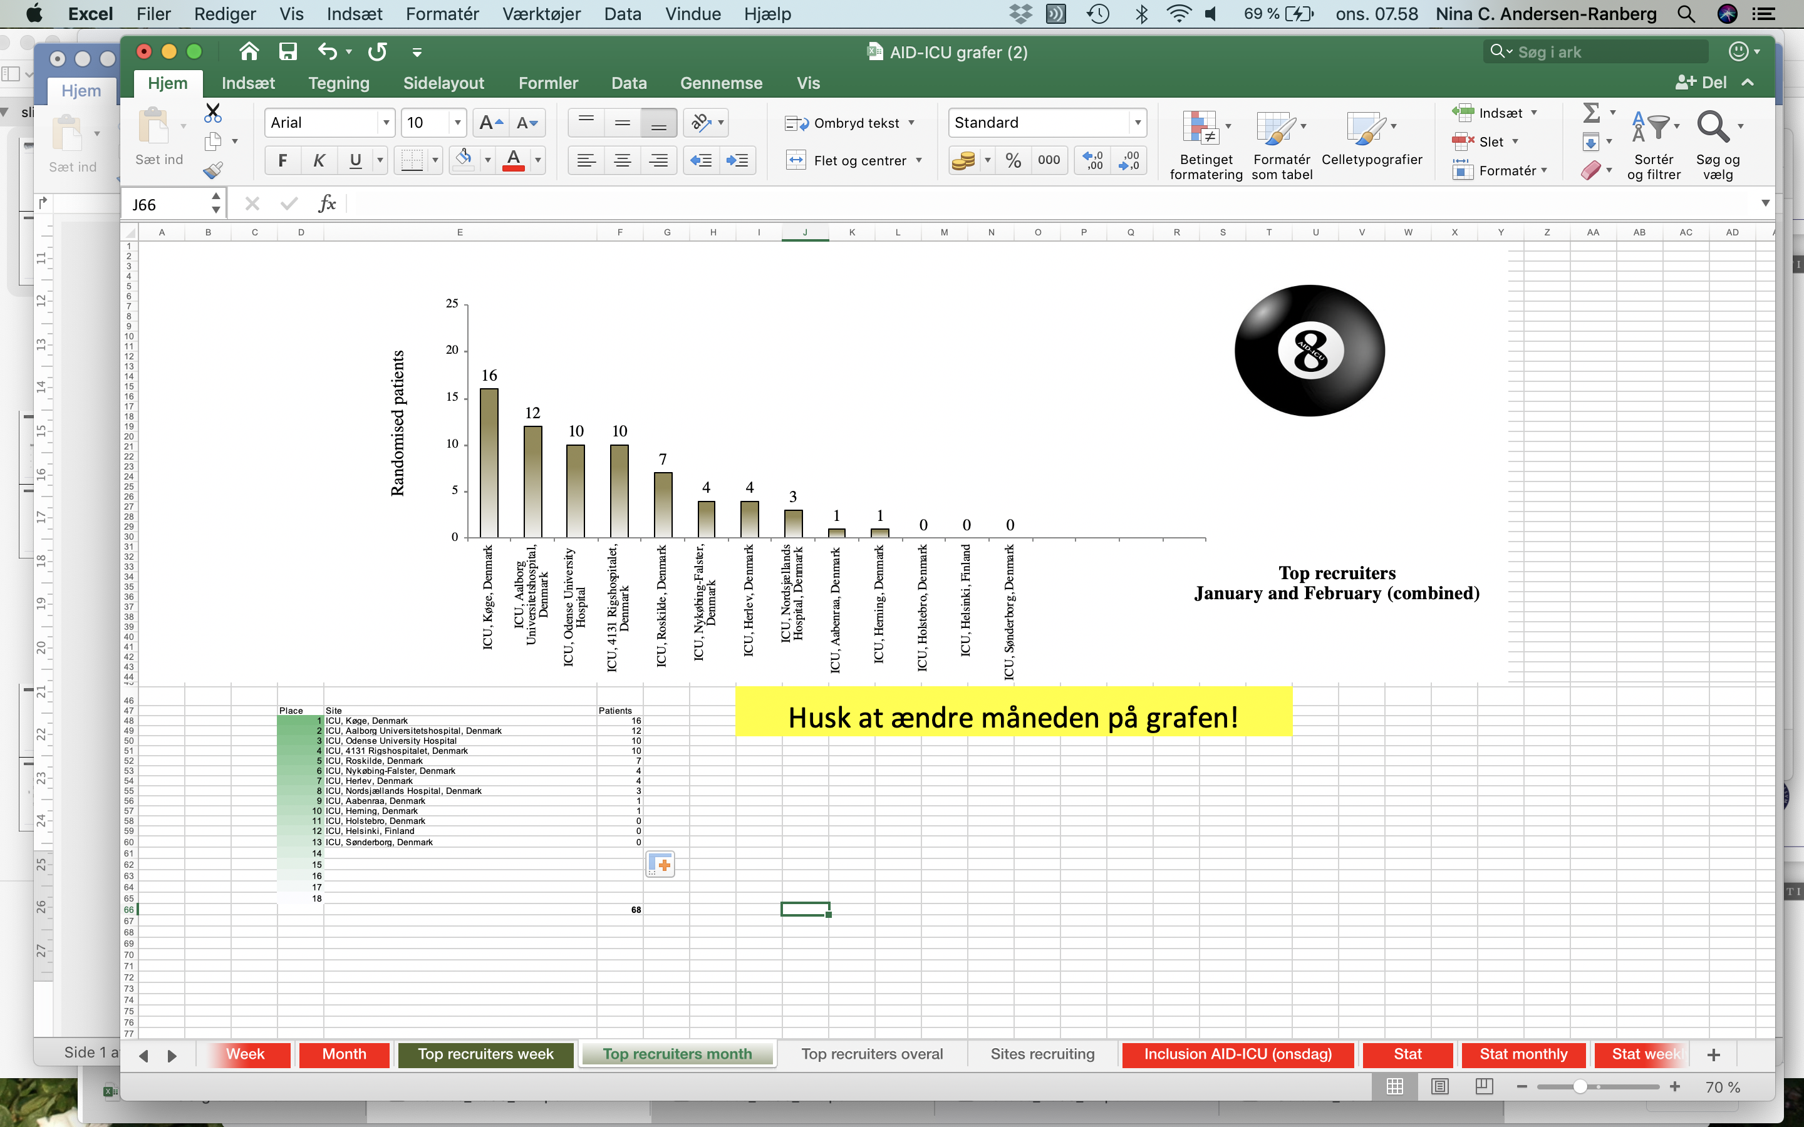

**ICU Aalborg**

**12 patients**

**ICU Koege**

**16 patients**

Congratulations to the top-recruiter:

**ICU ZUH Koege**

**ICU Odense**

**10 patients**

**Top Recruiters in January and February (combined)**

**Top recruiters overall**

THIS PERIOD RECRUITER-CLIMBER:

**ICU Roskilde from 1 to 7!**

Thanks to Uslu Bülent and his team at Roskilde University Hospital

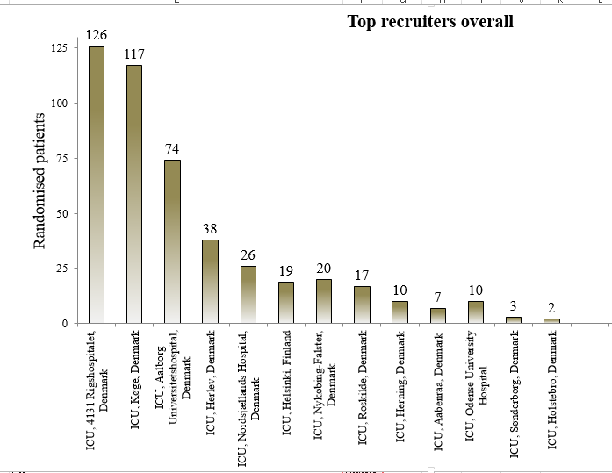



**Other important news from the coordinating centre**

1. Unfortunately we have seen an increase in protocol violation due to open-label antipsychotics. Please strive to keep protocol compliance, It is very important to manage delirium with trial medication. When trial medication is insufficient for safe delirium management use escape medication. Please check SOP Trial medication (<http://www.cric.nu/aid-icu-sop-trial-medication/>).
2. Remember to screen all patients with either CAM-ICU or ICDSC twice daily
3. Please strive to screen all patients fulfilling inclusion criteria (acutely admitted, adult patient with a positive CAM-ICU or ICDSC ≥ 4) in the AID-ICU database
4. Please check the site master file log (<http://www.cric.nu/aid-icu-log-for-site-master-file/>) regularly for updates.

**Welcoming new sites**

National Investigator of Spain; Jésus Caballero López just received approval to run the trial in Spain. We expect 4-6 sites to participate and initiation being planned.



**Remember the Coordinating Center is always available on the:**

**AID-ICU HOT-LINE: +45 93 57 77 50**

www.cric.nu/aid-icu

**Kind Regards from the AID-ICU team**

**Lone (sponsor), Camilla Bekker Mortensen (After-AID)**

**and Nina (Coordinating Investigator)**