Notes workbook  Making & Justifying Recommendations in a Children’s Hearing | NAME:  DETAILS:

ONLINE Module 1 Workbook Page:
Section 2 – Preparing a report:

Section 1 – Preparing for a hearing:

Section 3 – The right to attend:

Section 5 – How to present yourself:

Section 4 – Common areas of difficulty:

Section 6 – Solicitors in hearings:

KEY QUESTIONS / COMMENTS FROM MODULE 1:

ONLINE Module 2 Workbook Page:

1) Chronology considerations about intervention

Family | The points in time where intervention was ‘missed’
1) The Smith Family
2) The Ferguson Family
3) The Grant Family
4) The Heriot Family
5) Declan Jones

2) Now we have a Children’s Hearing

Family | Recommendation & Reasons
1) The Smith Family
2) The Ferguson Family
3) The Grant Family
4) The Heriot Family
5) Declan Jones

3 & 4) The child’s views.

Family | How will you gather child’s views? | How will you present views to the Children’s Hearing?
1) The Smith Family
2) The Ferguson Family
3) The Grant Family
4) The Heriot Family
5) Declan Jones

Children’s Hearing PROCESS DIAGRAM:

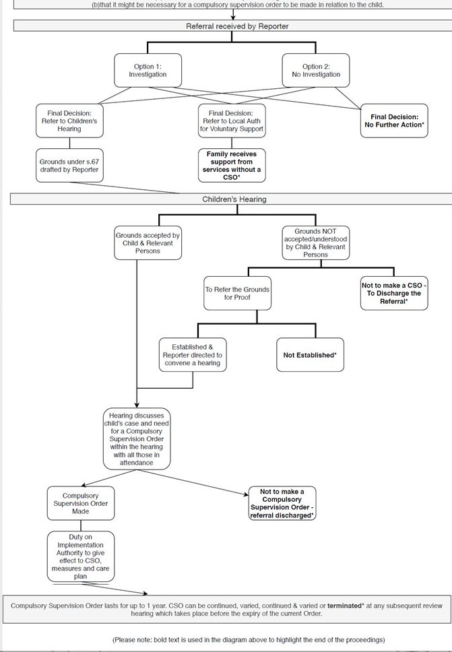

KEY QUESTIONS / COMMENTS FROM MODULE 2:

