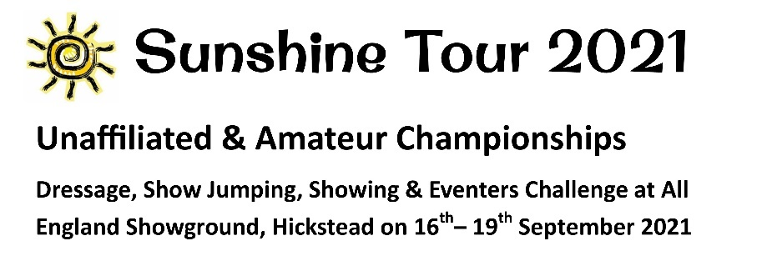  www.sunshinetour.co.uk  Checkendon Equestrian Centre also runs regular  Show Jumping  Gymkhana Games  Dressage  see website for details:  www.CheckendonEquestrian.co.uk |  |  | CHECKENDON EQUESTRIAN CENTRE  LOVEGROVE’S LANE, CHECKENDON  READING RG8 0NE  01491 680225  Linda@checkendonequestrian.co.uk  www.checkendonequestrian.co.uk  EVENTER’S CHALLENGE 2021  Each class consists of one round of at least 8 show jumps and 7 cross country  fences with a timed section.  SATURDAY 24th April 2021  SATURDAY 26th June 2021  SATURDAY 25th September 2021 - CANCELLED  All Classes (until July 31st ) are Sunshine Tour Qualifiers(www.sunshinetour.co.uk)  - ENTRY FEES - £20 per class. Entries close the Thursday before the event. NO ENTRIES ON THE DAY  - ROSETTES to 6th place.  - CLASS numbers will be limited.  - ENTRIES TO: Show Secretary at the above address.  - ENTRY TIMES: Telephone 01491-680225 between 5pm and 7pm on Thursday before the competition or by email request to linda@checkendonequestrian.co.uk  CLEAR ROUND SHOW JUMPING ON THE SUNDAY AFTER THE COMPETITION – PLEASE CALL 01491 680225 FOR TIME WHEN THE COURSE IS AVAILABLE.
1 | Minimus | Fences 60cm (2’) approx. May be led. May not compete in class 4 or above | EVENTERS CHALLENGE ENTRY FORM  Entries can be emailed to Linda@CheckendonEquestrian.co.uk but must be paid by bank transfer to:  Account Name: Lovegroves Farm Ltd, Sort Code: 09-01-50, Account Number 02072726.  DATE CLASS HORSE RIDER FEE  TOTAL DUE ……………  Cheques made payable to: Lovegrove's Farm Ltd  Name: ..................................................................................................... Telephone: .................................................................  Address: ….......................................……………………………………………………….......................................................  Email: …………………………………………………………….…………………..…….......................................................  I agree to abide by the rules of the Competition Signed: ………..........……………………....................................................
2 | Novice | Fences 70cm (2’3”) approx.
3 | Open Novice | Fences 75cm (2’6”) approx.
4 | Intermediate | Fences 85cm (2’9”) approx.
5 | Open | Fences 90cm (3’) approx.
Classes 3, 4 and 5 will include water tray, ditch (with alternative) and bank.

RULES AND CONDITIONS OF ENTRY

- Under BSJA rules with the exception of allowing 3 refusals before elimination.
- The judge's decision is final.
- Horses must be 4 years or older.
- Hard hats with permanent three-point attachment, must be worn at all times when mounted. Hats must meet one of the following standards:
- PAS 015, BSEN 1384, EN 1385 with BSI Kitemark ASTM with SEI mark.
- Back protectors and long-sleeved jacket/shirt must be worn
- Competitors must report to secretary on arrival to collect number and verify medical information
- No entry fee will be refunded or deferred except on production of a Vet or Doctors certificate, up to 25% will be retained to cover administration costs.
- NO DOGS
- The organisers and owners of Checkendon Equestrian Centre accept no responsibility for any damages, loss or accident, injury to horses, owners, riders, spectators or any other persons or property whatsoever.
- Please use the bins provided for all litter.
- We reserve the right to alter classes or cancel them.
- Practice jumps flagged with red on right.
- The gate to the parking field must be kept shut at all times.
- Competitors making telephone or email entries will be expected to pay their entry fee whether or not they compete.
- Closing date is Thursday before competition.
- NO ENTRIES ON THE DAY.
- Consent is given for results to be published in public domain

Contact - 01491-680225 or email linda@checkendonequestrian.co.uk

