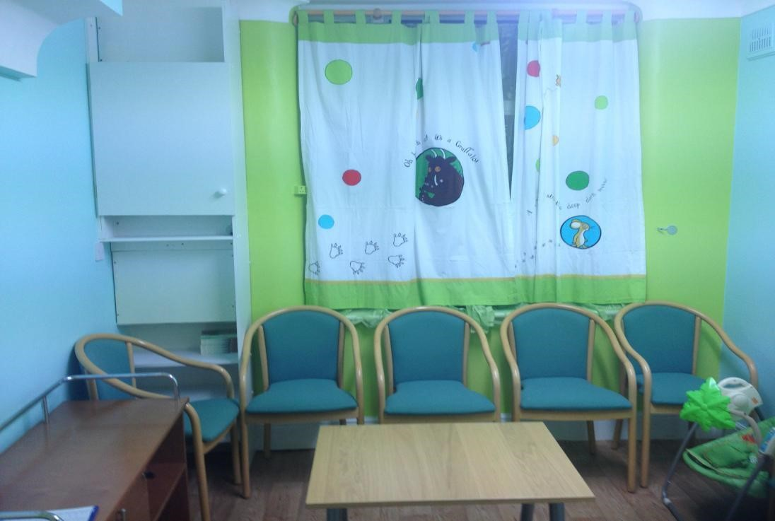

8-10 Khartoum Road,
Plaistow London E13 8RF
Telephone: 02084725444
Email: chariteensltd@yahoo.co.uk

Welcome:

Management welcomes you to Chariteens Residential Family Centre. Thank you for choosing us and hope you will enjoy staying with us. We will do our best to ensure you are supported according to your family parenting assessment plan and you will develop new skills and knowledge that you need to be a good parent.

We are here at your service to ensure that your safety, comfort and welfare are achieved. I promise to address all questions you might have and look into any emerging needs, concerns, issues, and complaints as soon as possible. Needless to say we will make your stay as homely and friendly as possible. Chariteens is the place to be, to share your experience with trained staff that are keen to support you to new levels so that you can achieve your full potential.

Our Philosophy:

At Chariteens we put young parents and their children first. We aim to support you and provide you with childcare experiential learning skills which will help you to fully integrate into the community. The social skills you will gain will help you to be a responsible and valued citizen where you are not only tolerated but celebrated in the community.

About Us:

Chariteens works with experienced, professional dedicated team to support you in reversing the negative effects of social exclusion. We shall support you by equipping you with the skills, knowledge and motivation necessary to reach your full potential and make a positive contribution to your community. Throughout your time with us you will receive support and guidance through key working sessions offered by our staff for your personal development and wellbeing.

Aims and objectives:

Our aim is to provide you and your child with a safe, secure and comfortable accommodation. This will help you to develop good parenting skills and establish higher family functioning to enable you to provide an environment in which your child is healthy, safe, and where you make a positive contribution to achieve the assessed outcomes. We work with the local community and together we will support you to fulfill the requirements among others such as stated in the National Minimum Standards 2013 (Residential), Residential Family Centres Regulations 2002 and Working Together to Safeguard Children 2018.

We will provide the highest quality care and support you with the aim to improve outcomes for you and your child. Together with you, we will plan personalized sessions (carefully selected from a lot of different sessions) that focus on your needs. They will be reviewed from time to time and you will have a say.
At Chariteens we encourage you to voice your views, feelings and choices and we promise to listen to you and take your views into account when supporting you.

We will consult and work with others who care about you and those involved in safeguarding you and your child by providing personal development plans for the best possible care and ultimately reintegrating you into the community.

You will be supported by carefully selected, well trained and experienced staff to meet the challenges of day to day quality service, including government policy and organizational changes.

We aim to deliver value for money by exercising and promoting best practice in the Health and Social Care Sector and being responsible to our commitments and accountable for our actions and upholding the spirit of excellence. We are open to positive criticism and take it seriously as part of our quality assurance and feedback and aim to improve were possible.

Our services are tailored to meet your needs and those of your child as agreed with the placing authority. We focus mainly on self-care skills, emotional well- being, education and training, welfare benefits and placement management. We provide accommodation and a comprehensive assessment of your parenting abilities and prepare you to move into semi-independent accommodation or significantly to independent living

This handbook is designed to help you settle into your new home. Keep it in a safe place so that you can refer to it when you need to. For more information about any of our services, please contact a member of staff who will assist you.

Location:

Chariteens Residential Family Centre is strategically located in a residential area of Plaistow (Green Gate) making it centrally accessible to local shops and five feeder underground train stations namely Plaistow, Canning Town, West ham, Stratford and Upton Park.

There are health services of 2 minutes’ walk from the centre e.g. Dental surgery and GP surgery plus children’s centres including a public park. It is also close to Newham General Hospital and Newham and Balaam Leisure Centres. There are schools and colleges close by and also different places of worship close by. There are shops and super markets to do shopping and general grocery within 5 minutes walk.

Getting There:

The train stations are located in Travel card Zone 3. Chariteens centre is maintained to a good standard and is comfortable, hospitable, warm, clean and tidy. Nearest Tube Stations: Stratford/Plaistow/Canning Town/West ham/Upton Park.

Buses: 473/262 from Stratford bus station to North Woolwich (473) and East Beckton (262) respectively. Get off at Green Gate bus stop. Cross the road by Halifax Banks and proceed along Khartoum Road.

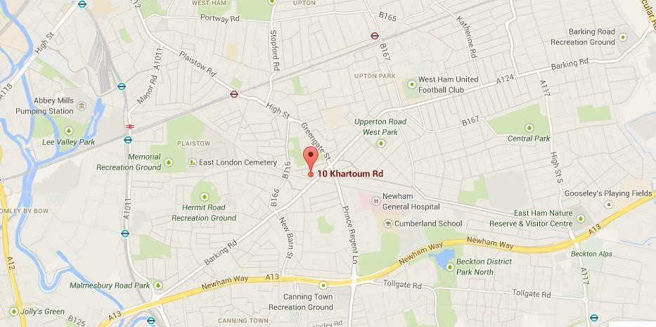

General Information:

Inside this handbook you will find helpful information about Chariteens’ obligations to you which are (your rights) and what is expected of you by Chariteens (your obligations).

Chariteens is a Residential Family Centre and it is important that you understand why your Social Worker has placed you here.

Our placement and support services are enshrined in standards of excellence to enable the difficult transition from dependence to independence. We aim to offer you with the same access to opportunities, enjoyment and aspirations as other young mothers in their life chances.

Chariteens expects you to be fully involved in the shared assessment process which involves planning, key working, feedback sessions and meetings. As a parent it is hoped that you will contribute positively and find the process beneficial.

Whilst you will be supported by staff, you have full responsibility for yourself and your baby, unless otherwise agreed as part of your assessment plan. We expect you to engage with the assessment and other professionals so that the support given to you will have a positive impact on your parenting including enhancing your lifeskills.

You will make sure that you and your baby are safe and healthy, with good food, nappies, plenty of fresh air and enough sleep. You must also keep yourself and your baby safe, clean and encourage your child’s development with play and communication.

Specialist support is available from Chariteens Centre and assessments are based firmly upon the National Framework for Assessment. This service includes complete Assessment and Court Reports. There is an out of hours Service Emergency Contact Numbers are through office landline on 02084725444.

Facilities and Services:

Your Room:

This is your private space for you and your baby. You must take care of the furniture, bedding, curtains, laundry basket and bins, which are all provided by Chariteens. Cot linen is available to you but we do ask you not to use duvets in the cot as these are dangerous and can cause babies to overheat. You will be given an inventory list on arrival. Staff will have access to your room once a week for health and safety inspection and notice will always be given prior to such inspections taking place.

You are asked to co-operate with the staff when they are carrying out this exercise as it is for your safety and wellbeing during your stay at Chariteens. There will be occasions when staff is permitted to enter your room without your permission or when you are not present. An example of this would be when the house has its monthly inspection by the Manager as part of our requirement under the National Care Standards.
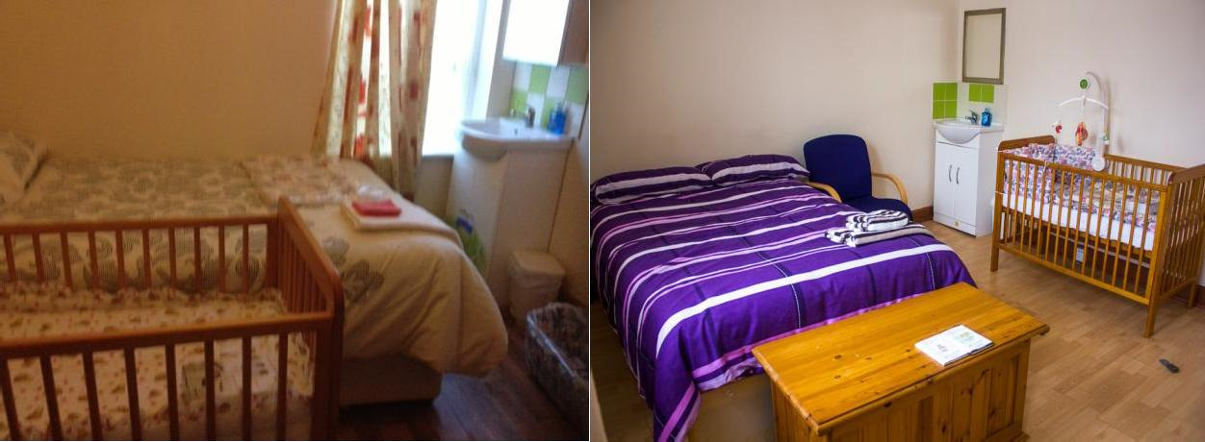

Main Kitchen - Safety Regulations:
This is a communal kitchen and is accessible for everyone. It is to be kept clean and tidy at all times. This is where you can cook your food and make up bottles for feeding. Plates, cups and utensils must be washed and dried after use and kept away in their respective drawers.

All kitchen equipment, sterilizer, kettles, crockery, cutlery, utensils, dish washer and adequate storage of food are provided. Each resident is allocated a cupboard with a key and it is your responsibility to make sure your cupboard is locked at all times.

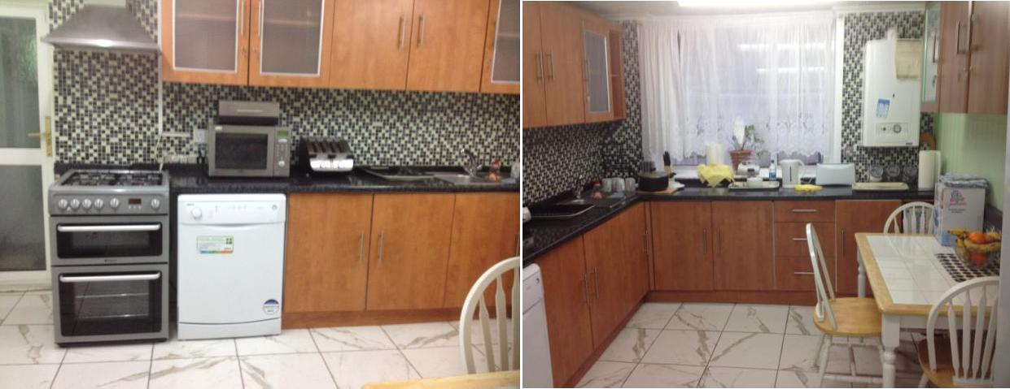

There is a communal dining room downstairs. You can make a cup of tea or prepare a meal and eat from the dining room but cups/plates should be removed and washed after you have finished with them. Please respect the house at all times. It is your home. Meals are not provided for your visitors or family unless pre-arranged by you with staff. No food is allowed in the bedroom.

Lounge/Dinning area

This is a place where you can sit, relax and watch the TV and also listen to music during your free time. The lounge comprises of a big screen TV with HD sky box. In the lounge is a massage chair which you can use for your health and fitness. You are expected to respect each other this means if the massage chair is occupied by another resident, you have to wait and use it when it becomes free. No babies are allowed in the lounge after 20.00hrs.

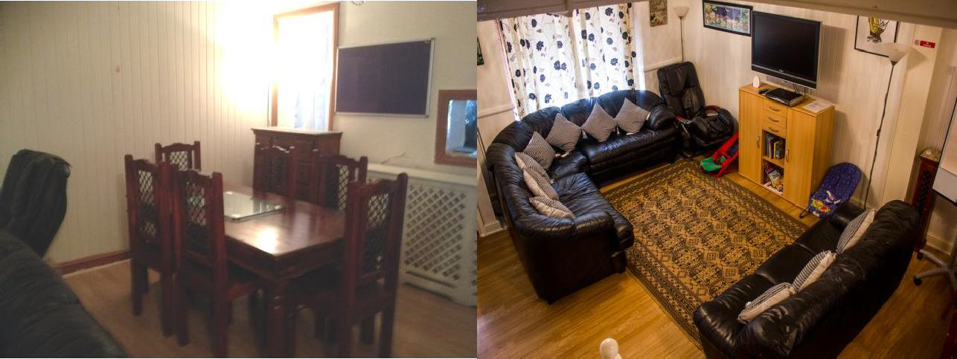

Fridge:
There are three fridges in the whole unit. You will be required to share a fridge with another resident and the fridge should be kept clean all the time. You need to cooperate with the resident you will be sharing the fridge with.
Should you have any concerns about the cleanliness of the fridge, and your fellow resident is not cooperative in cleaning it, you need to inform staff about it.

Laundry:

Chariteens supply all bedding for you and you are required to do your own laundry during your stay at Chariteens. Chariteens have a washing machine available and a tumble dryer for your use. You are expected to supply your own powder soap and softener (if required). The times for laundry are between 09.00hrs and 20.00hrs and you are advised to adhere to the laundry times and rota. The laundry room is equipped with laundry baskets, iron and ironing board, so should you wish to iron your clothes, use the laundry room.

Parent’s/visitor’s room:

This is where you will be entertaining your visitors. This room can also be used by parents to bond with their babies in case there are no visitors using it. Make sure the room is kept tidy all the time.

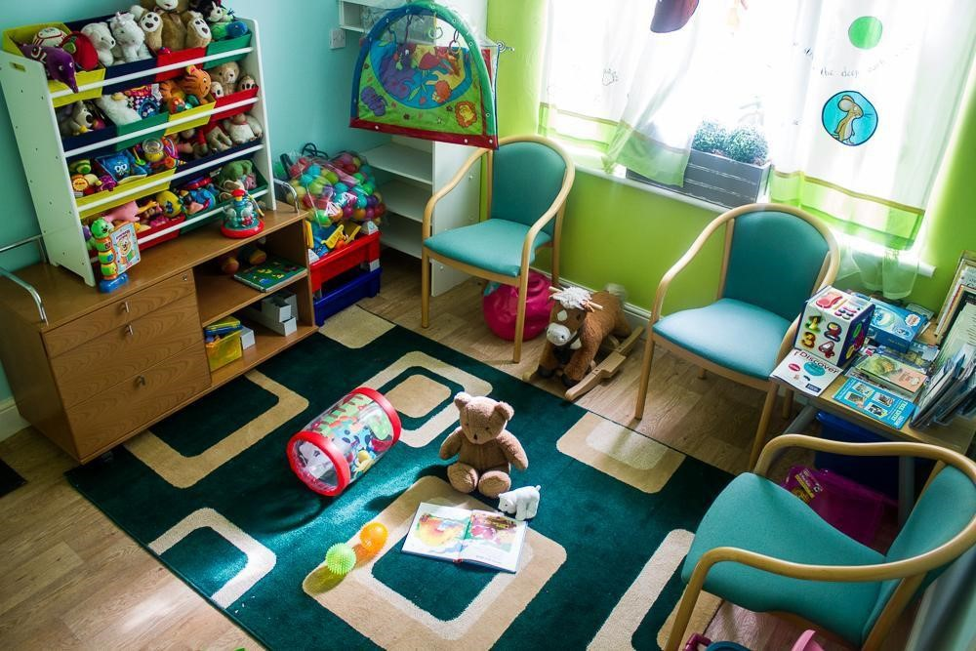

Toilets:

There are four toilets in the building, two on the ground floor and two on the first floor. When you are downstairs, you can only use the toilet which is next to the kitchen. The toilet next to the parents’ room is for staff and visitors only.

Buggy Compartment Area:

This area is strictly for buggies only. When you come in with your buggy, you should fold it properly and make sure it is kept inside the designated area. The place must be kept tidy at all times.

Resource room:
The resource room is situated on the 2nd floor of No.10. This is where workshops and meetings take place. It can also be used as a staff room. No babies are allowed in this room.

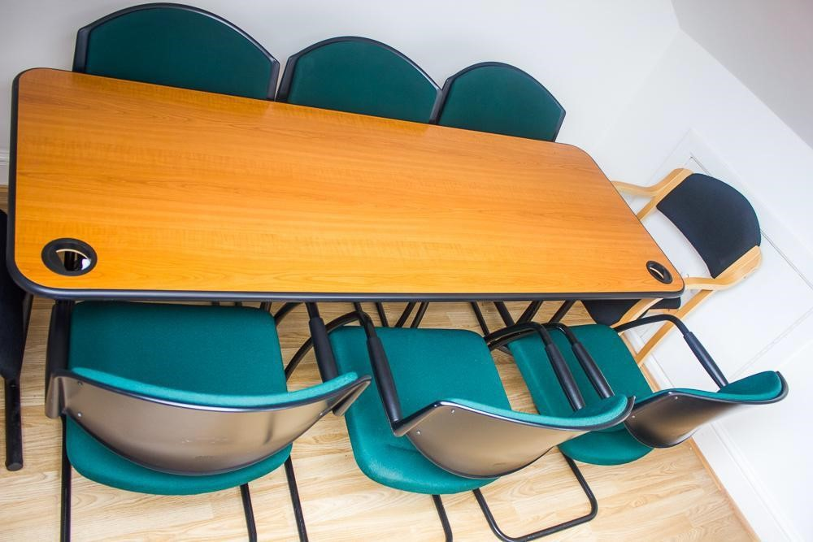

Garden:

There is a large rear garden via the parents’ room where you can relax with your baby when the weather permits. While in the garden you will be under CCTV, this is to make sure that you and your baby are safe at all times.

The garden should always be left clean and chairs folded and put under the shade/canopy in case it rains in the night. The toys should be left clean and kept away in the provided containers which are situated in the garden under the canopy after use.

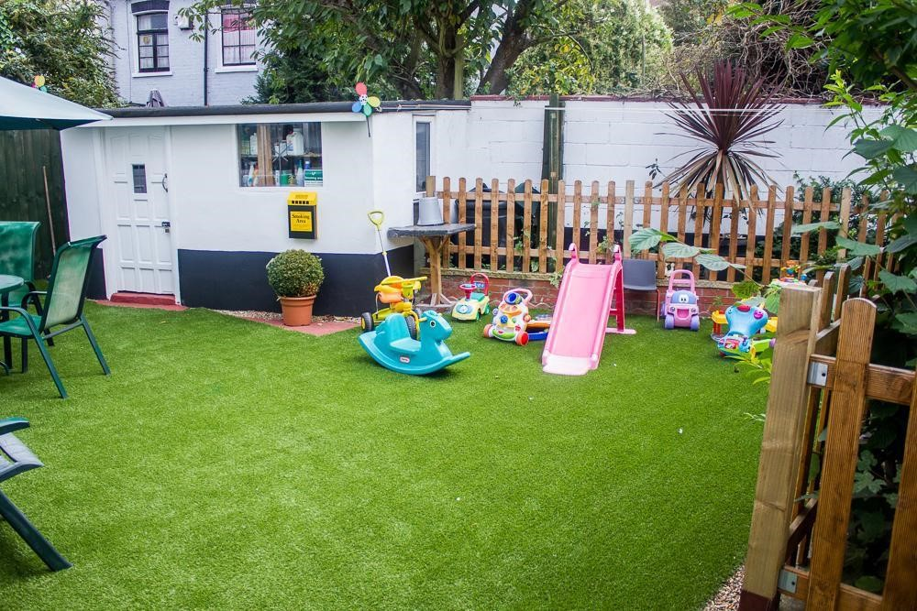

Telephone:

Residents are allowed to use the office telephone to contact the professionals involved in their care between the office hours from 09:00hrs – 17:00hrs. No private calls are allowed to be made using the office telephone unless in emergency cases only. If a resident asks to make a call, staff should dial the number and put the resident on line. All calls will be recorded by staff.

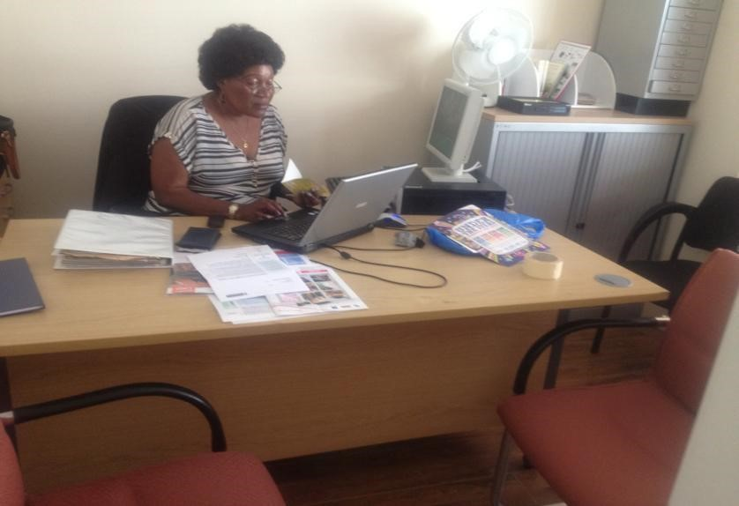

Keys:

When you arrive at Chariteens Centre you will be given a set of keys to your room, your chest of drawers and the kitchen cupboard where you will keep your food stuff. You are responsible for these keys and if you lose them you will be subject to a cost replacement fee.

Fire Safety:

When you arrive at Chariteens Centre, you will be inducted about the Fire Alarm, location of fire exits, call points and evacuation procedure. In the event of a fire alarm you are to immediately evacuate the premises and congregate at the Assembly Point which is located at the bend of Khartoum Road and adjacent to Dongola Car Park. Staff will support you to evacuate safely. Please in the event of fire take your baby only and get further instruction from the staff on duty or staff fire warden.

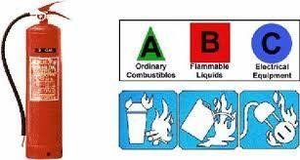

For everyone’s safety we carry out monthly Fire Drills as required by law.

Baby Equipment:
Use of CCTV and Baby Monitors:
Our CCTV policy, statement of purpose and agreement with the placing authorities will always be reviewed and updated to demonstrate exactly how CCTV will be used for each family. If the CCTV is unmanned, the CCTV will only be used to review after incidents or events or where the placing authority has requested specific circumstances before the placement. The CCTV is also used as part of monitoring health and safety at the centre including people/visitors or other professionals coming and going out of the centre.
Every resident is provided with a baby monitor. This is to help you monitor your baby whenever the baby is awake and needs attention, especially when you are busy doing other things. When the baby is asleep the monitor will show green. When the monitor shows red that means the baby is awake and might need attention. You are required to use the baby monitor in your room and wherever you are around the house until it is agreed in your care plan that it is no longer necessary. Monitors should be handed over to the night staff at 23:00hrs when you are required to retire to bed.

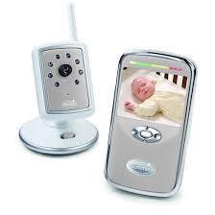

Chariteens will also provide you with a Moses basket, baby bouncer, changing mat, bottle steriliser and baby bathtub in addition to a baby monitor. There are also baby high chairs for use in case you want to dine with your baby. All this equipment is to assist you in attending to your baby’s daily needs; it is your responsibility to make sure they are looked after and kept clean.
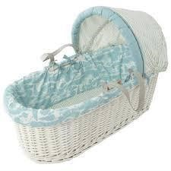
Group Sessions:

The daily and weekly group activities/teachings are compulsory. During the group sessions you are expected to participate fully, which will help you to get to know everyone and vice versa. Each session may not be educational but may exhibit experiential learning processes. There are a lot of activities to be done with your baby but your weekly plan will determine your engagement in these activities. If you fail to turn up for three consecutive sessions your Social Worker will be informed. You are also required to attend the children’s centre activities for your baby’s stimulation and development.

Smoking:

Chariteens is a no smoking area. If however, you are a smoker you are allowed to use a designated area in the garden. Please make sure you empty the ashtray when it is full. No throwing of cigarette butts around the garden but in the ashtray provided only.
Needless to say after each smoke parents must thorough wash their hands before coming into contact with their children.

Visitors:

Throughout your stay at Chariteens you are allowed visitors. The frequency of their visits will be discussed on admission, and at your reviews in consultation with social services. You are responsible for their behaviour and, if at any time, they behave inappropriately, a member of staff will ask them to leave.

Visiting Times:

Monday - Friday visits start from 15:00hrs – 19:00hrs, but you are only allowed three hours with your visitors. This is to allow you time to engage in the in-house activities. Weekend visits begin at 13:00hrs – 19:00hrs. It is your responsibility to make sure your visitors adhere to this time.

HOUSE RULES:

We expect you to comply with the following house rules during your placement:-

No meals to be taken in the rooms. This is for Health and Safety reasons.
No alcohol or non-prescribed drugs are allowed in Chariteens.
No laundry after 8pm. This is due to minimizing noise and creating a tranquil environment for parents and babies.
The volume of radios and televisions must be kept low after 19:00hrs. Babies must be upstairs by 2000hrs.
All visitors to leave by the designated time (19:00hrs). This is for everyone’s safety and privacy. Ensure you clean up after your visitor/s.
Visitors to sign in and out of Visitor’s Book, so that we know who is in the building if we have a Fire Alarm. Your visitors must sign the Visitors’ Book when they arrive at Chariteens Centre and when they leave by 19.00hrs. This is to safeguard the security of the residents and their babies including staff at the centre and its environment.
Room check once a week, so we can ensure that your personal space is being kept to a hygienic standard and is safe for you and your child, ie, no drugs/alcohol or sharp instruments that can cause harm.
Night checks – Staff will check throughout the night to see if you and your baby are secure. This can be physical or by remote CCTV whichever is applicable.
Weekdays parents to be upstairs by 23:00hrs. You need your sleep. Television is off by midnight for those who have them in their rooms. Weekends we ask you to be upstairs by midnight. You still need your sleep. Respect other people and their property.
No physical violence or abuse of staff no physical or emotional abuse to other residents or staff will be tolerated as appropriate action will be taken under behaviour management and document.
To be in house by at least 19:30hrs as door will be locked by 21:00hrs for security and safety reasons. No ordering of takeaways after 21:00hrs as they will be sent back. If these rules are broken by you, then a meeting will take place. You will have two verbal warnings, and one written warning before Chariteens considers terminating your placement. If you bring in, or use illegal substances or alcohol at Chariteens, or if you are violent towards another person, you may have your placement terminated without these warnings.

Staff are here for you at any time of the day or night, so whenever you are feeling angry, frustrated or anxious, please feel free to talk to them.

We are an Equal Opportunities establishment and we will NOT tolerate people discriminating on the grounds of race, ethnicity, gender, sex, sexuality, religion, culture, creed, disability or age. We take this very seriously and discrimination will result in immediate action being taken.

Chariteens acknowledges and celebrates each person’s culture in line with the protected characteristics as defined and embedded in the Equality Act 2010.

Useful information:

Chariteens is centrally located where you will have access to:-

- Banks, GP Surgeries, Dental Surgery
- Police Stations, Optician Main Post Office
- Library, Recreation Parks, Churches, Mosques
- Chemist, Schools, Colleges, Children’s centres
- Markets: Tesco Express, Iceland Supermarket and a wide variety of shops
- A variety of support groups and counselling.
- Newham General Hospital
- Newham and Balaam Leisure centres

You can speak to staff for more details and leaflets.

Emergencies: Health & Safety, Electricity and Gas appliances

Gas:

By law we have to carry out a yearly safety inspection of any gas appliance that we have installed in Chariteens. Staff at Chariteens will arrange these appointments.

Electricity:

If there is an electrical fault, the supply should be turned off at the mains, which is in the fuse box. Please report the problem to a member of staff immediately who will then take action, i.e. turn off the electricity and seek further help.

Portable Appliance Test and NICEIC tests on fixed electrical installations are carried out on a yearly basis by contracted Engineers who come on site to inspect if all is well.

Fire safety:

You can help to prevent a fire by unplugging electrical appliances like televisions and DVD players before you go to bed and when you go out. Keep matches away from children and never leave candles unattended.
Smoke alarms can save your life by giving you an early warning of a fire so these must be checked regularly to make sure they work. We have a fixed/hard-wired alarm which will be checked annually when gas inspections take place. You are not allowed to use extra electric gadgets in your bedroom like hair dryers.

Fire alarm and fire drill tests:

A test of the fire alarm equipment will be carried out once a week. This test is to ensure the fire alarm equipment is working correctly. An alarm will ring for a short time. There will be no need to evacuate the building when staff are carrying out the test. A schedule of the times this test will be carried out each week which will be displayed before hand for First Aid information.

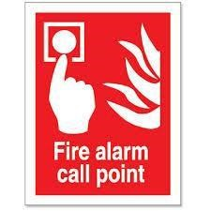

If you discover a Fire:
- Sound the Fire Alarm or break the nearest Call Point.
- Close the door blockading the Fire.
- Collect your baby or children.
- Leave by the front door to the Assembly point which is on the bend of Khartoum Road adjacent to Dongola Car Park.
- Do not stop to collect anything except your baby and child.

If you hear the Fire Alarm:
- Collect your baby or children.
- Leave by the front door to the Assembly point
- Inform the Fire Marshall that you are safe. You will be told the name of the fire marshal during your induction to the home and this is also displayed on the notice board.
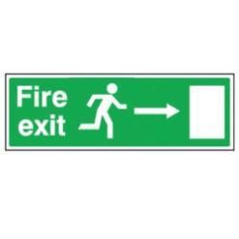
First Aid:

Basic first aid equipment is available at Chariteens Centre Office. Key staff and appointed first aiders will administer first aid.

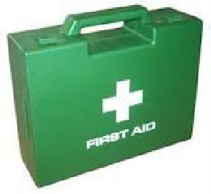

Health & Safety inspections:

Once a month, two members of staff will do a comprehensive health and safety inspection of the whole property. Access to your rooms will be required by staff when carrying out this inspection. Notice will always be given to you prior to inspections taking place. It is vital health and safety inspections are undertaken on a monthly basis for your safety and well-being whilst you reside at Chariteens.

Burst pipes:

If you discover a burst pipe, the water should be turned off at the main stopcock. Please report the problem to a member of staff at Chariteens.

Maintenance:

We are responsible for keeping the structure and outside of your home repaired, it is important you report all maintenance repairs to staff or management. To report a repair, please contact a member of staff at Chariteens.

Maintenance repairs response times:

You have the right to expect that reported maintenance repairs within the centre, will be completed within a reasonable timescale according to our Health and Safety policies and procedures.

Condensation:
If your room has condensation problems, you will often find black mould growing in the corners of the rooms, on windows and outside walls. This can damage your room and furnishings. You can help prevent condensation by:

- Keeping air vents in your room open.
- Wiping down windows in the morning where water may have collected overnight.
- Keeping rooms warm in cold weather.
- Opening windows to allow fresh air in whenever possible.

Planned maintenance:
Planned maintenance is different from day-to-day repairs. It means major repairs or improvements such as replacing the roof or installing new windows, or it can include full refurbishment such as installing central heating, new windows, a kitchen or a bathroom or rewiring. Our staff will let you know if there is any planned work in your room. They will also give you notice about this and tell you what the contractors plan to do and when, according to our contractor control policy and procedures.

Tackling Anti-Social Behaviour:

Chariteens is committed to creating sustainable accommodation, where our residents can enjoy a quality of life free from anti-social behaviour (ASB). We expect our residents and visitors to act in a considerate and reasonable way to others living in their locality. Our staff are trained to deal with all anti-social behaviour cases.

What is Anti-Social Behaviour?

There is no single definition of ASB, but we have accepted it will commonly involve the following types of behaviour:-

Harassment/bullying/intimidation: Verbal, written or physical abuse, racial, homophobic, religious, physical disability or mental health based or other motivation.

Environmental: streams of visitors/nuisance calls to property, animal fouling, urinating in communal areas, general rubbish,

Criminal acts: theft, joy riding, assault, vandalism, arson, damage to property, damage to vehicles, graffiti.

Drugs: syringes, drug use, drug dealing.

Noise: loud music, shouting, animals, burglar alarms, door slamming.

General nuisance:

Gangs of youths hanging out, begging, street drinking.

Confidentiality and Privacy of residents:

Residents have their own lockable room and food cupboard. We encourage positive assistance to help parents recognize the needs of their children, building their self- esteem and working towards creating a safe, caring, loving and protective environment for their children.

Staff aim to provide a supportive advocacy role for parents and work tirelessly to develop relationships based on trust and honesty.

You need your privacy and your room is private. Whilst on assessment staff will knock on your door before entering and will only enter when invited to do so, unless they have serious concerns regarding health and safety. You are however, expected to spend most of your time in the communal rooms with staff so that they can support you in looking after yourself and your baby.

Chariteens provides private facilities for professional meetings between you and your solicitor, social worker and the children’s guardian.

If you happen to have personal counselling, your sessions will remain confidential between yourself and your counsellor, unless serious safety concerns arose from any of the sessions.

Use of CCTV surveillance equipment:

Chariteens is mindful that the use of cameras must present the minimum necessary interference with the privacy and rights of the individual. Camera observations will only be used to capture people at the entrance and at the rear garden. There will also be use of mobile surveillance to make sure you are safe all the time.

The use of camera in your room is initiated where there are concerns regarding a parent’s ability to respond to their child’s needs therefore, placing the child at risk of significant harm and is only initiated upon request from the Local Authorities. You may not be in agreement with a camera in your room, but if the local authority approves it then you will have no choice but to have it. The level of monitoring will be agreed and determined at the point of referral and admission stage and will be risk assessed and reviewed regularly.

On the ground floor next to the main entrance is the office, enabling the staff team to be attentive to the needs of the residents. There is CCTV Surveillance equipment ensuring the safety and wellbeing of residents, staff and visitors. All visitors to the centre are signed in/out in a visitors’ book at the office.

Your views and feelings:

You will get the chance to say how you are feeling and to express your views and opinion about the care you receive and any decisions being made about you.

This will be done through individual key-work sessions with a member of staff and through house meetings.

We do not accept any form of bullying at Chariteens. Staff will challenge it at all times and staff will not tolerate bullying of any type. If you feel bullied, report this to a member of staff or an adult you can trust. Do not suffer in silence; we are here to help and ensure your safety and happiness at Chariteens.

Complaints Procedure:

If you have any complaints about our services or complaints about the conduct of our staff refer the complaint to the Centre Manager. For a more detailed complaints procedure refer to our Complaints Policy by asking any member of staff on duty.

Useful Numbers:

These are people you can contact if you feel you need outside support for any reason:-

Watch Child - 01482325552
Do you feel unable to talk about your problems to your parents? Are you being bullied at school? Do your friends pressure you to do things you don’t want to do? Do you have problems with drugs or the police.

Victim Support - 08453030900 - Helping victims of crime.
Have someone to talk to in confidence. Get information on police and court procedures and get rid of court’s intimidating factor.
Get help dealing with other organizations.

Voice - 0808 800 5792 - Been a victim of crime or abuse?

Ofsted - 08456 404040 or 03001231231 Ofsted regulates and inspects childcare and children’s social care.
We assess children’s services in local areas, and inspect services for looked after children, safeguarding and child protection. We seek to promote improvement in the services we inspect.

Newham Local Safeguarding Children Board ---------------0208430200

Parents or relatives | ----------------------------------------
Social worker | ----------------------------------------
Children’s rights Director | 0800528 0731
Child line | 0800 1111
Voice of the child in care | 0808 800 5792
Local police | 0208 340 1212
Responsible individual | ..................................................
Unauthorized absence:

This is when you run away or do not return to the unit as expected (missing from care/centre):-

We hope to provide you with the best support and ensure you are well looked after. Hopefully you will be very happy and never want to run away. If you are upset, worried or angry it is best to tell someone before you decide to run away (go missing). If you go missing, you put yourself and your child at risk and people have to look for you. You will be reported missing to social service, the police and other responsible people.

We also expect you to return to the unit at the agreed times and if you do not, staff will report you to social services (unauthorized absence). Communication is key to avoiding situations that may upset you and yet it could be avoided by communicating with staff most of the time.

Behaviour:

There might be times where you misbehave. This could lead to the staff giving you a sanction. This is to help you learn how to behave more appropriately in the future. This may include being extra chores and supervision.

We expect you to behave properly and to treat others fairly and with kindness and respect.

1. We do not accept any type of bullying at Chariteens. All forms of bullying will be challenged at the time. Staff will not tolerate bullying of any type.

There are certain sanctions that are not allowed. These are called prohibited sanctions which are listed below.

We are not allowed to punish you by (Prohibited sanctions)

- Any form of corporal punishment

- Stop you having food and drink. (Deprivation of food or drink)

- Stop you from taking medication, seeing a dentist or doctor. (Use or withhold medication or dental treatment.)

- Not letting you sleep when you want (Intentional deprivation of sleep)

- Not letting you have some money.

We are not allowed to treat you in the following ways:

- Not letting you talk to your family or friends. (Restrict visits or telephone calls from parents, friends as punishment).
Records:

Staff have to write things about you every day. These things include what you have been doing, if you are feeling ill, how you behave and how you get on with other people in the house. Usually you will be allowed to read what is written about you. There may be times when things are written about you by other people that you are not able to see. These are called confidential records. All your assessments will be recorded and staff will ensure your views, feelings and wishes are included.

Education:

Staff will support you to access education and training that suits you. You will be provided with information and advice and we will also help you apply for any suitable course.

House meetings:

Usually once a week we will have a meeting for you (residents) to tell us how you are feeling, if you want us to change anything and what we can all do better.

FEEDBACK – We are delighted when we receive feedback from our parents.
Upon receiving feedback, we ensure we respond to the comments appropriately, whether this means continuing our great practice or addressing any challenges that may arise.

WE WISH YOU A PLEASANT AND FRUITFUL STAY AT CHARITEENS RESIDENTIAL FAMILY CENTRE. WE ARE HERE FOR YOU. ENJOY AND ACHIEVE EVERY BIT OF IT!

CHARITEENS MANAGEMENT

