The Muslim Brotherhood and the Turkish government

2023
20.1.2023

CSIORS.org
Author: Issam Khoury

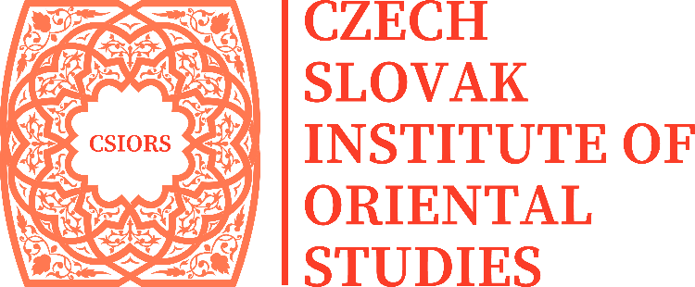

Czech - Slovak Institute of Oriental Studies
Karpatské námestie 10A
Bratislava
Slovakia
+ 421 915 426 500
info@csiors.org
www.csiors.org
© CSIORS

The Muslim Brotherhood and the Turkish government
By Issam Khoury
Table of Contents

Introduction 2
Political Islam under the Turkish secular regime 3
Erdogan's presidency 6
The trick of political Islam to dominate the presidency of the country 7
The bets are on Erdogan's change 7
The conclusion 9

Introduction

March 2021 was a qualitative month in the nature of the Turkish-Egyptian relationship, as Turkey announced the resumption of its diplomatic contacts with Egypt and directed the pro-Muslim Brotherhood media outlets operating from Istanbul to the need to reduce the critical tone of the Egyptian government.
It also prevented the appearance of the Muslim Brotherhood journalist and broadcaster Haitham Abu Khalil, and the Turkish government decided to stop the television programs of journalists Moataz Matar, Muhammad Nasser, Hamza Zawbaa, and artist Hisham Abdullah, and warned them against violating its instructions.
In November 2022, the Turkish authorities arrested Hossam Al-Ghamry , the editor-in-chief of Al-Sharq TV, because of his call for protests in Egypt against President Sisi after the Zamalek and Al-Ahly soccer match. This arrest was preceded by the arrest of several pro-Brotherhood media figures in October 2022, based on Article G-87 , which imposes restrictions leading to the deportation of foreigners from Turkish territory on charges of "posing a threat to public safety."
Al-Arabiya TV, funded by Saudi Arabia, published on December 1, 2022 , news stating that Turkish intelligence is investigating members of the Brotherhood on charges that include money laundering, association with terrorist groups, and transferring fighters between Syria and Libya. Of course, this news was not denied by Turkey. But it coincided with a series of shifts in the foreign policy of Erdogan's government, which are:
- Erdogan's announcement of the possibility of his government reconciling with the Syrian regime in coordination with the Russians
- Turkish-Egyptian reconciliation
- Erdogan’s visit to Saudi Arabia in April 2022 , and the suspension of the Turkish investigation into the killing of journalist Jamal Khashoggi.
- Erdogan's visit to the United Arab Emirates in February 2022.

Political Islam under the Turkish secular regime

It is not possible to talk about political Islam movements in Turkey without addressing the personality of Necmettin Erbakan . In 1970, he established the first Islamic party since the end of the Ottoman Empire under the name of the “National System.” However, the Turkish army, the protector of secularism, dissolved this party after several months for violating the terms of the state’s secularism.

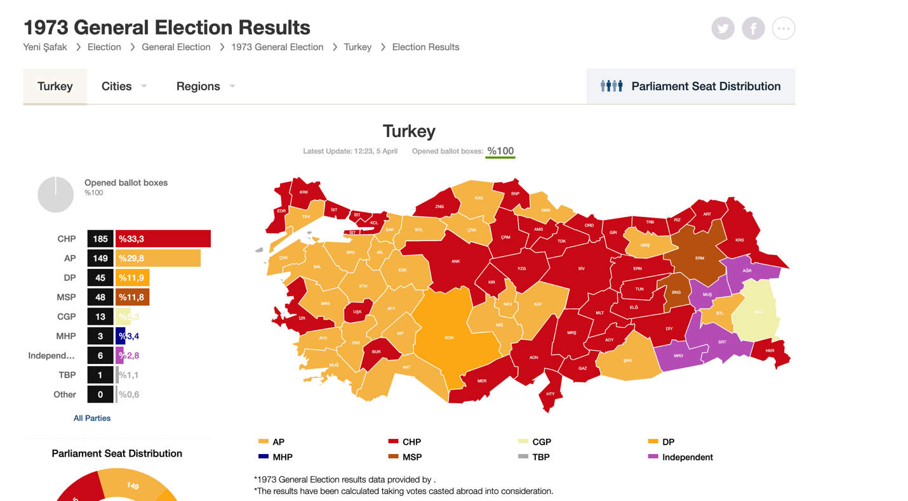

In 1972, the National Safety Party was established with the support of Necmettin Erbakan, with its political leader Suleiman Aref Emre, and after the success of this party by obtaining 48 parliamentary seats in the 1973 elections, Emre stepped down from the leadership of the party, and the presidency was handed over to Necmettin Erbakan, but as a result of the party's organization of a huge demonstration under the title "Liberation of Jerusalem" that carried Islamic slogans in 1980, the army announced the dissolution of this party.

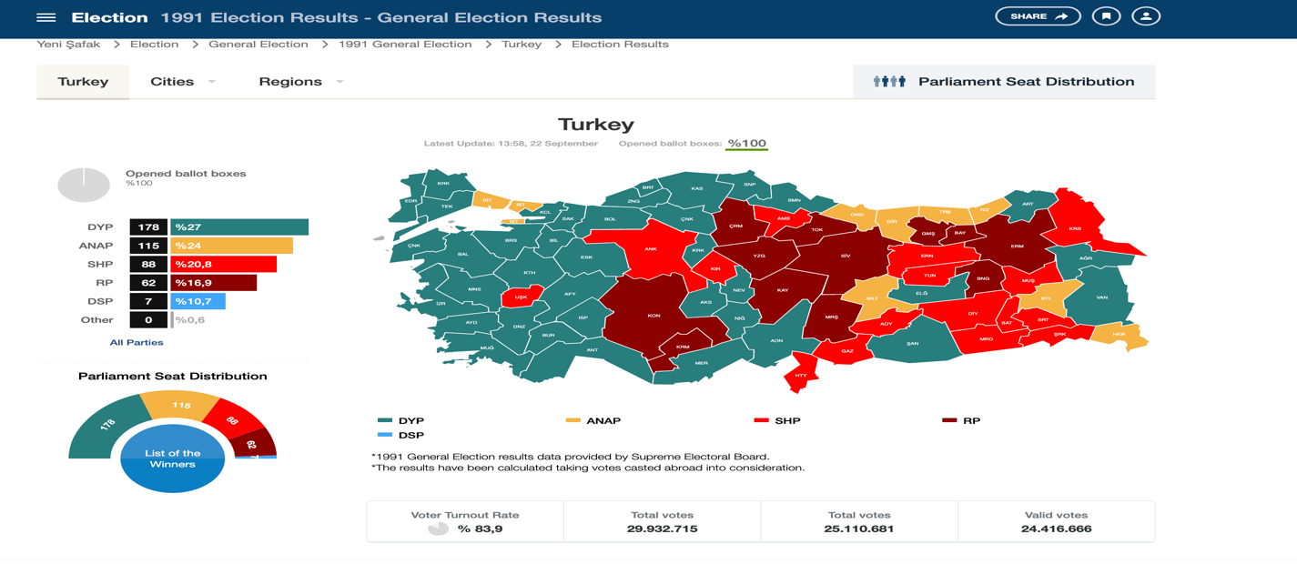

In 1983, the Islamic politician Ali Turan founded the Welfare Party, and this party did not make clear mass Islamic calls as Necmettin Erbakan used to call, so this party did not achieve great popularity, but it was able to open offices in most Turkish cities, which paved the way for the Islamists in 1991 to return strongly for political life, as the elements of both the "National Order and National Safety" party joined the Welfare Party, and Necmettin Erbakan was chosen as the new head of the party, and in the same year this party was able to obtain 62 parliamentary representatives, and in the 1995 elections the Welfare Party was able to obtain It has the highest parliamentary percentage, represented by 158 parliamentarians.

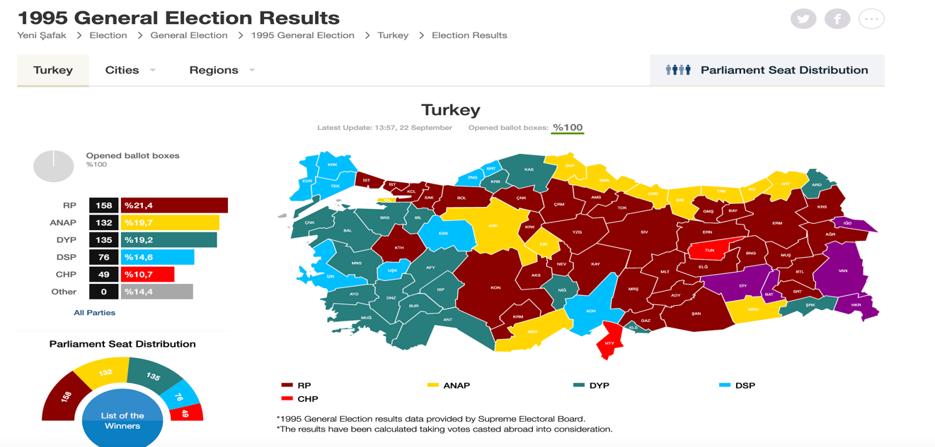

Erbakan invested the success of his parliamentary party in creating the conditions for the Islamization of the state, as he announced his endeavours to project an Islamic market as a response to the European market and allowed female employees to wear the veil. He also started building a mosque in the vicinity of the Republican Palace, which prompted the Turkish army to intervene and dissolve the Welfare Party in 1997. Erbakan was also banned from practicing politics for five years.
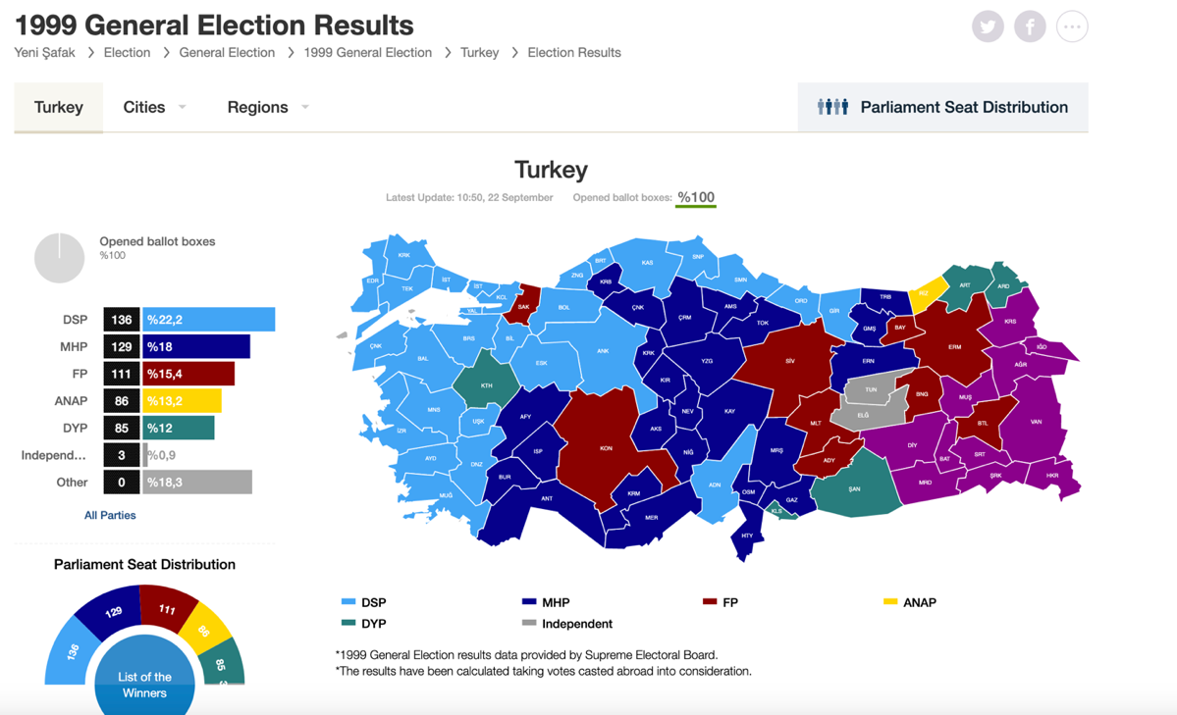

However, the Islamists’ project did not calm down. Rather, the “Virtue” party was established in 1999, headed by Rajai Qutan, and this party managed in the elections of that year to obtain 111 parliamentary representatives.
This demonstrated the weakness of the secularists and the increase in the strength of the Islamists despite the policies of repression towards them, so the decision of the Turkish army came in 2001, and the Virtue Party was dissolved.
The new political Islamist "Youth" in Turkey realized that the shocking confrontational policies adopted by Necmettin Erbakan with the secular authority were not possible, so they decided to establish the "Justice and Development Party" to be a pragmatic Islamic party, while the hard-line Islamists of Erbakan's behaviour "Older" formed the "Happiness" party, and the surprise was that the "Justice and Development" party won 365 parliamentary deputies in the 2002 elections, which indicates that the Turkish street was thirsty for Islamic political leaders capable of addressing the secularists in a rational manner.
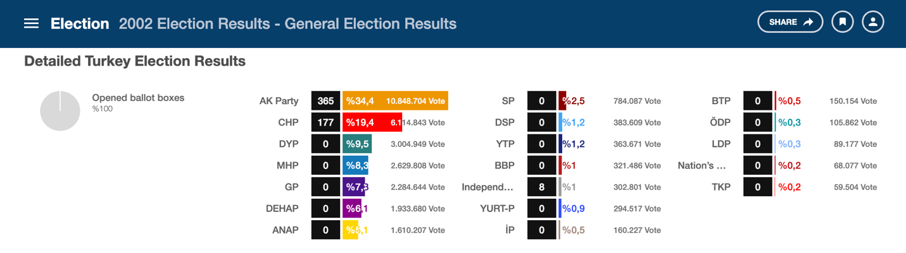

In the 2007 elections, the Justice and Development Party won 341 parliamentary deputies, and in the 2011 elections, the Justice and Development Party won 326 parliamentary deputies, and in the 2015 elections, the Justice and Development Party won 317 parliamentary deputies, and in the 2018 elections, the Justice and Development Party won 295 deputies Parliamentarians, which indicates that the party's popularity has declined, as the party lost 70 deputies in 16 years, and this party also lost the leadership of the city of Istanbul, which represented a severe blow to Erdogan.

Erdogan's presidency

Recep Tayyip Erdogan, head of the Justice and Development Party, won the presidency of the Republic of Turkey in 2014, for a period of five years, and Erdogan amended the Turkish constitution on April 16, 2017, with the help of his party.
As 339 parliamentarians approved these amendments, while 142 deputies opposed them, this gave the Turkish president broader powers in the executive and legislative branches, which authorized him to intervene in issues of the army, security, and administrative appointments. It also allowed the Turkish president to dissolve parliament and demand new parliamentary elections.
The 2017 constitutional amendment also allowed the president not to sever his relationship with his party, which helped him succeed in the presidential elections and made the elements of the Justice and Development Party more influential in governance.
The constitutional amendment of 2017 also allowed for the abolition of the role of the military courts led to the dissolution of all the former Islamic parties of the Justice and Development Party, and this means an insurance instrument for President Erdogan’s party if the Army decided to dissolve this party.

Perhaps the most important legislative amendment is the abolition of the role of the House of Representatives in appointing the President of the Republic and the adoption of direct election by the people. In fact, this amendment is more suitable for religious forces than for secular academic ones.
In general, the forces of political Islam depend on places of worship as a place for advocacy to serve their constituents, and this allows every Islamic candidate to obtain five free meetings with worshipers by performing prayers in mosques during the period of his electoral campaign, and this is actually what the leaders of political Islam have mastered in all Islamic countries, while secular parties cost large sums of money to organize electoral crowds.

The trick of political Islam to dominate the presidency of the country

Article 101 of the Turkish constitution stipulates that the presidential term be limited to two terms of "five years each" that are not subject to renewal. However, Article 106 stipulates that the term of the Turkish president will not be counted if the House of Representatives is dissolved and reconstituted with new elections.
Indeed, the constitutional amendment in 2017 allowed President Recep Tayyip Erdogan to dissolve the House of Representatives, which he did in 2018, which means that he is constitutionally qualified to obtain the right to run for a third time as President of the Republic of Turkey.
Of course, if Erdogan succeeds for the third time, as is likely according to opinion polls, he may repeat the experiment of dissolving the Turkish Parliament for a second time, which would entitle him to run for the presidency of the country in the year 2027!
This constitutional reality, which Erdogan enshrined by amending the constitution in 2017, cannot be changed without a parliamentary majority opposing political Islam.

The bets are on Erdogan's change

Constitutionally, the country's Constitutional Court has the right to intervene to prevent President Erdogan's candidacy for a third time, so that it looks at the democratic values of the country, and not only Article 101 or Article 106.
This is certainly something that will be supported by all opposition parties, as well as by a team of the army, but the Justice and Development Party prepared for this matter, by promoting a broad idea that President Erdogan is a de facto ruler for one term after the constitutional amendment of 2017, while his rule extending from 2014 to 2017 is an uncalculated period because it is based on an old and unfashionable constitution, so his candidacy for the elections in 2023 is a legitimate matter, and it's a second time, not a third.
Erdogan was also able, during his nine-year rule, to change many positions in the army and the state to become loyal to him, justifying this by trying to trim the nails of his Islamist opponent, "Fethullah Gulen," whom Turkey accuses of attempting a failed military coup on July 15, 2016. In fact, the groups opposing Erdogan are numerous in Turkey and are not limited to the Gulen group.
A sizeable portion of the Alawites lean towards secular thought, so they will not be supporters of him in the 2023 elections. Erdogan is aware of this fact even though he visited their religious synagogues and sought to provide more funding for their houses of worship.
Also, the Kurdish nationalists, especially the supporters of the Kurdistan Workers’ Party, will not be on his side, so Erdogan sought to try to support the religious Kurdish party to be a supporter of it, and, this matter is difficult to achieve, so Erdogan decided his order to try to support the Turkish nationalist side for him, by striking the separatist Kurds "PKK". As described in both Syria and Iraq.
From here, it was necessary for him to obtain a clear military achievement on the Syrian borders, but the American side prevented him from that, so he resorted to the Russian ally who marketed Erdogan's project, with the idea of expelling the Democratic Autonomous Administration forces from the areas west of the Euphrates that are actually under the protection of the Russians, provided that he takes their place The Syrian regime forces, on condition that a Turkish reconciliation takes place with the Syrian regime, which the Russians sponsored in the meeting of the Turkish and Syrian army commanders with the intelligence services in Moscow on December 28, 2022.
In fact, the reconciliation of the Turks with the Syrian regime does not disturb the Emirati and Egyptian parties, who see Bashar al-Assad as an acceptable president for Syria considering the chaos in this country. Therefore, it was natural for Erdogan to anticipate this step by limiting the number of Arab Muslim Brotherhood leaders, and this matter will make countries Gulf anti-Muslim Brotherhood happy "Kingdom of Saudi Arabia, United Arab Emirates, Bahrain".
In turn, Qatar, which is protected by Turkish military units, showed an open policy with its Gulf neighbours during the FIFA World Cup. All these things gave a kind of softening of the situation between Turkey, which will witness presidential elections in June 2023, and the Arab oil countries and this is exactly what Erdogan needs, as he has surpassed Turkey's trade deficit is $110 billion in the year 2022. Also, the value of the Turkish lira declined by 5 liras between the beginning and end of 2022, and the exchange rate of the Turkish lira was "3.8 liras" against the dollar when the Turkish constitution was amended in 2017, and it reached its price in December 2022 to "18.7 liras" against one dollar, which means that the Turkish currency has deteriorated by nearly 15 Turkish liras in five years, and this is certainly an economic disaster and indicates the lack of satisfaction of the Americans and Europeans with Erdogan's policies, from here Erdogan resorted to reform His relations with the wealthy Arab countries, which he previously accused of terrorism and the absence of democracy, in an effort to benefit from the markets of those countries, hoping to revive his economy before the elections, thus increasing his chances of success.

The conclusion

In general, the leaders of political Islam began their political life as populist personalities with the aim of gaining people's trust, and as soon as they gained the reins of power, they turned their populist policy towards a policy of central thought confined to the individual, and this matter is religiously justified, as the caliph in Islam has all the powers.
So, the modern leaders of political Islam such as Necmettin Erbakan, Khamenei, and Erdogan imagine that God chose them alone to complete the task of serving their people, by promoting the message of Islam, for this reason, Necmettin Erbakan was adamant about taking over the parties that he supported in secretly. Also, Erdogan was insisting on being the sole candidate of the Justice and Development Party In the 2023 elections.
Indeed, Erdogan transformed from a leader in the political Islam movement to a single leader for all of Turkey, as his interest became focused first and foremost on consolidating his rule as an Islamic leader in a secular state, as his government imprisoned “81 journalists” during the failed coup in 2016, and in 2017 the decline The number decreased to "73 journalists", and in the year 2021 the number decreased to "21 journalists" due to the press's preoccupation with the Corona pandemic, but with the global recovery in 2022, the number of detained journalists returned to rise to reach "40 journalists", of whom "25 are of Kurdish origin", according to what he said. The Committee to Protect Journalists “CPJ” published its report on December 14, 2022.
Of course, the state of repression practiced by Erdogan’s government towards the press coincided with political developments, i.e., it was not based on the concept of shura adopted by political Islam groups, which put him in a state of disagreement with his partners in the Justice and Development Party, where on December 13, 2019, Ahmet Davutoglu founded the new party "GELECEK PARTİSİ,The Future " to compete with Erdogan politically. Former President Abdullah Gul also criticized Erdogan extensively through the Ahval news in February 2020, when he stated the following:
- Turkey's problems with the United States have brought it closer to Russia but moving away from the West will weaken Turkish democracy.
- Parliament did not witness a marginal situation as it is now.

Davutoglu's competition and Gul's statements, the two former friends of Erdogan, clearly indicate that a section of Turkish political Islam has become resentful of Erdogan's policies, so the idea of turning all political Islam towards Erdogan in the upcoming elections will be unsuccessful. Especially since both men enjoy great media coverage from the Arab countries that met Recently with Erdogan, despite her previous criticism of his policies.
Therefore, it is not expected that these countries will make large investments in Turkey before the Turkish elections period, in order not to give Erdogan an opportunity to develop his economy and invest it politically during the presidential elections. Also, the hard-right section in Washington, which is beloved to Saudi Arabia and the UAE, represented by former National Security Adviser John Bolton, has announced that "Turkey's membership in NATO may become questionable in 2023 due to its relations with Russia and its refusal to impose sanctions against it".
The generality of these matters, if added to the state of global economic inflation, the continuation of Turkish disputes with Greece, the unilateral attacks of ISIS near the Turkish border, and the activity of the Kurdistan Workers’ Party, will reduce Erdogan’s popularity, especially since the latter sought to prosecute his opponent in the elections, Istanbul Mayor Ekrem Imamoglu, one of the most prominent CHP leaders, prompting the latter to declare on January 2, 2023 "With every investigation you open, you are far from the hearts of not only 16 million Istanbul residents, but also 85 millions of our nation. I warn you, listen to your senses, make up your mind, stop Stubbornness with people".

@HossamAlGhamry https://twitter.com/haythamabokhal1/status/1588600396771397632?ref_src=twsrc%5Etfw%7Ctwcamp%5Etweetembed%7Ctwterm%5E1588600396771397632%7Ctwgr%5E4fc4afc8c53f27daf4216c8bb21f861c8809e479%7Ctwcon%5Es1_&ref_url=https%3A%2F%2Fnwafez.com%2FD8ADD8B3D8A7D985-D8A7D984D8BAD985D8B1D98A-2%2F
G-87 (Persons who pose a danger for general safety) https://kayapartner.com/en/the-deportation-of-foreigners-the-restriction-codes-and-the-rules-of-procedure-in-turkey/
انقلاب تركي على الإخوان.. تحقيقات تكشف غسيل أموال وتجسس (alhadath.net)
https://www.youtube.com/watch?v=zLxHPUzA8Wo
https://www.youtube.com/watch?v=Ju7tBcosz5Q
https://www.youtube.com/watch?v=YHqU9OEPEYo
https://www.youtube.com/watch?v=_H4ccvNGuxs
Necmettin Erbakan was a Turkish politician, engineer, and academic who was the Prime Minister of Turkey from 1996 to 1997.
https://www.yenisafak.com/ar/secim-2002/secim-sonuclari
https://www.yenisafak.com/en/secim-2018/secim-sonuclari
مباحثات ثلاثية في موسكو تجمع وزراء دفاع روسيا وتركيا وسوريا (alarabiya.net)
العجز التجاري لتركيا يتجاوز الـ 110 مليار دولار في 2022 (snabusiness.com)
العجز التجاري لتركيا يتجاوز الـ 110 مليار دولار في 2022 (alaraby.co.uk)
https://ahvalnews.com/ar/ardwghan-yshdwd-alkhnaq-ly-khswmh-wmardyh/almardt-altrkyt
https://cpj.org/reports/2022/12/number-of-jailed-journalists-spikes-to-new-global-record/
Ahmet Davutoğlu is a politician and former diplomat who served as the 26th Prime Minister of Turkey and Leader of the Justice and Development Party from 2014 to 2016
GELECEK PARTİSİ, https://www.yargitaycb.gov.tr/icerik/1573/gelecek-partisi
Abdullah Gül is the 11th President of Turkey, in office from 2007 to 2014. He previously served for four months as Prime Minister from 2002 to 2003, and concurrently served as both Deputy Prime Minister and as Foreign Minister between 2003 and 2007.
عبد الله غول يخرج بتصريحات نارية ضد أردوغان | سكاي نيوز عربية (skynewsarabia.com)
أحمد داود أوغلو يُهاجم أردوغان وتحالفاته الانتخابية | أحوال تركية (ahvalnews.com)
https://ahvalnews.com/abdullah-gul/turkish-presidents-past-and-present-square-possible-election-showdown
أحمد داود أوغلو يُهاجم أردوغان وتحالفاته الانتخابية | أحوال تركية (rt.com)
The court sentenced Istanbul’s popular mayor, Ekrem Imamoglu, to almost three years in prison and barred him from politics for allegedly insulting the judges in the Supreme Election Council (YSK) for their decision of canceling the mayoral election results in 2019. https://www.brookings.edu/blog/order-from-chaos/2022/12/21/as-a-turkish-court-bans-istanbuls-mayor-from-politics-has-erdogan-miscalculated/
arabic.rt.com

