

**Name:**



**My ‘Diff Diaries**

**Age:**

**Area:**

**Date:**

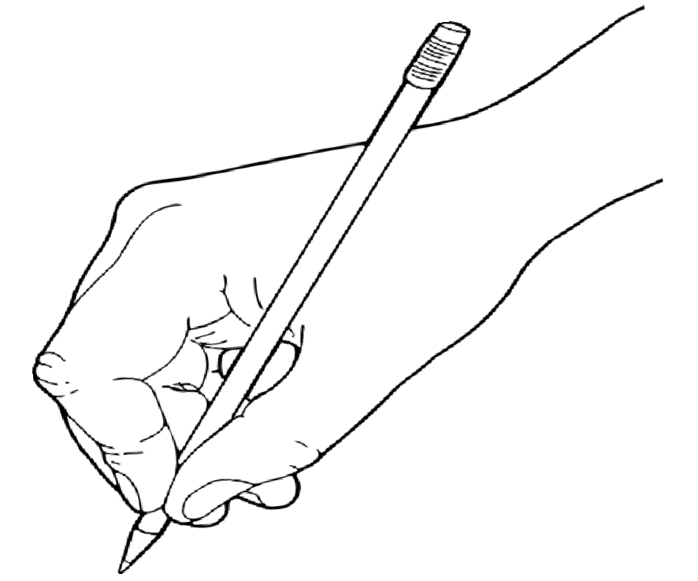

**Draw yourself in the circle below!**

#TheDiffDiaries #DyddiaduronDiff

## Who are you home with?

**Write what you appreciate about these people?**

**Name:**



#### Name:

**Name:**

**Name:**

#### Name:

**Name:**

#TheDiffDiaries #DyddiaduronDiff



# Draw the view from your bedroom window.

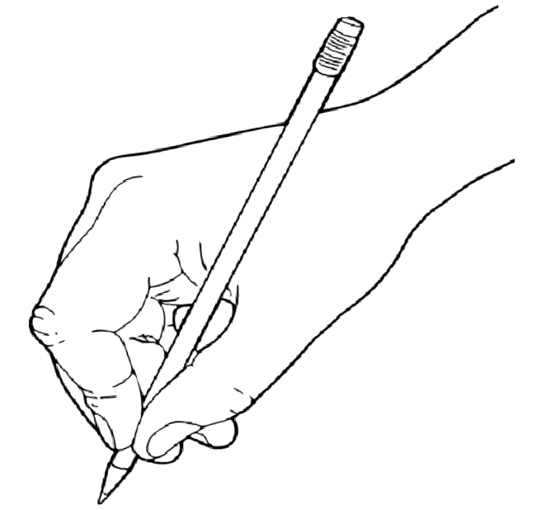

**Is there something you didn’t notice before?**

#TheDiffDiaries #DyddiaduronDiff

# Today’s Date:

#### Good Morning! Wakey Wakey! What are your plans for today?

**If you can, go outside, take a walk and draw things you can see. Or make a note of things you can hear.**

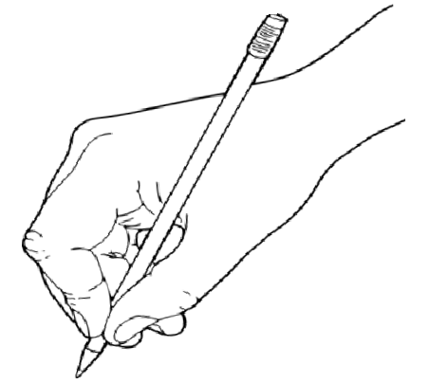

#TheDiffDiaries #DyddiaduronDiff

# What did you do today?

**What did you appreciate most about today?**

### For Example...

I watched... I read...

I sang...

I drew...

I painted... I made...

I helped... I did...

I cooked...

I went...

I listened to... I ate...

I felt...

I am thankful for... I appreciate...



#TheDiffDiaries #DyddiaduronDiff



#TheDiffDiaries #DyddiaduronDiff

# Five awesome things about today!

#### 1.

**2.**

**3.**

**4.**

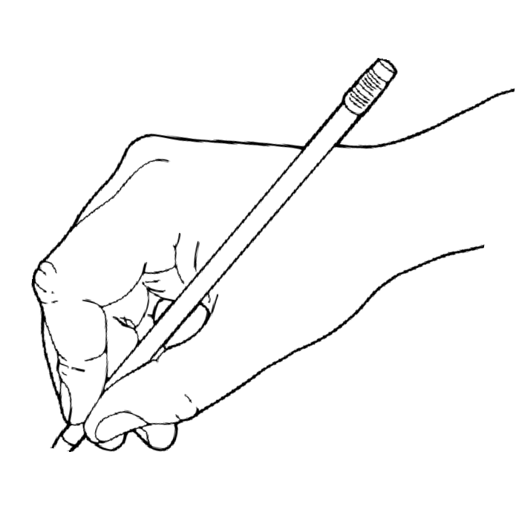

**5.**

**Draw today in pictures:**

#TheDiffDiaries #DyddiaduronDiff

# Today’s Date:

#### Good Morning! Wakey Wakey! What are your plans for today?

**If you can, go outside, take a walk and draw things you can see. Or make a note of things you can hear.**



#TheDiffDiaries #DyddiaduronDiff

# What did you do today?

**What did you appreciate most about today?**

### For Example...

I watched... I read...

I sang...

I drew...

I painted... I made...

I helped... I did...

I cooked...

I went...

I listened to... I ate...

I felt...

I am thankful for... I appreciate...



#TheDiffDiaries #DyddiaduronDiff



#TheDiffDiaries #DyddiaduronDiff

# Five awesome things about today!

#### 1.

**2.**

**3.**

**4.**



**5.**

**Draw today in pictures:**

#TheDiffDiaries #DyddiaduronDiff

# Today’s Date:

#### Good Morning! Wakey Wakey! What are your plans for today?

**If you can, go outside, take a walk and draw things you can see. Or make a note of things you can hear.**



#TheDiffDiaries #DyddiaduronDiff

# What did you do today?

**What did you appreciate most about today?**

### For Example...

I watched... I read...

I sang...

I drew...

I painted... I made...

I helped... I did...

I cooked...

I went...

I listened to... I ate...

I felt...

I am thankful for... I appreciate...



#TheDiffDiaries #DyddiaduronDiff



#TheDiffDiaries #DyddiaduronDiff

# Five awesome things about today!

#### 1.

**2.**

**3.**

**4.**



**5.**

**Draw today in pictures:**

#TheDiffDiaries #DyddiaduronDiff

# Today’s Date:

#### Good Morning! Wakey Wakey! What are your plans for today?

**If you can, go outside, take a walk and draw things you can see. Or make a note of things you can hear.**



#TheDiffDiaries #DyddiaduronDiff

# What did you do today?

**What did you appreciate most about today?**

### For Example...

I watched... I read...

I sang...

I drew...

I painted... I made...

I helped... I did...

I cooked...

I went...

I listened to... I ate...

I felt...

I am thankful for... I appreciate...



#TheDiffDiaries #DyddiaduronDiff



#TheDiffDiaries #DyddiaduronDiff

# Five awesome things about today!

#### 1.

**2.**

**3.**

**4.**



**5.**

**Draw today in pictures:**

#TheDiffDiaries #DyddiaduronDiff

# Today’s Date:

#### Good Morning! Wakey Wakey! What are your plans for today?

**If you can, go outside, take a walk and draw things you can see. Or make a note of things you can hear.**



#TheDiffDiaries #DyddiaduronDiff

# What did you do today?

**What did you appreciate most about today?**

### For Example...

I watched... I read...

I sang...

I drew...

I painted... I made...

I helped... I did...

I cooked...

I went...

I listened to... I ate...

I felt...

I am thankful for... I appreciate...



#TheDiffDiaries #DyddiaduronDiff



#TheDiffDiaries #DyddiaduronDiff

# Five awesome things about today!

#### 1.

**2.**

**3.**

**4.**



**5.**

**Draw today in pictures:**

#TheDiffDiaries #DyddiaduronDiff

# Today’s Date:

#### Good Morning! Wakey Wakey! What are your plans for today?

**If you can, go outside, take a walk and draw things you can see. Or make a note of things you can hear.**



#TheDiffDiaries #DyddiaduronDiff

# What did you do today?

**What did you appreciate most about today?**

### For Example...

I watched... I read...

I sang...

I drew...

I painted... I made...

I helped... I did...

I cooked...

I went...

I listened to... I ate...

I felt...

I am thankful for... I appreciate...



#TheDiffDiaries #DyddiaduronDiff



#TheDiffDiaries #DyddiaduronDiff

# Five awesome things about today!

#### 1.

**2.**

**3.**

**4.**



**5.**

**Draw today in pictures:**

#TheDiffDiaries #DyddiaduronDiff

# Today’s Date:

#### Good Morning! Wakey Wakey! What are your plans for today?

**If you can, go outside, take a walk and draw things you can see. Or make a note of things you can hear.**



#TheDiffDiaries #DyddiaduronDiff

# What did you do today?

**What did you appreciate most about today?**

### For Example...

I watched... I read...

I sang...

I drew...

I painted... I made...

I helped... I did...

I cooked...

I went...

I listened to... I ate...

I felt...

I am thankful for... I appreciate...



#TheDiffDiaries #DyddiaduronDiff



#TheDiffDiaries #DyddiaduronDiff

# Five awesome things about today!

#### 1.

**2.**

**3.**

**4.**



**5.**

**Draw today in pictures:**

#TheDiffDiaries #DyddiaduronDiff

# My ‘Diff Diaries ‘Best Bits’ of the Week!

### What were the highlights of the week just gone?

Day: Day:

Day: Day:

Day: Day:

Day:

#TheDiffDiaries #DyddiaduronDiff