Support Your County Golf Union

THE BB&O ARTISAN SPRING MEETING 2022
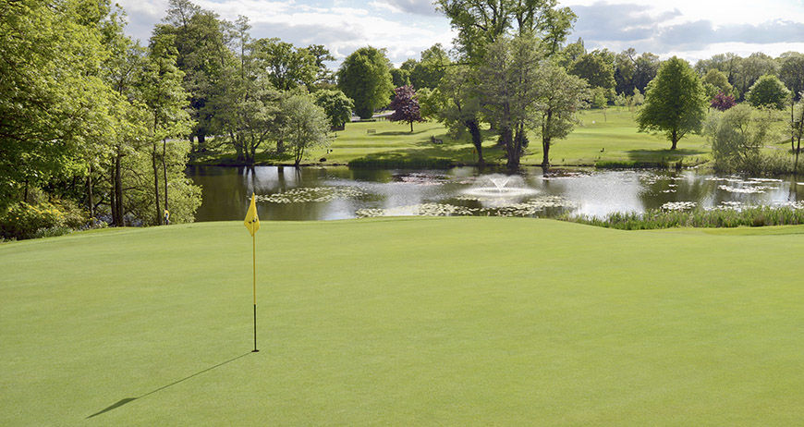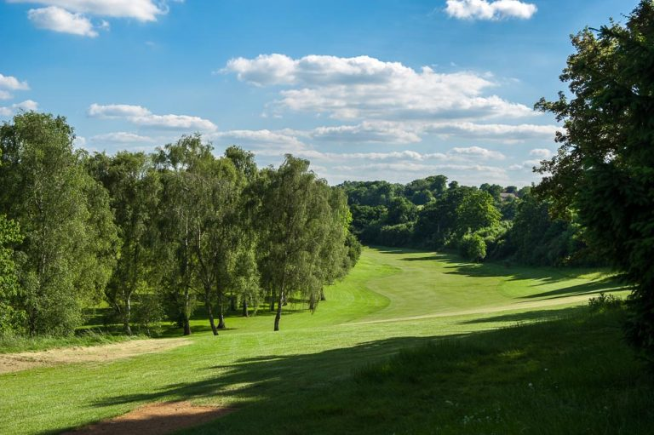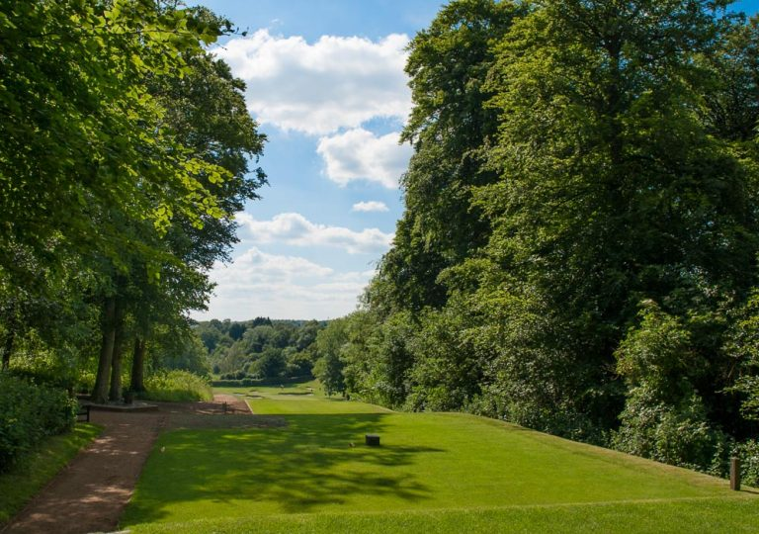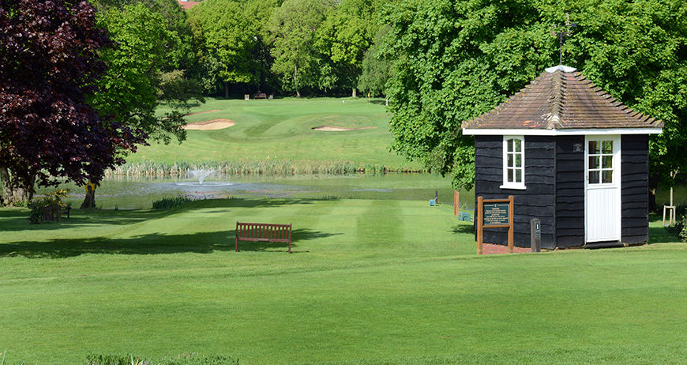
AT CALCOT PARK GOLF CLUB.
Friday 20th May 2022.(12.00 Onwards)
TWO COURSE DINNER & 18 HOLES
£53 INCLUSIVE
This Meeting has been subsidised as agreed
At the AGM November 2021

Name & Handicap

Format : Pairs Betterball Stableford

HSBC: Berks,Bucks&Oxon Artisan Golf Union : 40:24:17 62137844

Name & Handicap

Format : Pairs Betterball Stableford

