14 September 2016

Dear Mr. John Kerry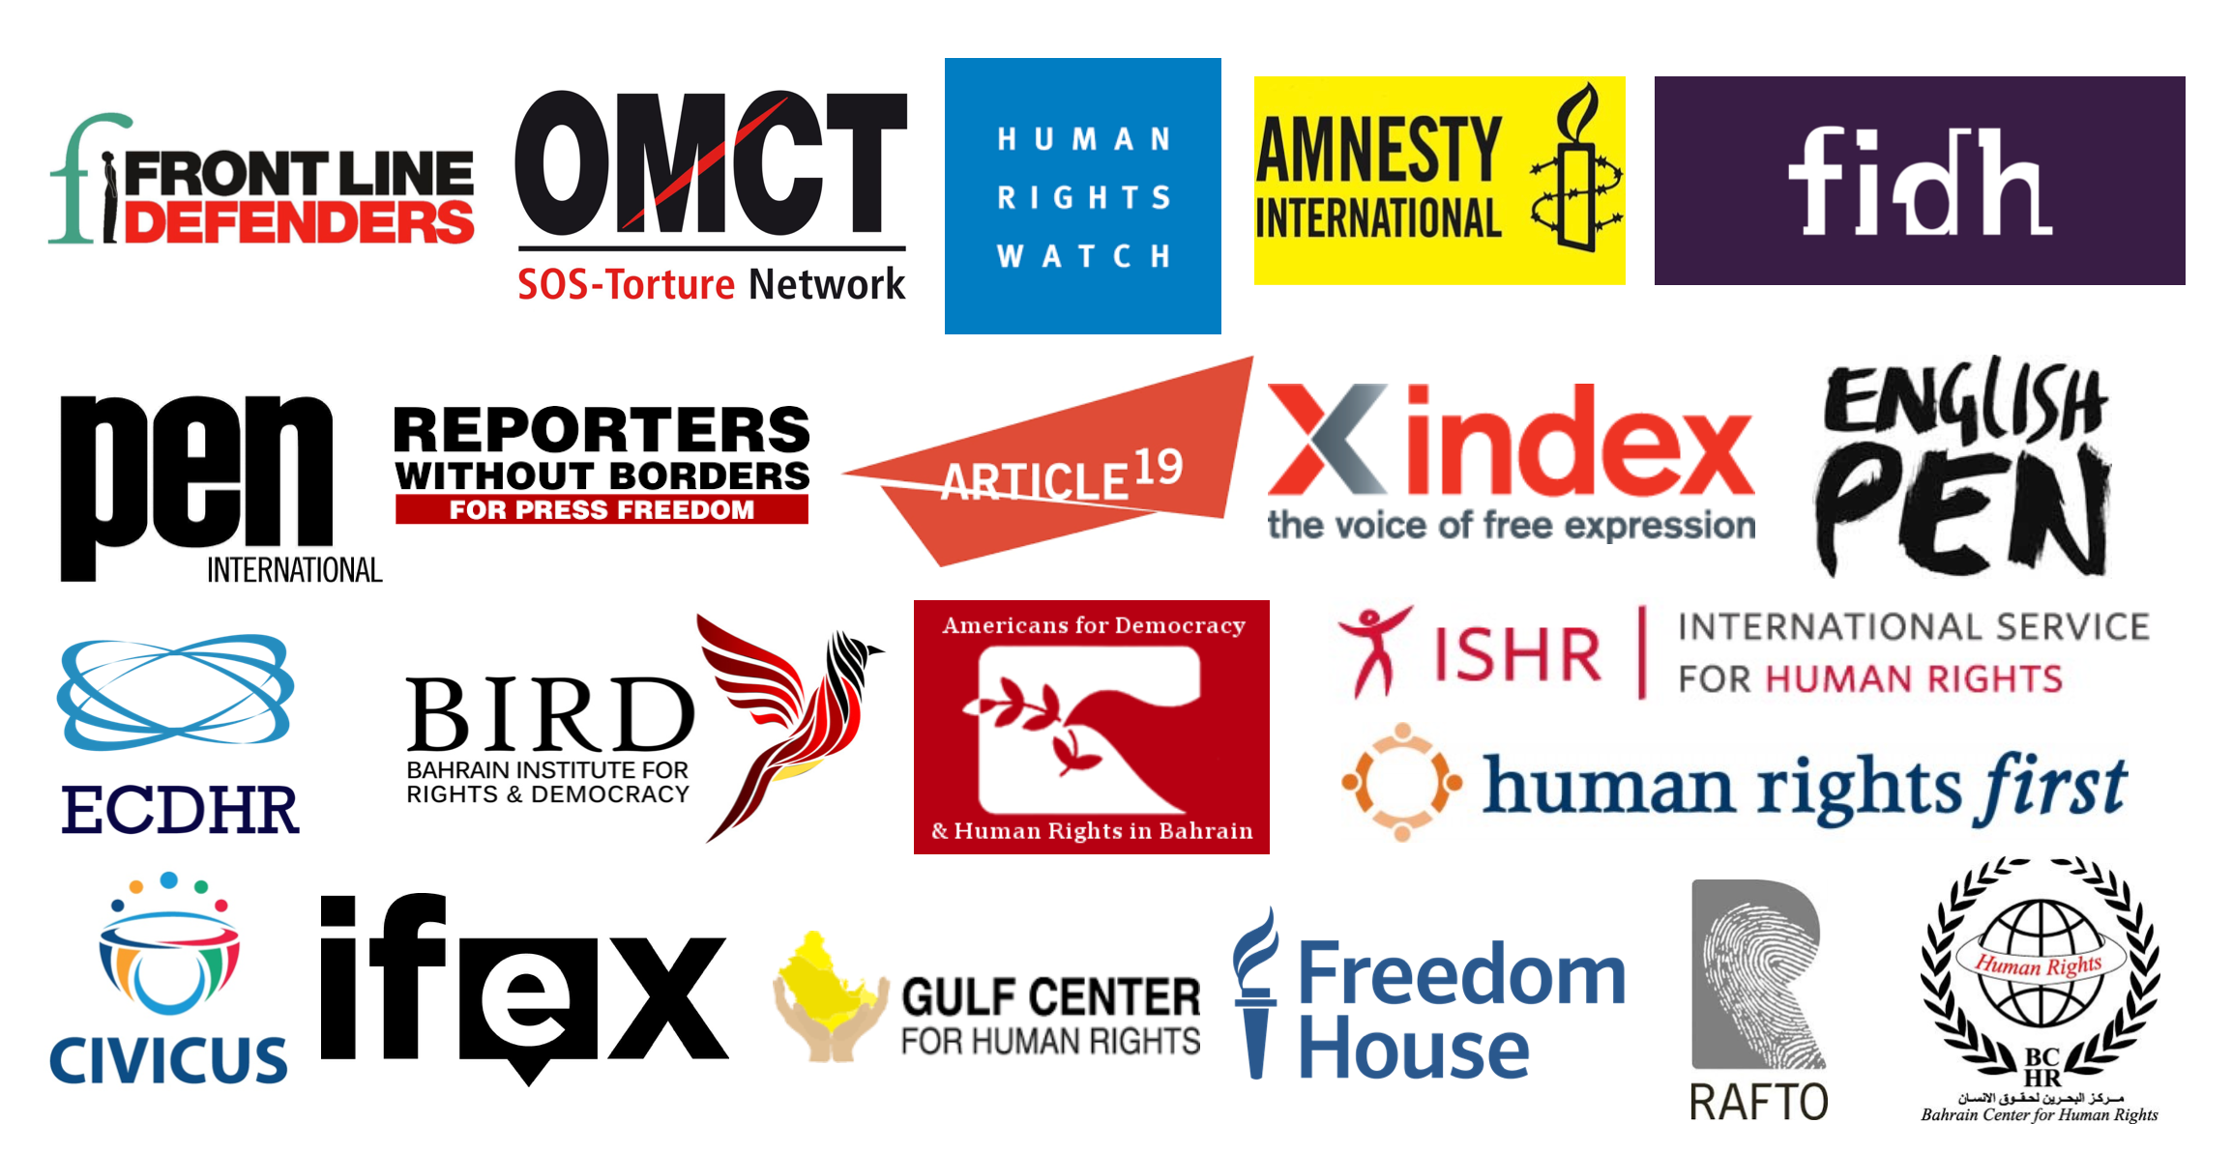,

The undersigned organisations are writing to you to urge theGovernment of the United States to call publicly and privately on the Government of Bahrain to release human rights defender Nabeel Rajab, immediately and unconditionally and drop the charges against him, as they relate solely to his peaceful exercise of his right to freedom of expression.

Nabeel Rajab’s trial is ongoing and if convicted, he could face up to 15 years in prison on charges relating to his criticism of Bahrain’s participation in Saudi Arabia-led military operations in Yemen which, according to the United Nations, have so far been responsible for the deaths of more than 900 civilians, and included numerous unlawful airstrikes on markets, homes, hospitals and schools. The Bahraini High Criminal Court is scheduled to issue its verdict on 6 October 2016.

Nabeel Rajab’s comments on Twitter about the Saudi-led coalition airstrikes in Yemen led to his [arrest](https://www.hrw.org/news/2015/04/03/bahrain-free-rights-activist-held-tweets)on 2 April 2015. Bahrain’s penal code provides for up to 10 years in prison for anyone who “deliberately announces in wartime false or malicious news, statements or rumors. The authorities released him on 13 July 2015, but the Prosecution did not close the case and ordered his [re-arrest](https://www.amnesty.org/en/press-releases/2016/06/bahrain-arrest-of-nabeel-rajab/) on 13 June 2016. Nabeel Rajab is also facing charges of “offending a foreign country,” - Saudi Arabia – and “offending national institutions,” for comments about the alleged torture of inmates in Jau Prison in March 2015.

Nabeel Rajab is the co-founder and president of the Bahrain Center for Human Rights, and holds advisory positions with Human Rights Watch, the International Federation for Human Rights, and the Gulf Center for Human Rights. Amnesty International consider him to be a prisoner of conscience. His human rights activism and his peaceful criticism of the Bahraini authorities has resulted in his imprisonment on two previous occasions, between May 2012 and May 2014, and between January 2015 and July 2015.

Your governmenthas signed joint statements calling on Bahrain to improve its human rights record at the UN Human Rights Council in the past and we urge you to now make a public call for Nabeel Rajab’s immediate and unconditional release.

Please find here attached a copy of an open letter written by Nabeel Rajab from his prison cell and published in the New York Times on 4 September 2016. The Bahraini authorities immediately responded to this letter and brought against Nabeel Rajab the additional charge of “undermining the prestige of the state”.

Yours Sincerely,

* Americans for Democracy & Human Rights in Bahrain
* Amnesty International
* ARTICLE 19
* Bahrain Center for Human Rights
* Bahrain Institute for Rights and Democracy
* CIVICUS: World Alliance for Citizen Participation
* Clive Stafford Smith OBE, Human Rights Lawyer
* English PEN
* European Centre for Democracy and Human Rights
* FIDH, within the framework of the Observatory for the Protection of Human Rights Defenders
* Freedom House
* Frontline Defenders
* Gulf Center for Human Rights
* Human Rights First
* Human Rights Watch
* IFEX
* Index on Censorship
* International Service for Human Rights
* PEN International
* Rafto Foundation for Human Rights
* Reporters Without Borders
* World Organisation Against Torture, within the framework of the Observatory for the Protection of Human Rights Defenders