**Weekly Report – 8 to 14 February**

14 February marked the fifth anniversary of Bahrain’s uprising. The authorities anticipated protests and began to deploy security measures days in advance. The Ministry of Interior’s head of public security [warned](http://www.alwasatnews.com/news/1077789.html) that the authorities would take ‘necessary action’ in response to “calls that may disrupt security and public order.”

Still, many people took to the streets and organized dozens of protests that continued all day on 14 February, as well as the days leading up to it. The demonstrators reiterated their determination to continue protesting for freedom and democracy in Bahrain. Security forces suppressed these demonstrations using tear gas and shotgun pellets. The number of arrests increased considerably compared to previous weeks, with those detained including children. Activists on the ground reported that several people were injured by shotgun pellets and/or nearly suffocated by tear gas. Residents of the areas where protests were being held claimed that security forces effectively put their villages and towns ‘under siege’ on 14 February.

**Arrests:**

According to Bahrain Center for Human Rights (BCHR), security forces [arrested](http://www.bahrainrights.org/) 89 individuals including 30 children; 21 were later released. The majority were arrested after security forces suppressed the protests. At least 59 of the arrests were carried out from 11 February to 14 February. Among these 59 individuals were 25 children.

Also, it was [reported](http://bahrainalyoum.uk/?p=47505) that four American journalists working for Huffington Post were arrested from Sitra while covering the protests. Security forces then [transferred](http://mirror.no-ip.org/news/29431.html) them to Nabih Saleh police station. It has since been [reported](http://www.nbcnews.com/news/world/bahrain-charges-releases-anna-day-3-other-american-journalists-n519291) that the journalists were released.

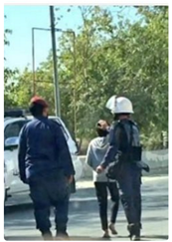

[Security forces arresting a child in Abu Saiba](https://twitter.com/byshr/status/698812608347049984)

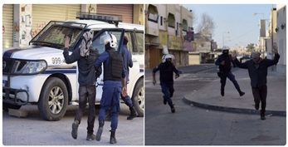

One of the journalists being arrested in Sitra

**Trials:**

Bahraini criminal and appeal courts altered, upheld convictions and sentenced seven individuals to 53 years in prison. Moreover, 99 individuals have had their trials postponed.

**Protests:**

Dozens of protests and sit-ins took place in different areas of Bahrain. The authorities suppressed many of the protests and used excessive force to disperse them. Security forces also used tear gas and shotgun pellets.

From 11 to 14 February, 157 protests were documented, at least 33 of which were suppressed by security forces.

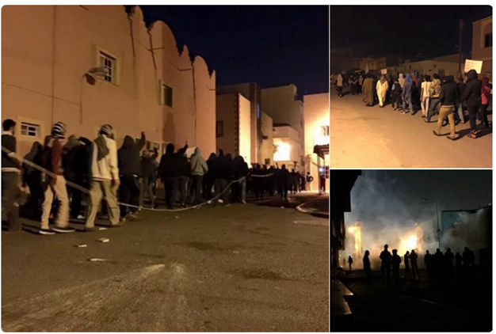

[Sitra](https://twitter.com/Huss3inRadhi/status/698940582673055744)

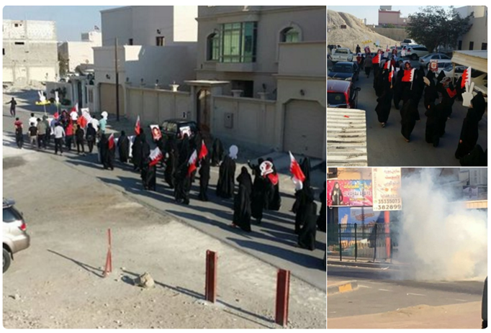

[Aali](https://twitter.com/Huss3inRadhi/status/698855728799420416)

**Collective Punishment/ Use of force:**

The authorities used excessive levels of tear gas and shotgun pellets to suppress peaceful protests. Many injuries were documented of shotgun pellets as well as near suffocation cases. Security forces not only suppressed protests but also collectively punished protests areas by putting them under siege, randomly raiding houses, and using excessive tear gas shot in residential areas.

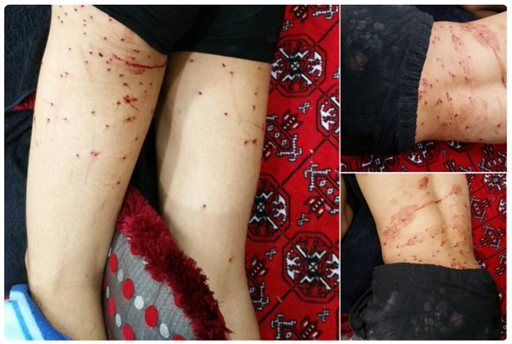

[Shotgun injuries](https://twitter.com/byshr/status/698577044440018946)

**Others:**

Parliament’s committee of legislative and legal affairs [approved](http://www.alwasatnews.com/news/1078852.html) a bill which imposes penalties on anyone who insults electoral commissions or steals lists of voters. According to the bill, whoever is convicted of these crimes will be sentenced to up to two years in prison and up to a BHD2000 fine.

Bahraini detainees [sentenced](http://bahrainalyoum.uk/?p=47502) to death went on a hunger strike in protest of being subjected to ill-treatment by prison administration. It was reported that all detainees sentenced to death and currently living in the special building in Jau Prison said that they are subjected to systematic harassment, including prevention from practicing religion. The administration also prevents the detainees from buying items at the prison’s shops and continuously provokes them to react violently in order to put violations on their records. The detainees have repeatedly asked to meet prison officials but these requests remain unanswered.