**Weekly Report – 28 to 3 January**

In the last few days of 2015 and the beginning of 2016, the human rights situation in Bahrain continued to deteriorate. The number of arbitrarily arrests has seen a considerable increase over previous weeks. The Bahraini judiciary, including the criminal courts and courts of appeal, has issued harsher sentences in cases related to the events of 2011. Lengthy imprisonment sentences, citizenship revocation, and even death penalties were handed down in trials that failed to observe minimum standards of due process. Moreover, opposition figures, human rights defenders, and social media activists have been harassed and prosecuted for exercising their right to free expression.

Last week also saw an increase in demonstrations across the country. Protesters demanded human rights protections and democratic reforms. The authorities suppressed the protests using excessive force, which resulted in several injuries and near-suffocation cases.

**Arrests:**

Security forces [arrested](http://www.bahrainrights.org/) 63 individuals last week, including 18 children.

Former member of al-Wefaq and the Manama municipal council, Hameed al-Basri, was [arrested](http://www.alwasatnews.com/news/1062217.html) at his house in Karbabad. Security forces raided his home, confiscated his laptop and mobile phone, and arrested him. They did not inform him or his family of the reason for arrest.

Approximately one week after the [arrest](http://www.alwasatnews.com/news/1062563.html) of *Al-Wasat* journalist Mahmood al-Jazeeri, the authorities have yet to inform his family or lawyer of the reason for his arrest. According to his lawyer, the authorities have not taken al-Jazeeri to the public prosecution, nor have they charged him. They have also prevented al-Jazeeri from meeting with his lawyer.

The Ministry of Interior [announced](http://www.alwasatnews.com/news/1064137.html) the arrest of several individuals over misuse of social media after they condemned the execution of Sheikh Nimr al-Nimr in Saudi Arabia. The MOI [threatened](https://twitter.com/moi_bahrain/status/683311101992419328) to take legal action against “anyone attempting to misuse the recent verdicts in Saudi Arabia” and [stated](https://twitter.com/moi_bahrain/status/683311166920212484) that it “will not accept interference in any form in the verdicts of the Saudi judiciary or any other brotherly or friendly countries.”

**Trials:**

Bahraini criminal and appeal courts altered, upheld, or issued sentences of more than 1,900 years in prison to 133 people. They also revoked the citizenship of 23 individuals, sentenced one individual to death, and upheld the death penalty for another individual. The courts also postponed the trials of 17 other defendants.

The high criminal court [ruled](http://www.alwasatnews.com/news/1062551.html) in the case of 29 defendants, aged 16 to 25 years, accused of planning an explosion in Bani Jamra and attempting to murder policemen. The court sentenced them to between 10 and 55 years in prison. It also revoked the citizenship of two defendants. The court based its convictions on confessions extracted from seven of the accused. Several of the defendants reported being subjected to torture and other ill-treatment. They claim that the authorities infringed on their rights to due process. One of the defendants, Ahmed al-Arab, was arrested when he was only 16 years old. The authorities allegedly tortured him and held him incommunicado. Al-Arab was reportedly [threatened](http://www.bahrainrights.org/en/node/7507) by the authorities prior to his arrest.

The high criminal court also [sentenced](http://www.alwasatnews.com/news/1063329.html) 22 defendants to life in prison and citizenship revocation on charges related to the murder of a policeman, illegal assembly, and use of explosives and weapons. The court sentenced an additional defendant to death. The convictions were based on defendants’ confessions.

The high criminal court [rejected](http://www.bahrainrights.org/ar/node/7575) the appeals of 12 defendants. The criminal court sentenced seven of them to life in prison, four to 10 years in prison, and one to death. It revoked the citizenship of all 12 individuals. Defendants in these cases reported being tortured into providing false confessions. Salman Isa, sentenced to death, was reportedly subjected to electrocution, sexual abuse, and threats of further torture. As a result the torture, he suffers from impaired hearing and a broken nose.

On 3 January 2016, security forces [summoned](http://www.alwasatnews.com/news/1063327.html) five opposition figures including, Al-Wefaq’s Political Assistant Khalil Marzooq, Sayed Mohammed al-Ghuraifi, Sayed Jameel Kadhem, Wa’ad’s Secretary-General Radhi al-Mosawi, and human rights activist Sheikh Maytham al-Salman. They were interrogated over insulting the regime after they delivered speeches at an event held by Al-Wefaq in solidarity of Sheikh Ali Salman. The authorities released Al-Mosawi, Kadhem, and al-Salman after their interrogations. Al-Ghuraifi and Marzooq were referred to the public prosecution for further interrogation before they were later released.

The high criminal court [postponed](http://www.alwasatnews.com/news/1063653.html) the trial of the owner of the twitter handle, “HajiAhmed,” to 7 January 2016. He was arrested in September 2015 for supposedly criticizing the war in Yemen and ‘disseminating harmful news.’

**Protests:**

Dozens of protests and sit-ins took place in different areas of Bahrain. Security forces reportedly used teargas and shotgun pellets against protesters which resulted in several injuries. Protesters demanded the release of political prisoners and increased democratic reform, among other things. Many demonstrations were held after the execution of Saudi opposition figure, Sheikh Nimr al-Nimr.

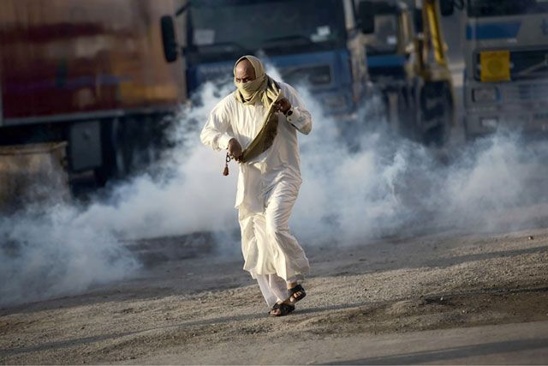

[Sitra](http://www.alwasatnews.com/news/1063640.html)

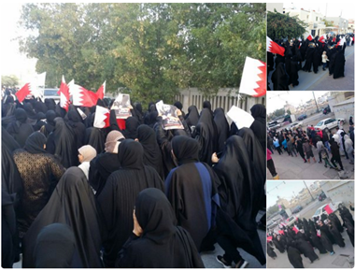

[Sitra](https://twitter.com/Huss3inRadhi/status/683635468865540097)

**Collective Punishment/Use of force:**

Security forces continued to use excessive force, tear gas, and shotgun pellets to suppress peaceful protests. Several injuries were documented by human rights activist on the ground.



[Shotgun injuries](https://twitter.com/Huss3inRadhi/status/683665837518139393)

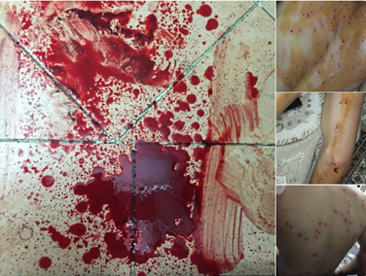

[More shotgun injuries](https://twitter.com/Huss3inRadhi/status/683658702499524608)

**Others:**

The head of the Supreme Judicial Council [stated](http://www.alwasatnews.com/news/1064254.html) that the sentences of imprisonment and citizenship revocation handed down to defendants in security related cases has precedent. He added that the judges did not create these sentences, and that they are based on Bahraini law. Moreover, the Council [announced](http://www.alwasatnews.com/news/1062564.html) the establishment of an additional criminal court, increasing the number of criminal courts to five by January 2016.

The Bahraini parliament’s Committee on Woman and Child Affairs [rejected](http://www.alwasatnews.com/news/1062192.html) a decree that proposed an amendment to bring the country’s legislation in line with the provisions of CEDAW. The committee stated that the decree violated Bahrain’s constitution.